**IWT ASSIGNMENT 1**

**Team Project on: MERIDIAN SCHOOL,BANJARA HILLS**

**Group Members:**

Roll No- Name

160120733129 Roshini Singh

160120733130 Yalla Sai Keertana

160120733133 Sanvi Reddy Sama

160120733147 Aniketh Reddy Konda

160120733170 Sriram Chagarlamudi

**PAGE 1:** Home

**HTML CODE:**

<!DOCTYPE html>

<html lang="en">

<head>

    <meta charset="UTF-8">

    <meta http-equiv="X-UA-Compatible" content="IE=edge">

    <meta name="viewport" content="width=device-width, initial-scale=1.0">

    <title>Home - Meridian School</title>

    <link rel="stylesheet" href="style.css">

    <link rel="stylesheet" href="https://pro.fontawesome.com/releases/v5.10.0/css/all.css" />

    <link rel="icon" type="imag/logo2.png" href="img/logo2.png">

    <link rel="stylesheet" href="https://stackpath.bootstrapcdn.com/bootstrap/4.4.1/css/bootstrap.min.css"

        integrity="sha384-Vkoo8x4CGs03+Hhxv8T/Q5paXtkKtu6ug5TOeNV6gBiFeWPGFN9MuhOf23Q9Ifjh" crossorigin="anonymous" />

    <link rel="stylesheet" href="https://cdnjs.cloudflare.com/ajax/libs/slick-carousel/1.8.1/slick-theme.min.css"

        integrity="sha512-17EgCFERpgZKcm0j0fEq1YCJuyAWdz9KUtv1EjVuaOz8pDnh/0nZxmU6BBXwaaxqoi9PQXnRWqlcDB027hgv9A=="

        crossorigin="anonymous" referrerpolicy="no-referrer" />

    <link rel="stylesheet" href="https://cdnjs.cloudflare.com/ajax/libs/slick-carousel/1.8.1/slick.min.css"

        integrity="sha512-yHknP1/AwR+yx26cB1y0cjvQUMvEa2PFzt1c9LlS4pRQ5NOTZFWbhBig+X9G9eYW/8m0/4OXNx8pxJ6z57x0dw=="

        crossorigin="anonymous" referrerpolicy="no-referrer" />

</head>

<body>

    <div class="navbar">

        <a href="home.html"><img src="img/logo.png" class="logo" alt=""></a>

        <nav>

            <a class="active" href="home.html">HOME</a>

            <div class="dropdown">

                <button class="dropbtn">ABOUT US

                </button>

                <div class="dropdown-content">

                    <a href="knowmeridian.html">KNOW MERIDIAN</a>

                    <a href="visionmission.html">THE VISION & MISSION</a>

                    <a href="http://meridianbanjara.com/the-founders/">THE FOUNDER'S MESSAGE</a>

                    <a href="ceomsg.html">CEO'S MESSAGE</a>

                    <a href="principalmsg.html">THE PRINCIPAL'S MESSAGE</a>

                    <a href="awards.html">AWARDS AND ACCOLADES</a>

                    <a href="http://meridianbanjara.com/affiliations-accreditations/">AFFILIATIONS & ACCREDITATIONS</a>

                    <a href="blog.html">BLOG</a>

                </div>

            </div>

            <div class="dropdown">

                <button class="dropbtn">LEADERSHIP TEAM

                </button>

                <div class="dropdown-content">

                    <a href="principal.html">PRINCIPAL</a>

                    <a href="vp.html">VICE PRINCIPAL</a>

                    <a href="headmistress.html">HEADMISTRESS</a>

                    <a href="midSchool.html">MIDDLE SCHOOL INCHARGE</a>

                    <a href="ipPyp.html">IB PYP COORDINATOR</a>

                    <a href="preprimary.html">PRE PRIMARY INCHARGE</a>

                    <a href="global.html">GLOBAL PARTNERSHIP COORDINATOR</a>

                </div>

            </div>

            <div class="dropdown">

                <button class="dropbtn">ACADEMICS

                </button>

                <div class="dropdown-content">

                    <a href="AcaOverview.html">OVERVIEW</a>

                    <a href="methodology.html">METHODOLOGY AND LEARNING STYLE</a>

                    <a href="curriculum.html">CURRICULUM</a>

                    <a href="faculty.html">FACULTY</a>

                    <a href="teacherTraining.html">TEACHER TRAINING</a>

                    <a href="careerGuidance.html">CAREER GUIDANCE</a>

                    <a href="scholrship.html">SCHOLARSHIP PROGRAMME</a>

                </div>

            </div>

            <div class="dropdown">

                <button class="dropbtn">BEYOND ACADEMICS

                </button>

                <div class="dropdown-content">

                    <a href="beyondAcaOverview.html">OVERVIEW</a>

                    <a href="sports.html">SPORTS</a>

                    <a href="creatveAct.html">CREATIVE ACTIVITIES</a>

                    <a href="eduTrips.html">EDUCATIONAL TRIPS AND STUDENT<br> EXCHANGE PROGRAMMES</a>

                    <a href="perfectSystem.html">PERFECT SYSTEM</a>

                    <a href="schoolSocialRes.html">SCHOOL'S SOCIAL RESPONSIBILITY</a>

                    <a href="interact.html">INTERACT</a>

                    <a href="heritageClub.html">HERITAGE CLUB</a>

                    <a href="mun.html">MUN</a>

                </div>

            </div>

            <div class="dropdown">

                <button class="dropbtn">ADMISSIONS

                </button>

                <div class="dropdown-content">

                    <a href="overview.html">OVERVIEW</a>

                    <a href="admissionpro.html">ADMISSION PROCEDURE</a>

                    <a href="feepolicy.html">FEE POLICY</a>

                    <a href="tranfercert.html">TRANSFER CERTIFICATE</a>

                    <a href="transport.html">TRANSPORT</a>

                </div>

            </div>

            <a class="active" href="gallery.html">GALLERY</a>

            <div class="dropdown">

                <button class="dropbtn">CONTACT US

                </button>

                <div class="dropdown-content">

                    <a href="contact.html">CAREERS</a>

                </div>

            </div>

            <a class="active" href="task5.html">FORM</a>

        </nav>

    </div>

    <div id="mobile">

        <i id="bar" class="fas fa-outdent "></i>

    </div>

    <section id="bg">

        <div id="bgSec">

            <div id="bgSec1">

                <h2>Welcome to Meridian School</h2>

                <button id="read" class="normal"><a style="text-decoration: none; color: white;"

                        href="knowmeridian.html">KNOW MERIDIAN</a></button>

            </div>

        </div>

    </section>

    <section id="feature1">

        <h2>Welcome To Meridian School</h2>

        <p id="p">A sacred space where knowledge and culture coexist, old world values with futuristic approach dwell in

            the annals. Established in the year 1995, Meridian School stands as a magnificent building in the midst of

            lofty Banjara Hills. Meridian instills love for learning, infuses values for living.</p>

        <img id="img" src="img/home/feature1.png" alt="">

        <div class="circle">

            <div class="cir1">

                <div class="image">

                    <img src="img/circle/1.jpg" alt="">

                </div>

                <div class="info">

                    <h3>Best School CBSE</h3>

                    <p id="span1">Committed to empower children to think independently and adapt to new environs, to

                        create balanced thinkers who can contribute to the progress of humanity.</p>

                </div>

            </div>

            <div class="cir1">

                <div class="image">

                    <img src="img/circle/2.jpg" alt="">

                </div>

                <div class="info">

                    <h3>Best IB PYP School </h3>

                    <p id="span2">Meridian works towards the holistic development of the students by providing them with

                        multiple opportunities and pathways to self-discovery.</p>

                </div>

            </div>

        </div>

    </section>

    <section id="picture">

        <div class="picM" id="picMain">

            <div class="pic" id="pic1">

                <img src="img/home/1.jpg" alt="">

            </div>

            <div class="pic" id="pic2">

                <img src="img/home/2.jpg" alt="">

            </div>

            <div class="pic" id="pic3">

                <img src="img/home/3.jpg" alt="">

            </div>

            <div class="picInfo" id="pic4">

                <p>Meridian is a New Generation Educational Group committed to educate children for life and thus bring

                    a change in the society. Learning philosophy practised at Meridian infuses traditional values into a

                    progressive approach, equipping students to adapt and excel anywhere in the world. Our alumni,

                    working in diverse fields, have found Meridian to be the best school for a successful career take

                    off.</p>

                <br>

                <p>Meridian School, Madhapur Campus welcomed students aboard for the first time in 2006. Following the

                    CBSE curriculum and implementing a wide range of extra-curricular activities, school now has

                    strength of 1400+ children from grades Nursery to Class XII, making it the Best School in Hi-Tech

                    city.</p>

            </div>

            <div class="pic" id="pic5">

                <img src="img/home/4.jpg" alt="">

            </div>

            <div class="pic" id="pic6">

                <img src="img/home/5.jpg" alt="">

            </div>

        </div>

    </section>

    <section id="video">

        <div id="vid">

            <div id="vid1">

                <h2>Meridian at a Glance</h2>

            </div>

            <div id="vid2">

                <iframe src="https://www.youtube.com/embed/7-P43exmzpk" width="560" height="315" title="A YouTube video"

                    frameborder="0" allowfullscreen></iframe>

            </div>

        </div>

    </section>

    <section id="topppers">

        <div id="topp">

            <div class="top1" id="topp1">

                <img src="img/home/XII.jpg" alt="">

            </div>

            <div class="top1" id="topp2">

                <img src="img/home/X.jpg" alt="">

            </div>

        </div>

    </section>

    <section id="slider">

        <h2>Our Testimonials</h2>

        <div class="row slider">

            <div class="col-md-4">

                <div class="details">

                    <h3>Rumana Sehgal</h3>

                    <h4>parent</h4>

                    <img src="img/home/sli1.jpg" alt="">

                </div>

                <div class="infoS">

                    <p>The most prominent thing I always feel about Meridian is that the school lives by its ethos -

                        connecting the heart and mind by promoting both intellectual and emotional development. The

                        Faculty is top talent in the industry and reflects &nbsp;in their teaching while the emphasis on

                        self learning encourages experimentation vs rote learning. Parents involvement is highly

                        promoted and expected, making this a valuable partnership. Meridian is a beacon amongst the

                        education system of the city and state, takes the lead in several avenues like the recently

                        concluded Online inter-school Literary and Cultural Fest “Melange"</p>

                </div>

            </div>

            <div class="col-md-4">

                <div class="details">

                    <h3>Sandip</h3>

                    <h4>parent</h4>

                    <img src="img/home/sli2.jpg" alt="">

                    <div class="infoS">

                        <p>' Boost ' that's the word that I prefer to choose of the moment the transition of my daughter

                            comes in mind on her joining Meridian School ! An impeccable blend of knowledge, personal

                            interaction, in depth scrutiny of a child's doubts and fun and frolic with the art and craft

                            or show and tells etc. for the children all under one plate makes our life as parents a

                            cakewalk ! My daughter gets an allround adrenaline to be up in the morning....gets geared up

                            for the periods and performs at her optimum. I am really amazed with the anchor shown by the

                            school especially in these difficult times of online study...still the teachers especially

                            our child's class teacher on how she grips on each child with their questions and sorts them

                            out in her unique way. Great work done by the school leading by example as its name

                            promises....thanks for taking the pressure of our shoulders...kudos to the school

                            management... especially with the making of an all-arounder which is what we look out for in

                            our children..... Great Service !! Always in complete support for your school and a content

                            and proud parent !!</p>

                    </div>

                </div>

            </div>

            <div class="col-md-4">

                <div class="details">

                    <h3>Supriya</h3>

                    <h4>parent</h4>

                    <img src="img/home/sli3.jpg" alt="">

                    <div class="infoS">

                        <p>"Our child has been in Meridian School Banjara Hills since her first class and we are very

                            happy with her progress. The School has helped in her all-round growth by providing

                            opportunities to participate in co-curricular and extra-curricular activities. Teachers have

                            invested their time and efforts to nurture her talents and provided care and concern beyond

                            the call of duty. School has run the same routine and have kept children engaged fully even

                            during the pandemic with innovative ideas for competitions and activities. We are happy and

                            proud Meridian parents and are looking forward to joining our younger one to join the School

                            next year."</p>

                    </div>

                </div>

            </div>

            <div class="col-md-4">

                <div class="details">

                    <h3>Swati & Rameshwar Jamwal

                    </h3>

                    <h4>parent</h4>

                    <img src="img/home/sli4.jpg" alt="">

                    <div class="infoS">

                        <p>What defines a good school? As defined by Joanne Yatvin , a good school is a school that

                            creates a sense of community that permits personal expression within a framework of social

                            responsibility. It focuses on learnings that grow through use, such as communication skills,

                            decision making, craftsmanship and group interaction. It makes children think for themselves

                            as people who find strength, nourishment and joy in learning. Our journey at Meridian

                            started when Krittika joined the school in 2007 as a ‘mid-term’ admission in PP1 ( pri

                            primary). I remember, the day, as clearly as though it happened yesterday. When the

                            interview was done and Usha Reddy Ma’am, asked me &nbsp;when Krittika could join the school,

                            I had queried, whether Krittika would be required to go through an assessment. She looked at

                            Krittika and asked her “Do you want to join my school?” Krittika, her eyes shining and

                            wearing her widest smile ever, just nodded. Ma’am then said &nbsp;“that’s all we need - big

                            bright eyes and a wide smile. The rest is for us to do.” That sentence defines our journey.

                            Krittika is poised to leave school next year. She’s still got her big bright smile and

                            shining eyes intact. Through the years whether it was camping in school, going on field

                            trips, participating in various events, singing &amp; dancing on stage, giving exams, being

                            coached when the results weren’t great to sharing high fives when they were, representing

                            the school in sporting &amp; cultural events, to participating in the MUN and holding

                            leadership roles like the sports secretary and most recently the head girl, she’s

                            experienced it all. &nbsp;She has grown and blossomed into this confident child who has

                            found strength, nourishment and joy in learning at Meridian. As we look back, we feel so

                            good that our child is a Meridianite, where she has been taught to connect her heart and her

                            mind to all that she does. &nbsp;Along with her I have seen her classmates become incredible

                            young people. I’ve also marveled at how the teaching staff, admin staff and heads of school

                            &nbsp;don’t seem to age. Thank you all for being incredible. For helping us cope as a family

                            as we went through our biggest personal loss. To ensure a child is taken care off even

                            outside the school environment, to support and protect the mental well-being of a child and

                            his/ her family. You have demonstrated it all in our time at the school. Class teachers,

                            subject teachers, non-teaching staff, admin staff – how does one even begin to say thank

                            you? &nbsp;I believe as Krittika leaves school and starts her next leg, through her actions

                            and contribution she will attempt &nbsp;to say “ Thank you – Meridian school for Boys and

                            Girls, Banjara Hills - for everything!” Swati &amp; Rameshwar Jamwal Parents of Krittika

                            Jamwal – (PP1 – XII)What defines a good school? As defined by Joanne Yatvin , a good school

                            is a school that creates a sense of community that permits personal expression within a

                            framework of social responsibility. It focuses on learnings that grow through use, such as

                            communication skills, decision making, craftsmanship and group interaction. It makes

                            children think for themselves as people who find strength, nourishment and joy in learning.

                            Our journey at Meridian started when Krittika joined the school in 2007 as a ‘mid-term’

                            admission in PP1 ( pri primary). I remember, the day, as clearly as though it happened

                            yesterday. When the interview was done and Usha Reddy Ma’am, asked me &nbsp;when Krittika

                            could join the school, I had queried, whether Krittika would be required to go through an

                            assessment. She looked at Krittika and asked her “Do you want to join my school?” Krittika,

                            her eyes shining and wearing her widest smile ever, just nodded. Ma’am then said

                            &nbsp;“that’s all we need - big bright eyes and a wide smile. The rest is for us to do.”

                            That sentence defines our journey. Krittika is poised to leave school next year. She’s still

                            got her big bright smile and shining eyes intact. Through the years whether it was camping

                            in school, going on field trips, participating in various events, singing &amp; dancing on

                            stage, giving exams, being coached when the results weren’t great to sharing high fives when

                            they were, representing the school in sporting &amp; cultural events, to participating in

                            the MUN and holding leadership roles like the sports secretary and most recently the head

                            girl, she’s experienced it all. &nbsp;She has grown and blossomed into this confident child

                            who has found strength, nourishment and joy in learning at Meridian. As we look back, we

                            feel so good that our child is a Meridianite, where she has been taught to connect her heart

                            and her mind to all that she does. &nbsp;Along with her I have seen her classmates become

                            incredible young people. I’ve also marveled at how the teaching staff, admin staff and heads

                            of school &nbsp;don’t seem to age. Thank you all for being incredible. For helping us cope

                            as a family as we went through our biggest personal loss. To ensure a child is taken care

                            off even outside the school environment, to support and protect the mental well-being of a

                            child and his/ her family. You have demonstrated it all in our time at the school. Class

                            teachers, subject teachers, non-teaching staff, admin staff – how does one even begin to say

                            thank you? &nbsp;I believe as Krittika leaves school and starts her next leg, through her

                            actions and contribution she will attempt &nbsp;to say “ Thank you – Meridian school for

                            Boys and Girls, Banjara Hills - for everything!” Swati &amp; Rameshwar Jamwal Parents of

                            Krittika Jamwal – (PP1 – XII)What defines a good school? As defined by Joanne Yatvin , a

                            good school is a school that creates a sense of community that permits personal expression

                            within a framework of social responsibility. It focuses on learnings that grow through use,

                            such as communication skills, decision making, craftsmanship and group interaction. It makes

                            children think for themselves as people who find strength, nourishment and joy in learning.

                            Our journey at Meridian started when Krittika joined the school in 2007 as a ‘mid-term’

                            admission in PP1 ( pri primary). I remember, the day, as clearly as though it happened

                            yesterday. When the interview was done and Usha Reddy Ma’am, asked me &nbsp;when Krittika

                            could join the school, I had queried, whether Krittika would be required to go through an

                            assessment. She looked at Krittika and asked her “Do you want to join my school?” Krittika,

                            her eyes shining and wearing her widest smile ever, just nodded. Ma’am then said

                            &nbsp;“that’s all we need - big bright eyes and a wide smile. The rest is for us to do.”

                            That sentence defines our journey. Krittika is poised to leave school next year. She’s still

                            got her big bright smile and shining eyes intact. Through the years whether it was camping

                            in school, going on field trips, participating in various events, singing &amp; dancing on

                            stage, giving exams, being coached when the results weren’t great to sharing high fives when

                            they were, representing the school in sporting &amp; cultural events, to participating in

                            the MUN and holding leadership roles like the sports secretary and most recently the head

                            girl, she’s experienced it all. &nbsp;She has grown and blossomed into this confident child

                            who has found strength, nourishment and joy in learning at Meridian. As we look back, we

                            feel so good that our child is a Meridianite, where she has been taught to connect her heart

                            and her mind to all that she does. &nbsp;Along with her I have seen her classmates become

                            incredible young people. I’ve also marveled at how the teaching staff, admin staff and heads

                            of school &nbsp;don’t seem to age. Thank you all for being incredible. For helping us cope

                            as a family as we went through our biggest personal loss. To ensure a child is taken care

                            off even outside the school environment, to support and protect the mental well-being of a

                            child and his/ her family. You have demonstrated it all in our time at the school. Class

                            teachers, subject teachers, non-teaching staff, admin staff – how does one even begin to say

                            thank you? &nbsp;I believe as Krittika leaves school and starts her next leg, through her

                            actions and contribution she will attempt &nbsp;to say “ Thank you – Meridian school for

                            Boys and Girls, Banjara Hills - for everything!” Swati &amp; Rameshwar Jamwal Parents of

                            Krittika Jamwal – (PP1 – XII)What defines a good school? As defined by Joanne Yatvin , a

                            good school is a school that creates a sense of community that permits personal expression

                            within a framework of social responsibility. It focuses on learnings that grow through use,

                            such as communication skills, decision making, craftsmanship and group interaction. It makes

                            children think for themselves as people who find strength, nourishment and joy in learning.

                            Our journey at Meridian started when Krittika joined the school in 2007 as a ‘mid-term’

                            admission in PP1 ( pri primary). I remember, the day, as clearly as though it happened

                            yesterday. When the interview was done and Usha Reddy Ma’am, asked me &nbsp;when Krittika

                            could join the school, I had queried, whether Krittika would be required to go through an

                            assessment. She looked at Krittika and asked her “Do you want to join my school?” Krittika,

                            her eyes shining and wearing her widest smile ever, just nodded. Ma’am then said

                            &nbsp;“that’s all we need - big bright eyes and a wide smile. The rest is for us to do.”

                            That sentence defines our journey. Krittika is poised to leave school next year. She’s still

                            got her big bright smile and shining eyes intact. Through the years whether it was camping

                            in school, going on field trips, participating in various events, singing &amp; dancing on

                            stage, giving exams, being coached when the results weren’t great to sharing high fives when

                            they were, representing the school in sporting &amp; cultural events, to participating in

                            the MUN and holding leadership roles like the sports secretary and most recently the head

                            girl, she’s experienced it all. &nbsp;She has grown and blossomed into this confident child

                            who has found strength, nourishment and joy in learning at Meridian. As we look back, we

                            feel so good that our child is a Meridianite, where she has been taught to connect her heart

                            and her mind to all that she does. &nbsp;Along with her I have seen her classmates become

                            incredible young people. I’ve also marveled at how the teaching staff, admin staff and heads

                            of school &nbsp;don’t seem to age. Thank you all for being incredible. For helping us cope

                            as a family as we went through our biggest personal loss. To ensure a child is taken care

                            off even outside the school environment, to support and protect the mental well-being of a

                            child and his/ her family. You have demonstrated it all in our time at the school. Class

                            teachers, subject teachers, non-teaching staff, admin staff – how does one even begin to say

                            thank you? &nbsp;I believe as Krittika leaves school and starts her next leg, through her

                            actions and contribution she will attempt &nbsp;to say “ Thank you – Meridian school for

                            Boys and Girls, Banjara Hills - for everything!” Swati &amp; Rameshwar Jamwal Parents of

                            Krittika Jamwal – (PP1 – XII)What defines a good school? As defined by Joanne Yatvin , a

                            good school is a school that creates a sense of community that permits personal expression

                            within a framework of social responsibility. It focuses on learnings that grow through use,

                            such as communication skills, decision making, craftsmanship and group interaction. It makes

                            children think for themselves as people who find strength, nourishment and joy in learning.

                            Our journey at Meridian started when Krittika joined the school in 2007 as a ‘mid-term’

                            admission in PP1 ( pri primary). I remember, the day, as clearly as though it happened

                            yesterday. When the interview was done and Usha Reddy Ma’am, asked me &nbsp;when Krittika

                            could join the school, I had queried, whether Krittika would be required to go through an

                            assessment. She looked at Krittika and asked her “Do you want to join my school?” Krittika,

                            her eyes shining and wearing her widest smile ever, just nodded. Ma’am then said

                            &nbsp;“that’s all we need - big bright eyes and a wide smile. The rest is for us to do.”

                            That sentence defines our journey. Krittika is poised to leave school next year. She’s still

                            got her big bright smile and shining eyes intact. Through the years whether it was camping

                            in school, going on field trips, participating in various events, singing &amp; dancing on

                            stage, giving exams, being coached when the results weren’t great to sharing high fives when

                            they were, representing the school in sporting &amp; cultural events, to participating in

                            the MUN and holding leadership roles like the sports secretary and most recently the head

                            girl, she’s experienced it all. &nbsp;She has grown and blossomed into this confident child

                            who has found strength, nourishment and joy in learning at Meridian. As we look back, we

                            feel so good that our child is a Meridianite, where she has been taught to connect her heart

                            and her mind to all that she does. &nbsp;Along with her I have seen her classmates become

                            incredible young people. I’ve also marveled at how the teaching staff, admin staff and heads

                            of school &nbsp;don’t seem to age. Thank you all for being incredible. For helping us cope

                            as a family as we went through our biggest personal loss. To ensure a child is taken care

                            off even outside the school environment, to support and protect the mental well-being of a

                            child and his/ her family. You have demonstrated it all in our time at the school. Class

                            teachers, subject teachers, non-teaching staff, admin staff – how does one even begin to say

                            thank you? &nbsp;I believe as Krittika leaves school and starts her next leg, through her

                            actions and contribution she will attempt &nbsp;to say “ Thank you – Meridian school for

                            Boys and Girls, Banjara Hills - for everything!” Swati &amp; Rameshwar Jamwal Parents of

                            Krittika Jamwal – (PP1 – XII)What defines a good school? As defined by Joanne Yatvin , a

                            good school is a school that creates a sense of community that permits personal expression

                            within a framework of social responsibility. It focuses on learnings that grow through use,

                            such as communication skills, decision making, craftsmanship and group interaction. It makes

                            children think for themselves as people who find strength, nourishment and joy in learning.

                            Our journey at Meridian started when Krittika joined the school in 2007 as a ‘mid-term’

                            admission in PP1 ( pri primary). I remember, the day, as clearly as though it happened

                            yesterday. When the interview was done and Usha Reddy Ma’am, asked me &nbsp;when Krittika

                            could join the school, I had queried, whether Krittika would be required to go through an

                            assessment. She looked at Krittika and asked her “Do you want to join my school?” Krittika,

                            her eyes shining and wearing her widest smile ever, just nodded. Ma’am then said

                            &nbsp;“that’s all we need - big bright eyes and a wide smile. The rest is for us to do.”

                            That sentence defines our journey. Krittika is poised to leave school next year. She’s still

                            got her big bright smile and shining eyes intact. Through the years whether it was camping

                            in school, going on field trips, participating in various events, singing &amp; dancing on

                            stage, giving exams, being coached when the results weren’t great to sharing high fives when

                            they were, representing the school in sporting &amp; cultural events, to participating in

                            the MUN and holding leadership roles like the sports secretary and most recently the head

                            girl, she’s experienced it all. &nbsp;She has grown and blossomed into this confident child

                            who has found strength, nourishment and joy in learning at Meridian. As we look back, we

                            feel so good that our child is a Meridianite, where she has been taught to connect her heart

                            and her mind to all that she does. &nbsp;Along with her I have seen her classmates become

                            incredible young people. I’ve also marveled at how the teaching staff, admin staff and heads

                            of school &nbsp;don’t seem to age. Thank you all for being incredible. For helping us cope

                            as a family as we went through our biggest personal loss. To ensure a child is taken care

                            off even outside the school environment, to support and protect the mental well-being of a

                            child and his/ her family. You have demonstrated it all in our time at the school. Class

                            teachers, subject teachers, non-teaching staff, admin staff – how does one even begin to say

                            thank you? &nbsp;I believe as Krittika leaves school and starts her next leg, through her

                            actions and contribution she will attempt &nbsp;to say “ Thank you – Meridian school for

                            Boys and Girls, Banjara Hills - for everything!” Swati &amp; Rameshwar Jamwal Parents of

                            Krittika Jamwal – (PP1 – XII)</p>

                    </div>

                </div>

            </div>

        </div>

    </section>

    <section id="pdf">

        <a href="img/home/MANDATORY-PUBLIC-DISCLOSURE.pdf">MPD</a>

    </section>

    <footer>

        <div class="col">

            <h4>ABOUT US</h4>

            <p>Meridian is a New Generation Educational Group committed to educate children for life and thus bring a

                change in the society. Learning philosophy practised at Meridian infuses traditional values into a

                progressive approach, equipping students to adapt and excel anywhere in the world. Our alumni, working

                in diverse fields, have found Meridian to be the best school for a successful career take off.</p>

        </div>

        <div class="col">

            <h4>USEFUL LINKS</h4>

            <ul class="three-col-links">

                <li><a href="home.html">HOME</a></li>

                <li><a href="AcaOverview.html">ACADEMICS</a></li>

                <li><a href="overview.html">ADMISSIONS</a></li>

                <li><a href="contact.html">CONTACT US</a></li>

                <li><a href="knowmeridian.html">ABOUT US</a></li>

                <li><a href="beyondAcaOverview.html">BEYOND ACADEMICS</a></li>

                <li><a href="contact.html">CAREERS</a></li>

            </ul>

        </div>

        <div class="col">

            <!--<div class="follow">

                <div class="icon">

                    <i class="fa fa-paper-plane-o"></i>

                </div>

        </div>-->

            <h4>MERIDIAN SCHOOL, Banjara Hills</h4>

            <p># 8-2-541, Road No 7, Banjara Hills, Hyderabad-500034, TELANGANA, INDIA.</p>

            <p>For contact : +91 8096918857, 9948508222, For Prinicipal Appointments : 8098420002</p>

            <p> For Admissions / Enquires : 8096918857, 9948508222</p>

            <p>info.banjara@meridianschool.inA</p>

        </div>

    </footer>

    <section id="copyright">

        <div id="cr">

            <p>© Copyright MERIDIAN SCHOOL, 2021.</p>

        </div>

    </section>

    <script src="https://ajax.googleapis.com/ajax/libs/jquery/3.6.0/jquery.min.js"></script>

    <script src="https://cdnjs.cloudflare.com/ajax/libs/slick-carousel/1.8.1/slick.min.js"

        integrity="sha512-XtmMtDEcNz2j7ekrtHvOVR4iwwaD6o/FUJe6+Zq+HgcCsk3kj4uSQQR8weQ2QVj1o0Pk6PwYLohm206ZzNfubg=="

        crossorigin="anonymous" referrerpolicy="no-referrer"></script>

    <!-- <script type="text/javascript">

        $('.slider').slick({

            dots: true,

            infinite: false,

            speed: 300,

            slidesToShow: 2,

            slidesToScroll: 1,

            responsive: [

                {

                    breakpoint: 1024,

                    settings: {

                        slidesToShow: 3,

                        slidesToScroll: 3,

                        infinite: true,

                        dots: true

                    }

                },

                {

                    breakpoint: 600,

                    settings: {

                        slidesToShow: 2,

                        slidesToScroll: 2

                    }

                },

                {

                    breakpoint: 480,

                    settings: {

                        slidesToShow: 1,

                        slidesToScroll: 1

                    }

                }

                // You can unslick at a given breakpoint now by adding:

                // settings: "unslick"

                // instead of a settings object

            ]

        });

    </script> -->

</body>

</html>

**CSS CODE:**

@import url('https://fonts.googleapis.com/css2?family=Lato:wght@300;400;700&display=swap');

* {

margin: 0;

padding: 0;

box-sizing: border-box;

font-family: 'Spartan', sans-serif;

}

a:hover {

transition: 0.2 ease;

}

/* div, section{

border: 2px solid black;

} */

h1 {

font-size: 40px;

line-height: 64px;

color: #fff;

}

h2 {

font-weight: 500;

font-size: 56px;

line-height: 54px;

color: #fff;

text-align: center;

}

h3 {

text-align: center;

font-size: 22px;

color: #c42329;

}

h6 {

font-weight: 700;

font-size: 12px;

}

p {

font-size: 15px;

line-height: 26px;

font-weight: 400;

font-style: normal;

color: #444;

}

span {

font-size: 15px;

line-height: 26px;

font-weight: 400;

font-style: normal;

color: #444444;

text-align: center;

}

.fa {

display: inline-block;

font: normal normal normal 14px/1 FontAwesome;

font-size: inherit;

text-rendering: auto;

color: #fff;

}

.icon1 {

padding: 8px 15px;

}

#follow .icon {

justify-content: flex-end;

}

#follow .icon i {

color: #fff;

}

#follow .followus {

display: flex;

background-color: #c42329;

}

#follow .followus a {

color: #fff;

text-decoration: none;

font-size: 14px;

font-weight: 550;

}

/* #follow .followus #phone {

padding: 10px 10px 10px 55px;

}

#follow .followus #mail {

padding: 10px 10px 10px 35px;

} */

#follow .followus a:hover {

text-decoration: underline;

}

#follow .icon {

margin-left: 619px;

padding: 10px 10px;

}

#follow .icon i {

padding: 0 3px;

}

.section-p1 {

margin: 40px 80px;

}

.section-m1 {

margin: 40px 0;

}

button.normal {

font-size: 14px;

font-weight: 600;

padding: 15px 30px;

color: #fff;

background-color: #c42329;

border-radius: 4px;

cursor: pointer;

border: none;

outline: none;

transition: 0.2s;

}

body {

width: 100%;

}

#header {

background-color: #fff;

border-bottom: #c42329;

display: flex;

align-items: center;

justify-content: space-between;

padding: 16px 80px;

box-shadow: 0 5px 15px rgba(0, 0, 0, 0.06);

/* z-index: 999; */

position: sticky;

top: 0;

left: 0;

}

#header a img {

width: 135px;

height: 61px;

}

#header a:hover {

border: 1px dotted orange;

}

#mobile {

display: none;

align-items: center;

}

#close {

display: none;

}

/*#navbar {

display: flex;

align-items: center;

justify-content: center;

}

#navbar li {

list-style: none;

padding: 0 8px;

position: relative;

}

#navbar li a {

text-decoration: none;

font-size: 13px;

font-weight: 600;

color: #c42329;

transition: 0.3 ease;

}

#navbar li a.active::after,

#navbar li a:hover::after {

content: "";

width: 30%;

height: 2px;

position: absolute;

bottom: -4px;

left: 20px;

}

#navbar .headButton {

border-left: 20px;

}

#navbar .headButton:hover {

border: #c42329;

background-color: #fff;

color: black;

}*/

.navbar {

overflow: hidden;

background-color: #fff;

}

.navbar a {

float: left;

font-size: 14px;

color: #c42329;

text-align: left;

padding: 14px 16px;

text-decoration: none;

}

.active {

font-weight: 650;

}

.dropdown {

float: left;

overflow: hidden;

}

.dropdown .dropbtn {

font-size: 14px;

border: none;

outline: none;

color: #c42329;

padding: 14px 16px;

background-color: inherit;

font-family: inherit;

margin: 0;

font-weight: 650;

}

.navbar a:hover,

.dropdown:hover .dropbtn {

color: orange;

}

.dropdown-content {

display: none;

position: absolute;

background-color: #c42329;

min-width: 160px;

box-shadow: 0px 8px 16px 0px rgba(0, 0, 0, 0.2);

z-index: 1;

}

.dropdown-content a {

float: none;

color: white;

padding: 12px 16px;

text-decoration: none;

display: block;

text-align: left;

}

.dropdown-content a:hover {

background-color: #c42329;

}

.dropdown:hover .dropdown-content {

display: block;

}

nav {

margin-top: 1.5%;

margin-left: 30%;

}

.logo {

margin-left: 60%;

width: 135px;

height: 61px;

}

#bg {

background-image: url('img/home/bg1.jpg');

background-size: 100%;

height: 500px;

}

/* #bgSec{

display: flex;

flex-direction: column;

} */

#bgSec1 {

padding-top: 336px;

}

#bgSec1 h2 {

background-color: #c42329;

color: #fff;

display: inline;

margin-left: 330px;

}

#bgSec1 p {

text-align: center;

margin: 20px 20% 10px;

}

#bgSec1 button {

margin-top: 20px;

margin-left: 563px;

}

#feature1 {

display: flex;

justify-content: center;

flex-wrap: wrap;

}

#feature1 h2 {

color: #c42329;

margin: 72px auto 11px;

}

#feature1 #p {

color: #444444;

text-align: center;

margin: 10px 15% 4px;

}

#feature1 #img {

margin-bottom: 90px;

}

.circle {

display: flex;

width: 100%;

margin-bottom: 50px;

}

.cir1 {

/* width: 30%; */

justify-content: center;

}

.cir1 img {

border-radius: 50%;

}

.cir1 .image {

margin-left: 241px;

}

.cir1 h3 {

margin: 10px 0 10px;

}

#span1 {

text-align: center;

color: #444444;

margin: 10px 0px 60px 69px;

}

#span2 {

text-align: center;

color: #444444;

margin: 10px 50px 10px 21px;

}

.picM {

display: flex;

flex-wrap: wrap;

background-color: #c42329;

/* border: 2px solid black; */

}

.pic img {

width: 275px;

height: 345px;

}

#pic1 img {

width: 579px;

height: 407px;

}

#pic4 {

width: 579px;

margin: 20px;

}

#pic4 p {

color: #fff;

}

#pic1 {

margin: 80px 10px 20px 20px;

}

#pic2,

#pic3 {

margin: 80px 20px 0px 20px;

}

#pic5,

#pic6 {

margin: 0px 20px 80px 20px;

}

.gall {

height: 400px;

}

.gall h2 {

color: #c42329;

margin: 50px 0;

}

.gall img {

width: 280px;

height: 220px;

margin-left: 80px;

}

/* #video{

background-color: #c43d42;

} */

#vid {

background-color: #c42329;

height: 700px;

background-image: url(img/home/7.jpg);

background-repeat: no-repeat;

}

#vid1 {

padding: 92px 0 20px;

}

#vid2 {

margin: 6px 40px 20px 226px;

}

#vid2 iframe {

width: 800px;

height: 430px;

}

/* #vidBG{

background-color: #c42329;

opacity: 0.5;

} */

#topp {

background-color: #f7fafd;

height: 580px;

}

#topp .top1 img {

width: 80%;

}

#topp #topp1 img {

margin: 100px 10% 0px 10%;

}

#topp #topp2 img {

margin: 0px 10% 100px 10%;

}

.container {

width: 300%;

}

#slider h2 {

color: #c42329;

margin-top: 40px;

}

#slider .row {

display: flex;

width: 294%;

}

#slider .col-md-4 {

width: 15%;

margin: 40px 0 40px 70px;

}

#slider .details h3 {

color: #c42329;

display: inline-block;

}

#slider .details h4 {

color: #646464;

margin: 10px 0 0px;

}

#slider .details {

z-index: 999;

}

#slider .details img {

margin: 0px 0px 0 414px;

border-radius: 50%;

}

#slider .infoS {

background-color: #ecf0f3;

display: flex;

width: 556px;

z-index: 0;

}

#slider .infoS p {

margin: 44px 127px 20px 44px;

color: #646464;

}

#pdf {

height: 100px;

}

#pdf a {

text-decoration: none;

color: #c42329;

font-weight: bold;

margin-left: 50px;

}

#pdf a:hover {

color: orange;

}

footer {

width: 100%;

background-color: #c42329;

display: flex;

flex-direction: row;

justify-content: space-between;

flex-wrap: wrap;

padding: 90px 70px 50px 70px;

}

footer .col {

display: flex;

flex-direction: column;

align-items: flex-start;

margin-bottom: 20px;

width: 30%;

height: 100%;

}

footer h4 {

font-size: 20px;

color: #fff;

padding-bottom: 20px;

}

footer p {

font-size: 16px;

color: #fff;

padding-bottom: 0 0 8px 0;

margin-bottom: 0;

}

footer a {

font-size: 17px;

margin-bottom: 10px;

color: #fff;

text-decoration: none;

}

/* Align Links in footer */

.three-col-links {

width: 105%;

-webkit-column-count: 2;

-moz-column-count: 2;

column-count: 2;

padding-top: 4%;

}

.three-col-links li {

width: 100%;

float: left;

display: inline;

margin-top: 8%;

color: #fff;

/* font-weight: 600; */

text-transform: uppercase;

}

/* END -Align Links in footer */

footer .follow {

margin-top: 20px;

}

footer .follow i {

color: #fff;

padding-right: 4px;

cursor: pointer;

}

footer .follow i:hover,

footer a:hover {

color: orange;

}

#cr {

background-color: black;

}

#cr p {

text-align: center;

color: #fff;

padding: 20px 0;

}

**OUTPUT:**

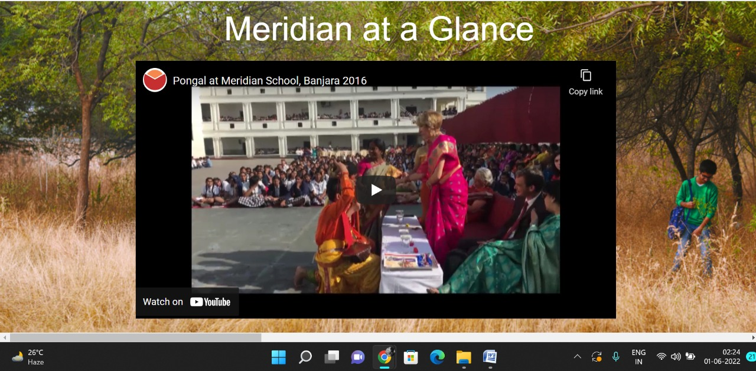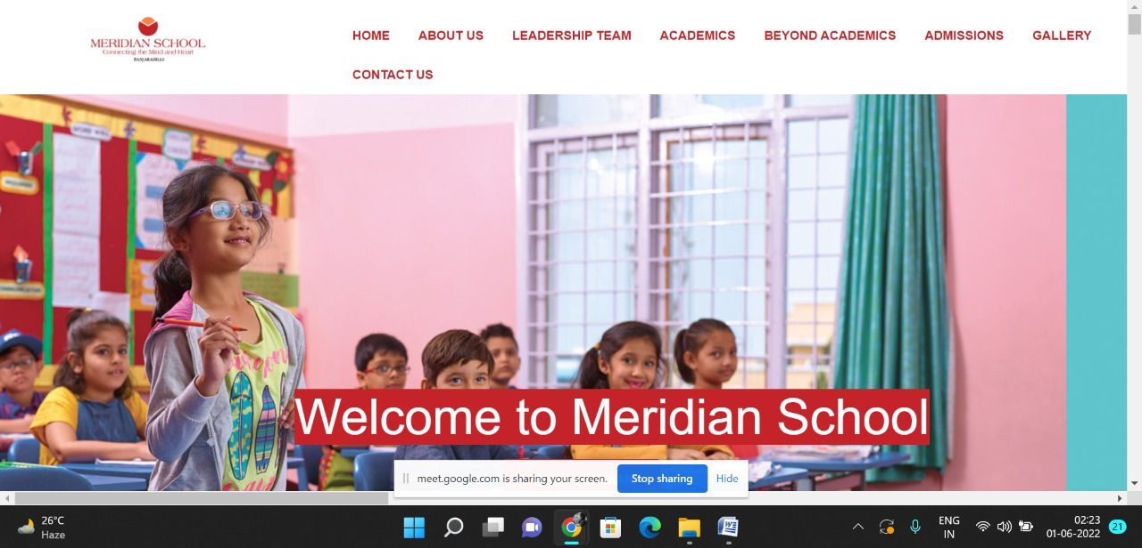

Beyond Academics Pages

**PAGE 2: Overview**

**HTML CODE:**

<!DOCTYPE html>

<html lang="en">

<head>

    <meta charset="UTF-8">

    <meta http-equiv="X-UA-Compatible" content="IE=edge">

    <meta name="viewport" content="width=device-width, initial-scale=1.0">

    <title>OVERVIEW - Meridian School</title>

    <link rel="stylesheet" href="style.css">

    <link rel="stylesheet" href="https://pro.fontawesome.com/releases/v5.10.0/css/all.css" />

    <link rel="icon" type="imag/logo2.png" href="img/logo2.png">

    <link rel="stylesheet" href="https://stackpath.bootstrapcdn.com/bootstrap/4.4.1/css/bootstrap.min.css"

        integrity="sha384-Vkoo8x4CGs03+Hhxv8T/Q5paXtkKtu6ug5TOeNV6gBiFeWPGFN9MuhOf23Q9Ifjh" crossorigin="anonymous" />

    <link rel="stylesheet" href="https://cdnjs.cloudflare.com/ajax/libs/slick-carousel/1.8.1/slick-theme.min.css"

        integrity="sha512-17EgCFERpgZKcm0j0fEq1YCJuyAWdz9KUtv1EjVuaOz8pDnh/0nZxmU6BBXwaaxqoi9PQXnRWqlcDB027hgv9A=="

        crossorigin="anonymous" referrerpolicy="no-referrer" />

    <link rel="stylesheet" href="https://cdnjs.cloudflare.com/ajax/libs/slick-carousel/1.8.1/slick.min.css"

        integrity="sha512-yHknP1/AwR+yx26cB1y0cjvQUMvEa2PFzt1c9LlS4pRQ5NOTZFWbhBig+X9G9eYW/8m0/4OXNx8pxJ6z57x0dw=="

        crossorigin="anonymous" referrerpolicy="no-referrer" />

</head>

<body>

    <section id="follow">

        <div class="followus">

            <div class="icon1">

                <i class="fa fa-phone"></i>

                <a id="phone" href="">8096918857, 9948508222</a>

            </div>

            <div class="icon1">

                <i class="fa fa-envelope"></i>

                <a id="mail" href="">info.banjara@meridianschool.in</a>

            </div>

            <div class="icon">

                <a href="https://www.facebook.com/MeridianSchoolBanjaraHills/" target="_blank"

                    class="fab fa-facebook-f"></i></a>

                <a href="https://twitter.com/meridianbanjara" target="_blank"><i class="fab fa-twitter"></i></a>

                <a href="https://www.youtube.com/channel/UCBZ_gLF9qM18O3CDWQHeN1A" target="_blank"><i

                        class="fab fa-youtube"></i></a>

                <a href="https://www.instagram.com/meridianschools/" target="_blank"><i

                        class="fab fa-instagram"></i></a>

            </div>

        </div>

    </section>

    <div class="navbar">

        <a href="home.html"><img src="img/logo.png" class="logo" alt=""></a>

        <nav>

            <a class="active" href="home.html">HOME</a>

            <div class="dropdown">

                <button class="dropbtn">ABOUT US

                </button>

                <div class="dropdown-content">

                    <a href="knowmeridian.html">KNOW MERIDIAN</a>

                    <a href="visionmission.html">THE VISION & MISSION</a>

                    <a href="http://meridianbanjara.com/the-founders/">THE FOUNDER'S MESSAGE</a>

                    <a href="ceomsg.html">CEO'S MESSAGE</a>

                    <a href="principalmsg.html">THE PRINCIPAL'S MESSAGE</a>

                    <a href="awards.html">AWARDS AND ACCOLADES</a>

                    <a href="http://meridianbanjara.com/affiliations-accreditations/">AFFILIATIONS & ACCREDITATIONS</a>

                    <a href="blog.html">BLOG</a>

                </div>

            </div>

            <div class="dropdown">

                <button class="dropbtn">LEADERSHIP TEAM

                </button>

                <div class="dropdown-content">

                    <a href="principal.html">PRINCIPAL</a>

                    <a href="vp.html">VICE PRINCIPAL</a>

                    <a href="headmistress.html">HEADMISTRESS</a>

                    <a href="midSchool.html">MIDDLE SCHOOL INCHARGE</a>

                    <a href="ipPyp.html">IB PYP COORDINATOR</a>

                    <a href="preprimary.html">PRE PRIMARY INCHARGE</a>

                    <a href="global.html">GLOBAL PARTNERSHIP COORDINATOR</a>

                </div>

            </div>

            <div class="dropdown">

                <button class="dropbtn">ACADEMICS

                </button>

                <div class="dropdown-content">

                    <a href="AcaOverview.html">OVERVIEW</a>

                    <a href="methodology.html">METHODOLOGY AND LEARNING STYLE</a>

                    <a href="curriculum.html">CURRICULUM</a>

                    <a href="faculty.html">FACULTY</a>

                    <a href="teacherTraining.html">TEACHER TRAINING</a>

                    <a href="careerGuidance.html">CAREER GUIDANCE</a>

                    <a href="scholrship.html">SCHOLARSHIP PROGRAMME</a>

                </div>

            </div>

            <div class="dropdown">

                <button class="dropbtn">BEYOND ACADEMICS

                </button>

                <div class="dropdown-content">

                    <a href="beyondAcaOverview.html">OVERVIEW</a>

                    <a href="sports.html">SPORTS</a>

                    <a href="creatveAct.html">CREATIVE ACTIVITIES</a>

                    <a href="eduTrips.html">EDUCATIONAL TRIPS AND STUDENT<br> EXCHANGE PROGRAMMES</a>

                    <a href="perfectSystem.html">PERFECT SYSTEM</a>

                    <a href="schoolSocialRes.html">SCHOOL'S SOCIAL RESPONSIBILITY</a>

                    <a href="interact.html">INTERACT</a>

                    <a href="heritageClub.html">HERITAGE CLUB</a>

                    <a href="mun.html">MUN</a>

                </div>

            </div>

            <div class="dropdown">

                <button class="dropbtn">ADMISSIONS

                </button>

                <div class="dropdown-content">

                    <a href="overview.html">OVERVIEW</a>

                    <a href="admissionpro.html">ADMISSION PROCEDURE</a>

                    <a href="feepolicy.html">FEE POLICY</a>

                    <a href="tranfercert.html">TRANSFER CERTIFICATE</a>

                    <a href="transport.html">TRANSPORT</a>

                </div>

            </div>

            <a class="active" href="gallery.html">GALLERY</a>

            <div class="dropdown">

                <button class="dropbtn">CONTACT US

                </button>

                <div class="dropdown-content">

                    <a href="contact.html">CAREERS</a>

                </div>

            </div>

        </nav>

    </div>

    <div id="mobile">

        <i id="bar" class="fas fa-outdent "></i>

    </div>

    <section id="principal">

        <div class="prin" id="sports">

            <h2>OVERVIEW</h2>

            <span id="orange"><a href="home.html">Meridian School Banjara Hills</a></span>

            <span> &gt; OVERVIEW</span>

        </div>

    </section>

    <section id="principal1">

        <div class="academics" id="overview">

            <h4>OVERVIEW</h4>

            <p>Based on Howard Gardner’s five specific mental abilities; the Disciplinary Mind, the Synthesizing Mind,

                the Creative Mind, the Respectful Mind and the Ethical Mind, education and learning must surpass the

                four walls of a classroom. Co-curricular activities help in the holistic development of students and

                assist in developing critical skills, creative skills and abilities to be successful in future. Meridian

                caters to the holistic development of the child’s persona and therefore, provides a plethora of

                activities for the students to opt. The full-fledged training equips them to scale greater heights.</p>

        </div>

        </div>

    </section>

    <footer>

        <div class="col">

            <h4>ABOUT US</h4>

            <p>Meridian is a New Generation Educational Group committed to educate children for life and thus bring a

                change in the society. Learning philosophy practised at Meridian infuses traditional values into a

                progressive approach, equipping students to adapt and excel anywhere in the world. Our alumni, working

                in diverse fields, have found Meridian to be the best school for a successful career take off.</p>

        </div>

        <div class="col">

            <h4>USEFUL LINKS</h4>

            <ul class="three-col-links">

                <li><a href="home.html">HOME</a></li>

                <li><a href="AcaOverview.html">ACADEMICS</a></li>

                <li><a href="overview.html">ADMISSIONS</a></li>

                <li><a href="contact.html">CONTACT US</a></li>

                <li><a href="knowmeridian.html">ABOUT US</a></li>

                <li><a href="beyondAcaOverview.html">BEYOND ACADEMICS</a></li>

                <li><a href="contact.html">CAREERS</a></li>

            </ul>

        </div>

        <div class="col">

            <!--<div class="follow">

                <div class="icon">

                    <i class="fa fa-paper-plane-o"></i>

                </div>

        </div>-->

            <h4>MERIDIAN SCHOOL, Banjara Hills</h4>

            <p># 8-2-541, Road No 7, Banjara Hills, Hyderabad-500034, TELANGANA, INDIA.</p>

            <p>For contact : +91 8096918857, 9948508222, For Prinicipal Appointments : 8098420002</p>

            <p> For Admissions / Enquires : 8096918857, 9948508222</p>

            <p>info.banjara@meridianschool.inA</p>

        </div>

    </footer>

    <section id="copyright">

        <div id="cr">

            <p>© Copyright MERIDIAN SCHOOL, 2021.</p>

        </div>

    </section>

</body>

</html>

**CSS CODE:**

#principal #sports {

background-image: url(img/sports.jpg);

}

#principal .prin h2 {

font-size: 34px;

font-weight: 600;

text-align: start;

/* color: #c42329; */

}

#principal .prin span {

color: #fff;

}

#principal #orange {

color: #f48243;

}

#principal #orange:hover {

color: #fff;

}

#principal1 .princi1 {

display: flex;

}

#principal1 .princi1 img {

width: 250px;

height: 169px;

border: 7px solid rgb(225, 222, 222);

}

#principal1 .princi1 h4 {

text-align: start;

color: #c42329;

margin: 100px 0 35px 0px;

}

#principal1 .princi1 #info {

width: 42%;

margin: 200px 53px 70px;

}

#principal1 .princi1 #info p {

margin-bottom: 20px;

}

#principal1 .princi1 #info #strong {

margin-bottom: 0px;

}

**OUTPUT:**

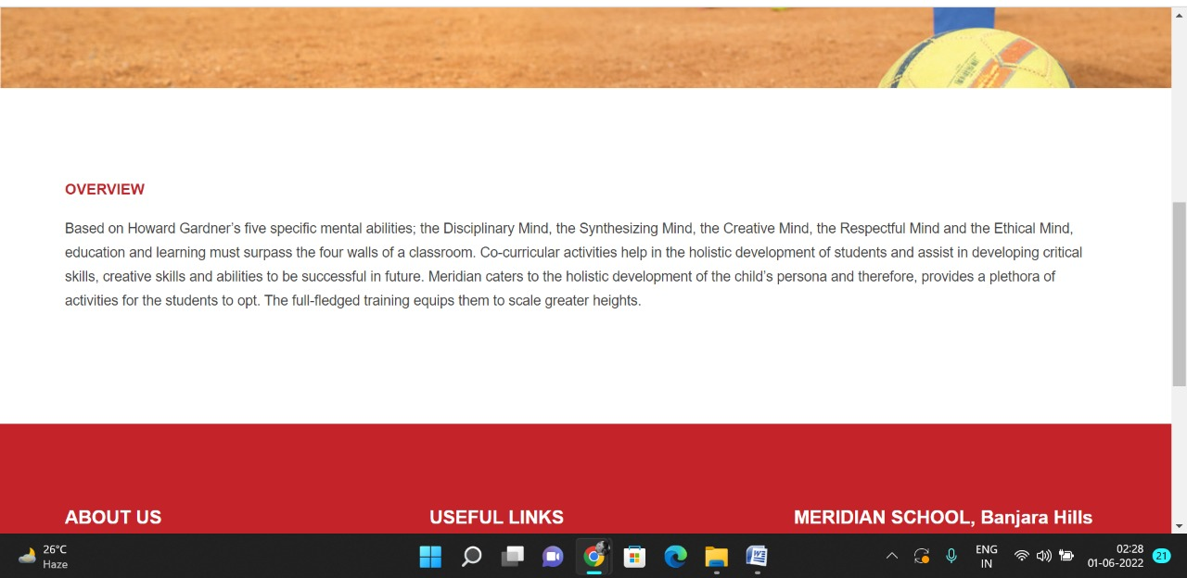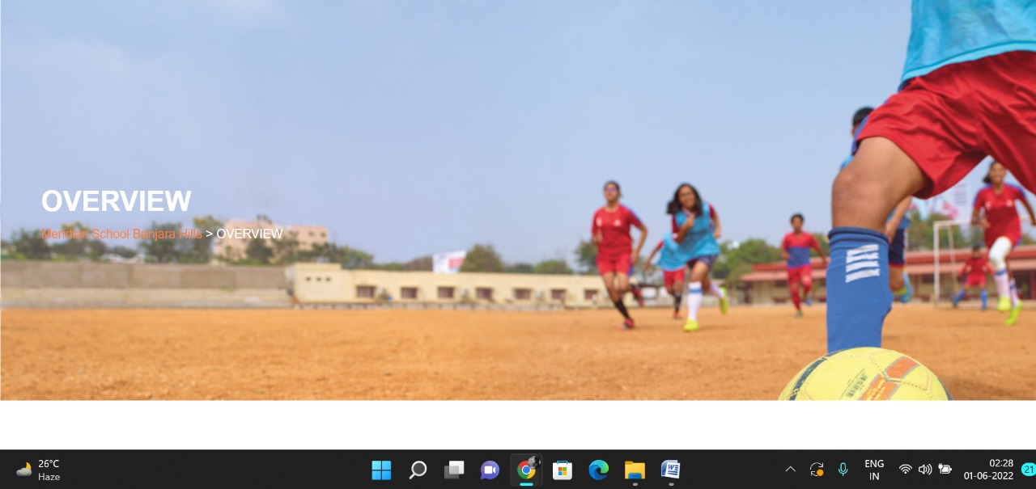

**PAGE 3:Sports**

**HTML CODE:**

<!DOCTYPE html>

<html lang="en">

<head>

    <meta charset="UTF-8">

    <meta http-equiv="X-UA-Compatible" content="IE=edge">

    <meta name="viewport" content="width=device-width, initial-scale=1.0">

    <title>SPORTS - Meridian School</title>

    <link rel="stylesheet" href="style.css">

    <link rel="stylesheet" href="https://pro.fontawesome.com/releases/v5.10.0/css/all.css" />

    <link rel="icon" type="imag/logo2.png" href="img/logo2.png">

    <link rel="stylesheet" href="https://stackpath.bootstrapcdn.com/bootstrap/4.4.1/css/bootstrap.min.css"

        integrity="sha384-Vkoo8x4CGs03+Hhxv8T/Q5paXtkKtu6ug5TOeNV6gBiFeWPGFN9MuhOf23Q9Ifjh" crossorigin="anonymous" />

    <link rel="stylesheet" href="https://cdnjs.cloudflare.com/ajax/libs/slick-carousel/1.8.1/slick-theme.min.css"

        integrity="sha512-17EgCFERpgZKcm0j0fEq1YCJuyAWdz9KUtv1EjVuaOz8pDnh/0nZxmU6BBXwaaxqoi9PQXnRWqlcDB027hgv9A=="

        crossorigin="anonymous" referrerpolicy="no-referrer" />

    <link rel="stylesheet" href="https://cdnjs.cloudflare.com/ajax/libs/slick-carousel/1.8.1/slick.min.css"

        integrity="sha512-yHknP1/AwR+yx26cB1y0cjvQUMvEa2PFzt1c9LlS4pRQ5NOTZFWbhBig+X9G9eYW/8m0/4OXNx8pxJ6z57x0dw=="

        crossorigin="anonymous" referrerpolicy="no-referrer" />

</head>

<body>

    <section id="follow">

        <div class="followus">

            <div class="icon1">

                <i class="fa fa-phone"></i>

                <a id="phone" href="">8096918857, 9948508222</a>

            </div>

            <div class="icon1">

                <i class="fa fa-envelope"></i>

                <a id="mail" href="">info.banjara@meridianschool.in</a>

            </div>

            <div class="icon">

                <a href="https://www.facebook.com/MeridianSchoolBanjaraHills/" target="_blank"

                    class="fab fa-facebook-f"></i></a>

                <a href="https://twitter.com/meridianbanjara" target="_blank"><i class="fab fa-twitter"></i></a>

                <a href="https://www.youtube.com/channel/UCBZ_gLF9qM18O3CDWQHeN1A" target="_blank"><i

                        class="fab fa-youtube"></i></a>

                <a href="https://www.instagram.com/meridianschools/" target="_blank"><i

                        class="fab fa-instagram"></i></a>

            </div>

        </div>

    </section>

    <div class="navbar">

        <a href="home.html"><img src="img/logo.png" class="logo" alt=""></a>

        <nav>

            <a class="active" href="home.html">HOME</a>

            <div class="dropdown">

                <button class="dropbtn">ABOUT US

                </button>

                <div class="dropdown-content">

                    <a href="knowmeridian.html">KNOW MERIDIAN</a>

                    <a href="visionmission.html">THE VISION & MISSION</a>

                    <a href="http://meridianbanjara.com/the-founders/">THE FOUNDER'S MESSAGE</a>

                    <a href="ceomsg.html">CEO'S MESSAGE</a>

                    <a href="principalmsg.html">THE PRINCIPAL'S MESSAGE</a>

                    <a href="awards.html">AWARDS AND ACCOLADES</a>

                    <a href="http://meridianbanjara.com/affiliations-accreditations/">AFFILIATIONS & ACCREDITATIONS</a>

                    <a href="blog.html">BLOG</a>

                </div>

            </div>

            <div class="dropdown">

                <button class="dropbtn">LEADERSHIP TEAM

                </button>

                <div class="dropdown-content">

                    <a href="principal.html">PRINCIPAL</a>

                    <a href="vp.html">VICE PRINCIPAL</a>

                    <a href="headmistress.html">HEADMISTRESS</a>

                    <a href="midSchool.html">MIDDLE SCHOOL INCHARGE</a>

                    <a href="ipPyp.html">IB PYP COORDINATOR</a>

                    <a href="preprimary.html">PRE PRIMARY INCHARGE</a>

                    <a href="global.html">GLOBAL PARTNERSHIP COORDINATOR</a>

                </div>

            </div>

            <div class="dropdown">

                <button class="dropbtn">ACADEMICS

                </button>

                <div class="dropdown-content">

                    <a href="AcaOverview.html">OVERVIEW</a>

                    <a href="methodology.html">METHODOLOGY AND LEARNING STYLE</a>

                    <a href="curriculum.html">CURRICULUM</a>

                    <a href="faculty.html">FACULTY</a>

                    <a href="teacherTraining.html">TEACHER TRAINING</a>

                    <a href="careerGuidance.html">CAREER GUIDANCE</a>

                    <a href="scholrship.html">SCHOLARSHIP PROGRAMME</a>

                </div>

            </div>

            <div class="dropdown">

                <button class="dropbtn">BEYOND ACADEMICS

                </button>

                <div class="dropdown-content">

                    <a href="beyondAcaOverview.html">OVERVIEW</a>

                    <a href="sports.html">SPORTS</a>

                    <a href="creatveAct.html">CREATIVE ACTIVITIES</a>

                    <a href="eduTrips.html">EDUCATIONAL TRIPS AND STUDENT<br> EXCHANGE PROGRAMMES</a>

                    <a href="perfectSystem.html">PERFECT SYSTEM</a>

                    <a href="schoolSocialRes.html">SCHOOL'S SOCIAL RESPONSIBILITY</a>

                    <a href="interact.html">INTERACT</a>

                    <a href="heritageClub.html">HERITAGE CLUB</a>

                    <a href="mun.html">MUN</a>

                </div>

            </div>

            <div class="dropdown">

                <button class="dropbtn">ADMISSIONS

                </button>

                <div class="dropdown-content">

                    <a href="overview.html">OVERVIEW</a>

                    <a href="admissionpro.html">ADMISSION PROCEDURE</a>

                    <a href="feepolicy.html">FEE POLICY</a>

                    <a href="tranfercert.html">TRANSFER CERTIFICATE</a>

                    <a href="transport.html">TRANSPORT</a>

                </div>

            </div>

            <a class="active" href="gallery.html">GALLERY</a>

            <div class="dropdown">

                <button class="dropbtn">CONTACT US

                </button>

                <div class="dropdown-content">

                    <a href="contact.html">CAREERS</a>

                </div>

            </div>

        </nav>

    </div>

    <div id="mobile">

        <i id="bar" class="fas fa-outdent "></i>

    </div>

    <section id="principal">

        <div class="prin" id="sports">

            <h2>SPORTS</h2>

            <span id="orange"><a href="home.html">Meridian School Banjara Hills</a></span>

            <span> &gt; SPORTS</span>

        </div>

    </section>

    <section id="principal1">

        <div class="academics" id="overview">

            <h4>SPORTS</h4>

            <p>‘What can be learned in the playground cannot be learned in the classroom.’ Physical education is an

                integral part of any child’s education as it enhances skills like strength, speed, endurance, agility,

                balance and flexibility. Meridian school lays strong emphasis on sports and physical development of

                students.</p>

            <p class="headOrange">Sporting Activities</p>

            <p>Sports and Games encompass more than just the benefits of physical things but also increase confidence,

                self esteem and mental alertness. Every student of Meridian exhibits true sportsmanship which is very

                essential to deal with life’s challenges. We proudly boast of our expert coaches and trainers who

                trained the students to win various competitions at Nationals. We offer various sports</p>

            <p>such as Cricket, Basket Ball, Throw Ball, Table Tennis, Chess, Yoga, Taekwondo.</p>

            <p class="headOrange">Scouts and Guides</p>

            <p>To help build a better world where people are self fulfilled as individuals and play a constructive role

                in society, the school has started Scouts and Guides programme in collaboration with Universal Scouts

                and Guides.</p>

            <p class="headOrange">Yoga</p>

            <p>The practice of Yoga leads to union of individual consciousness with that of the Universal Consciousness

                indicating a perfect harmony between the mind and body, Man and Nature. At Meridian both yoga and

                physical education are seen as routes for achieving overall development of the students.</p>

        </div>

        </div>

    </section>

    <footer>

        <div class="col">

            <h4>ABOUT US</h4>

            <p>Meridian is a New Generation Educational Group committed to educate children for life and thus bring a

                change in the society. Learning philosophy practised at Meridian infuses traditional values into a

                progressive approach, equipping students to adapt and excel anywhere in the world. Our alumni, working

                in diverse fields, have found Meridian to be the best school for a successful career take off.</p>

        </div>

        <div class="col">

            <h4>USEFUL LINKS</h4>

            <ul class="three-col-links">

                <li><a href="home.html">HOME</a></li>

                <li><a href="AcaOverview.html">ACADEMICS</a></li>

                <li><a href="overview.html">ADMISSIONS</a></li>

                <li><a href="contact.html">CONTACT US</a></li>

                <li><a href="knowmeridian.html">ABOUT US</a></li>

                <li><a href="beyondAcaOverview.html">BEYOND ACADEMICS</a></li>

                <li><a href="contact.html">CAREERS</a></li>

            </ul>

        </div>

        <div class="col">

            <!--<div class="follow">

                <div class="icon">

                    <i class="fa fa-paper-plane-o"></i>

                </div>

        </div>-->

            <h4>MERIDIAN SCHOOL, Banjara Hills</h4>

            <p># 8-2-541, Road No 7, Banjara Hills, Hyderabad-500034, TELANGANA, INDIA.</p>

            <p>For contact : +91 8096918857, 9948508222, For Prinicipal Appointments : 8098420002</p>

            <p> For Admissions / Enquires : 8096918857, 9948508222</p>

            <p>info.banjara@meridianschool.inA</p>

        </div>

    </footer>

    <section id="copyright">

        <div id="cr">

            <p>© Copyright MERIDIAN SCHOOL, 2021.</p>

        </div>

    </section>

</body>

</html>

**CSS CODE:**

#principal .prin h2 {

font-size: 34px;

font-weight: 600;

text-align: start;

/* color: #c42329; */

}

#principal .prin span {

color: #fff;

}

#principal #orange {

color: #f48243;

}

#principal #orange:hover {

color: #fff;

}

#principal1 .princi1 {

display: flex;

}

#principal1 .princi1 img {

width: 250px;

height: 169px;

border: 7px solid rgb(225, 222, 222);

}

#principal1 .princi1 h4 {

text-align: start;

color: #c42329;

margin: 100px 0 35px 0px;

}

#principal1 .princi1 #info {

width: 42%;

margin: 200px 53px 70px;

}

#principal1 .princi1 #info p {

margin-bottom: 20px;

}

#principal1 .princi1 #info #strong {

margin-bottom: 0px;

}

**OUTPUT:**

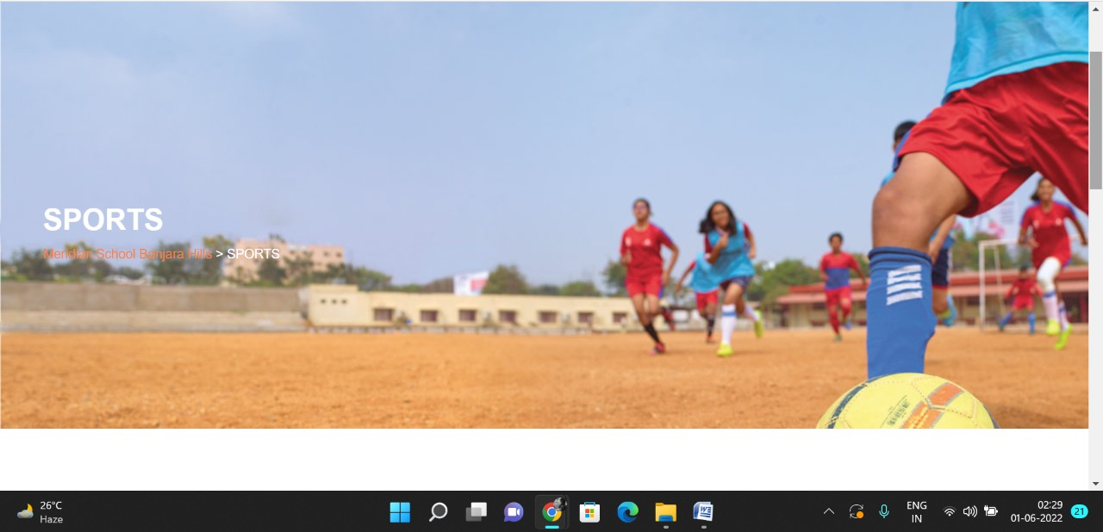

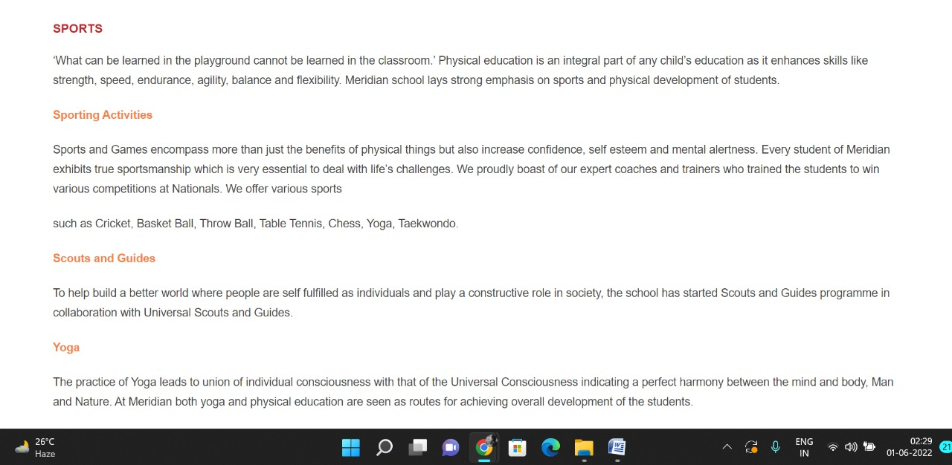

**PAGE 4:Creative Activities**

**HTML CODE:**

<!DOCTYPE html>

<html lang="en">

<head>

    <meta charset="UTF-8">

    <meta http-equiv="X-UA-Compatible" content="IE=edge">

    <meta name="viewport" content="width=device-width, initial-scale=1.0">

    <title>CREATIVE ACTIVITIES - Meridian School</title>

    <link rel="stylesheet" href="style.css">

    <link rel="stylesheet" href="https://pro.fontawesome.com/releases/v5.10.0/css/all.css" />

    <link rel="icon" type="imag/logo2.png" href="img/logo2.png">

    <link rel="stylesheet" href="https://stackpath.bootstrapcdn.com/bootstrap/4.4.1/css/bootstrap.min.css"

        integrity="sha384-Vkoo8x4CGs03+Hhxv8T/Q5paXtkKtu6ug5TOeNV6gBiFeWPGFN9MuhOf23Q9Ifjh" crossorigin="anonymous" />

    <link rel="stylesheet" href="https://cdnjs.cloudflare.com/ajax/libs/slick-carousel/1.8.1/slick-theme.min.css"

        integrity="sha512-17EgCFERpgZKcm0j0fEq1YCJuyAWdz9KUtv1EjVuaOz8pDnh/0nZxmU6BBXwaaxqoi9PQXnRWqlcDB027hgv9A=="

        crossorigin="anonymous" referrerpolicy="no-referrer" />

    <link rel="stylesheet" href="https://cdnjs.cloudflare.com/ajax/libs/slick-carousel/1.8.1/slick.min.css"

        integrity="sha512-yHknP1/AwR+yx26cB1y0cjvQUMvEa2PFzt1c9LlS4pRQ5NOTZFWbhBig+X9G9eYW/8m0/4OXNx8pxJ6z57x0dw=="

        crossorigin="anonymous" referrerpolicy="no-referrer" />

</head>

<body>

    <section id="follow">

        <div class="followus">

            <div class="icon1">

                <i class="fa fa-phone"></i>

                <a id="phone" href="">8096918857, 9948508222</a>

            </div>

            <div class="icon1">

                <i class="fa fa-envelope"></i>

                <a id="mail" href="">info.banjara@meridianschool.in</a>

            </div>

            <div class="icon">

                <a href="https://www.facebook.com/MeridianSchoolBanjaraHills/" target="_blank"

                    class="fab fa-facebook-f"></i></a>

                <a href="https://twitter.com/meridianbanjara" target="_blank"><i class="fab fa-twitter"></i></a>

                <a href="https://www.youtube.com/channel/UCBZ_gLF9qM18O3CDWQHeN1A" target="_blank"><i

                        class="fab fa-youtube"></i></a>

                <a href="https://www.instagram.com/meridianschools/" target="_blank"><i

                        class="fab fa-instagram"></i></a>

            </div>

        </div>

    </section>

    <div class="navbar">

        <a href="home.html"><img src="img/logo.png" class="logo" alt=""></a>

        <nav>

            <a class="active" href="home.html">HOME</a>

            <div class="dropdown">

                <button class="dropbtn">ABOUT US

                </button>

                <div class="dropdown-content">

                    <a href="knowmeridian.html">KNOW MERIDIAN</a>

                    <a href="visionmission.html">THE VISION & MISSION</a>

                    <a href="http://meridianbanjara.com/the-founders/">THE FOUNDER'S MESSAGE</a>

                    <a href="ceomsg.html">CEO'S MESSAGE</a>

                    <a href="principalmsg.html">THE PRINCIPAL'S MESSAGE</a>

                    <a href="awards.html">AWARDS AND ACCOLADES</a>

                    <a href="http://meridianbanjara.com/affiliations-accreditations/">AFFILIATIONS & ACCREDITATIONS</a>

                    <a href="blog.html">BLOG</a>

                </div>

            </div>

            <div class="dropdown">

                <button class="dropbtn">LEADERSHIP TEAM

                </button>

                <div class="dropdown-content">

                    <a href="principal.html">PRINCIPAL</a>

                    <a href="vp.html">VICE PRINCIPAL</a>

                    <a href="headmistress.html">HEADMISTRESS</a>

                    <a href="midSchool.html">MIDDLE SCHOOL INCHARGE</a>

                    <a href="ipPyp.html">IB PYP COORDINATOR</a>

                    <a href="preprimary.html">PRE PRIMARY INCHARGE</a>

                    <a href="global.html">GLOBAL PARTNERSHIP COORDINATOR</a>

                </div>

            </div>

            <div class="dropdown">

                <button class="dropbtn">ACADEMICS

                </button>

                <div class="dropdown-content">

                    <a href="AcaOverview.html">OVERVIEW</a>

                    <a href="methodology.html">METHODOLOGY AND LEARNING STYLE</a>

                    <a href="curriculum.html">CURRICULUM</a>

                    <a href="faculty.html">FACULTY</a>

                    <a href="teacherTraining.html">TEACHER TRAINING</a>

                    <a href="careerGuidance.html">CAREER GUIDANCE</a>

                    <a href="scholrship.html">SCHOLARSHIP PROGRAMME</a>

                </div>

            </div>

            <div class="dropdown">

                <button class="dropbtn">BEYOND ACADEMICS

                </button>

                <div class="dropdown-content">

                    <a href="beyondAcaOverview.html">OVERVIEW</a>

                    <a href="sports.html">SPORTS</a>

                    <a href="creatveAct.html">CREATIVE ACTIVITIES</a>

                    <a href="eduTrips.html">EDUCATIONAL TRIPS AND STUDENT<br> EXCHANGE PROGRAMMES</a>

                    <a href="perfectSystem.html">PERFECT SYSTEM</a>

                    <a href="schoolSocialRes.html">SCHOOL'S SOCIAL RESPONSIBILITY</a>

                    <a href="interact.html">INTERACT</a>

                    <a href="heritageClub.html">HERITAGE CLUB</a>

                    <a href="mun.html">MUN</a>

                </div>

            </div>

            <div class="dropdown">

                <button class="dropbtn">ADMISSIONS

                </button>

                <div class="dropdown-content">

                    <a href="overview.html">OVERVIEW</a>

                    <a href="admissionpro.html">ADMISSION PROCEDURE</a>

                    <a href="feepolicy.html">FEE POLICY</a>

                    <a href="tranfercert.html">TRANSFER CERTIFICATE</a>

                    <a href="transport.html">TRANSPORT</a>

                </div>

            </div>

            <a class="active" href="gallery.html">GALLERY</a>

            <div class="dropdown">

                <button class="dropbtn">CONTACT US

                </button>

                <div class="dropdown-content">

                    <a href="contact.html">CAREERS</a>

                </div>

            </div>

        </nav>

    </div>

    <div id="mobile">

        <i id="bar" class="fas fa-outdent "></i>

    </div>

    <section id="principal">

        <div class="prin" id="sports">

            <h2>CREATIVE ACTIVITIES</h2>

            <span id="orange"><a href="home.html">Meridian School Banjara Hills</a></span>

            <span> &gt; CREATIVE ACTIVITIES</span>

        </div>

    </section>

    <section id="principal1">

        <div class="academics" id="overview">

            <h4>CREATIVE ACTIVITIES</h4>

            <p>Being creative helps you become a better problem solver. Creative people are better abled to live with

                uncertainty. Meridian provides the right platform to hone the creative skills among the students.

                Performing Arts play a significant role in the co-curricular activities of the school. State of art

                infrastructure gives the right impetus to develop creative skills. Students are given various

                opportunities through regular assemblies, special celebrations, competitions etc. Our school Annual Days

                are always the best productions in the twin cities. Some of our creative initiatives are:</p>

            <p><strong>Under The Mango Tree </strong>– Reading Club</p>

            <p><strong>International Dimension in Schools </strong>– A British Council Programme</p>

            <p><strong>Confero </strong>– Debating Club</p>

            <p><strong>Melange </strong>– Interschool Literary and Cultural Fest</p>

            <p><strong>Music Club </strong>– In association with Furtados School of Music</p>

            <p>Moot Court, MUNs, Sculpture, Heritage Club, Eco Club, Rotary Interact Club, Filmit, Theatre, Western and

                Classical Music and Dance, Painting, Photography and many more.</p>

        </div>

        </div>

    </section>

    <footer>

        <div class="col">

            <h4>ABOUT US</h4>

            <p>Meridian is a New Generation Educational Group committed to educate children for life and thus bring a

                change in the society. Learning philosophy practised at Meridian infuses traditional values into a

                progressive approach, equipping students to adapt and excel anywhere in the world. Our alumni, working

                in diverse fields, have found Meridian to be the best school for a successful career take off.</p>

        </div>

        <div class="col">

            <h4>USEFUL LINKS</h4>

            <ul class="three-col-links">

                <li><a href="home.html">HOME</a></li>

                <li><a href="AcaOverview.html">ACADEMICS</a></li>

                <li><a href="overview.html">ADMISSIONS</a></li>

                <li><a href="contact.html">CONTACT US</a></li>

                <li><a href="knowmeridian.html">ABOUT US</a></li>

                <li><a href="beyondAcaOverview.html">BEYOND ACADEMICS</a></li>

                <li><a href="contact.html">CAREERS</a></li>

            </ul>

        </div>

        <div class="col">

            <!--<div class="follow">

                <div class="icon">

                    <i class="fa fa-paper-plane-o"></i>

                </div>

        </div>-->

            <h4>MERIDIAN SCHOOL, Banjara Hills</h4>

            <p># 8-2-541, Road No 7, Banjara Hills, Hyderabad-500034, TELANGANA, INDIA.</p>

            <p>For contact : +91 8096918857, 9948508222, For Prinicipal Appointments : 8098420002</p>

            <p> For Admissions / Enquires : 8096918857, 9948508222</p>

            <p>info.banjara@meridianschool.inA</p>

        </div>

    </footer>

    <section id="copyright">

        <div id="cr">

            <p>© Copyright MERIDIAN SCHOOL, 2021.</p>

        </div>

    </section>

</body>

</html>

**CSS CODE:**

#principal .prin h2 {

font-size: 34px;

font-weight: 600;

text-align: start;

/* color: #c42329; */

}

#principal .prin span {

color: #fff;

}

#principal #orange {

color: #f48243;

}

#principal #orange:hover {

color: #fff;

}

#principal1 .princi1 {

display: flex;

}

#principal1 .princi1 img {

width: 250px;

height: 169px;

border: 7px solid rgb(225, 222, 222);

}

#principal1 .princi1 h4 {

text-align: start;

color: #c42329;

margin: 100px 0 35px 0px;

}

#principal1 .princi1 #info {

width: 42%;

margin: 200px 53px 70px;

}

#principal1 .princi1 #info p {

margin-bottom: 20px;

}

#principal1 .princi1 #info #strong {

margin-bottom: 0px;

}

**OUTPUT:**

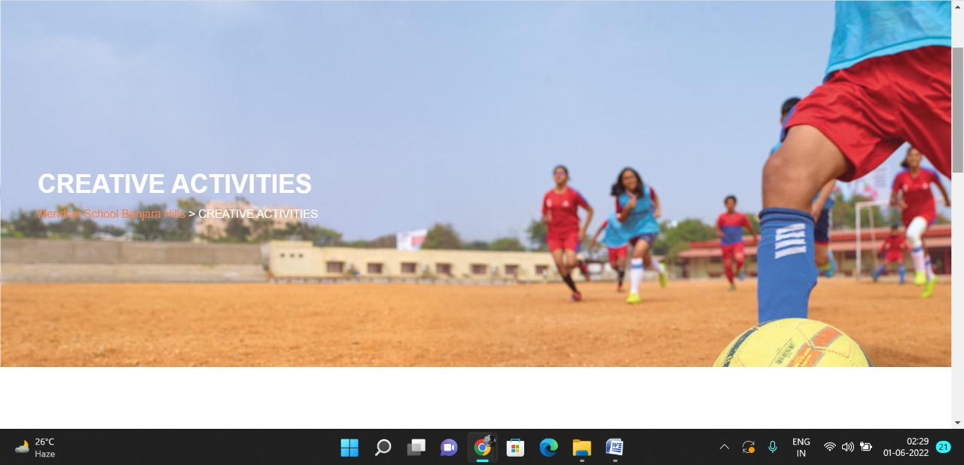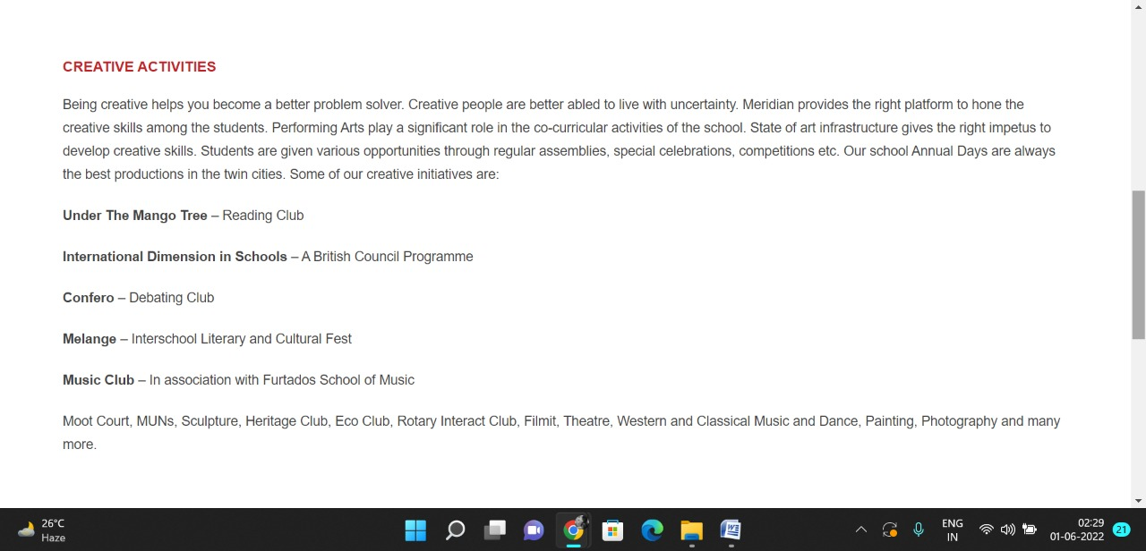

**PAGE 5:Education System and Student Exchange Programme**

**HTML CODE:**

<!DOCTYPE html>

<html lang="en">

<head>

    <meta charset="UTF-8">

    <meta http-equiv="X-UA-Compatible" content="IE=edge">

    <meta name="viewport" content="width=device-width, initial-scale=1.0">

    <title>EDUCATIONAL TRIPS AND STUDENT EXCHANGE PROGRAMMES - Meridian School</title>

    <link rel="stylesheet" href="style.css">

    <link rel="stylesheet" href="https://pro.fontawesome.com/releases/v5.10.0/css/all.css" />

    <link rel="icon" type="imag/logo2.png" href="img/logo2.png">

    <link rel="stylesheet" href="https://stackpath.bootstrapcdn.com/bootstrap/4.4.1/css/bootstrap.min.css"

        integrity="sha384-Vkoo8x4CGs03+Hhxv8T/Q5paXtkKtu6ug5TOeNV6gBiFeWPGFN9MuhOf23Q9Ifjh" crossorigin="anonymous" />

    <link rel="stylesheet" href="https://cdnjs.cloudflare.com/ajax/libs/slick-carousel/1.8.1/slick-theme.min.css"

        integrity="sha512-17EgCFERpgZKcm0j0fEq1YCJuyAWdz9KUtv1EjVuaOz8pDnh/0nZxmU6BBXwaaxqoi9PQXnRWqlcDB027hgv9A=="

        crossorigin="anonymous" referrerpolicy="no-referrer" />

    <link rel="stylesheet" href="https://cdnjs.cloudflare.com/ajax/libs/slick-carousel/1.8.1/slick.min.css"

        integrity="sha512-yHknP1/AwR+yx26cB1y0cjvQUMvEa2PFzt1c9LlS4pRQ5NOTZFWbhBig+X9G9eYW/8m0/4OXNx8pxJ6z57x0dw=="

        crossorigin="anonymous" referrerpolicy="no-referrer" />

</head>

<body>

    <section id="follow">

        <div class="followus">

            <div class="icon1">

                <i class="fa fa-phone"></i>

                <a id="phone" href="">8096918857, 9948508222</a>

            </div>

            <div class="icon1">

                <i class="fa fa-envelope"></i>

                <a id="mail" href="">info.banjara@meridianschool.in</a>

            </div>

            <div class="icon">

                <a href="https://www.facebook.com/MeridianSchoolBanjaraHills/" target="_blank"

                    class="fab fa-facebook-f"></i></a>

                <a href="https://twitter.com/meridianbanjara" target="_blank"><i class="fab fa-twitter"></i></a>

                <a href="https://www.youtube.com/channel/UCBZ_gLF9qM18O3CDWQHeN1A" target="_blank"><i

                        class="fab fa-youtube"></i></a>

                <a href="https://www.instagram.com/meridianschools/" target="_blank"><i

                        class="fab fa-instagram"></i></a>

            </div>

        </div>

    </section>

    <div class="navbar">

        <a href="home.html"><img src="img/logo.png" class="logo" alt=""></a>

        <nav>

            <a class="active" href="home.html">HOME</a>

            <div class="dropdown">

                <button class="dropbtn">ABOUT US

                </button>

                <div class="dropdown-content">

                    <a href="knowmeridian.html">KNOW MERIDIAN</a>

                    <a href="visionmission.html">THE VISION & MISSION</a>

                    <a href="http://meridianbanjara.com/the-founders/">THE FOUNDER'S MESSAGE</a>

                    <a href="ceomsg.html">CEO'S MESSAGE</a>

                    <a href="principalmsg.html">THE PRINCIPAL'S MESSAGE</a>

                    <a href="awards.html">AWARDS AND ACCOLADES</a>

                    <a href="http://meridianbanjara.com/affiliations-accreditations/">AFFILIATIONS & ACCREDITATIONS</a>

                    <a href="blog.html">BLOG</a>

                </div>

            </div>

            <div class="dropdown">

                <button class="dropbtn">LEADERSHIP TEAM

                </button>

                <div class="dropdown-content">

                    <a href="principal.html">PRINCIPAL</a>

                    <a href="vp.html">VICE PRINCIPAL</a>

                    <a href="headmistress.html">HEADMISTRESS</a>

                    <a href="midSchool.html">MIDDLE SCHOOL INCHARGE</a>

                    <a href="ipPyp.html">IB PYP COORDINATOR</a>

                    <a href="preprimary.html">PRE PRIMARY INCHARGE</a>

                    <a href="global.html">GLOBAL PARTNERSHIP COORDINATOR</a>

                </div>

            </div>

            <div class="dropdown">

                <button class="dropbtn">ACADEMICS

                </button>

                <div class="dropdown-content">

                    <a href="AcaOverview.html">OVERVIEW</a>

                    <a href="methodology.html">METHODOLOGY AND LEARNING STYLE</a>

                    <a href="curriculum.html">CURRICULUM</a>

                    <a href="faculty.html">FACULTY</a>

                    <a href="teacherTraining.html">TEACHER TRAINING</a>

                    <a href="careerGuidance.html">CAREER GUIDANCE</a>

                    <a href="scholrship.html">SCHOLARSHIP PROGRAMME</a>

                </div>

            </div>

            <div class="dropdown">

                <button class="dropbtn">BEYOND ACADEMICS

                </button>

                <div class="dropdown-content">

                    <a href="beyondAcaOverview.html">OVERVIEW</a>

                    <a href="sports.html">SPORTS</a>

                    <a href="creatveAct.html">CREATIVE ACTIVITIES</a>

                    <a href="eduTrips.html">EDUCATIONAL TRIPS AND STUDENT<br> EXCHANGE PROGRAMMES</a>

                    <a href="perfectSystem.html">PERFECT SYSTEM</a>

                    <a href="schoolSocialRes.html">SCHOOL'S SOCIAL RESPONSIBILITY</a>

                    <a href="interact.html">INTERACT</a>

                    <a href="heritageClub.html">HERITAGE CLUB</a>

                    <a href="mun.html">MUN</a>

                </div>

            </div>

            <div class="dropdown">

                <button class="dropbtn">ADMISSIONS

                </button>

                <div class="dropdown-content">

                    <a href="overview.html">OVERVIEW</a>

                    <a href="admissionpro.html">ADMISSION PROCEDURE</a>

                    <a href="feepolicy.html">FEE POLICY</a>

                    <a href="tranfercert.html">TRANSFER CERTIFICATE</a>

                    <a href="transport.html">TRANSPORT</a>

                </div>

            </div>

            <a class="active" href="gallery.html">GALLERY</a>

            <div class="dropdown">

                <button class="dropbtn">CONTACT US

                </button>

                <div class="dropdown-content">

                    <a href="contact.html">CAREERS</a>

                </div>

            </div>

        </nav>

    </div>

    <div id="mobile">

        <i id="bar" class="fas fa-outdent "></i>

    </div>

    <section id="principal">

        <div class="prin" id="sports">

            <h2>EDUCATIONAL TRIPS AND STUDENT EXCHANGE PROGRAMMES</h2>

            <span id="orange"><a href="home.html">Meridian School Banjara Hills</a></span>

            <span> &gt; EDUCATIONAL TRIPS AND STUDENT EXCHANGE PROGRAMMES</span>

        </div>

    </section>

    <section id="principal1">

        <div class="academics" id="overview">

            <h4>EXCURSIONS, EDUCATIONAL TRIPS AND STUDENT EXCHANGE PROGRAMMES</h4>

            <p>Every student loves to go beyond the classroom to explore and learn new things. Meridianites are given

                opportunities to go on excursions, educational tours and adventure camps every year for a better

                understanding of new places, to develop enduring bonds with their friends and to gain skills that are

                required for future jobs.</p>

            <p>Regular Field Trips are organized for in depth learning and hands on experience. These cater to each

                student’s learning abilities and ensure that the information is truly grasped by visual appeal, tactile

                approach and kinesthetic way.</p>

            <p>Many International Student Exchange programmes are held every year and the most sought after is the

                Exchange Programme with students of Caousou School at Toulouse, France. It is a mutual exchange

                programme to learn and understand cross cultural ideologies. Our students play perfect hosts when their

                counterparts from France visit them.</p>

        </div>

        </div>

    </section>

    <footer>

        <div class="col">

            <h4>ABOUT US</h4>

            <p>Meridian is a New Generation Educational Group committed to educate children for life and thus bring a

                change in the society. Learning philosophy practised at Meridian infuses traditional values into a

                progressive approach, equipping students to adapt and excel anywhere in the world. Our alumni, working

                in diverse fields, have found Meridian to be the best school for a successful career take off.</p>

        </div>

        <div class="col">

            <h4>USEFUL LINKS</h4>

            <ul class="three-col-links">

                <li><a href="home.html">HOME</a></li>

                <li><a href="AcaOverview.html">ACADEMICS</a></li>

                <li><a href="overview.html">ADMISSIONS</a></li>

                <li><a href="contact.html">CONTACT US</a></li>

                <li><a href="knowmeridian.html">ABOUT US</a></li>

                <li><a href="beyondAcaOverview.html">BEYOND ACADEMICS</a></li>

                <li><a href="contact.html">CAREERS</a></li>

            </ul>

        </div>

        <div class="col">

            <!--<div class="follow">

                <div class="icon">

                    <i class="fa fa-paper-plane-o"></i>

                </div>

        </div>-->

            <h4>MERIDIAN SCHOOL, Banjara Hills</h4>

            <p># 8-2-541, Road No 7, Banjara Hills, Hyderabad-500034, TELANGANA, INDIA.</p>

            <p>For contact : +91 8096918857, 9948508222, For Prinicipal Appointments : 8098420002</p>

            <p> For Admissions / Enquires : 8096918857, 9948508222</p>

            <p>info.banjara@meridianschool.inA</p>

        </div>

    </footer>

    <section id="copyright">

        <div id="cr">

            <p>© Copyright MERIDIAN SCHOOL, 2021.</p>

        </div>

    </section>

</body>

</html>

**CSS CODE:**

#principal .prin h2 {

font-size: 34px;

font-weight: 600;

text-align: start;

/* color: #c42329; */

}

#principal .prin span {

color: #fff;

}

#principal #orange {

color: #f48243;

}

#principal #orange:hover {

color: #fff;

}

#principal1 .princi1 {

display: flex;

}

#principal1 .princi1 img {

width: 250px;

height: 169px;

border: 7px solid rgb(225, 222, 222);

}

#principal1 .princi1 h4 {

text-align: start;

color: #c42329;

margin: 100px 0 35px 0px;

}

#principal1 .princi1 #info {

width: 42%;

margin: 200px 53px 70px;

}

#principal1 .princi1 #info p {

margin-bottom: 20px;

}

#principal1 .princi1 #info #strong {

margin-bottom: 0px;

}

**OUTPUT:**

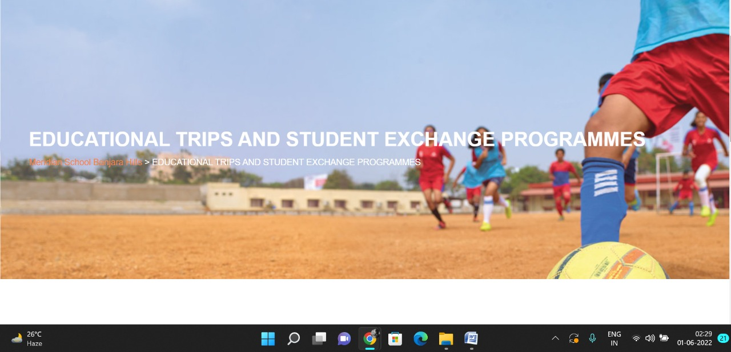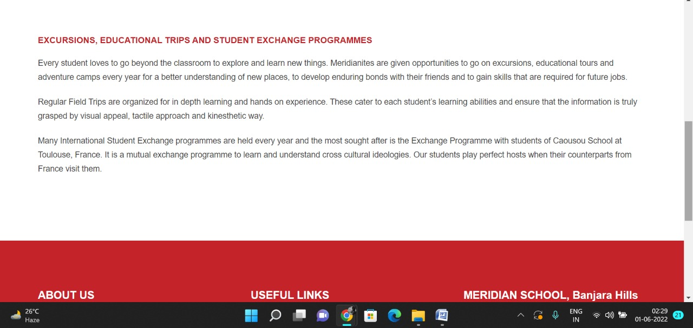

**PAGE 6:Perfect System**

**HTML CODE:**

<!DOCTYPE html>

<html lang="en">

<head>

    <meta charset="UTF-8">

    <meta http-equiv="X-UA-Compatible" content="IE=edge">

    <meta name="viewport" content="width=device-width, initial-scale=1.0">

    <title>PERFECT SYSTEM - Meridian School</title>

    <link rel="stylesheet" href="style.css">

    <link rel="stylesheet" href="https://pro.fontawesome.com/releases/v5.10.0/css/all.css" />

    <link rel="icon" type="imag/logo2.png" href="img/logo2.png">

    <link rel="stylesheet" href="https://stackpath.bootstrapcdn.com/bootstrap/4.4.1/css/bootstrap.min.css"

        integrity="sha384-Vkoo8x4CGs03+Hhxv8T/Q5paXtkKtu6ug5TOeNV6gBiFeWPGFN9MuhOf23Q9Ifjh" crossorigin="anonymous" />

    <link rel="stylesheet" href="https://cdnjs.cloudflare.com/ajax/libs/slick-carousel/1.8.1/slick-theme.min.css"

        integrity="sha512-17EgCFERpgZKcm0j0fEq1YCJuyAWdz9KUtv1EjVuaOz8pDnh/0nZxmU6BBXwaaxqoi9PQXnRWqlcDB027hgv9A=="

        crossorigin="anonymous" referrerpolicy="no-referrer" />

    <link rel="stylesheet" href="https://cdnjs.cloudflare.com/ajax/libs/slick-carousel/1.8.1/slick.min.css"

        integrity="sha512-yHknP1/AwR+yx26cB1y0cjvQUMvEa2PFzt1c9LlS4pRQ5NOTZFWbhBig+X9G9eYW/8m0/4OXNx8pxJ6z57x0dw=="

        crossorigin="anonymous" referrerpolicy="no-referrer" />

</head>

<body>

    <section id="follow">

        <div class="followus">

            <div class="icon1">

                <i class="fa fa-phone"></i>

                <a id="phone" href="">8096918857, 9948508222</a>

            </div>

            <div class="icon1">

                <i class="fa fa-envelope"></i>

                <a id="mail" href="">info.banjara@meridianschool.in</a>

            </div>

            <div class="icon">

                <a href="https://www.facebook.com/MeridianSchoolBanjaraHills/" target="_blank"

                    class="fab fa-facebook-f"></i></a>

                <a href="https://twitter.com/meridianbanjara" target="_blank"><i class="fab fa-twitter"></i></a>

                <a href="https://www.youtube.com/channel/UCBZ_gLF9qM18O3CDWQHeN1A" target="_blank"><i

                        class="fab fa-youtube"></i></a>

                <a href="https://www.instagram.com/meridianschools/" target="_blank"><i

                        class="fab fa-instagram"></i></a>

            </div>

        </div>

    </section>

    <div class="navbar">

        <a href="home.html"><img src="img/logo.png" class="logo" alt=""></a>

        <nav>

            <a class="active" href="home.html">HOME</a>

            <div class="dropdown">

                <button class="dropbtn">ABOUT US

                </button>

                <div class="dropdown-content">

                    <a href="knowmeridian.html">KNOW MERIDIAN</a>

                    <a href="visionmission.html">THE VISION & MISSION</a>

                    <a href="http://meridianbanjara.com/the-founders/">THE FOUNDER'S MESSAGE</a>

                    <a href="ceomsg.html">CEO'S MESSAGE</a>

                    <a href="principalmsg.html">THE PRINCIPAL'S MESSAGE</a>

                    <a href="awards.html">AWARDS AND ACCOLADES</a>

                    <a href="http://meridianbanjara.com/affiliations-accreditations/">AFFILIATIONS & ACCREDITATIONS</a>

                    <a href="blog.html">BLOG</a>

                </div>

            </div>

            <div class="dropdown">

                <button class="dropbtn">LEADERSHIP TEAM

                </button>

                <div class="dropdown-content">

                    <a href="principal.html">PRINCIPAL</a>

                    <a href="vp.html">VICE PRINCIPAL</a>

                    <a href="headmistress.html">HEADMISTRESS</a>

                    <a href="midSchool.html">MIDDLE SCHOOL INCHARGE</a>

                    <a href="ipPyp.html">IB PYP COORDINATOR</a>

                    <a href="preprimary.html">PRE PRIMARY INCHARGE</a>

                    <a href="global.html">GLOBAL PARTNERSHIP COORDINATOR</a>

                </div>

            </div>

            <div class="dropdown">

                <button class="dropbtn">ACADEMICS

                </button>

                <div class="dropdown-content">

                    <a href="AcaOverview.html">OVERVIEW</a>

                    <a href="methodology.html">METHODOLOGY AND LEARNING STYLE</a>

                    <a href="curriculum.html">CURRICULUM</a>

                    <a href="faculty.html">FACULTY</a>

                    <a href="teacherTraining.html">TEACHER TRAINING</a>

                    <a href="careerGuidance.html">CAREER GUIDANCE</a>

                    <a href="scholrship.html">SCHOLARSHIP PROGRAMME</a>

                </div>

            </div>

            <div class="dropdown">

                <button class="dropbtn">BEYOND ACADEMICS

                </button>

                <div class="dropdown-content">

                    <a href="beyondAcaOverview.html">OVERVIEW</a>

                    <a href="sports.html">SPORTS</a>

                    <a href="creatveAct.html">CREATIVE ACTIVITIES</a>

                    <a href="eduTrips.html">EDUCATIONAL TRIPS AND STUDENT<br> EXCHANGE PROGRAMMES</a>

                    <a href="perfectSystem.html">PERFECT SYSTEM</a>

                    <a href="schoolSocialRes.html">SCHOOL'S SOCIAL RESPONSIBILITY</a>

                    <a href="interact.html">INTERACT</a>

                    <a href="heritageClub.html">HERITAGE CLUB</a>

                    <a href="mun.html">MUN</a>

                </div>

            </div>

            <div class="dropdown">

                <button class="dropbtn">ADMISSIONS

                </button>

                <div class="dropdown-content">

                    <a href="overview.html">OVERVIEW</a>

                    <a href="admissionpro.html">ADMISSION PROCEDURE</a>

                    <a href="feepolicy.html">FEE POLICY</a>

                    <a href="tranfercert.html">TRANSFER CERTIFICATE</a>

                    <a href="transport.html">TRANSPORT</a>

                </div>

            </div>

            <a class="active" href="gallery.html">GALLERY</a>

            <div class="dropdown">

                <button class="dropbtn">CONTACT US

                </button>

                <div class="dropdown-content">

                    <a href="contact.html">CAREERS</a>

                </div>

            </div>

        </nav>

    </div>

    <div id="mobile">

        <i id="bar" class="fas fa-outdent "></i>

    </div>

    <section id="principal">

        <div class="prin" id="sports">

            <h2>PREFECT SYSTEM</h2>

            <span id="orange"><a href="home.html">Meridian School Banjara Hills</a></span>

            <span> &gt; PREFECT SYSTEM</span>

        </div>

    </section>

    <section id="principal1">

        <div class="academics" id="overview">

            <h4>PREFECT SYSTEM</h4>

            <p>The School believes in training students to take leadership roles in their lives and move ahead of

                others. In order to maintain the system of self government, the entire strength of the school is divided

                into five houses, Amon Re, Helios, Mithras, Sol and Surya named after the sun god in various languages.

                Each House has captains at four levels, Pre primary, Primary, Junior and Senior. This helps the teachers

                and students to identify the innate leadership qualities. Apart from these 20 captains the school is

                governed by a strong body of School Prefects making a School Cabinet or Council. Various contingencies

                include Sports, Discipline, International Affairs, Social Service, Literary etc. Following the practice

                of a true democracy the school selects its prefects by a transparent and digital Ballot system. All

                students and teachers elect the members with fairness.</p>

            <P>Investiture ceremony usually clubbed with the Founder’s day of the school is a grand and spectacular

                function every year. The prefects under the guidance of their captains meet regularly to discuss various

                issues. Meridian is well known for honing independent thinking and leadership skills of its students.

            </P>

        </div>

        </div>

    </section>

    <footer>

        <div class="col">

            <h4>ABOUT US</h4>

            <p>Meridian is a New Generation Educational Group committed to educate children for life and thus bring a

                change in the society. Learning philosophy practised at Meridian infuses traditional values into a

                progressive approach, equipping students to adapt and excel anywhere in the world. Our alumni, working

                in diverse fields, have found Meridian to be the best school for a successful career take off.</p>

        </div>

        <div class="col">

            <h4>USEFUL LINKS</h4>

            <ul class="three-col-links">

                <li><a href="home.html">HOME</a></li>

                <li><a href="AcaOverview.html">ACADEMICS</a></li>

                <li><a href="overview.html">ADMISSIONS</a></li>

                <li><a href="contact.html">CONTACT US</a></li>

                <li><a href="knowmeridian.html">ABOUT US</a></li>

                <li><a href="beyondAcaOverview.html">BEYOND ACADEMICS</a></li>

                <li><a href="contact.html">CAREERS</a></li>

            </ul>

        </div>

        <div class="col">

            <!--<div class="follow">

                <div class="icon">

                    <i class="fa fa-paper-plane-o"></i>

                </div>

        </div>-->

            <h4>MERIDIAN SCHOOL, Banjara Hills</h4>

            <p># 8-2-541, Road No 7, Banjara Hills, Hyderabad-500034, TELANGANA, INDIA.</p>

            <p>For contact : +91 8096918857, 9948508222, For Prinicipal Appointments : 8098420002</p>

            <p> For Admissions / Enquires : 8096918857, 9948508222</p>

            <p>info.banjara@meridianschool.inA</p>

        </div>

    </footer>

    <section id="copyright">

        <div id="cr">

            <p>© Copyright MERIDIAN SCHOOL, 2021.</p>

        </div>

    </section>

</body>

</html>

**CSS CODE:**

#principal .prin h2 {

font-size: 34px;

font-weight: 600;

text-align: start;

/* color: #c42329; */

}

#principal .prin span {

color: #fff;

}

#principal #orange {

color: #f48243;

}

#principal #orange:hover {

color: #fff;

}

#principal1 .princi1 {

display: flex;

}

#principal1 .princi1 img {

width: 250px;

height: 169px;

border: 7px solid rgb(225, 222, 222);

}

#principal1 .princi1 h4 {

text-align: start;

color: #c42329;

margin: 100px 0 35px 0px;

}

#principal1 .princi1 #info {

width: 42%;

margin: 200px 53px 70px;

}

#principal1 .princi1 #info p {

margin-bottom: 20px;

}

#principal1 .princi1 #info #strong {

margin-bottom: 0px;

}

**OUTPUT:**

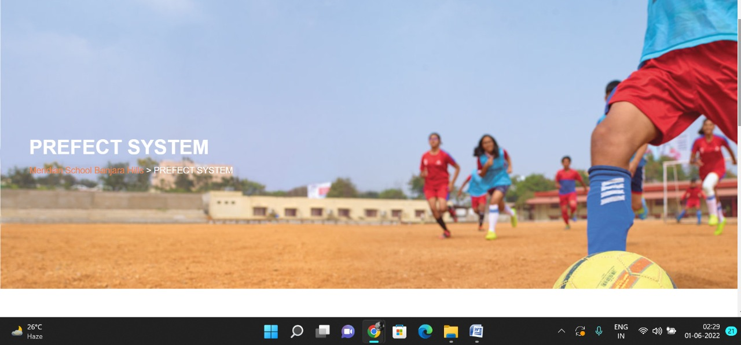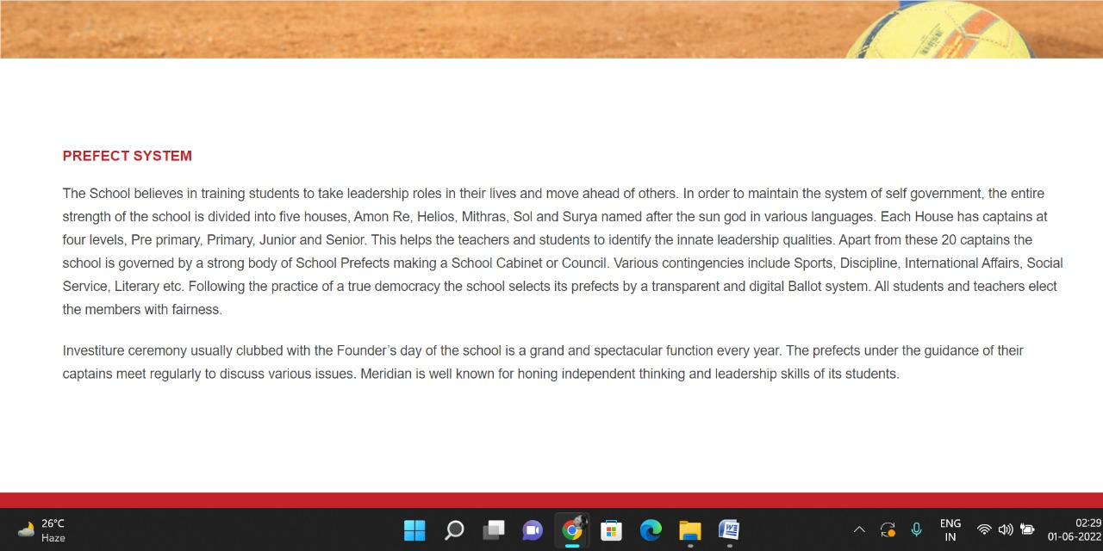

**PAGE 7:School’s Social Responsibility**

**HTML CODE:**

<!DOCTYPE html>

<html lang="en">

<head>

    <meta charset="UTF-8">

    <meta http-equiv="X-UA-Compatible" content="IE=edge">

    <meta name="viewport" content="width=device-width, initial-scale=1.0">

    <title>SCHOOL’S SOCIAL RESPONSIBILITY - Meridian School</title>

    <link rel="stylesheet" href="style.css">

    <link rel="stylesheet" href="https://pro.fontawesome.com/releases/v5.10.0/css/all.css" />

    <link rel="icon" type="imag/logo2.png" href="img/logo2.png">

    <link rel="stylesheet" href="https://stackpath.bootstrapcdn.com/bootstrap/4.4.1/css/bootstrap.min.css"

        integrity="sha384-Vkoo8x4CGs03+Hhxv8T/Q5paXtkKtu6ug5TOeNV6gBiFeWPGFN9MuhOf23Q9Ifjh" crossorigin="anonymous" />

    <link rel="stylesheet" href="https://cdnjs.cloudflare.com/ajax/libs/slick-carousel/1.8.1/slick-theme.min.css"

        integrity="sha512-17EgCFERpgZKcm0j0fEq1YCJuyAWdz9KUtv1EjVuaOz8pDnh/0nZxmU6BBXwaaxqoi9PQXnRWqlcDB027hgv9A=="

        crossorigin="anonymous" referrerpolicy="no-referrer" />

    <link rel="stylesheet" href="https://cdnjs.cloudflare.com/ajax/libs/slick-carousel/1.8.1/slick.min.css"

        integrity="sha512-yHknP1/AwR+yx26cB1y0cjvQUMvEa2PFzt1c9LlS4pRQ5NOTZFWbhBig+X9G9eYW/8m0/4OXNx8pxJ6z57x0dw=="

        crossorigin="anonymous" referrerpolicy="no-referrer" />

</head>

<body>

    <section id="follow">

        <div class="followus">

            <div class="icon1">

                <i class="fa fa-phone"></i>

                <a id="phone" href="">8096918857, 9948508222</a>

            </div>

            <div class="icon1">

                <i class="fa fa-envelope"></i>

                <a id="mail" href="">info.banjara@meridianschool.in</a>

            </div>

            <div class="icon">

                <a href="https://www.facebook.com/MeridianSchoolBanjaraHills/" target="_blank"

                    class="fab fa-facebook-f"></i></a>

                <a href="https://twitter.com/meridianbanjara" target="_blank"><i class="fab fa-twitter"></i></a>

                <a href="https://www.youtube.com/channel/UCBZ_gLF9qM18O3CDWQHeN1A" target="_blank"><i

                        class="fab fa-youtube"></i></a>

                <a href="https://www.instagram.com/meridianschools/" target="_blank"><i

                        class="fab fa-instagram"></i></a>

            </div>

        </div>

    </section>

    <div class="navbar">

        <a href="home.html"><img src="img/logo.png" class="logo" alt=""></a>

        <nav>

            <a class="active" href="home.html">HOME</a>

            <div class="dropdown">

                <button class="dropbtn">ABOUT US

                </button>

                <div class="dropdown-content">

                    <a href="knowmeridian.html">KNOW MERIDIAN</a>

                    <a href="visionmission.html">THE VISION & MISSION</a>

                    <a href="http://meridianbanjara.com/the-founders/">THE FOUNDER'S MESSAGE</a>

                    <a href="ceomsg.html">CEO'S MESSAGE</a>

                    <a href="principalmsg.html">THE PRINCIPAL'S MESSAGE</a>

                    <a href="awards.html">AWARDS AND ACCOLADES</a>

                    <a href="http://meridianbanjara.com/affiliations-accreditations/">AFFILIATIONS & ACCREDITATIONS</a>

                    <a href="blog.html">BLOG</a>

                </div>

            </div>

            <div class="dropdown">

                <button class="dropbtn">LEADERSHIP TEAM

                </button>

                <div class="dropdown-content">

                    <a href="principal.html">PRINCIPAL</a>

                    <a href="vp.html">VICE PRINCIPAL</a>

                    <a href="headmistress.html">HEADMISTRESS</a>

                    <a href="midSchool.html">MIDDLE SCHOOL INCHARGE</a>

                    <a href="ipPyp.html">IB PYP COORDINATOR</a>

                    <a href="preprimary.html">PRE PRIMARY INCHARGE</a>

                    <a href="global.html">GLOBAL PARTNERSHIP COORDINATOR</a>

                </div>

            </div>

            <div class="dropdown">

                <button class="dropbtn">ACADEMICS

                </button>

                <div class="dropdown-content">

                    <a href="AcaOverview.html">OVERVIEW</a>

                    <a href="methodology.html">METHODOLOGY AND LEARNING STYLE</a>

                    <a href="curriculum.html">CURRICULUM</a>

                    <a href="faculty.html">FACULTY</a>

                    <a href="teacherTraining.html">TEACHER TRAINING</a>

                    <a href="careerGuidance.html">CAREER GUIDANCE</a>

                    <a href="scholrship.html">SCHOLARSHIP PROGRAMME</a>

                </div>

            </div>

            <div class="dropdown">

                <button class="dropbtn">BEYOND ACADEMICS

                </button>

                <div class="dropdown-content">

                    <a href="beyondAcaOverview.html">OVERVIEW</a>

                    <a href="sports.html">SPORTS</a>

                    <a href="creatveAct.html">CREATIVE ACTIVITIES</a>

                    <a href="eduTrips.html">EDUCATIONAL TRIPS AND STUDENT<br> EXCHANGE PROGRAMMES</a>

                    <a href="perfectSystem.html">PERFECT SYSTEM</a>

                    <a href="schoolSocialRes.html">SCHOOL'S SOCIAL RESPONSIBILITY</a>

                    <a href="interact.html">INTERACT</a>

                    <a href="heritageClub.html">HERITAGE CLUB</a>

                    <a href="mun.html">MUN</a>

                </div>

            </div>

            <div class="dropdown">

                <button class="dropbtn">ADMISSIONS

                </button>

                <div class="dropdown-content">

                    <a href="overview.html">OVERVIEW</a>

                    <a href="admissionpro.html">ADMISSION PROCEDURE</a>

                    <a href="feepolicy.html">FEE POLICY</a>

                    <a href="tranfercert.html">TRANSFER CERTIFICATE</a>

                    <a href="transport.html">TRANSPORT</a>

                </div>

            </div>

            <a class="active" href="gallery.html">GALLERY</a>

            <div class="dropdown">

                <button class="dropbtn">CONTACT US

                </button>

                <div class="dropdown-content">

                    <a href="contact.html">CAREERS</a>

                </div>

            </div>

        </nav>

    </div>

    <div id="mobile">

        <i id="bar" class="fas fa-outdent "></i>

    </div>

    <section id="principal">

        <div class="prin" id="sports">

            <h2>SCHOOL’S SOCIAL RESPONSIBILITY</h2>

            <span id="orange"><a href="home.html">Meridian School Banjara Hills</a></span>

            <span> &gt; SCHOOL’S SOCIAL RESPONSIBILITY</span>

        </div>

    </section>

    <section id="principal1">

        <div class="academics" id="overview">

            <h4>SCHOOL’S SOCIAL RESPONSIBILITY</h4>

            <p>In modern education system, there is more to learn by venturing beyond the boundaries of the school. This

                education system was the fulcrum of learning process during ancient Vedic times. The modern education

                system with outward way of gathering values in students creates a better human amongst them. At

                Meridian, we give a high priority to this way of learning. These values give back to the community and

                society making it a healthy and a peaceful way of life for students.</p>

            <p class="headOrange">Urban-Rural Bridge</p>

            <p>A synergy between city life and rural life is vital for overall development of the society and the

                country. An understanding of rural way of life for the citizens gives them an interactive experience and

                similarly the rural folks get to know the city way of living. Meridian School has adopted 23 Govt.

                Schools in Mahabubnagar Dist. Of Telangana. Under this program the school has constructed washrooms for

                girl students which has promoted them to continue with their education. A mutual exchange of students

                from the district schools happens every year for enhancement of education and life skills.</p>

            <p class="headOrange">Flood Relief Programme</p>

            <p>During the trying times of floods in Kurnool, Kanchipuram and Kerala Meridianites came forward with the

                spirit of humanity and worked relentlessly by pooling up all possible resources and distributing

                survival kits to help those in distress.</p>

            <p class="headOrange"> Visit to Orphanages</p>

            <p>In our social fabric there are some underprivileged children who are bereft of love and affection. These

                children yearn to get the feel of happiness which the Rotary Club of Meridian understands and plans

                regular visits. Under such a programme, an annual visit to orphanages like ‘Helping Hands Humanities’ is

                undertaken to entertain, engage and teach such children. Activities like playing musical instruments,

                organizing games, quiz programmes, dance programmes etc. are organized to give joy and happiness to

                these children.</p>

            <p class="headOrange"> Visit to Old Age Homes</p>

            <p>In modern societies, just like underprivileged children the elderly are also often neglected. Therefore,

                there are some organizations who work with the help of donations to take care of such elderly people who

                require love and affection in their twilight years. Meridian takes initiative in raising funds and

                donates to such organizations like ‘Little Sisters of the Poor’. In addition to the financial help,

                students take steps forward in making greeting cards, gifting flowers and entertaining them with songs

                and dance.</p>

            <p class="headOrange">Adoption of Cows and Calfs</p>

            <p>We at Meridian give priority to protect flora and fauna. The children are regularly educated to conserve

                and protect these valuable resources. Under this programme, Meridian takes pride in adopting cows and

                calves in association with Satyam Sivam Sundaram Goshala.</p>

            <p class="headOrange">A Fistful of Rice</p>

            <p>‘Service to Mankind is Service to God’</p>

            <p>Hunger is the worst enemy of all living beings. Particularly in an organised society if someone goes

                hungry it is an appalling situation. Keeping this in mind, we in Meridian undertake projects to

                contribute towards reducing malnutrition and hunger. Under this project, the entire school collected

                food grains and donated to Ramakrishna Math. This inculcates a sense of responsibility in our students

                who never miss an opportunity when it comes to contributing to the society.</p>

            <a href="img/pdf/MANDATORY-PUBLIC-DISCLOSURE.pdf" class="pdf">MANDATORY PUBLIC DISCLOSURE</a>

            <a href="img/pdf/1-AFFILIATIONLETTER.pdf" target="_blank" class="pdf">AFFILIATION LETTER</a>

            <a href="img/pdf/TRUST-CERTIFICATE.pdf" class="pdf">TRUST CERTIFICATE</a>

            <a href="img/pdf/3-NOC.pdf" class="pdf" target="_blank">NOC</a>

            <a href="img/pdf/RECOGNITION-CERTIFICATE.pdf" class="pdf">RECOGNITION CERTIFICATE</a>

            <a href="img/pdf/5-BUILDINGCERTIFICATE.pdf" class="pdf" target="_blank">BUILDING CERTIFICATE</a>

            <a href="img/pdf/6-FIRECERTIFICATE.pdf" class="pdf" target="_blank">FIRE CERTIFICATE</a>

            <a href="img/pdf/7-DEOCERTIFICATE.pdf" class="pdf" target="_blank">DEO CERTIFICATE</a>

            <a href="img/pdf/8-WATER-HEALTH-CERTIFICATE.pdf" class="pdf" target="_blank">WATER HEALTH CERTIFICATE</a>

            <a href="img/pdf/FEE-STRUCTURE.pdf" class="pdf" target="_blank">FEE STRUCTURE</a>

            <a href="img/pdf/10-ACADEMIC-CALENDAR.pdf" class="pdf" target="_blank">ACADEMIC CALENDAR</a>

            <a href="img/pdf/11-SMC-Details-OF-PTA-Formation.pdf" class="pdf" target="_blank">SMC Details OF PTA

                Formation</a>

            <a href="img/pdf/12-RESULTS.pdf" class="pdf" target="_blank">RESULTS</a>

        </div>

        </div>

    </section>

    <footer>

        <div class="col">

            <h4>ABOUT US</h4>

            <p>Meridian is a New Generation Educational Group committed to educate children for life and thus bring a

                change in the society. Learning philosophy practised at Meridian infuses traditional values into a

                progressive approach, equipping students to adapt and excel anywhere in the world. Our alumni, working

                in diverse fields, have found Meridian to be the best school for a successful career take off.</p>

        </div>

        <div class="col">

            <h4>USEFUL LINKS</h4>

            <ul class="three-col-links">

                <li><a href="home.html">HOME</a></li>

                <li><a href="AcaOverview.html">ACADEMICS</a></li>

                <li><a href="overview.html">ADMISSIONS</a></li>

                <li><a href="contact.html">CONTACT US</a></li>

                <li><a href="knowmeridian.html">ABOUT US</a></li>

                <li><a href="beyondAcaOverview.html">BEYOND ACADEMICS</a></li>

                <li><a href="contact.html">CAREERS</a></li>

            </ul>

        </div>

        <div class="col">

            <!--<div class="follow">

                <div class="icon">

                    <i class="fa fa-paper-plane-o"></i>

                </div>

        </div>-->

            <h4>MERIDIAN SCHOOL, Banjara Hills</h4>

            <p># 8-2-541, Road No 7, Banjara Hills, Hyderabad-500034, TELANGANA, INDIA.</p>

            <p>For contact : +91 8096918857, 9948508222, For Prinicipal Appointments : 8098420002</p>

            <p> For Admissions / Enquires : 8096918857, 9948508222</p>

            <p>info.banjara@meridianschool.inA</p>

        </div>

    </footer>

    <section id="copyright">

        <div id="cr">

            <p>© Copyright MERIDIAN SCHOOL, 2021.</p>

        </div>

    </section>

</body>

</html>

**CSS CODE:**

#principal1 #overview .pdf {

display: block;

margin-bottom: 20px;

color: #c42329;

font-weight: 500;

text-decoration: none;

}

#principal1 #overview .pdf:hover {

color: #f48243;

transition: 0.2s ease;

}

**OUTPUT:**

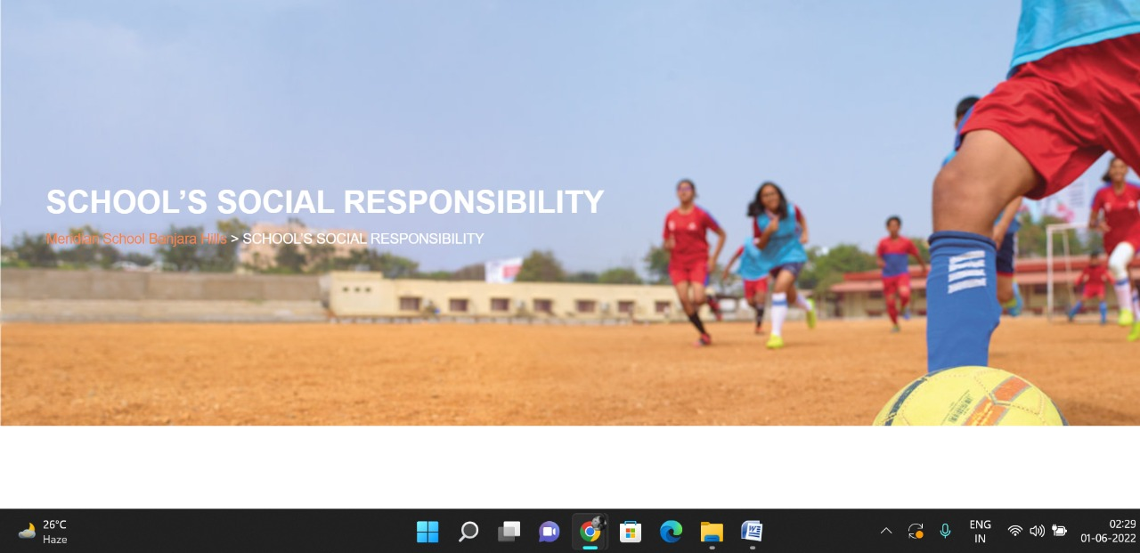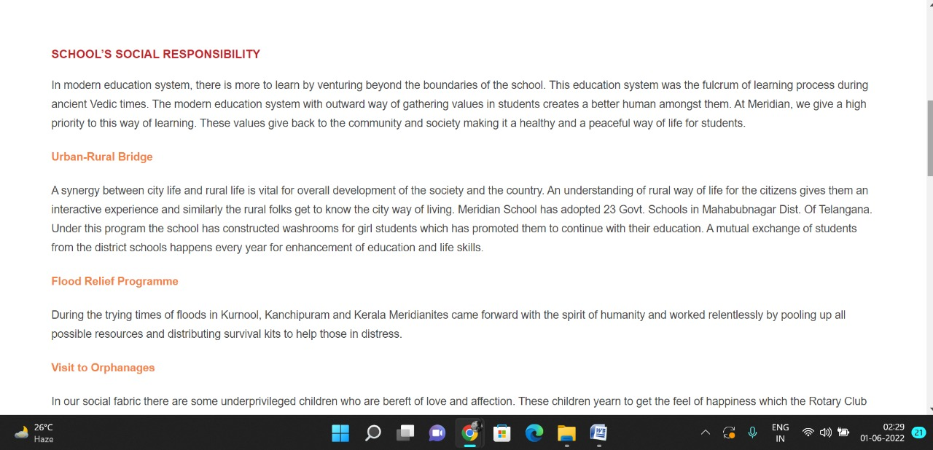

**PAGE 8:Interact**

**HTML CODE:**

<!DOCTYPE html>

<html lang="en">

<head>

    <meta charset="UTF-8">

    <meta http-equiv="X-UA-Compatible" content="IE=edge">

    <meta name="viewport" content="width=device-width, initial-scale=1.0">

    <title>INTERACT - Meridian School</title>

    <link rel="stylesheet" href="style.css">

    <link rel="stylesheet" href="https://pro.fontawesome.com/releases/v5.10.0/css/all.css" />

    <link rel="icon" type="imag/logo2.png" href="img/logo2.png">

    <link rel="stylesheet" href="https://stackpath.bootstrapcdn.com/bootstrap/4.4.1/css/bootstrap.min.css"

        integrity="sha384-Vkoo8x4CGs03+Hhxv8T/Q5paXtkKtu6ug5TOeNV6gBiFeWPGFN9MuhOf23Q9Ifjh" crossorigin="anonymous" />

    <link rel="stylesheet" href="https://cdnjs.cloudflare.com/ajax/libs/slick-carousel/1.8.1/slick-theme.min.css"

        integrity="sha512-17EgCFERpgZKcm0j0fEq1YCJuyAWdz9KUtv1EjVuaOz8pDnh/0nZxmU6BBXwaaxqoi9PQXnRWqlcDB027hgv9A=="

        crossorigin="anonymous" referrerpolicy="no-referrer" />

    <link rel="stylesheet" href="https://cdnjs.cloudflare.com/ajax/libs/slick-carousel/1.8.1/slick.min.css"

        integrity="sha512-yHknP1/AwR+yx26cB1y0cjvQUMvEa2PFzt1c9LlS4pRQ5NOTZFWbhBig+X9G9eYW/8m0/4OXNx8pxJ6z57x0dw=="

        crossorigin="anonymous" referrerpolicy="no-referrer" />

</head>

<body>

    <section id="follow">

        <div class="followus">

            <div class="icon1">

                <i class="fa fa-phone"></i>

                <a id="phone" href="">8096918857, 9948508222</a>

            </div>

            <div class="icon1">

                <i class="fa fa-envelope"></i>

                <a id="mail" href="">info.banjara@meridianschool.in</a>

            </div>

            <div class="icon">

                <a href="https://www.facebook.com/MeridianSchoolBanjaraHills/" target="_blank"

                    class="fab fa-facebook-f"></i></a>

                <a href="https://twitter.com/meridianbanjara" target="_blank"><i class="fab fa-twitter"></i></a>

                <a href="https://www.youtube.com/channel/UCBZ_gLF9qM18O3CDWQHeN1A" target="_blank"><i

                        class="fab fa-youtube"></i></a>

                <a href="https://www.instagram.com/meridianschools/" target="_blank"><i

                        class="fab fa-instagram"></i></a>

            </div>

        </div>

    </section>

    <div class="navbar">

        <a href="home.html"><img src="img/logo.png" class="logo" alt=""></a>

        <nav>

            <a class="active" href="home.html">HOME</a>

            <div class="dropdown">

                <button class="dropbtn">ABOUT US

                </button>

                <div class="dropdown-content">

                    <a href="knowmeridian.html">KNOW MERIDIAN</a>

                    <a href="visionmission.html">THE VISION & MISSION</a>

                    <a href="http://meridianbanjara.com/the-founders/">THE FOUNDER'S MESSAGE</a>

                    <a href="ceomsg.html">CEO'S MESSAGE</a>

                    <a href="principalmsg.html">THE PRINCIPAL'S MESSAGE</a>

                    <a href="awards.html">AWARDS AND ACCOLADES</a>

                    <a href="http://meridianbanjara.com/affiliations-accreditations/">AFFILIATIONS & ACCREDITATIONS</a>

                    <a href="blog.html">BLOG</a>

                </div>

            </div>

            <div class="dropdown">

                <button class="dropbtn">LEADERSHIP TEAM

                </button>

                <div class="dropdown-content">

                    <a href="principal.html">PRINCIPAL</a>

                    <a href="vp.html">VICE PRINCIPAL</a>

                    <a href="headmistress.html">HEADMISTRESS</a>

                    <a href="midSchool.html">MIDDLE SCHOOL INCHARGE</a>

                    <a href="ipPyp.html">IB PYP COORDINATOR</a>

                    <a href="preprimary.html">PRE PRIMARY INCHARGE</a>

                    <a href="global.html">GLOBAL PARTNERSHIP COORDINATOR</a>

                </div>

            </div>

            <div class="dropdown">

                <button class="dropbtn">ACADEMICS

                </button>

                <div class="dropdown-content">

                    <a href="AcaOverview.html">OVERVIEW</a>

                    <a href="methodology.html">METHODOLOGY AND LEARNING STYLE</a>

                    <a href="curriculum.html">CURRICULUM</a>

                    <a href="faculty.html">FACULTY</a>

                    <a href="teacherTraining.html">TEACHER TRAINING</a>

                    <a href="careerGuidance.html">CAREER GUIDANCE</a>

                    <a href="scholrship.html">SCHOLARSHIP PROGRAMME</a>

                </div>

            </div>

            <div class="dropdown">

                <button class="dropbtn">BEYOND ACADEMICS

                </button>

                <div class="dropdown-content">

                    <a href="beyondAcaOverview.html">OVERVIEW</a>

                    <a href="sports.html">SPORTS</a>

                    <a href="creatveAct.html">CREATIVE ACTIVITIES</a>

                    <a href="eduTrips.html">EDUCATIONAL TRIPS AND STUDENT<br> EXCHANGE PROGRAMMES</a>

                    <a href="perfectSystem.html">PERFECT SYSTEM</a>

                    <a href="schoolSocialRes.html">SCHOOL'S SOCIAL RESPONSIBILITY</a>

                    <a href="interact.html">INTERACT</a>

                    <a href="heritageClub.html">HERITAGE CLUB</a>

                    <a href="mun.html">MUN</a>

                </div>

            </div>

            <div class="dropdown">

                <button class="dropbtn">ADMISSIONS

                </button>

                <div class="dropdown-content">

                    <a href="overview.html">OVERVIEW</a>

                    <a href="admissionpro.html">ADMISSION PROCEDURE</a>

                    <a href="feepolicy.html">FEE POLICY</a>

                    <a href="tranfercert.html">TRANSFER CERTIFICATE</a>

                    <a href="transport.html">TRANSPORT</a>

                </div>

            </div>

            <a class="active" href="gallery.html">GALLERY</a>

            <div class="dropdown">

                <button class="dropbtn">CONTACT US

                </button>

                <div class="dropdown-content">

                    <a href="contact.html">CAREERS</a>

                </div>

            </div>

        </nav>

    </div>

    <div id="mobile">

        <i id="bar" class="fas fa-outdent "></i>

    </div>

    <section id="principal">

        <div class="prin" id="interactbg">

            <h2>INTERACT</h2>

            <span id="orange"><a href="home.html">Meridian School Banjara Hills</a></span>

            <span> &gt; INTERACT</span>

        </div>

    </section>

    <section id="principal1">

        <div class="academics" id="overview">

            <h4>INTERACT</h4>

            <p>Interact is a service club of Rotary Club International. The aim of the club is to take action, build

                understanding, make new friends and help the society. The Interact Club of Meridian School in

                association with Rotary Club of Jubilee Hills, Hyderabad aims to aid Meridian students to understand

                this fine line, and ‘making the change we wish to see in the world’, as Mahatma Gandhiji wisely said.

            </p>

            <p>Just as the Meridian motto says- ‘Connecting the Mind and Heart’ – the members of the Interact Club have

                been using this sense of Empathy to arouse humanity not just in themselves, but also in others. With

                more than 10 years in the bag, and countless projects varying in type and objective, the Club has been

                improving the lives of humans, plants, and animals alike! And every project has a team effort of several

                helping hands from fellow students and thus helping shape even their lives with the thought of nurturing

                the world around-us with the thought of Humanity.</p>

            <h4>OFFICE BEARERS</h4>

            <img src="img/interact2.jpg" id="int2" alt="">

        </div>

        </div>

    </section>

    <footer>

        <div class="col">

            <h4>ABOUT US</h4>

            <p>Meridian is a New Generation Educational Group committed to educate children for life and thus bring a

                change in the society. Learning philosophy practised at Meridian infuses traditional values into a

                progressive approach, equipping students to adapt and excel anywhere in the world. Our alumni, working

                in diverse fields, have found Meridian to be the best school for a successful career take off.</p>

        </div>

        <div class="col">

            <h4>USEFUL LINKS</h4>

            <ul class="three-col-links">

                <li><a href="home.html">HOME</a></li>

                <li><a href="AcaOverview.html">ACADEMICS</a></li>

                <li><a href="overview.html">ADMISSIONS</a></li>

                <li><a href="contact.html">CONTACT US</a></li>

                <li><a href="knowmeridian.html">ABOUT US</a></li>

                <li><a href="beyondAcaOverview.html">BEYOND ACADEMICS</a></li>

                <li><a href="contact.html">CAREERS</a></li>

            </ul>

        </div>

        <div class="col">

            <!--<div class="follow">

                <div class="icon">

                    <i class="fa fa-paper-plane-o"></i>

                </div>

        </div>-->

            <h4>MERIDIAN SCHOOL, Banjara Hills</h4>

            <p># 8-2-541, Road No 7, Banjara Hills, Hyderabad-500034, TELANGANA, INDIA.</p>

            <p>For contact : +91 8096918857, 9948508222, For Prinicipal Appointments : 8098420002</p>

            <p> For Admissions / Enquires : 8096918857, 9948508222</p>

            <p>info.banjara@meridianschool.inA</p>

        </div>

    </footer>

    <section id="copyright">

        <div id="cr">

            <p>© Copyright MERIDIAN SCHOOL, 2021.</p>

        </div>

    </section>

</body>

</html>

**CSS CODE:**

#principal1 #overview #int2 {

margin: 0;

border: none;

}

#principal #interactbg {

background-image: url(img/interact.jpg);

position: absolute;

top: 50%;

left: 50%;

transform: translate(-130%, -50%);

}

**OUTPUT:**

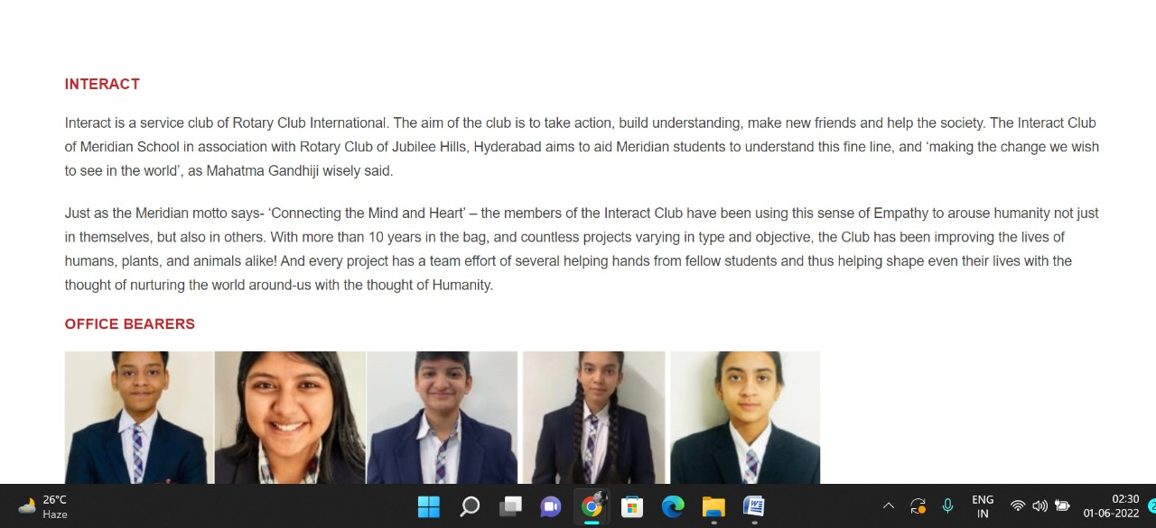

**PAGE 9:Heritage Club**

**HTML CODE:**

<!DOCTYPE html>

<html lang="en">

<head>

    <meta charset="UTF-8">

    <meta http-equiv="X-UA-Compatible" content="IE=edge">

    <meta name="viewport" content="width=device-width, initial-scale=1.0">

    <title>HERITAGE CLUB - Meridian School</title>

    <link rel="stylesheet" href="style.css">

    <link rel="stylesheet" href="https://pro.fontawesome.com/releases/v5.10.0/css/all.css" />

    <link rel="icon" type="imag/logo2.png" href="img/logo2.png">

    <link rel="stylesheet" href="https://stackpath.bootstrapcdn.com/bootstrap/4.4.1/css/bootstrap.min.css"

        integrity="sha384-Vkoo8x4CGs03+Hhxv8T/Q5paXtkKtu6ug5TOeNV6gBiFeWPGFN9MuhOf23Q9Ifjh" crossorigin="anonymous" />

    <link rel="stylesheet" href="https://cdnjs.cloudflare.com/ajax/libs/slick-carousel/1.8.1/slick-theme.min.css"

        integrity="sha512-17EgCFERpgZKcm0j0fEq1YCJuyAWdz9KUtv1EjVuaOz8pDnh/0nZxmU6BBXwaaxqoi9PQXnRWqlcDB027hgv9A=="

        crossorigin="anonymous" referrerpolicy="no-referrer" />

    <link rel="stylesheet" href="https://cdnjs.cloudflare.com/ajax/libs/slick-carousel/1.8.1/slick.min.css"

        integrity="sha512-yHknP1/AwR+yx26cB1y0cjvQUMvEa2PFzt1c9LlS4pRQ5NOTZFWbhBig+X9G9eYW/8m0/4OXNx8pxJ6z57x0dw=="

        crossorigin="anonymous" referrerpolicy="no-referrer" />

</head>

<body>

    <section id="follow">

        <div class="followus">

            <div class="icon1">

                <i class="fa fa-phone"></i>

                <a id="phone" href="">8096918857, 9948508222</a>

            </div>

            <div class="icon1">

                <i class="fa fa-envelope"></i>

                <a id="mail" href="">info.banjara@meridianschool.in</a>

            </div>

            <div class="icon">

                <a href="https://www.facebook.com/MeridianSchoolBanjaraHills/" target="_blank"

                    class="fab fa-facebook-f"></i></a>

                <a href="https://twitter.com/meridianbanjara" target="_blank"><i class="fab fa-twitter"></i></a>

                <a href="https://www.youtube.com/channel/UCBZ_gLF9qM18O3CDWQHeN1A" target="_blank"><i

                        class="fab fa-youtube"></i></a>

                <a href="https://www.instagram.com/meridianschools/" target="_blank"><i

                        class="fab fa-instagram"></i></a>

            </div>

        </div>

    </section>

    <div class="navbar">

        <a href="home.html"><img src="img/logo.png" class="logo" alt=""></a>

        <nav>

            <a class="active" href="home.html">HOME</a>

            <div class="dropdown">

                <button class="dropbtn">ABOUT US

                </button>

                <div class="dropdown-content">

                    <a href="knowmeridian.html">KNOW MERIDIAN</a>

                    <a href="visionmission.html">THE VISION & MISSION</a>

                    <a href="http://meridianbanjara.com/the-founders/">THE FOUNDER'S MESSAGE</a>

                    <a href="ceomsg.html">CEO'S MESSAGE</a>

                    <a href="principalmsg.html">THE PRINCIPAL'S MESSAGE</a>

                    <a href="awards.html">AWARDS AND ACCOLADES</a>

                    <a href="http://meridianbanjara.com/affiliations-accreditations/">AFFILIATIONS & ACCREDITATIONS</a>

                    <a href="blog.html">BLOG</a>

                </div>

            </div>

            <div class="dropdown">

                <button class="dropbtn">LEADERSHIP TEAM

                </button>

                <div class="dropdown-content">

                    <a href="principal.html">PRINCIPAL</a>

                    <a href="vp.html">VICE PRINCIPAL</a>

                    <a href="headmistress.html">HEADMISTRESS</a>

                    <a href="midSchool.html">MIDDLE SCHOOL INCHARGE</a>

                    <a href="ipPyp.html">IB PYP COORDINATOR</a>

                    <a href="preprimary.html">PRE PRIMARY INCHARGE</a>

                    <a href="global.html">GLOBAL PARTNERSHIP COORDINATOR</a>

                </div>

            </div>

            <div class="dropdown">

                <button class="dropbtn">ACADEMICS

                </button>

                <div class="dropdown-content">

                    <a href="AcaOverview.html">OVERVIEW</a>

                    <a href="methodology.html">METHODOLOGY AND LEARNING STYLE</a>

                    <a href="curriculum.html">CURRICULUM</a>

                    <a href="faculty.html">FACULTY</a>

                    <a href="teacherTraining.html">TEACHER TRAINING</a>

                    <a href="careerGuidance.html">CAREER GUIDANCE</a>

                    <a href="scholrship.html">SCHOLARSHIP PROGRAMME</a>

                </div>

            </div>

            <div class="dropdown">

                <button class="dropbtn">BEYOND ACADEMICS

                </button>

                <div class="dropdown-content">

                    <a href="beyondAcaOverview.html">OVERVIEW</a>

                    <a href="sports.html">SPORTS</a>

                    <a href="creatveAct.html">CREATIVE ACTIVITIES</a>

                    <a href="eduTrips.html">EDUCATIONAL TRIPS AND STUDENT<br> EXCHANGE PROGRAMMES</a>

                    <a href="perfectSystem.html">PERFECT SYSTEM</a>

                    <a href="schoolSocialRes.html">SCHOOL'S SOCIAL RESPONSIBILITY</a>

                    <a href="interact.html">INTERACT</a>

                    <a href="heritageClub.html">HERITAGE CLUB</a>

                    <a href="mun.html">MUN</a>

                </div>

            </div>

            <div class="dropdown">

                <button class="dropbtn">ADMISSIONS

                </button>

                <div class="dropdown-content">

                    <a href="overview.html">OVERVIEW</a>

                    <a href="admissionpro.html">ADMISSION PROCEDURE</a>

                    <a href="feepolicy.html">FEE POLICY</a>

                    <a href="tranfercert.html">TRANSFER CERTIFICATE</a>

                    <a href="transport.html">TRANSPORT</a>

                </div>

            </div>

            <a class="active" href="gallery.html">GALLERY</a>

            <div class="dropdown">

                <button class="dropbtn">CONTACT US

                </button>

                <div class="dropdown-content">

                    <a href="contact.html">CAREERS</a>

                </div>

            </div>

        </nav>

    </div>

    <div id="mobile">

        <i id="bar" class="fas fa-outdent "></i>

    </div>

    <section id="principal">

        <div class="prin" id="interactbg">

            <h2>HERITAGE CLUB</h2>

            <span id="orange"><a href="home.html">Meridian School Banjara Hills</a></span>

            <span> &gt; HERITAGE CLUB</span>

        </div>

    </section>

    <section id="principal1">

        <div class="academics" id="overview">

            <h4>HERITAGE CLUB</h4>

            <p>Heritage is the full range of our inherited traditions, monuments, objects and culture. It is the range

                of contemporary activities, meanings and behaviours that we draw from them.</p>

            <p>India is a land of cultural and architectural diversities exhibiting the best of the monuments, palaces,

                temples, representing the various dynasties that ruled over India.</p>

            <p>One will be awestruck by the magnificent skills that were exhibited by the artists of that time. Each one

                is a marvel in its own way.</p>

            <p>The Social Science Department at Meridian School, Banjara hills believes that it is our duty to make the

                students acquaint with the Indian Heritage and make them to explore the richness of our country’s

                ancient culture and tradition.</p>

            <p>Under the concept called ‘Bharat Ek Koj ‘we conduct Heritage quiz competitions to make the students

                research and explore many facts and artefacts and appreciate the great cultural heritage of Our Country.

            </p>

            <p>Every year we compile the activities done in our school and send it to INTACH CLUB headquarters located

                in New Delhi, in the form of PPT .</p>

            <p>In 2017-18 we were awarded 3rd place all over India for our documentation.</p>

            <p>In 2018 -19 we were awarded Special Mention memento.</p>

        </div>

        </div>

    </section>

    <footer>

        <div class="col">

            <h4>ABOUT US</h4>

            <p>Meridian is a New Generation Educational Group committed to educate children for life and thus bring a

                change in the society. Learning philosophy practised at Meridian infuses traditional values into a

                progressive approach, equipping students to adapt and excel anywhere in the world. Our alumni, working

                in diverse fields, have found Meridian to be the best school for a successful career take off.</p>

        </div>

        <div class="col">

            <h4>USEFUL LINKS</h4>

            <ul class="three-col-links">

                <li><a href="home.html">HOME</a></li>

                <li><a href="AcaOverview.html">ACADEMICS</a></li>

                <li><a href="overview.html">ADMISSIONS</a></li>

                <li><a href="contact.html">CONTACT US</a></li>

                <li><a href="knowmeridian.html">ABOUT US</a></li>

                <li><a href="beyondAcaOverview.html">BEYOND ACADEMICS</a></li>

                <li><a href="contact.html">CAREERS</a></li>

            </ul>

        </div>

        <div class="col">

            <!--<div class="follow">

                <div class="icon">

                    <i class="fa fa-paper-plane-o"></i>

                </div>

        </div>-->

            <h4>MERIDIAN SCHOOL, Banjara Hills</h4>

            <p># 8-2-541, Road No 7, Banjara Hills, Hyderabad-500034, TELANGANA, INDIA.</p>

            <p>For contact : +91 8096918857, 9948508222, For Prinicipal Appointments : 8098420002</p>

            <p> For Admissions / Enquires : 8096918857, 9948508222</p>

            <p>info.banjara@meridianschool.inA</p>

        </div>

    </footer>

    <section id="copyright">

        <div id="cr">

            <p>© Copyright MERIDIAN SCHOOL, 2021.</p>

        </div>

    </section>

</body>

</html>

**CSS CODE:**

#principal .prin h2 {

font-size: 34px;

font-weight: 600;

text-align: start;

/* color: #c42329; */

}

#principal .prin span {

color: #fff;

}

#principal #orange {

color: #f48243;

}

#principal #orange:hover {

color: #fff;

}

#principal1 .princi1 {

display: flex;

}

#principal1 .princi1 img {

width: 250px;

height: 169px;

border: 7px solid rgb(225, 222, 222);

}

#principal1 .princi1 h4 {

text-align: start;

color: #c42329;

margin: 100px 0 35px 0px;

}

#principal1 .princi1 #info {

width: 42%;

margin: 200px 53px 70px;

}

#principal1 .princi1 #info p {

margin-bottom: 20px;

}

#principal1 .princi1 #info #strong {

margin-bottom: 0px;

}

**OUTPUT:**

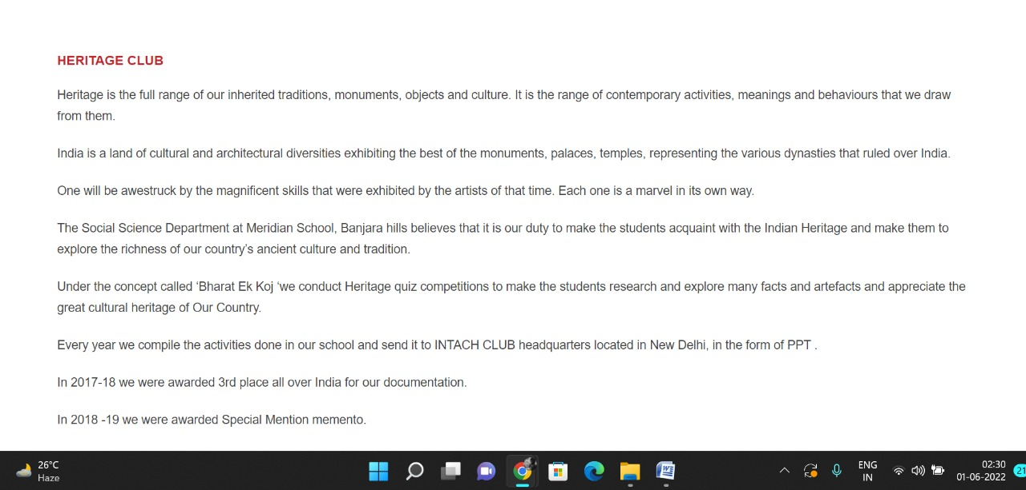

**PAGE 10:MUN**

**HTML CODE:**

<!DOCTYPE html>

<html lang="en">

<head>

    <meta charset="UTF-8">

    <meta http-equiv="X-UA-Compatible" content="IE=edge">

    <meta name="viewport" content="width=device-width, initial-scale=1.0">

    <title>MUN - Meridian School</title>

    <link rel="stylesheet" href="style.css">

    <link rel="stylesheet" href="https://pro.fontawesome.com/releases/v5.10.0/css/all.css" />

    <link rel="icon" type="imag/logo2.png" href="img/logo2.png">

    <link rel="stylesheet" href="https://stackpath.bootstrapcdn.com/bootstrap/4.4.1/css/bootstrap.min.css"

        integrity="sha384-Vkoo8x4CGs03+Hhxv8T/Q5paXtkKtu6ug5TOeNV6gBiFeWPGFN9MuhOf23Q9Ifjh" crossorigin="anonymous" />

    <link rel="stylesheet" href="https://cdnjs.cloudflare.com/ajax/libs/slick-carousel/1.8.1/slick-theme.min.css"

        integrity="sha512-17EgCFERpgZKcm0j0fEq1YCJuyAWdz9KUtv1EjVuaOz8pDnh/0nZxmU6BBXwaaxqoi9PQXnRWqlcDB027hgv9A=="

        crossorigin="anonymous" referrerpolicy="no-referrer" />

    <link rel="stylesheet" href="https://cdnjs.cloudflare.com/ajax/libs/slick-carousel/1.8.1/slick.min.css"

        integrity="sha512-yHknP1/AwR+yx26cB1y0cjvQUMvEa2PFzt1c9LlS4pRQ5NOTZFWbhBig+X9G9eYW/8m0/4OXNx8pxJ6z57x0dw=="

        crossorigin="anonymous" referrerpolicy="no-referrer" />

</head>

<body>

    <section id="follow">

        <div class="followus">

            <div class="icon1">

                <i class="fa fa-phone"></i>

                <a id="phone" href="">8096918857, 9948508222</a>

            </div>

            <div class="icon1">

                <i class="fa fa-envelope"></i>

                <a id="mail" href="">info.banjara@meridianschool.in</a>

            </div>

            <div class="icon">

                <a href="https://www.facebook.com/MeridianSchoolBanjaraHills/" target="_blank"

                    class="fab fa-facebook-f"></i></a>

                <a href="https://twitter.com/meridianbanjara" target="_blank"><i class="fab fa-twitter"></i></a>

                <a href="https://www.youtube.com/channel/UCBZ_gLF9qM18O3CDWQHeN1A" target="_blank"><i

                        class="fab fa-youtube"></i></a>

                <a href="https://www.instagram.com/meridianschools/" target="_blank"><i

                        class="fab fa-instagram"></i></a>

            </div>

        </div>

    </section>

    <div class="navbar">

        <a href="home.html"><img src="img/logo.png" class="logo" alt=""></a>

        <nav>

            <a class="active" href="home.html">HOME</a>

            <div class="dropdown">

                <button class="dropbtn">ABOUT US

                </button>

                <div class="dropdown-content">

                    <a href="knowmeridian.html">KNOW MERIDIAN</a>

                    <a href="visionmission.html">THE VISION & MISSION</a>

                    <a href="http://meridianbanjara.com/the-founders/">THE FOUNDER'S MESSAGE</a>

                    <a href="ceomsg.html">CEO'S MESSAGE</a>

                    <a href="principalmsg.html">THE PRINCIPAL'S MESSAGE</a>

                    <a href="awards.html">AWARDS AND ACCOLADES</a>

                    <a href="http://meridianbanjara.com/affiliations-accreditations/">AFFILIATIONS & ACCREDITATIONS</a>

                    <a href="blog.html">BLOG</a>

                </div>

            </div>

            <div class="dropdown">

                <button class="dropbtn">LEADERSHIP TEAM

                </button>

                <div class="dropdown-content">

                    <a href="principal.html">PRINCIPAL</a>

                    <a href="vp.html">VICE PRINCIPAL</a>

                    <a href="headmistress.html">HEADMISTRESS</a>

                    <a href="midSchool.html">MIDDLE SCHOOL INCHARGE</a>

                    <a href="ipPyp.html">IB PYP COORDINATOR</a>

                    <a href="preprimary.html">PRE PRIMARY INCHARGE</a>

                    <a href="global.html">GLOBAL PARTNERSHIP COORDINATOR</a>

                </div>

            </div>

            <div class="dropdown">

                <button class="dropbtn">ACADEMICS

                </button>

                <div class="dropdown-content">

                    <a href="AcaOverview.html">OVERVIEW</a>

                    <a href="methodology.html">METHODOLOGY AND LEARNING STYLE</a>

                    <a href="curriculum.html">CURRICULUM</a>

                    <a href="faculty.html">FACULTY</a>

                    <a href="teacherTraining.html">TEACHER TRAINING</a>

                    <a href="careerGuidance.html">CAREER GUIDANCE</a>

                    <a href="scholrship.html">SCHOLARSHIP PROGRAMME</a>

                </div>

            </div>

            <div class="dropdown">

                <button class="dropbtn">BEYOND ACADEMICS

                </button>

                <div class="dropdown-content">

                    <a href="beyondAcaOverview.html">OVERVIEW</a>

                    <a href="sports.html">SPORTS</a>

                    <a href="creatveAct.html">CREATIVE ACTIVITIES</a>

                    <a href="eduTrips.html">EDUCATIONAL TRIPS AND STUDENT<br> EXCHANGE PROGRAMMES</a>

                    <a href="perfectSystem.html">PERFECT SYSTEM</a>

                    <a href="schoolSocialRes.html">SCHOOL'S SOCIAL RESPONSIBILITY</a>

                    <a href="interact.html">INTERACT</a>

                    <a href="heritageClub.html">HERITAGE CLUB</a>

                    <a href="mun.html">MUN</a>

                </div>

            </div>

            <div class="dropdown">

                <button class="dropbtn">ADMISSIONS

                </button>

                <div class="dropdown-content">

                    <a href="overview.html">OVERVIEW</a>

                    <a href="admissionpro.html">ADMISSION PROCEDURE</a>

                    <a href="feepolicy.html">FEE POLICY</a>

                    <a href="tranfercert.html">TRANSFER CERTIFICATE</a>

                    <a href="transport.html">TRANSPORT</a>

                </div>

            </div>

            <a class="active" href="gallery.html">GALLERY</a>

            <div class="dropdown">

                <button class="dropbtn">CONTACT US

                </button>

                <div class="dropdown-content">

                    <a href="contact.html">CAREERS</a>

                </div>

            </div>

        </nav>

    </div>

    <div id="mobile">

        <i id="bar" class="fas fa-outdent "></i>

    </div>

    <section id="principal">

        <div class="prin" id="munbg">

            <h2>MUN</h2>

            <span id="orange"><a href="home.html">Meridian School Banjara Hills</a></span>

            <span> &gt; MUN</span>

        </div>

    </section>

    <section id="principal1">

        <div class="academics" id="overview">

            <h4>Meridian MUN 2020</h4>

            <p>Meridian School Banjara Hills hosted its Fifth Edition of Model United Nations, Meridian MUN 2020 on 30th

                & 31st October 2020. But this time with a difference ! Keeping the current situation in mind the

                sessions were organised on a virtual platform but without losing its originality and gravity.</p>

            <p>Along with the two-day conference with extremely talented and proficient Executive Boards, ROP (Rules of

                Procedure) Training Sessions for the delegates were organised, and a Career fair by some of the top

                universities in the world to provide exposure to the delegates and equip them with the necessary skill

                sets they may need during the conference and their future endeavours as well.</p>

            <p>Opening Ceremony <a href="https://youtu.be/hePWW38GwoE" class="munA">https://youtu.be/hePWW38GwoE</a></p>

            <p>Closing Ceremony <a href="https://youtu.be/-enZMtZijtk" class="munA">https://youtu.be/-enZMtZijtk</a></p>

            <p>After movie <a href="https://www.instagram.com/tv/CIdOHpRAxze/?igshid=1so85ezimd0jl"

                    class="munA">https://www.instagram.com/tv/CIdOHpRAxze/?igshid=1so85ezimd0jl</a></p>

            <h4>MUN SECRETARIAT</h4>

            <div id="career2">

                <img class="mun1" src="img/mun/mun1.jpg" alt="">

                <img class="mun1" src="img/mun/mun2.png" alt="">

                <img class="mun1" src="img/mun/mun3.png" alt="">

                <img class="mun1" src="img/mun/mun4.png" alt="">

                <img class="mun1" src="img/mun/mun5.png" alt="">

                <img class="mun1" src="img/mun/mun6.png" alt="">

                <img class="mun1" src="img/mun/mun7.png" alt="">

                <img class="mun1" src="img/mun/mun8.png" alt="">

                <img class="mun1" src="img/mun/mun9.png" alt="">

                <img class="mun1" src="img/mun/mun10.png" alt="">

            </div>

        </div>

    </section>

    <footer>

        <div class="col">

            <h4>ABOUT US</h4>

            <p>Meridian is a New Generation Educational Group committed to educate children for life and thus bring a

                change in the society. Learning philosophy practised at Meridian infuses traditional values into a

                progressive approach, equipping students to adapt and excel anywhere in the world. Our alumni, working

                in diverse fields, have found Meridian to be the best school for a successful career take off.</p>

        </div>

        <div class="col">

            <h4>USEFUL LINKS</h4>

            <ul class="three-col-links">

                <li><a href="home.html">HOME</a></li>

                <li><a href="AcaOverview.html">ACADEMICS</a></li>

                <li><a href="overview.html">ADMISSIONS</a></li>

                <li><a href="contact.html">CONTACT US</a></li>

                <li><a href="knowmeridian.html">ABOUT US</a></li>

                <li><a href="beyondAcaOverview.html">BEYOND ACADEMICS</a></li>

                <li><a href="contact.html">CAREERS</a></li>

            </ul>

        </div>

        <div class="col">

            <!--<div class="follow">

                <div class="icon">

                    <i class="fa fa-paper-plane-o"></i>

                </div>

        </div>-->

            <h4>MERIDIAN SCHOOL, Banjara Hills</h4>

            <p># 8-2-541, Road No 7, Banjara Hills, Hyderabad-500034, TELANGANA, INDIA.</p>

            <p>For contact : +91 8096918857, 9948508222, For Prinicipal Appointments : 8098420002</p>

            <p> For Admissions / Enquires : 8096918857, 9948508222</p>

            <p>info.banjara@meridianschool.inA</p>

        </div>

    </footer>

    <section id="copyright">

        <div id="cr">

            <p>© Copyright MERIDIAN SCHOOL, 2021.</p>

        </div>

    </section>

</body>

</html>

**CSS CODE:**

#pri

ncipal1 #career2 .mun1 {

width: 160px;

height: 80px;

margin: 0;

border: none;

}

#principal1 #career2 {

margin-top: 0;

}

#principal1 #overview .munA {

color: #c42329;

text-decoration: none;

margin-left: 10px;

}

#principal1 #overview .munA:hover {

color: #f48243;

}

#principal .prin #munbg {

background-image: url(img/admisson/comp.jpg);

height: 500px;

position: absolute;

top: 50%;

left: 50%;

transform: translate(-160%, -50%);

}

**OUTPUT:**

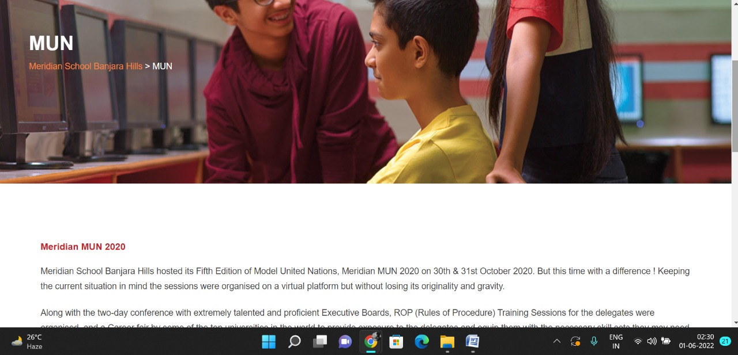

About Us Pages

**PAGE 11:Know Meridian**

**HTML CODE:**

<!DOCTYPE html>

<html lang="en">

<head>

    <meta charset="UTF-8">

    <meta http-equiv="X-UA-Compatible" content="IE=edge">

    <meta name="viewport" content="width=device-width, initial-scale=1.0">

    <title>KNOW MERIDIAN - Meridian School</title>

    <link rel="stylesheet" href="css/knowmeridian.css">

    <link rel="stylesheet" href="https://pro.fontawesome.com/releases/v5.10.0/css/all.css" />

    <link rel="icon" type="imag/logo2.png" href="img/logo2.png">

    <link rel="stylesheet" href="https://stackpath.bootstrapcdn.com/bootstrap/4.4.1/css/bootstrap.min.css"

        integrity="sha384-Vkoo8x4CGs03+Hhxv8T/Q5paXtkKtu6ug5TOeNV6gBiFeWPGFN9MuhOf23Q9Ifjh" crossorigin="anonymous" />

    <link rel="stylesheet" href="https://cdnjs.cloudflare.com/ajax/libs/slick-carousel/1.8.1/slick-theme.min.css"

        integrity="sha512-17EgCFERpgZKcm0j0fEq1YCJuyAWdz9KUtv1EjVuaOz8pDnh/0nZxmU6BBXwaaxqoi9PQXnRWqlcDB027hgv9A=="

        crossorigin="anonymous" referrerpolicy="no-referrer" />

    <link rel="stylesheet" href="https://cdnjs.cloudflare.com/ajax/libs/slick-carousel/1.8.1/slick.min.css"

        integrity="sha512-yHknP1/AwR+yx26cB1y0cjvQUMvEa2PFzt1c9LlS4pRQ5NOTZFWbhBig+X9G9eYW/8m0/4OXNx8pxJ6z57x0dw=="

        crossorigin="anonymous" referrerpolicy="no-referrer" />

    <link rel="stylesheet" href="https://cdnjs.cloudflare.com/ajax/libs/font-awesome/4.7.0/css/font-awesome.min.css">

</head>

<body>

    <section id="follow">

        <div class="followus">

            <div class="icon1">

                <i class="fa fa-phone"></i>

                <a id="phone" href="">8096918857, 9948508222</a>

            </div>

            <div class="icon1">

                <i class="fa fa-envelope"></i>

                <a id="mail" href="">info.banjara@meridianschool.in</a>

            </div>

            <div class="icon">

                <a href="https://www.facebook.com/MeridianSchoolBanjaraHills/" target="_blank"

                    class="fab fa-facebook-f"></i></a>

                <a href="https://twitter.com/meridianbanjara" target="_blank"><i class="fab fa-twitter"></i></a>

                <a href="https://www.youtube.com/channel/UCBZ_gLF9qM18O3CDWQHeN1A" target="_blank"><i

                        class="fab fa-youtube"></i></a>

                <a href="https://www.instagram.com/meridianschools/" target="_blank"><i

                        class="fab fa-instagram"></i></a>

            </div>

        </div>

    </section>

    <div class="navbar">

        <a href="home.html"><img src="img/logo.png" class="logo" alt=""></a>

        <nav>

            <a class="active" href="home.html">HOME</a>

            <div class="dropdown">

                <button class="dropbtn">ABOUT US

                </button>

                <div class="dropdown-content">

                    <a href="knowmeridian.html">KNOW MERIDIAN</a>

                    <a href="visionmission.html">THE VISION & MISSION</a>

                    <a href="http://meridianbanjara.com/the-founders/">THE FOUNDER'S MESSAGE</a>

                    <a href="ceomsg.html">CEO'S MESSAGE</a>

                    <a href="principalmsg.html">THE PRINCIPAL'S MESSAGE</a>

                    <a href="awards.html">AWARDS AND ACCOLADES</a>

                    <a href="http://meridianbanjara.com/affiliations-accreditations/">AFFILIATIONS & ACCREDITATIONS</a>

                    <a href="blog.html">BLOG</a>

                </div>

            </div>

            <div class="dropdown">

                <button class="dropbtn">LEADERSHIP TEAM

                </button>

                <div class="dropdown-content">

                    <a href="principal.html">PRINCIPAL</a>

                    <a href="vp.html">VICE PRINCIPAL</a>

                    <a href="headmistress.html">HEADMISTRESS</a>

                    <a href="midSchool.html">MIDDLE SCHOOL INCHARGE</a>

                    <a href="ipPyp.html">IB PYP COORDINATOR</a>

                    <a href="preprimary.html">PRE PRIMARY INCHARGE</a>

                    <a href="global.html">GLOBAL PARTNERSHIP COORDINATOR</a>

                </div>

            </div>

            <div class="dropdown">

                <button class="dropbtn">ACADEMICS

                </button>

                <div class="dropdown-content">

                    <a href="AcaOverview.html">OVERVIEW</a>

                    <a href="methodology.html">METHODOLOGY AND LEARNING STYLE</a>

                    <a href="curriculum.html">CURRICULUM</a>

                    <a href="faculty.html">FACULTY</a>

                    <a href="teacherTraining.html">TEACHER TRAINING</a>

                    <a href="careerGuidance.html">CAREER GUIDANCE</a>

                    <a href="scholrship.html">SCHOLARSHIP PROGRAMME</a>

                </div>

            </div>

            <div class="dropdown">

                <button class="dropbtn">BEYOND ACADEMICS

                </button>

                <div class="dropdown-content">

                    <a href="beyondAcaOverview.html">OVERVIEW</a>

                    <a href="sports.html">SPORTS</a>

                    <a href="creatveAct.html">CREATIVE ACTIVITIES</a>

                    <a href="eduTrips.html">EDUCATIONAL TRIPS AND STUDENT<br> EXCHANGE PROGRAMMES</a>

                    <a href="perfectSystem.html">PERFECT SYSTEM</a>

                    <a href="schoolSocialRes.html">SCHOOL'S SOCIAL RESPONSIBILITY</a>

                    <a href="interact.html">INTERACT</a>

                    <a href="heritageClub.html">HERITAGE CLUB</a>

                    <a href="mun.html">MUN</a>

                </div>

            </div>

            <div class="dropdown">

                <button class="dropbtn">ADMISSIONS

                </button>

                <div class="dropdown-content">

                    <a href="overview.html">OVERVIEW</a>

                    <a href="admissionpro.html">ADMISSION PROCEDURE</a>

                    <a href="feepolicy.html">FEE POLICY</a>

                    <a href="tranfercert.html">TRANSFER CERTIFICATE</a>

                    <a href="transport.html">TRANSPORT</a>

                </div>

            </div>

            <a class="active" href="gallery.html">GALLERY</a>

            <div class="dropdown">

                <button class="dropbtn">CONTACT US

                </button>

                <div class="dropdown-content">

                    <a href="contact.html">CAREERS</a>

                </div>

            </div>

        </nav>

    </div>

    <div id="mobile">

        <i id="bar" class="fas fa-outdent "></i>

    </div>

    <section id="meridian">

        <img src="img/aboutus/2.jpg" width="100%" />

        <div class="meri">

            <h2>KNOW MERIDIAN</h2>

            <span id="orange"><a href="home.html">Meridian School Banjara Hills</a></span>

            <span> &gt; KNOW MERIDIAN</span>

        </div>

    </section>

    <section id="dp">

        <div class="dp1">

            <div id="info">

                <h4>KNOW MERIDIAN</h4>

                <p>Meridian Educational Society has completed a quarter of a century and is poised <br>for a quantum

                    leap into the future by adapting to the challenges of an ever-evolving<br>educational scenario.

                    Connecting the Mind and Heart fluidly and flawlessly, it<br> creates a holistic new millennial

                    global generation of

                    citizens who are high<br> achievers, balancing professional commitment with a social conscience.</p>

                <br>

                <p>Meridian School for Boys and Girls, Banjara Hills was founded on 12th July, 1995, by<br> Mr.

                    Neelakanta

                    and Mrs. Renuka Butta with a vision to offer quality education. The<br> Flagship School has grown

                    from

                    strength to strength and has achieved unparalleled<br> success not only in academics but also in

                    co-scholastic activities like performing<br> arts and sports ensuring 360o achievement. As the

                    school

                    celebrates its Silver<br> Jubilee Year in 2020, the success of the school is validated by its Alumni

                    many of<br> whom have gone on to study in prestigious institutes like IITs, NITs, AFMC, JIPMER<br>

                    and

                    global premium institutes like the IVY Leagues. The success of the flagship<br> school led to the

                    founding of equally successful branches at Madhapur in 2006,<br> Kukatpally in 2008 and most

                    recently at

                    Uppal in 2020.</p>

            </div>

            <div>

                <img style="float: right;" src="img/aboutus/1.jpg" width="100%" />

            </div>

        </div>

    </section>

    <footer>

        <div class="col">

            <h4>ABOUT US</h4>

            <p>Meridian is a New Generation Educational Group committed to educate children for life and thus bring a

                change in the society. Learning philosophy practised at Meridian infuses traditional values into a

                progressive approach, equipping students to adapt and excel anywhere in the world. Our alumni, working

                in diverse fields, have found Meridian to be the best school for a successful career take off.</p>

        </div>

        <div class="col">

            <h4>USEFUL LINKS</h4>

            <ul class="three-col-links">

                <li><a href="home.html">HOME</a></li>

                <li><a href="AcaOverview.html">ACADEMICS</a></li>

                <li><a href="overview.html">ADMISSIONS</a></li>

                <li><a href="contact.html">CONTACT US</a></li>

                <li><a href="knowmeridian.html">ABOUT US</a></li>

                <li><a href="beyondAcaOverview.html">BEYOND ACADEMICS</a></li>

                <li><a href="contact.html">CAREERS</a></li>

            </ul>

        </div>

        <div class="col">

            <h4>MERIDIAN SCHOOL, Banjara Hills</h4>

            <p># 8-2-541, Road No 7, Banjara Hills, Hyderabad-500034, TELANGANA, INDIA.</p><br>

            <p>For contact : +91 8096918857, 9948508222, <br>For Prinicipal Appointments : 8098420002</p><br>

            <p> For Admissions / Enquires : 8096918857, 9948508222</p><br>

            <p>info.banjara@meridianschool.inA</p>

        </div>

    </footer>

    <section id="copyright">

        <div id="cr">

            <p>© Copyright MERIDIAN SCHOOL, BANJARA HILLS 2020.</p>

        </div>

    </section>

    <script src="https://ajax.googleapis.com/ajax/libs/jquery/3.6.0/jquery.min.js"></script>

    <script src="https://cdnjs.cloudflare.com/ajax/libs/slick-carousel/1.8.1/slick.min.js"

        integrity="sha512-XtmMtDEcNz2j7ekrtHvOVR4iwwaD6o/FUJe6+Zq+HgcCsk3kj4uSQQR8weQ2QVj1o0Pk6PwYLohm206ZzNfubg=="

        crossorigin="anonymous" referrerpolicy="no-referrer"></script>

**CSS CODE:**

@import url('https://fonts.googleapis.com/css2?family=Lato:wght@300;400;700&display=swap');

* {

    margin: 0;

    padding: 0;

    box-sizing: border-box;

    font-family: 'Spartan', sans-serif;

}

a:hover {

    transition: 0.2 ease;

}

/* div, section{

    border: 2px solid black;

} */

h1 {

    font-size: 40px;

    line-height: 64px;

    color: #fff;

}

h2 {

    font-weight: 500;

    font-size: 56px;

    line-height: 54px;

    color: #fff;

    text-align: center;

}

h3 {

    text-align: center;

    font-size: 22px;

    color: #c42329;

}

h6 {

    font-weight: 700;

    font-size: 12px;

}

p {

    font-size: 15px;

    line-height: 26px;

    font-weight: 400;

    font-style: normal;

    color: #444;

}

span {

    font-size: 15px;

    line-height: 26px;

    font-weight: 400;

    font-style: normal;

    color: #444444;

    text-align: center;

}

.section-p1 {

    margin: 40px 80px;

}

.section-m1 {

    margin: 40px 0;

}

button.normal {

    font-size: 14px;

    font-weight: 600;

    padding: 15px 30px;

    color: #fff;

    background-color: #c42329;

    border-radius: 4px;

    cursor: pointer;

    border: none;

    outline: none;

    transition: 0.2s;

}

body {

    width: 100%;

}

#header {

    background-color: #fff;

    border-bottom: #c42329;

    display: flex;

    align-items: center;

    justify-content: space-between;

    padding: 16px 80px;

    box-shadow: 0 5px 15px rgba(0, 0, 0, 0.06);

    /* z-index: 999; */

    position: sticky;

    top: 0;

    left: 0;

}

#header a img {

    width: 135px;

    height: 61px;

}

#header a:hover {

    border: 1px dotted orange;

}

#mobile {

    display: none;

    align-items: center;

}

#close {

    display: none;

}

/*#navbar {

    display: flex;

    align-items: center;

    justify-content: center;

}

#navbar li {

    list-style: none;

    padding: 0 8px;

    position: relative;

}

#navbar li a {

    text-decoration: none;

    font-size: 13px;

    font-weight: 600;

    color: #c42329;

    transition: 0.3 ease;

}

#navbar li a.active::after,

#navbar li a:hover::after {

    content: "";

    width: 30%;

    height: 2px;

    position: absolute;

    bottom: -4px;

    left: 20px;

}

#navbar .headButton {

    border-left: 20px;

}

#navbar .headButton:hover {

    border: #c42329;

    background-color: #fff;

    color: black;

}*/

.navbar {

    overflow: hidden;

    background-color: #fff;

}

.navbar a {

    float: left;

    font-size: 14px;

    color: #c42329;

    text-align: left;

    padding: 14px 16px;

    text-decoration: none;

}

.active {

    font-weight: 650;

}

.dropdown {

    float: left;

    overflow: hidden;

}

.dropdown .dropbtn {

    font-size: 14px;

    border: none;

    outline: none;

    color: #c42329;

    padding: 14px 16px;

    background-color: inherit;

    font-family: inherit;

    margin: 0;

    font-weight: 650;

}

.navbar a:hover,

.dropdown:hover .dropbtn {

    color: orange;

}

.dropdown-content {

    display: none;

    position: absolute;

    background-color: #c42329;

    min-width: 160px;

    box-shadow: 0px 8px 16px 0px rgba(0, 0, 0, 0.2);

    z-index: 1;

}

.dropdown-content a {

    float: none;

    color: white;

    padding: 12px 16px;

    text-decoration: none;

    display: block;

    text-align: left;

}

.dropdown-content a:hover {

    background-color: #c42329;

}

.dropdown:hover .dropdown-content {

    display: block;

}

nav {

    margin-top: 1.5%;

    margin-left: 30%;

}

.logo {

    margin-left: 60%;

    width: 135px;

    height: 61px;

}

footer {

    width: 100%;

    background-color: #c42329;

    display: flex;

    flex-direction: row;

    justify-content: space-between;

    flex-wrap: wrap;

    padding: 90px 70px 50px 70px;

}

footer .col {

    display: flex;

    flex-direction: column;

    align-items: flex-start;

    margin-bottom: 20px;

    width: 30%;

    height: 100%;

}

footer h4 {

    font-size: 20px;

    color: #fff;

    padding-bottom: 20px;

}

footer p {

    font-size: 16px;

    color: #fff;

    padding-bottom: 0 0 8px 0;

    margin-bottom: 0;

}

footer a {

    font-size: 17px;

    margin-bottom: 10px;

    color: #fff;

    text-decoration: none;

}

/* Align Links in footer */

.three-col-links {

    width: 105%;

    -webkit-column-count: 2;

    -moz-column-count: 2;

    column-count: 2;

    padding-top: 4%;

}

.three-col-links li {

    width: 100%;

    float: left;

    display: inline;

    margin-top: 8%;

    text-transform: uppercase;

}

/* END -Align Links in footer */

footer .follow {

    margin-top: 20px;

}

footer .follow i {

    color: #fff;

    padding-right: 4px;

    cursor: pointer;

}

footer .follow i:hover,

footer a:hover {

    color: orange;

}

#cr {

    background-color: black;

}

#cr p {

    text-align: center;

    color: #fff;

    padding: 20px 0;

}

#follow .icon {

    justify-content: flex-end;

}

#follow .icon i {

    color: #fff;

}

#follow .followus {

    display: flex;

    background-color: #c42329;

}

#follow .followus a {

    color: #fff;

    text-decoration: none;

    font-size: 14px;

    font-weight: 550;

}

/*#follow .followus #phone {

    padding: 10px 10px 10px 55px;

}

#follow .followus #mail {

    padding: 10px 10px 10px 35px;

}*/

#follow .followus a:hover {

    text-decoration: underline;

}

#follow .icon {

    margin-left: 890px;

    padding: 10px 10px;

}

#follow .icon i {

    padding: 0 3px;

}

#dp .dp1 {

    display: flex;

    margin: 150px 70px 130px 70px;

}

#dp .dp1 #info {

    width: 50%;

}

#dp .dp1 img {

    width: 572px;

    margin-left: 72px;

    height: 275px;

    border: 7px solid rgb(225, 222, 222);

}

#dp .dp1 #info h4 {

    margin: -55px 50px 35px 100px;

    color: #c42329;

}

#dp .dp1 #info p {

    margin: -25px 0px 35px 100px;

}

#meridian {

    position: relative;

    text-align: center;

    color: white;

}

#meridian .meri {

    height: 500px;

    background-repeat: no-repeat;

    padding: 230px 0 0 50px;

    /* background-position: 100%; */

    position: absolute;

    top: 50%;

    left: 50%;

    transform: translate(-160%, -50%);

}

#meridian .meri h2 {

    font-size: 34px;

    font-weight: 600;

    text-align: start;

    /* color: #c42329; */

}

#meridian .meri span {

    color: #fff;

}

#meridian .meri span a {

    text-decoration: none;

}

#meridian #orange a {

    color: #f48243;

}

#meridian #orange a:hover {

    color: #fff;

}

.fa {

    display: inline-block;

    font: normal normal normal 14px/1 FontAwesome;

    font-size: inherit;

    text-rendering: auto;

    color: #fff;

}

.icon1 {

    padding: 8px 15px;

}

**OUTPUT:**

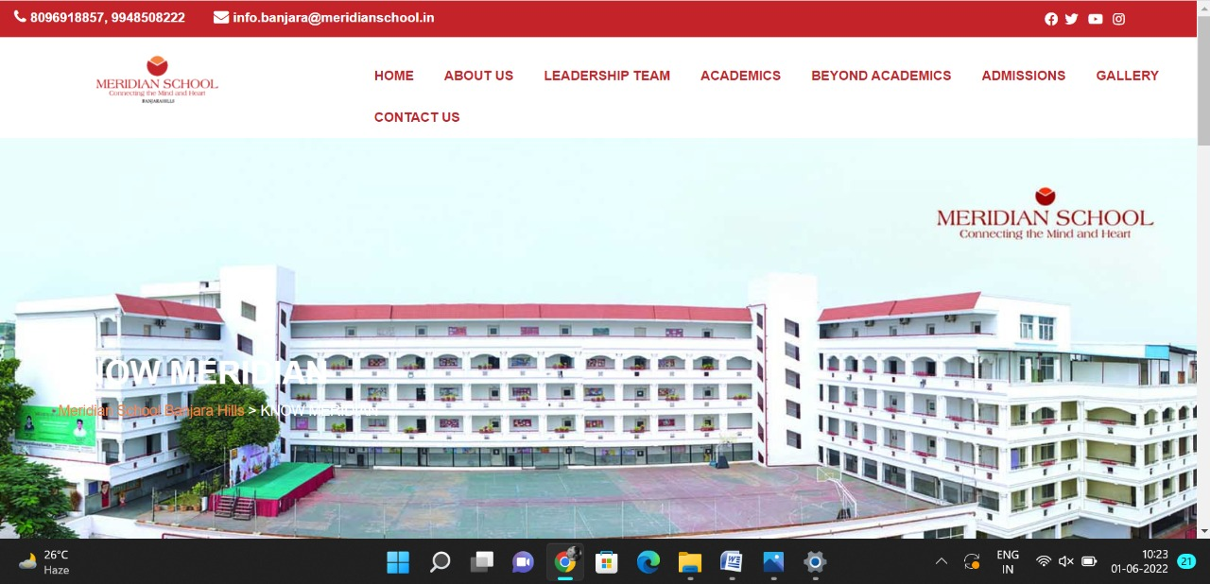

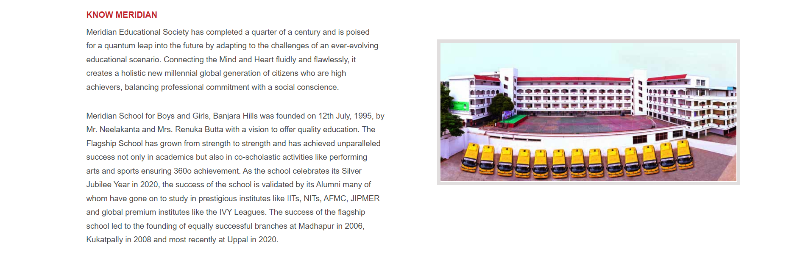

**PAGE 12:The Vision & Mission**

**HTML CODE:**

<!DOCTYPE html>

<html lang="en">

<head>

    <meta charset="UTF-8">

    <meta http-equiv="X-UA-Compatible" content="IE=edge">

    <meta name="viewport" content="width=device-width, initial-scale=1.0">

    <title>VISION & MISSION - Meridian School</title>

    <link rel="stylesheet" href="css/vision.css">

    <link rel="stylesheet" href="https://pro.fontawesome.com/releases/v5.10.0/css/all.css" />

    <link rel="icon" type="imag/logo2.png" href="img/logo2.png">

    <link rel="stylesheet" href="https://stackpath.bootstrapcdn.com/bootstrap/4.4.1/css/bootstrap.min.css"

        integrity="sha384-Vkoo8x4CGs03+Hhxv8T/Q5paXtkKtu6ug5TOeNV6gBiFeWPGFN9MuhOf23Q9Ifjh" crossorigin="anonymous" />

    <link rel="stylesheet" href="https://cdnjs.cloudflare.com/ajax/libs/slick-carousel/1.8.1/slick-theme.min.css"

        integrity="sha512-17EgCFERpgZKcm0j0fEq1YCJuyAWdz9KUtv1EjVuaOz8pDnh/0nZxmU6BBXwaaxqoi9PQXnRWqlcDB027hgv9A=="

        crossorigin="anonymous" referrerpolicy="no-referrer" />

    <link rel="stylesheet" href="https://cdnjs.cloudflare.com/ajax/libs/slick-carousel/1.8.1/slick.min.css"

        integrity="sha512-yHknP1/AwR+yx26cB1y0cjvQUMvEa2PFzt1c9LlS4pRQ5NOTZFWbhBig+X9G9eYW/8m0/4OXNx8pxJ6z57x0dw=="

        crossorigin="anonymous" referrerpolicy="no-referrer" />

</head>

<body>

    <section id="follow">

        <div class="followus">

            <div class="icon1">

                <i class="fa fa-phone"></i>

                <a id="phone" href="">8096918857, 9948508222</a>

            </div>

            <div class="icon1">

                <i class="fa fa-envelope"></i>

                <a id="mail" href="">info.banjara@meridianschool.in</a>

            </div>

            <div class="icon">

                <a href="https://www.facebook.com/MeridianSchoolBanjaraHills/" target="_blank"

                    class="fab fa-facebook-f"></i></a>

                <a href="https://twitter.com/meridianbanjara" target="_blank"><i class="fab fa-twitter"></i></a>

                <a href="https://www.youtube.com/channel/UCBZ_gLF9qM18O3CDWQHeN1A" target="_blank"><i

                        class="fab fa-youtube"></i></a>

                <a href="https://www.instagram.com/meridianschools/" target="_blank"><i

                        class="fab fa-instagram"></i></a>

            </div>

        </div>

    </section>

    <div class="navbar">

        <a href="home.html"><img src="img/logo.png" class="logo" alt=""></a>

        <nav>

            <a class="active" href="home.html">HOME</a>

            <div class="dropdown">

                <button class="dropbtn">ABOUT US

                </button>

                <div class="dropdown-content">

                    <a href="knowmeridian.html">KNOW MERIDIAN</a>

                    <a href="visionmission.html">THE VISION & MISSION</a>

                    <a href="http://meridianbanjara.com/the-founders/">THE FOUNDER'S MESSAGE</a>

                    <a href="ceomsg.html">CEO'S MESSAGE</a>

                    <a href="principalmsg.html">THE PRINCIPAL'S MESSAGE</a>

                    <a href="awards.html">AWARDS AND ACCOLADES</a>

                    <a href="http://meridianbanjara.com/affiliations-accreditations/">AFFILIATIONS & ACCREDITATIONS</a>

                    <a href="blog.html">BLOG</a>

                </div>

            </div>

            <div class="dropdown">

                <button class="dropbtn">LEADERSHIP TEAM

                </button>

                <div class="dropdown-content">

                    <a href="principal.html">PRINCIPAL</a>

                    <a href="vp.html">VICE PRINCIPAL</a>

                    <a href="headmistress.html">HEADMISTRESS</a>

                    <a href="midSchool.html">MIDDLE SCHOOL INCHARGE</a>

                    <a href="ipPyp.html">IB PYP COORDINATOR</a>

                    <a href="preprimary.html">PRE PRIMARY INCHARGE</a>

                    <a href="global.html">GLOBAL PARTNERSHIP COORDINATOR</a>

                </div>

            </div>

            <div class="dropdown">

                <button class="dropbtn">ACADEMICS

                </button>

                <div class="dropdown-content">

                    <a href="AcaOverview.html">OVERVIEW</a>

                    <a href="methodology.html">METHODOLOGY AND LEARNING STYLE</a>

                    <a href="curriculum.html">CURRICULUM</a>

                    <a href="faculty.html">FACULTY</a>

                    <a href="teacherTraining.html">TEACHER TRAINING</a>

                    <a href="careerGuidance.html">CAREER GUIDANCE</a>

                    <a href="scholrship.html">SCHOLARSHIP PROGRAMME</a>

                </div>

            </div>

            <div class="dropdown">

                <button class="dropbtn">BEYOND ACADEMICS

                </button>

                <div class="dropdown-content">

                    <a href="beyondAcaOverview.html">OVERVIEW</a>

                    <a href="sports.html">SPORTS</a>

                    <a href="creatveAct.html">CREATIVE ACTIVITIES</a>

                    <a href="eduTrips.html">EDUCATIONAL TRIPS AND STUDENT<br> EXCHANGE PROGRAMMES</a>

                    <a href="perfectSystem.html">PERFECT SYSTEM</a>

                    <a href="schoolSocialRes.html">SCHOOL'S SOCIAL RESPONSIBILITY</a>

                    <a href="interact.html">INTERACT</a>

                    <a href="heritageClub.html">HERITAGE CLUB</a>

                    <a href="mun.html">MUN</a>

                </div>

            </div>

            <div class="dropdown">

                <button class="dropbtn">ADMISSIONS

                </button>

                <div class="dropdown-content">

                    <a href="overview.html">OVERVIEW</a>

                    <a href="admissionpro.html">ADMISSION PROCEDURE</a>

                    <a href="feepolicy.html">FEE POLICY</a>

                    <a href="tranfercert.html">TRANSFER CERTIFICATE</a>

                    <a href="transport.html">TRANSPORT</a>

                </div>

            </div>

            <a class="active" href="gallery.html">GALLERY</a>

            <div class="dropdown">

                <button class="dropbtn">CONTACT US

                </button>

                <div class="dropdown-content">

                    <a href="contact.html">CAREERS</a>

                </div>

            </div>

        </nav>

    </div>

    <div id="mobile">

        <i id="bar" class="fas fa-outdent "></i>

    </div>

    <section id="vision">

        <img src="img/aboutus/3.jpg" width="100%" />

        <div class="visi">

            <h2>VISION & MISSION</h2>

            <span id="orange"><a href="home.html">Meridian School Banjara Hills</a></span>

            <span> &gt; VISION & MISSION</span>

        </div>

    </section>

    <section id="vm">

        <div class="vm1">

            <div id="info">

                <h4>VISION</h4>

                <p>To inspire and empower children to think independently, integrate, excel and contribute to the

                    progress of humanity.</p>

                <h4>MISSION</h4>

                <p>To synthesize old world values with a futuristic approach, creating a perfect alignment of the body,

                    mind and soul, producing thinkers and balanced achievers, who are sensitive to various social,

                    ethical and environmental issues.</p>

            </div>

        </div>

    </section>

    <footer>

        <div class="col">

            <h4>ABOUT US</h4>

            <p>Meridian is a New Generation Educational Group committed to educate children for life and thus bring a

                change in the society. Learning philosophy practised at Meridian infuses traditional values into a

                progressive approach, equipping students to adapt and excel anywhere in the world. Our alumni, working

                in diverse fields, have found Meridian to be the best school for a successful career take off.</p>

        </div>

        <div class="col">

            <h4>USEFUL LINKS</h4>

            <ul class="three-col-links">

                <li><a href="home.html">HOME</a></li>

                <li><a href="AcaOverview.html">ACADEMICS</a></li>

                <li><a href="overview.html">ADMISSIONS</a></li>

                <li><a href="contact.html">CONTACT US</a></li>

                <li><a href="knowmeridian.html">ABOUT US</a></li>

                <li><a href="beyondAcaOverview.html">BEYOND ACADEMICS</a></li>

                <li><a href="contact.html">CAREERS</a></li>

            </ul>

        </div>

        <div class="col">

            <!--<div class="follow">

                <div class="icon">

                    <i class="fa fa-paper-plane-o"></i>

                </div>

        </div>-->

            <h4>MERIDIAN SCHOOL, Banjara Hills</h4>

            <p># 8-2-541, Road No 7, Banjara Hills, Hyderabad-500034, TELANGANA, INDIA.</p><br>

            <p>For contact : +91 8096918857, 9948508222, <br>For Prinicipal Appointments : 8098420002</p><br>

            <p> For Admissions / Enquires : 8096918857, 9948508222</p><br>

            <p>info.banjara@meridianschool.inA</p>

        </div>

    </footer>

    <section id="copyright">

        <div id="cr">

            <p>© Copyright MERIDIAN SCHOOL, BANJARA HILLS 2020.</p>

        </div>

    </section>

    <script src="https://ajax.googleapis.com/ajax/libs/jquery/3.6.0/jquery.min.js"></script>

    <script src="https://cdnjs.cloudflare.com/ajax/libs/slick-carousel/1.8.1/slick.min.js"

        integrity="sha512-XtmMtDEcNz2j7ekrtHvOVR4iwwaD6o/FUJe6+Zq+HgcCsk3kj4uSQQR8weQ2QVj1o0Pk6PwYLohm206ZzNfubg=="

        crossorigin="anonymous" referrerpolicy="no-referrer"></script>

**CSS CODE:**

@import url('https://fonts.googleapis.com/css2?family=Lato:wght@300;400;700&display=swap');

* {

    margin: 0;

    padding: 0;

    box-sizing: border-box;

    font-family: 'Spartan', sans-serif;

}

a:hover {

    transition: 0.2 ease;

}

/* div, section{

    border: 2px solid black;

} */

h1 {

    font-size: 40px;

    line-height: 64px;

    color: #fff;

}

h2 {

    font-weight: 500;

    font-size: 56px;

    line-height: 54px;

    color: #fff;

    text-align: center;

}

h3 {

    text-align: center;

    font-size: 22px;

    color: #c42329;

}

h6 {

    font-weight: 700;

    font-size: 12px;

}

p {

    font-size: 15px;

    line-height: 26px;

    font-weight: 400;

    font-style: normal;

    color: #444;

}

span {

    font-size: 15px;

    line-height: 26px;

    font-weight: 400;

    font-style: normal;

    color: #444444;

    text-align: center;

}

.section-p1 {

    margin: 40px 80px;

}

.section-m1 {

    margin: 40px 0;

}

button.normal {

    font-size: 14px;

    font-weight: 600;

    padding: 15px 30px;

    color: #fff;

    background-color: #c42329;

    border-radius: 4px;

    cursor: pointer;

    border: none;

    outline: none;

    transition: 0.2s;

}

body {

    width: 100%;

}

#header {

    background-color: #fff;

    border-bottom: #c42329;

    display: flex;

    align-items: center;

    justify-content: space-between;

    padding: 16px 80px;

    box-shadow: 0 5px 15px rgba(0, 0, 0, 0.06);

    /* z-index: 999; */

    position: sticky;

    top: 0;

    left: 0;

}

#header a img {

    width: 135px;

    height: 61px;

}

#header a:hover {

    border: 1px dotted orange;

}

#mobile {

    display: none;

    align-items: center;

}

#close {

    display: none;

}

.navbar {

    overflow: hidden;

    background-color: #fff;

}

.navbar a {

    float: left;

    font-size: 14px;

    color: #c42329;

    text-align: left;

    padding: 14px 16px;

    text-decoration: none;

}

.active {

    font-weight: 650;

}

.dropdown {

    float: left;

    overflow: hidden;

}

.dropdown .dropbtn {

    font-size: 14px;

    border: none;

    outline: none;

    color: #c42329;

    padding: 14px 16px;

    background-color: inherit;

    font-family: inherit;

    margin: 0;

    font-weight: 650;

}

.navbar a:hover,

.dropdown:hover .dropbtn {

    color: orange;

}

.dropdown-content {

    display: none;

    position: absolute;

    background-color: #c42329;

    min-width: 160px;

    box-shadow: 0px 8px 16px 0px rgba(0, 0, 0, 0.2);

    z-index: 1;

}

.dropdown-content a {

    float: none;

    color: white;

    padding: 12px 16px;

    text-decoration: none;

    display: block;

    text-align: left;

}

.dropdown-content a:hover {

    background-color: #c42329;

}

.dropdown:hover .dropdown-content {

    display: block;

}

nav {

    margin-top: 1.5%;

    margin-left: 30%;

}

.logo {

    margin-left: 60%;

    width: 135px;

    height: 61px;

}

footer {

    width: 100%;

    background-color: #c42329;

    display: flex;

    flex-direction: row;

    justify-content: space-between;

    flex-wrap: wrap;

    padding: 90px 70px 50px 70px;

}

footer .col {

    display: flex;

    flex-direction: column;

    align-items: flex-start;

    margin-bottom: 20px;

    width: 30%;

    height: 100%;

}

footer h4 {

    font-size: 20px;

    color: #fff;

    padding-bottom: 20px;

}

footer p {

    font-size: 16px;

    color: #fff;

    padding-bottom: 0 0 8px 0;

    margin-bottom: 0;

}

footer a {

    font-size: 17px;

    margin-bottom: 10px;

    color: #fff;

    text-decoration: none;

}

/* Align Links in footer */

.three-col-links {

    width: 105%;

    -webkit-column-count: 2;

    -moz-column-count: 2;

    column-count: 2;

    padding-top: 4%;

}

.three-col-links li {

    width: 100%;

    float: left;

    display: inline;

    margin-top: 8%;

    text-transform: uppercase;

}

/* END -Align Links in footer */

footer .follow {

    margin-top: 20px;

}

footer .follow i {

    color: #fff;

    padding-right: 4px;

    cursor: pointer;

}

footer .follow i:hover,

footer a:hover {

    color: orange;

}

#cr {

    background-color: black;

}

#cr p {

    text-align: center;

    color: #fff;

    padding: 20px 0;

}

#follow .icon {

    justify-content: flex-end;

}

#follow .icon i {

    color: #fff;

}

#follow .followus {

    display: flex;

    background-color: #c42329;

}

#follow .followus a {

    color: #fff;

    text-decoration: none;

    font-size: 14px;

    font-weight: 550;

}

/*#follow .followus #phone {

    padding: 10px 10px 10px 55px;

}

#follow .followus #mail {

    padding: 10px 10px 10px 35px;

}*/

#follow .followus a:hover {

    text-decoration: underline;

}

#follow .icon {

    margin-left: 890px;

    padding: 10px 10px;

}

#follow .icon i {

    padding: 0 3px;

}

#vm .vm1 {

    display: flex;

    margin: 150px 70px 130px 70px;

}

#vm .vm1 #info {

    width: 90%;

}

#vm .vm1 #info h4 {

    margin: -25px 50px 35px 100px;

    color: #c42329;

}

#vm .vm1 #info p {

    margin: -25px 0px 35px 100px;

}

#vision {

    position: relative;

    text-align: center;

    color: white;

}

#vision .visi {

    height: 500px;

    background-repeat: no-repeat;

    padding: 230px 0 0 50px;

    /* background-position: 100%; */

    position: absolute;

    top: 50%;

    left: 50%;

    transform: translate(-160%, -50%);

}

#vision .visi h2 {

    font-size: 34px;

    font-weight: 600;

    text-align: start;

    /* color: #c42329; */

}

#vision .visi span {

    color: #fff;

}

#vision .visi span a {

    text-decoration: none;

}

#vision #orange a {

    color: #f48243;

}

#vision #orange a:hover {

    color: #fff;

}

.fa {

    display: inline-block;

    font: normal normal normal 14px/1 FontAwesome;

    font-size: inherit;

    text-rendering: auto;

    color: #fff;

}

.icon1 {

    padding: 8px 15px;

}

**OUTPUT:**

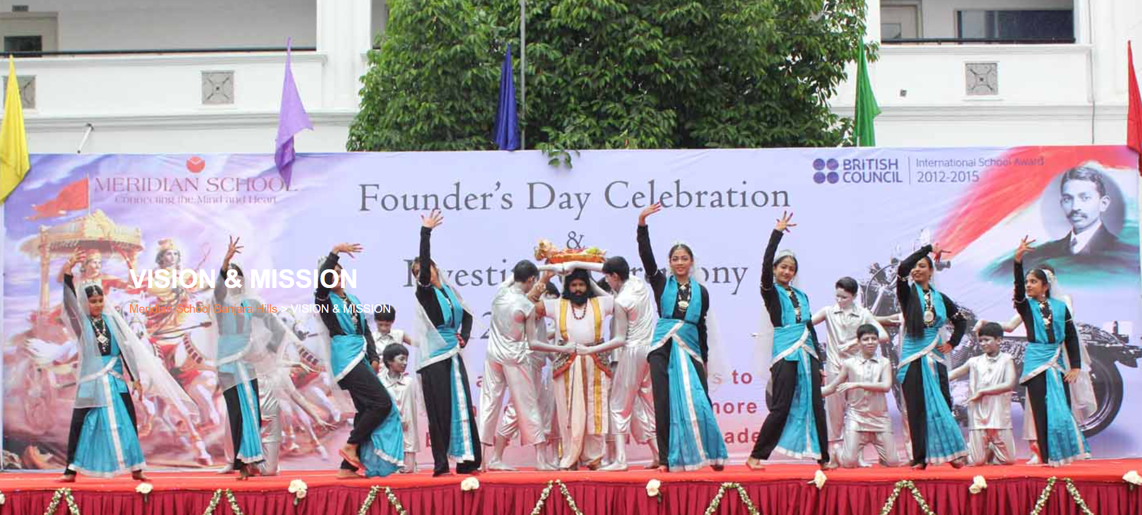

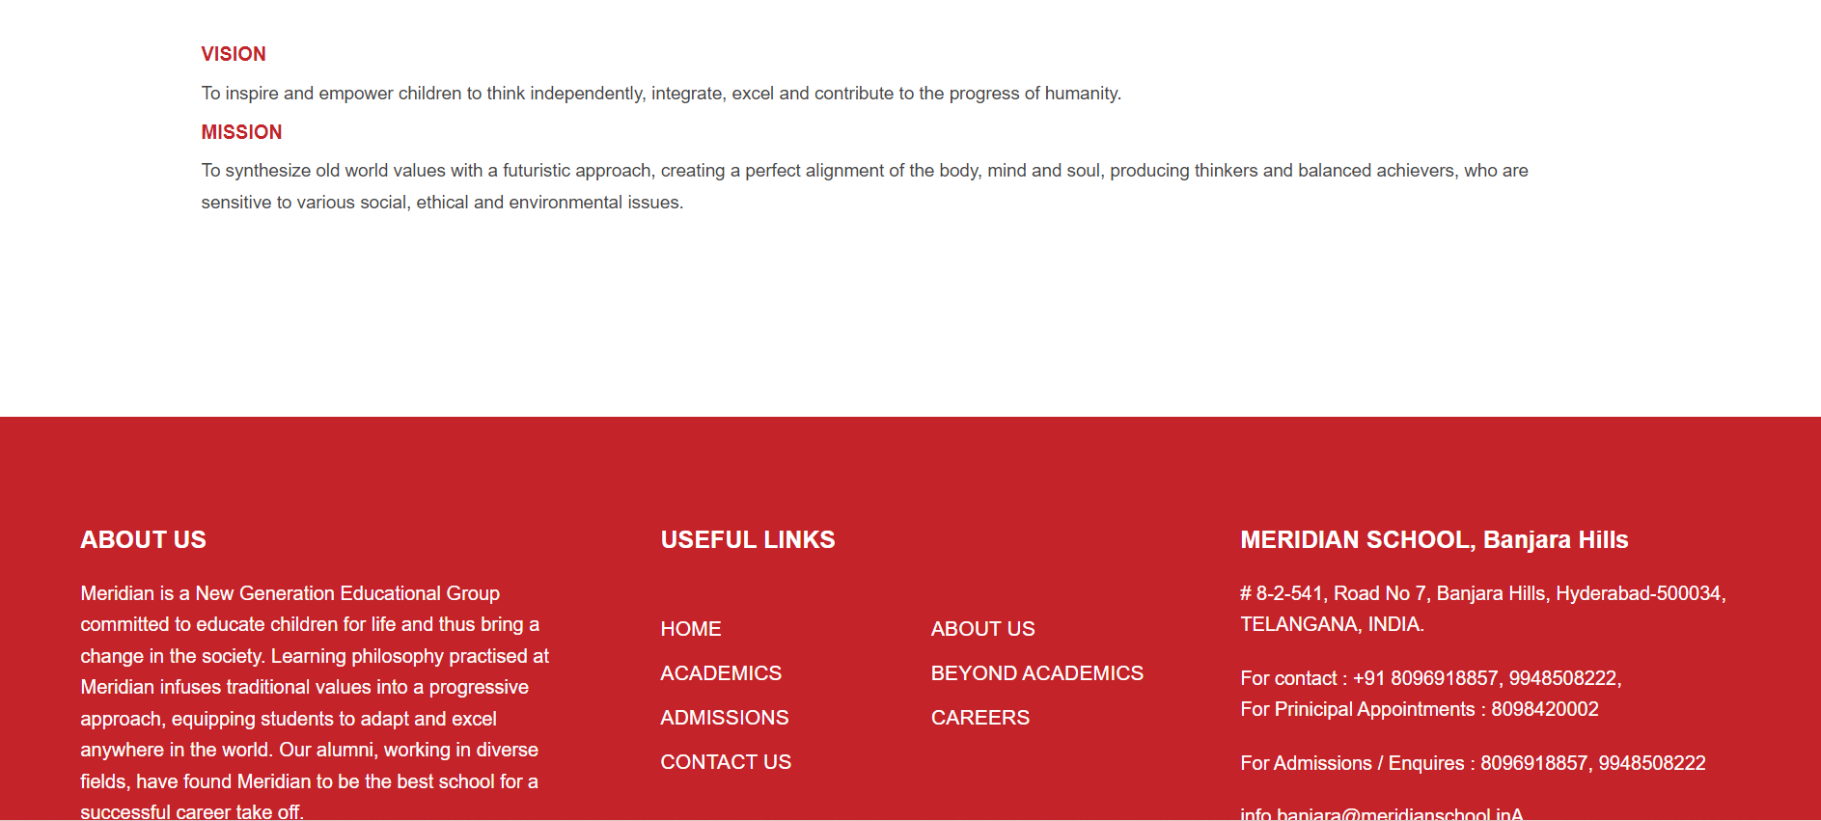

**PAGE 13:CEO’s Message**

**HTML CODE:**

<!DOCTYPE html>

<html lang="en">

<head>

    <meta charset="UTF-8">

    <meta http-equiv="X-UA-Compatible" content="IE=edge">

    <meta name="viewport" content="width=device-width, initial-scale=1.0">

    <title>CEO'S MESSAGE - Meridian School</title>

    <link rel="stylesheet" href="css/ceomsg.css">

    <link rel="stylesheet" href="https://pro.fontawesome.com/releases/v5.10.0/css/all.css" />

    <link rel="icon" type="imag/logo2.png" href="img/logo2.png">

    <link rel="stylesheet" href="https://stackpath.bootstrapcdn.com/bootstrap/4.4.1/css/bootstrap.min.css"

        integrity="sha384-Vkoo8x4CGs03+Hhxv8T/Q5paXtkKtu6ug5TOeNV6gBiFeWPGFN9MuhOf23Q9Ifjh" crossorigin="anonymous" />

    <link rel="stylesheet" href="https://cdnjs.cloudflare.com/ajax/libs/slick-carousel/1.8.1/slick-theme.min.css"

        integrity="sha512-17EgCFERpgZKcm0j0fEq1YCJuyAWdz9KUtv1EjVuaOz8pDnh/0nZxmU6BBXwaaxqoi9PQXnRWqlcDB027hgv9A=="

        crossorigin="anonymous" referrerpolicy="no-referrer" />

    <link rel="stylesheet" href="https://cdnjs.cloudflare.com/ajax/libs/slick-carousel/1.8.1/slick.min.css"

        integrity="sha512-yHknP1/AwR+yx26cB1y0cjvQUMvEa2PFzt1c9LlS4pRQ5NOTZFWbhBig+X9G9eYW/8m0/4OXNx8pxJ6z57x0dw=="

        crossorigin="anonymous" referrerpolicy="no-referrer" />

</head>

<body>

    <section id="follow">

        <div class="followus">

            <div class="icon1">

                <i class="fa fa-phone"></i>

                <a id="phone" href="">8096918857, 9948508222</a>

            </div>

            <div class="icon1">

                <i class="fa fa-envelope"></i>

                <a id="mail" href="">info.banjara@meridianschool.in</a>

            </div>

            <div class="icon">

                <a href="https://www.facebook.com/MeridianSchoolBanjaraHills/" target="_blank"

                    class="fab fa-facebook-f"></i></a>

                <a href="https://twitter.com/meridianbanjara" target="_blank"><i class="fab fa-twitter"></i></a>

                <a href="https://www.youtube.com/channel/UCBZ_gLF9qM18O3CDWQHeN1A" target="_blank"><i

                        class="fab fa-youtube"></i></a>

                <a href="https://www.instagram.com/meridianschools/" target="_blank"><i

                        class="fab fa-instagram"></i></a>

            </div>

        </div>

    </section>

    <div class="navbar">

        <a href="home.html"><img src="img/logo.png" class="logo" alt=""></a>

        <nav>

            <a class="active" href="home.html">HOME</a>

            <div class="dropdown">

                <button class="dropbtn">ABOUT US

                </button>

                <div class="dropdown-content">

                    <a href="knowmeridian.html">KNOW MERIDIAN</a>

                    <a href="visionmission.html">THE VISION & MISSION</a>

                    <a href="http://meridianbanjara.com/the-founders/">THE FOUNDER'S MESSAGE</a>

                    <a href="ceomsg.html">CEO'S MESSAGE</a>

                    <a href="principalmsg.html">THE PRINCIPAL'S MESSAGE</a>

                    <a href="awards.html">AWARDS AND ACCOLADES</a>

                    <a href="http://meridianbanjara.com/affiliations-accreditations/">AFFILIATIONS & ACCREDITATIONS</a>

                    <a href="blog.html">BLOG</a>

                </div>

            </div>

            <div class="dropdown">

                <button class="dropbtn">LEADERSHIP TEAM

                </button>

                <div class="dropdown-content">

                    <a href="principal.html">PRINCIPAL</a>

                    <a href="vp.html">VICE PRINCIPAL</a>

                    <a href="headmistress.html">HEADMISTRESS</a>

                    <a href="midSchool.html">MIDDLE SCHOOL INCHARGE</a>

                    <a href="ipPyp.html">IB PYP COORDINATOR</a>

                    <a href="preprimary.html">PRE PRIMARY INCHARGE</a>

                    <a href="global.html">GLOBAL PARTNERSHIP COORDINATOR</a>

                </div>

            </div>

            <div class="dropdown">

                <button class="dropbtn">ACADEMICS

                </button>

                <div class="dropdown-content">

                    <a href="AcaOverview.html">OVERVIEW</a>

                    <a href="methodology.html">METHODOLOGY AND LEARNING STYLE</a>

                    <a href="curriculum.html">CURRICULUM</a>

                    <a href="faculty.html">FACULTY</a>

                    <a href="teacherTraining.html">TEACHER TRAINING</a>

                    <a href="careerGuidance.html">CAREER GUIDANCE</a>

                    <a href="scholrship.html">SCHOLARSHIP PROGRAMME</a>

                </div>

            </div>

            <div class="dropdown">

                <button class="dropbtn">BEYOND ACADEMICS

                </button>

                <div class="dropdown-content">

                    <a href="beyondAcaOverview.html">OVERVIEW</a>

                    <a href="sports.html">SPORTS</a>

                    <a href="creatveAct.html">CREATIVE ACTIVITIES</a>

                    <a href="eduTrips.html">EDUCATIONAL TRIPS AND STUDENT<br> EXCHANGE PROGRAMMES</a>

                    <a href="perfectSystem.html">PERFECT SYSTEM</a>

                    <a href="schoolSocialRes.html">SCHOOL'S SOCIAL RESPONSIBILITY</a>

                    <a href="interact.html">INTERACT</a>

                    <a href="heritageClub.html">HERITAGE CLUB</a>

                    <a href="mun.html">MUN</a>

                </div>

            </div>

            <div class="dropdown">

                <button class="dropbtn">ADMISSIONS

                </button>

                <div class="dropdown-content">

                    <a href="overview.html">OVERVIEW</a>

                    <a href="admissionpro.html">ADMISSION PROCEDURE</a>

                    <a href="feepolicy.html">FEE POLICY</a>

                    <a href="tranfercert.html">TRANSFER CERTIFICATE</a>

                    <a href="transport.html">TRANSPORT</a>

                </div>

            </div>

            <a class="active" href="gallery.html">GALLERY</a>

            <div class="dropdown">

                <button class="dropbtn">CONTACT US

                </button>

                <div class="dropdown-content">

                    <a href="contact.html">CAREERS</a>

                </div>

            </div>

        </nav>

    </div>

    <div id="mobile">

        <i id="bar" class="fas fa-outdent "></i>

    </div>

    <section id="ceomsg">

        <img src="img/aboutus/7.jpg" width="100%" />

        <div class="ceo">

            <h2>CEO'S MESSAGE</h2>

            <span id="orange"><a href="home.html">Meridian School Banjara Hills</a></span>

            <span> &gt; CEO'S MESSAGE</span>

        </div>

    </section>

    <section id="ce">

        <div class="ce1">

            <div>

                <div id="data">

                    <h4>CEO'S MESSAGE</h4>

                </div>

                <img style="float: left;" src="img/aboutus/8.jpg" width="100%" />

            </div>

            <div id="info">

                <h4>Nurtured under the Tutelage!</h4>

                <p>

                    A collective of thinkers and visionaries with the singular passion of providing quality education

                    for

                    future generations from across the country are all gathered under the umbrella of Butta Education

                    that

                    is set to promote learning of International standards in India. The leadership cadre of Meridian

                    Schools

                    is given utmost freedom to run the schools as deemed fit to be acclaimed and accepted as globally

                    ranked

                    premium institutions.

                </p>

                <br>

                <p>Transformation of the world begins with the evolution of its most dynamic citizens, the youth.

                    Meridian is committed to shaping the future of the world by grooming future citizens. We aim at

                    providing not just quality education but to spot latent talent in diverse areas and nurture it. Our

                    endeavour has been to familiarise, understand and assimilate the nuances of global education and

                    tune it to suit the needs of our learners. In this attempt we have been extremely successful.</p>

                <p id="name"><b>Dr. D. Usha Reddy</b><br>CEO, Meridian Schools</p>

            </div>

        </div>

    </section>

    <footer>

        <div class="col">

            <h4>ABOUT US</h4>

            <p>Meridian is a New Generation Educational Group committed to educate children for life and thus bring a

                change in the society. Learning philosophy practised at Meridian infuses traditional values into a

                progressive approach, equipping students to adapt and excel anywhere in the world. Our alumni, working

                in diverse fields, have found Meridian to be the best school for a successful career take off.</p>

        </div>

        <div class="col">

            <h4>USEFUL LINKS</h4>

            <ul class="three-col-links">

                <li><a href="home.html">HOME</a></li>

                <li><a href="AcaOverview.html">ACADEMICS</a></li>

                <li><a href="overview.html">ADMISSIONS</a></li>

                <li><a href="contact.html">CONTACT US</a></li>

                <li><a href="knowmeridian.html">ABOUT US</a></li>

                <li><a href="beyondAcaOverview.html">BEYOND ACADEMICS</a></li>

                <li><a href="contact.html">CAREERS</a></li>

            </ul>

        </div>

        <div class="col">

            <h4>MERIDIAN SCHOOL, Banjara Hills</h4>

            <p># 8-2-541, Road No 7, Banjara Hills, Hyderabad-500034, TELANGANA, INDIA.</p><br>

            <p>For contact : +91 8096918857, 9948508222, <br>For Prinicipal Appointments : 8098420002</p><br>

            <p> For Admissions / Enquires : 8096918857, 9948508222</p><br>

            <p>info.banjara@meridianschool.inA</p>

        </div>

    </footer>

    <section id="copyright">

        <div id="cr">

            <p>© Copyright MERIDIAN SCHOOL, BANJARA HILLS 2020.</p>

        </div>

    </section>

    <script src="https://ajax.googleapis.com/ajax/libs/jquery/3.6.0/jquery.min.js"></script>

    <script src="https://cdnjs.cloudflare.com/ajax/libs/slick-carousel/1.8.1/slick.min.js"

        integrity="sha512-XtmMtDEcNz2j7ekrtHvOVR4iwwaD6o/FUJe6+Zq+HgcCsk3kj4uSQQR8weQ2QVj1o0Pk6PwYLohm206ZzNfubg=="

        crossorigin="anonymous" referrerpolicy="no-referrer"></script>

**CSS CODE:**

@import url('https://fonts.googleapis.com/css2?family=Lato:wght@300;400;700&display=swap');

* {

    margin: 0;

    padding: 0;

    box-sizing: border-box;

    font-family: 'Spartan', sans-serif;

}

a:hover {

    transition: 0.2 ease;

}

/* div, section{

    border: 2px solid black;

} */

h1 {

    font-size: 40px;

    line-height: 64px;

    color: #fff;

}

h2 {

    font-weight: 500;

    font-size: 56px;

    line-height: 54px;

    color: #fff;

    text-align: center;

}

h3 {

    text-align: center;

    font-size: 22px;

    color: #c42329;

}

h6 {

    font-weight: 700;

    font-size: 12px;

}

p {

    font-size: 15px;

    line-height: 26px;

    font-weight: 400;

    font-style: normal;

    color: #444;

}

span {

    font-size: 15px;

    line-height: 26px;

    font-weight: 400;

    font-style: normal;

    color: #444444;

    text-align: center;

}

.section-p1 {

    margin: 40px 80px;

}

.section-m1 {

    margin: 40px 0;

}

button.normal {

    font-size: 14px;

    font-weight: 600;

    padding: 15px 30px;

    color: #fff;

    background-color: #c42329;

    border-radius: 4px;

    cursor: pointer;

    border: none;

    outline: none;

    transition: 0.2s;

}

body {

    width: 100%;

}

#header {

    background-color: #fff;

    border-bottom: #c42329;

    display: flex;

    align-items: center;

    justify-content: space-between;

    padding: 16px 80px;

    box-shadow: 0 5px 15px rgba(0, 0, 0, 0.06);

    /* z-index: 999; */

    position: sticky;

    top: 0;

    left: 0;

}

#header a img {

    width: 135px;

    height: 61px;

}

#header a:hover {

    border: 1px dotted orange;

}

#mobile {

    display: none;

    align-items: center;

}

#close {

    display: none;

}

/*#navbar {

    display: flex;

    align-items: center;

    justify-content: center;

}

#navbar li {

    list-style: none;

    padding: 0 8px;

    position: relative;

}

#navbar li a {

    text-decoration: none;

    font-size: 13px;

    font-weight: 600;

    color: #c42329;

    transition: 0.3 ease;

}

#navbar li a.active::after,

#navbar li a:hover::after {

    content: "";

    width: 30%;

    height: 2px;

    position: absolute;

    bottom: -4px;

    left: 20px;

}

#navbar .headButton {

    border-left: 20px;

}

#navbar .headButton:hover {

    border: #c42329;

    background-color: #fff;

    color: black;

}*/

.navbar {

    overflow: hidden;

    background-color: #fff;

}

.navbar a {

    float: left;

    font-size: 14px;

    color: #c42329;

    text-align: left;

    padding: 14px 16px;

    text-decoration: none;

}

.active {

    font-weight: 650;

}

.dropdown {

    float: left;

    overflow: hidden;

}

.dropdown .dropbtn {

    font-size: 14px;

    border: none;

    outline: none;

    color: #c42329;

    padding: 14px 16px;

    background-color: inherit;

    font-family: inherit;

    margin: 0;

    font-weight: 650;

}

.navbar a:hover,

.dropdown:hover .dropbtn {

    color: orange;

}

.dropdown-content {

    display: none;

    position: absolute;

    background-color: #c42329;

    min-width: 160px;

    box-shadow: 0px 8px 16px 0px rgba(0, 0, 0, 0.2);

    z-index: 1;

}

.dropdown-content a {

    float: none;

    color: white;

    padding: 12px 16px;

    text-decoration: none;

    display: block;

    text-align: left;

}

.dropdown-content a:hover {

    background-color: #c42329;

}

.dropdown:hover .dropdown-content {

    display: block;

}

nav {

    margin-top: 1.5%;

    margin-left: 30%;

}

.logo {

    margin-left: 60%;

    width: 135px;

    height: 61px;

}

footer {

    width: 100%;

    background-color: #c42329;

    display: flex;

    flex-direction: row;

    justify-content: space-between;

    flex-wrap: wrap;

    padding: 90px 70px 50px 70px;

}

footer .col {

    display: flex;

    flex-direction: column;

    align-items: flex-start;

    margin-bottom: 20px;

    width: 30%;

    height: 100%;

}

footer h4 {

    font-size: 20px;

    color: #fff;

    padding-bottom: 20px;

}

footer p {

    font-size: 16px;

    color: #fff;

    padding-bottom: 0 0 8px 0;

    margin-bottom: 0;

}

footer a {

    font-size: 17px;

    margin-bottom: 10px;

    color: #fff;

    text-decoration: none;

}

/* Align Links in footer */

.three-col-links {

    width: 105%;

    -webkit-column-count: 2;

    -moz-column-count: 2;

    column-count: 2;

    padding-top: 4%;

}

.three-col-links li {

    width: 100%;

    float: left;

    display: inline;

    margin-top: 8%;

    text-transform: uppercase;

}

/* END -Align Links in footer */

footer .follow {

    margin-top: 20px;

}

footer .follow i {

    color: #fff;

    padding-right: 4px;

    cursor: pointer;

}

footer .follow i:hover,

footer a:hover {

    color: orange;

}

#cr {

    background-color: black;

}

#cr p {

    text-align: center;

    color: #fff;

    padding: 20px 0;

}

#follow .icon {

    justify-content: flex-end;

}

#follow .icon i {

    color: #fff;

}

#follow .followus {

    display: flex;

    background-color: #c42329;

}

#follow .followus a {

    color: #fff;

    text-decoration: none;

    font-size: 14px;

    font-weight: 550;

}

/*#follow .followus #phone {

    padding: 10px 10px 10px 55px;

}

#follow .followus #mail {

    padding: 10px 10px 10px 35px;

}*/

#follow .followus a:hover {

    text-decoration: underline;

}

#follow .icon {

    margin-left: 890px;

    padding: 10px 10px;

}

#follow .icon i {

    padding: 0 3px;

}

#ce .ce1 {

    display: flex;

    margin: 130px 80px 130px 80px;

}

#ce .ce1 #info {

    width: 90%;

}

#ce .ce1 #info h4 {

    margin: -10px 50px 35px 50px;

    color: #c42329;

}

#ce .ce1 #data h4 {

    position: relative;

    margin: -50px 20px 35px 40px;

    color: #c42329;

    text-align: left;

}

#ce .ce1 img {

    width: 272px;

    margin-left: 40px;

    height: 272px;

    border: 7px solid rgb(225, 222, 222);

}

#ce .ce1 #info p {

    margin: -20px 50px 35px 50px;

    font-size: 15px;

}

#ce .ce1 #info #name {

    margin: -8px 0px 35px 825px;

    text-align: right;

}

#ceomsg {

    position: relative;

    text-align: center;

    color: white;

}

#ceomsg .ceo {

    height: 500px;

    background-repeat: no-repeat;

    padding: 230px 0 0 50px;

    /* background-position: 100%; */

    position: absolute;

    top: 50%;

    left: 50%;

    transform: translate(-160%, -50%);

}

#ceomsg .ceo h2 {

    font-size: 34px;

    font-weight: 600;

    text-align: start;

    /* color: #c42329; */

}

#ceomsg .ceo span {

    color: #fff;

}

#ceomsg .ceo span a {

    text-decoration: none;

}

#ceomsg #orange a {

    color: #f48243;

}

#ceomsg #orange a:hover {

    color: #fff;

}

.fa {

    display: inline-block;

    font: normal normal normal 14px/1 FontAwesome;

    font-size: inherit;

    text-rendering: auto;

    color: #fff;

}

.icon1 {

    padding: 8px 15px;

}

**OUTPUT:**

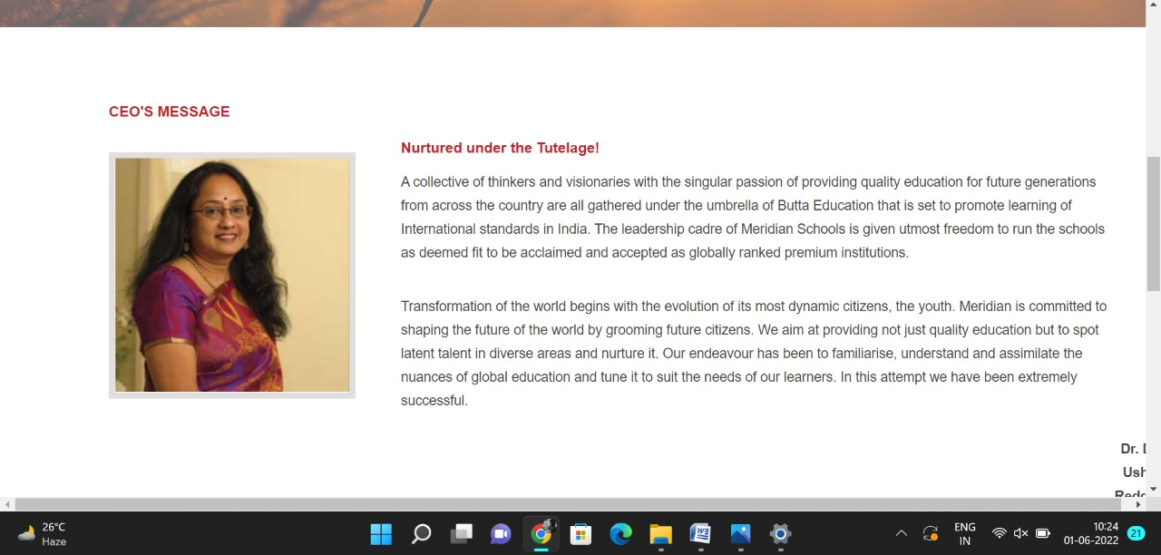

**PAGE 14:Blog**

**HTML CODE:**

<!DOCTYPE html>

<html lang="en">

<head>

    <meta charset="UTF-8">

    <meta http-equiv="X-UA-Compatible" content="IE=edge">

    <meta name="viewport" content="width=device-width, initial-scale=1.0">

    <title>Blog - Meridian School</title>

    <link rel="stylesheet" href="css/blog.css">

    <link rel="stylesheet" href="https://pro.fontawesome.com/releases/v5.10.0/css/all.css" />

    <link rel="icon" type="imag/logo2.png" href="img/logo2.png">

    <link rel="stylesheet" href="https://stackpath.bootstrapcdn.com/bootstrap/4.4.1/css/bootstrap.min.css"

        integrity="sha384-Vkoo8x4CGs03+Hhxv8T/Q5paXtkKtu6ug5TOeNV6gBiFeWPGFN9MuhOf23Q9Ifjh" crossorigin="anonymous" />

    <link rel="stylesheet" href="https://cdnjs.cloudflare.com/ajax/libs/slick-carousel/1.8.1/slick-theme.min.css"

        integrity="sha512-17EgCFERpgZKcm0j0fEq1YCJuyAWdz9KUtv1EjVuaOz8pDnh/0nZxmU6BBXwaaxqoi9PQXnRWqlcDB027hgv9A=="

        crossorigin="anonymous" referrerpolicy="no-referrer" />

    <link rel="stylesheet" href="https://cdnjs.cloudflare.com/ajax/libs/slick-carousel/1.8.1/slick.min.css"

        integrity="sha512-yHknP1/AwR+yx26cB1y0cjvQUMvEa2PFzt1c9LlS4pRQ5NOTZFWbhBig+X9G9eYW/8m0/4OXNx8pxJ6z57x0dw=="

        crossorigin="anonymous" referrerpolicy="no-referrer" />

</head>

<body>

    <section id="follow">

        <div class="followus">

            <div class="icon1">

                <i class="fa fa-phone"></i>

                <a id="phone" href="">8096918857, 9948508222</a>

            </div>

            <div class="icon1">

                <i class="fa fa-envelope"></i>

                <a id="mail" href="">info.banjara@meridianschool.in</a>

            </div>

            <div class="icon">

                <a href="https://www.facebook.com/MeridianSchoolBanjaraHills/" target="_blank"

                    class="fab fa-facebook-f"></i></a>

                <a href="https://twitter.com/meridianbanjara" target="_blank"><i class="fab fa-twitter"></i></a>

                <a href="https://www.youtube.com/channel/UCBZ_gLF9qM18O3CDWQHeN1A" target="_blank"><i

                        class="fab fa-youtube"></i></a>

                <a href="https://www.instagram.com/meridianschools/" target="_blank"><i

                        class="fab fa-instagram"></i></a>

            </div>

        </div>

    </section>

    <div class="navbar">

        <a href="home.html"><img src="img/logo.png" class="logo" alt=""></a>

        <nav>

            <a class="active" href="home.html">HOME</a>

            <div class="dropdown">

                <button class="dropbtn">ABOUT US

                </button>

                <div class="dropdown-content">

                    <a href="knowmeridian.html">KNOW MERIDIAN</a>

                    <a href="visionmission.html">THE VISION & MISSION</a>

                    <a href="http://meridianbanjara.com/the-founders/">THE FOUNDER'S MESSAGE</a>

                    <a href="ceomsg.html">CEO'S MESSAGE</a>

                    <a href="principalmsg.html">THE PRINCIPAL'S MESSAGE</a>

                    <a href="awards.html">AWARDS AND ACCOLADES</a>

                    <a href="http://meridianbanjara.com/affiliations-accreditations/">AFFILIATIONS & ACCREDITATIONS</a>

                    <a href="blog.html">BLOG</a>

                </div>

            </div>

            <div class="dropdown">

                <button class="dropbtn">LEADERSHIP TEAM

                </button>

                <div class="dropdown-content">

                    <a href="principal.html">PRINCIPAL</a>

                    <a href="vp.html">VICE PRINCIPAL</a>

                    <a href="headmistress.html">HEADMISTRESS</a>

                    <a href="midSchool.html">MIDDLE SCHOOL INCHARGE</a>

                    <a href="ipPyp.html">IB PYP COORDINATOR</a>

                    <a href="preprimary.html">PRE PRIMARY INCHARGE</a>

                    <a href="global.html">GLOBAL PARTNERSHIP COORDINATOR</a>

                </div>

            </div>

            <div class="dropdown">

                <button class="dropbtn">ACADEMICS

                </button>

                <div class="dropdown-content">

                    <a href="AcaOverview.html">OVERVIEW</a>

                    <a href="methodology.html">METHODOLOGY AND LEARNING STYLE</a>

                    <a href="curriculum.html">CURRICULUM</a>

                    <a href="faculty.html">FACULTY</a>

                    <a href="teacherTraining.html">TEACHER TRAINING</a>

                    <a href="careerGuidance.html">CAREER GUIDANCE</a>

                    <a href="scholrship.html">SCHOLARSHIP PROGRAMME</a>

                </div>

            </div>

            <div class="dropdown">

                <button class="dropbtn">BEYOND ACADEMICS

                </button>

                <div class="dropdown-content">

                    <a href="beyondAcaOverview.html">OVERVIEW</a>

                    <a href="sports.html">SPORTS</a>

                    <a href="creatveAct.html">CREATIVE ACTIVITIES</a>

                    <a href="eduTrips.html">EDUCATIONAL TRIPS AND STUDENT<br> EXCHANGE PROGRAMMES</a>

                    <a href="perfectSystem.html">PERFECT SYSTEM</a>

                    <a href="schoolSocialRes.html">SCHOOL'S SOCIAL RESPONSIBILITY</a>

                    <a href="interact.html">INTERACT</a>

                    <a href="heritageClub.html">HERITAGE CLUB</a>

                    <a href="mun.html">MUN</a>

                </div>

            </div>

            <div class="dropdown">

                <button class="dropbtn">ADMISSIONS

                </button>

                <div class="dropdown-content">

                    <a href="overview.html">OVERVIEW</a>

                    <a href="admissionpro.html">ADMISSION PROCEDURE</a>

                    <a href="feepolicy.html">FEE POLICY</a>

                    <a href="tranfercert.html">TRANSFER CERTIFICATE</a>

                    <a href="transport.html">TRANSPORT</a>

                </div>

            </div>

            <a class="active" href="gallery.html">GALLERY</a>

            <div class="dropdown">

                <button class="dropbtn">CONTACT US

                </button>

                <div class="dropdown-content">

                    <a href="contact.html">CAREERS</a>

                </div>

            </div>

        </nav>

    </div>

    <div id="mobile">

        <i id="bar" class="fas fa-outdent "></i>

    </div>

    <section id="blogs">

        <img src="img/aboutus/a1.jpg" width="100%" />

        <div class="blo">

            <h2>Blog</h2>

            <span id="orange"><a href="home.html">Meridian School Banjara Hills</a></span>

            <span> &gt; Blog</span>

        </div>

    </section>

    <section id="bl">

        <div class="bl1">

            <div id="info">

                <h4>VIRTUAL LEARNING DURING PANDEMIC<br><br>(महामारी के दौरान आभासी ज्ञान-अर्जन)</h4>

                <p>शिक्षा अपने मूल में सामाजीकरण की एक प्रक्रिया है। जब-जब समाज का स्वरूप बदला, शिक्षा के स्वरूप में भी

                    परिवर्तन की बात हुई। आज कोरोना संकट के दौर में ऑनलाइन शिक्षण के ज़रिये शिक्षा के स्वरूप में बदलाव

                    आया है। पूरा विश्व कोविड-19 नामक एक अदृश्य विषाणु के प्रकोप से पीडित है। कोई भी ऐसा क्षेत्र नहीं बचा

                    जो कोरोना महामारी से प्रभावित न हुआ हो। इस बीच संसार की सारी प्रगति, सारे विकास मानों रुक से गए थे।

                </p>

                <br>

                <p>24 मार्च को कोविड-19 रोकथाम के लिए जब देश भर में लॉकडाउन लागू किया गया तो उसके तुरंत बाद राज्यों की

                    सरकारों ने स्कूली शिक्षा को ऑनलाइन करने का प्रावधान शुरू कर दिया। आमने-सामने की पढ़ाई से अचानक

                    ऑनलाइन माध्यम में स्थानांतरित होने से शिक्षा प्रदान करने का स्वरूप बिल्कुल बदल गया। कल तक बैग व

                    बस्ते के साथ विद्यालय जाने वाले बच्चे अब घर पर ही पूरी तन्मयता से पढ़ाई कर रहें हैं। कोरोना महामारी

                    के समय ऑनलाइन शिक्षा एक ऐसी चुनौती के तौर पर सामने आया, जिसके लिए देश के अधिकांश शिक्षक पहले तैयार

                    नहीं थे। कई ऐसे भी थे, जिनका जूम, गूगल मीट, एम. एस. टीम्स जैसे सॉफ्टवेयर से दूर-दूर तक नाता नहीं था।

                    विद्यार्थियों के भविष्य के लिए शिक्षकों ने इस चुनौती को भी स्वीकार किया और नई तकनीक से जुड़ने के लिए

                    कड़ी मेहनत की। नतीजा यह रहा कि जो शिक्षक कंप्यूटर व लैपटॉप चलाने से डरते थे, आज वह इतने प्रशिक्षित

                    हो गए हैं कि ऑनलाइन माध्यम से विद्यार्थियों को पढ़ा रहे हैं। आज स्कूल के सभी शिक्षक ऑनलाइन शिक्षण

                    में उत्तम प्रदर्शन कर रहे हैं। शिक्षकों द्वारा अप्रैल से बच्चों को ऑनलाइन कक्षा से जोड़ने व उनके

                    शिक्षण को नियमित रखने के लिए हमारे स्कूल प्रबंधन, प्रधानाचार्या एवं अन्य प्रभारियों का बहुत बड़ा

                    योगदान रहा है। हमारे स्कूल के आईटी विभाग ने शिक्षकों और विद्यार्थियों को प्रशिक्षित किया। शिक्षकों

                    ने पहले खुद सीखा और फिर ऑनलाइन शिक्षा से विद्यार्थियों को जोड़ा। हालाँकि, तकनीक को समझना और हर दिन

                    उनका उपयोग करना शुरूआत में थोड़ा मुश्किल ज़रूर लगा लेकिन चीजें धीरे-धीरे मन-मस्तिष्क में बस गईं और

                    शिक्षक नए तरीके के लिए अभ्यस्त हो गए। समय-समय पर वेबिनार, विभिन्न कार्यक्रम एवं प्रतियोगिताएँ भी

                    आयोजित की जा रही हैं। हमें यह पता ही न था कि इतनी जल्दी हम सौ प्रतिशत वर्चुअल लर्निंग में बदल जाएँगे

                    और पूरा स्कूल एक वर्चुअल स्कूल बन जाएगा। आज विद्यार्थियों को समय पर वर्कशीट, पी.पी.टी व नोट्स

                    पहुँचाना, वर्कशीट के साथ अपना ऑडियो-वीडियो भेजना व ऑनलाइन कक्षा में वर्कशीट को समझाने आदि सभी

                    कार्यों में शिक्षक बेहतर प्रदर्शन कर रहे हैं। ब्लैकबोर्ड ने व्हाइटबोर्ड, जामबोर्ड और प्रोजेक्टर,

                    नोटबुक को टैबलेट के लिए रास्ता दिया। हालाँकि, कोविड -19 महामारी ने पूरी कक्षाओं को ऑनलाइन शिफ्ट करके

                    सीखने में एक बदलाव लाया। आज घर बैठे ही विद्यार्थी आभासी परीक्षाएँ भी दे रहे हैं। साथ ही शिक्षकों

                    द्वारा परीक्षा-पत्रों की जाँच भी ऑनलाईन ही हो रही है जो बहुत सराहनीय है। इस तरह पारंपरिक कक्षाओं को

                    नवीनतम तकनीकों के माध्यम से एक आभासी कक्षा में बदल दिया गया है और पारंपरिक शिक्षक एक आभासी शिक्षक बन

                    गए हैं।<br><br></p>

                <p>

                    ऑनलाइन शिक्षण का एक और सकारात्मक प्रभाव यह रहा कि छात्र एवं शिक्षक अधिक तकनीक-प्रेमी बन गए हैं।

                    उन्हें विभिन्न एप्लिकेशन और कार्यक्रमों के बारे में अधिक जानकारी मिल रही है। कोरोना<br></p>

                <p> महामारी ने वर्चुअल स्पेस में शिक्षा, शिक्षण और शिक्षण संस्थाओं को नए ढ़ंग के अभ्यास करने को प्रेरित

                    किया और बदलने को बाध्य भी किया है। परिणामतः ऑनलाइन शिक्षण ने क्लासरूम टीचिंग के अर्थ, अवधारणा और

                    आह्वान के उददेश्यों व लक्ष्यों को ही बदलकर रख दिया है।<br><br>

                    बीना दिलीप<br><br>(हिंदी विभाग)</p><br><br>

                <h4>ACTIVITY BASED LEARNING</h4>

                <p>“What we learn with pleasure, we never forget.”</p>

                <p>Education is not just about going to school and getting a degree. It’s about widening your knowledge

                    and absorbing it with pleasure. Pleasure in gaining knowledge comes only when learning is made

                    interactive. This can be possible when it is learned by doing activities practically, which brings

                    out creativity. Creativity leads to thinking and thinking provides knowledge.</p><br>

                <p>Activity-based learning (ABL) is the process of learning by doing. Firstly, ABL helps the children to

                    learn how to take up the responsibility. They engage themselves to do activities that will help them

                    to be more focused and increase their concentration level.</p><br>

                <p>Secondly, while doing the activity, the children will explore and do more research work. ABL

                    encourages the students to actively participate in their own learning experience through practical

                    activities and independent investigations. They understand the real-life relevance of learning

                    material to explore and solve real problems. It helps the students to be more confident and creative

                    in expressing their knowledge through the act of doing as well as through the verbal presentation.

                </p><br>

                <p>It is concluded that ABL – activity-based learning motivates the child to take up the responsibility.

                    Instead of rote learning, they will be learning with understanding. It will enhance the retention of

                    the knowledge gained. It makes the class more interactive and interesting with hands-on experience.

                    This approach of teaching also helps in personality development, enhancement of social traits, and

                    interpersonal management skills.</p><br>

                <p>“Teaching can be remembered – Involvement makes you learn”</p><br><br>

                <h4>SPORTS AT MERIDIAN</h4><br>

                <p>Meridian aim at holistic development of the students. Meridian gives equal importance to academics

                    and co-curricular activities. Apart from academic activities Meridian offers many co-curricular

                    activities like art, music, dance, sports and games etc. which are the part of the curriculum. At

                    Meridian activities are offered under two categories – Performing Activities and Sporting

                    activities. At Meridian learning and participating in activities is a must for every student.</p>

                <br>

                <p>At Meridian sports are given much importance, here right from primary level to senior secondary level

                    students are given coaching in various sports and games like Basketball, Cricket, Chess, Football,

                    Skating, Table-Tennis, Taekwondo etc. For every sport/game there is a professional coach, under

                    their guidance the students are trained during school hours and talented students are given special

                    training in extended hours of the school (i.e. before or after the school hours). At Meridian

                    participation in sports is given more importance then winning, which helps in encouraging 100%

                    participation of the students. At Meridian various sports competition are conducted for students

                    like Intramurals and Extramurals.</p><br>

                <p>Students are encouraged to participate in various Inter house and inter school competitions. Meridian

                    students represent the school in all major inter school competitions conducted by CBSE, SGFI etc. in

                    sports and games. Meridian students have won many State level and National level competitions in

                    various sports. Few of our students made a mark at International level too. To inculcate the

                    Sporting culture in students, Meridian hosted many CBSE Cluster VII and National meets successfully.

                    Meridian students not only won many competitions state and National level but also bagged the CBSE’s

                    most prestigious Chacha Nehru Award- which is presented to the students perform exceptionally well

                    in National competition. To conclude at Meridian we believe:</p><br>

                <p><b><i>“The will to win is not nearly so important as the will to prepare to win”.</i></b></p>

            </div>

        </div>

    </section>

    <footer>

        <div class="col">

            <h4>ABOUT US</h4>

            <p>Meridian is a New Generation Educational Group committed to educate children for life and thus bring a

                change in the society. Learning philosophy practised at Meridian infuses traditional values into a

                progressive approach, equipping students to adapt and excel anywhere in the world. Our alumni, working

                in diverse fields, have found Meridian to be the best school for a successful career take off.</p>

        </div>

        <div class="col">

            <h4>USEFUL LINKS</h4>

            <ul class="three-col-links">

                <li><a href="home.html">HOME</a></li>

                <li><a href="AcaOverview.html">ACADEMICS</a></li>

                <li><a href="overview.html">ADMISSIONS</a></li>

                <li><a href="contact.html">CONTACT US</a></li>

                <li><a href="knowmeridian.html">ABOUT US</a></li>

                <li><a href="beyondAcaOverview.html">BEYOND ACADEMICS</a></li>

                <li><a href="contact.html">CAREERS</a></li>

            </ul>

        </div>

        <div class="col">

            <!--<div class="follow">

                <div class="icon">

                    <i class="fa fa-paper-plane-o"></i>

                </div>

        </div>-->

            <h4>MERIDIAN SCHOOL, Banjara Hills</h4>

            <p># 8-2-541, Road No 7, Banjara Hills, Hyderabad-500034, TELANGANA, INDIA.</p><br>

            <p>For contact : +91 8096918857, 9948508222, <br>For Prinicipal Appointments : 8098420002</p><br>

            <p> For Admissions / Enquires : 8096918857, 9948508222</p><br>

            <p>info.banjara@meridianschool.inA</p>

        </div>

    </footer>

    <section id="copyright">

        <div id="cr">

            <p>© Copyright MERIDIAN SCHOOL, BANJARA HILLS 2020.</p>

        </div>

    </section>

    <script src="https://ajax.googleapis.com/ajax/libs/jquery/3.6.0/jquery.min.js"></script>

    <script src="https://cdnjs.cloudflare.com/ajax/libs/slick-carousel/1.8.1/slick.min.js"

        integrity="sha512-XtmMtDEcNz2j7ekrtHvOVR4iwwaD6o/FUJe6+Zq+HgcCsk3kj4uSQQR8weQ2QVj1o0Pk6PwYLohm206ZzNfubg=="

        crossorigin="anonymous" referrerpolicy="no-referrer"></script>

**CSS CODE:**

@import url('https://fonts.googleapis.com/css2?family=Lato:wght@300;400;700&display=swap');

* {

    margin: 0;

    padding: 0;

    box-sizing: border-box;

    font-family: 'Spartan', sans-serif;

}

a:hover {

    transition: 0.2 ease;

}

/* div, section{

    border: 2px solid black;

} */

h1 {

    font-size: 40px;

    line-height: 64px;

    color: #fff;

}

h2 {

    font-weight: 500;

    font-size: 56px;

    line-height: 54px;

    color: #fff;

    text-align: center;

}

h3 {

    text-align: center;

    font-size: 22px;

    color: #c42329;

}

h6 {

    font-weight: 700;

    font-size: 12px;

}

p {

    font-size: 15px;

    line-height: 26px;

    font-weight: 400;

    font-style: normal;

    color: #444;

}

span {

    font-size: 15px;

    line-height: 26px;

    font-weight: 400;

    font-style: normal;

    color: #444444;

    text-align: center;

}

.section-p1 {

    margin: 40px 80px;

}

.section-m1 {

    margin: 40px 0;

}

button.normal {

    font-size: 14px;

    font-weight: 600;

    padding: 15px 30px;

    color: #fff;

    background-color: #c42329;

    border-radius: 4px;

    cursor: pointer;

    border: none;

    outline: none;

    transition: 0.2s;

}

body {

    width: 100%;

}

#header {

    background-color: #fff;

    border-bottom: #c42329;

    display: flex;

    align-items: center;

    justify-content: space-between;

    padding: 16px 80px;

    box-shadow: 0 5px 15px rgba(0, 0, 0, 0.06);

    /* z-index: 999; */

    position: sticky;

    top: 0;

    left: 0;

}

#header a img {

    width: 135px;

    height: 61px;

}

#header a:hover {

    border: 1px dotted orange;

}

#mobile {

    display: none;

    align-items: center;

}

#close {

    display: none;

}

/*#navbar {

    display: flex;

    align-items: center;

    justify-content: center;

}

#navbar li {

    list-style: none;

    padding: 0 8px;

    position: relative;

}

#navbar li a {

    text-decoration: none;

    font-size: 13px;

    font-weight: 600;

    color: #c42329;

    transition: 0.3 ease;

}

#navbar li a.active::after,

#navbar li a:hover::after {

    content: "";

    width: 30%;

    height: 2px;

    position: absolute;

    bottom: -4px;

    left: 20px;

}

#navbar .headButton {

    border-left: 20px;

}

#navbar .headButton:hover {

    border: #c42329;

    background-color: #fff;

    color: black;

}*/

.navbar {

    overflow: hidden;

    background-color: #fff;

}

.navbar a {

    float: left;

    font-size: 14px;

    color: #c42329;

    text-align: left;

    padding: 14px 16px;

    text-decoration: none;

}

.active {

    font-weight: 650;

}

.dropdown {

    float: left;

    overflow: hidden;

}

.dropdown .dropbtn {

    font-size: 14px;

    border: none;

    outline: none;

    color: #c42329;

    padding: 14px 16px;

    background-color: inherit;

    font-family: inherit;

    margin: 0;

    font-weight: 650;

}

.navbar a:hover,

.dropdown:hover .dropbtn {

    color: orange;

}

.dropdown-content {

    display: none;

    position: absolute;

    background-color: #c42329;

    min-width: 160px;

    box-shadow: 0px 8px 16px 0px rgba(0, 0, 0, 0.2);

    z-index: 1;

}

.dropdown-content a {

    float: none;

    color: white;

    padding: 12px 16px;

    text-decoration: none;

    display: block;

    text-align: left;

}

.dropdown-content a:hover {

    background-color: #c42329;

}

.dropdown:hover .dropdown-content {

    display: block;

}

nav {

    margin-top: 1.5%;

    margin-left: 30%;

}

.logo {

    margin-left: 60%;

    width: 135px;

    height: 61px;

}

footer {

    width: 100%;

    background-color: #c42329;

    display: flex;

    flex-direction: row;

    justify-content: space-between;

    flex-wrap: wrap;

    padding: 90px 70px 50px 70px;

}

footer .col {

    display: flex;

    flex-direction: column;

    align-items: flex-start;

    margin-bottom: 20px;

    width: 30%;

    height: 100%;

}

footer h4 {

    font-size: 20px;

    color: #fff;

    padding-bottom: 20px;

}

footer p {

    font-size: 16px;

    color: #fff;

    padding-bottom: 0 0 8px 0;

    margin-bottom: 0;

}

footer a {

    font-size: 17px;

    margin-bottom: 10px;

    color: #fff;

    text-decoration: none;

}

/* Align Links in footer */

.three-col-links {

    width: 105%;

    -webkit-column-count: 2;

    -moz-column-count: 2;

    column-count: 2;

    padding-top: 4%;

}

.three-col-links li {

    width: 100%;

    float: left;

    display: inline;

    margin-top: 8%;

    text-transform: uppercase;

}

/* END -Align Links in footer */

footer .follow {

    margin-top: 20px;

}

footer .follow i {

    color: #fff;

    padding-right: 4px;

    cursor: pointer;

}

footer .follow i:hover,

footer a:hover {

    color: orange;

}

#cr {

    background-color: black;

}

#cr p {

    text-align: center;

    color: #fff;

    padding: 20px 0;

}

#follow .icon {

    justify-content: flex-end;

}

#follow .icon i {

    color: #fff;

}

#follow .followus {

    display: flex;

    background-color: #c42329;

}

#follow .followus a {

    color: #fff;

    text-decoration: none;

    font-size: 14px;

    font-weight: 550;

}

/*#follow .followus #phone {

    padding: 10px 10px 10px 55px;

}

#follow .followus #mail {

    padding: 10px 10px 10px 35px;

}*/

#follow .followus a:hover {

    text-decoration: underline;

}

#follow .icon {

    margin-left: 890px;

    padding: 10px 10px;

}

#follow .icon i {

    padding: 0 3px;

}

#bl .bl1 {

    display: flex;

    margin: 150px 70px 130px 70px;

}

#bl .bl1 #info {

    width: 90%;

}

#bl .bl1 img {

    width: 572px;

    margin-left: 72px;

    height: 275px;

    border: 7px solid rgb(225, 222, 222);

}

#bl .bl1 #info h4 {

    margin: -55px 50px 35px 100px;

    color: #c42329;

}

#bl .bl1 #info p {

    margin: -25px 0px 35px 100px;

}

#blogs {

    position: relative;

    text-align: center;

    color: white;

}

#blogs .blo {

    height: 500px;

    background-repeat: no-repeat;

    padding: 230px 0 0 50px;

    /* background-position: 100%; */

    position: absolute;

    top: 50%;

    left: 50%;

    transform: translate(-200%, -50%);

}

#blogs .blo h2 {

    font-size: 34px;

    font-weight: 600;

    text-align: start;

    /* color: #c42329; */

}

#blogs .blo span {

    color: #fff;

}

#blogs .blo span a {

    text-decoration: none;

}

#blogs #orange a {

    color: #f48243;

}

#blogs #orange a:hover {

    color: #fff;

}

.fa {

    display: inline-block;

    font: normal normal normal 14px/1 FontAwesome;

    font-size: inherit;

    text-rendering: auto;

    color: #fff;

}

.icon1 {

    padding: 8px 15px;

}

**OUTPUT:**



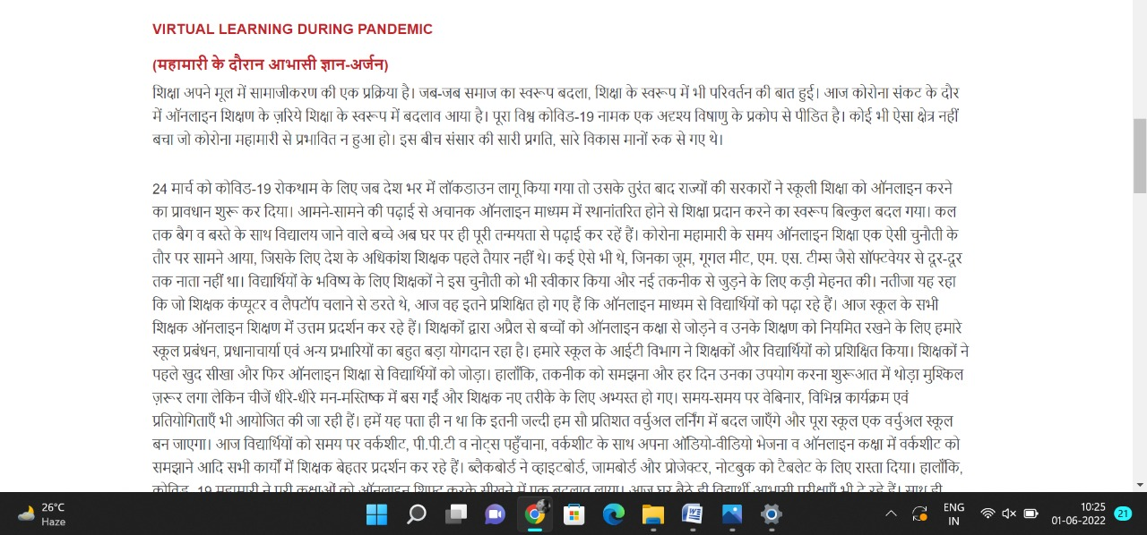

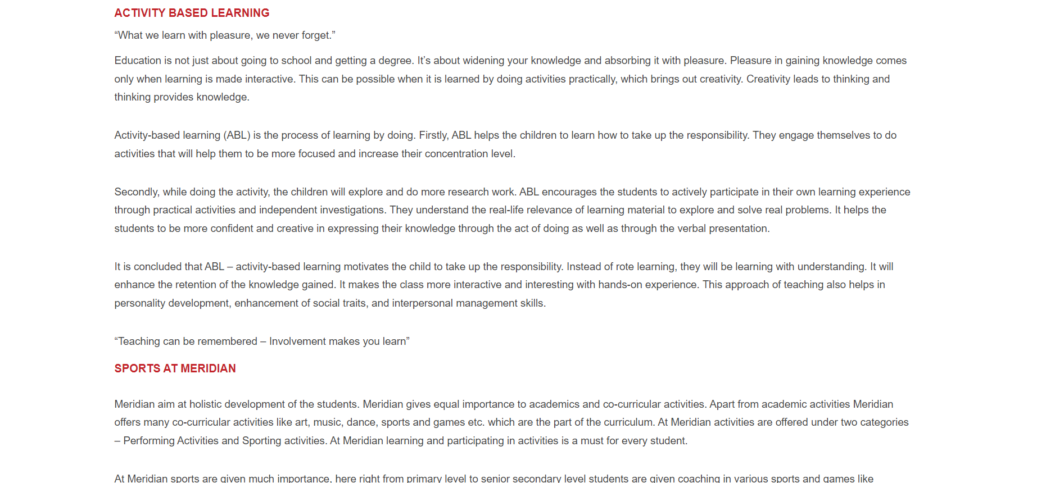

**PAGE 15:Awards & Accolades**

**HTML CODE:**

<!DOCTYPE html>

<html lang="en">

<head>

    <meta charset="UTF-8">

    <meta http-equiv="X-UA-Compatible" content="IE=edge">

    <meta name="viewport" content="width=device-width, initial-scale=1.0">

    <title>AWARDS & ACCOLADES - Meridian School</title>

    <link rel="stylesheet" href="css/awards.css">

    <link rel="stylesheet" href="https://pro.fontawesome.com/releases/v5.10.0/css/all.css" />

    <link rel="icon" type="imag/logo2.png" href="img/logo2.png">

    <link rel="stylesheet" href="https://stackpath.bootstrapcdn.com/bootstrap/4.4.1/css/bootstrap.min.css"

        integrity="sha384-Vkoo8x4CGs03+Hhxv8T/Q5paXtkKtu6ug5TOeNV6gBiFeWPGFN9MuhOf23Q9Ifjh" crossorigin="anonymous" />

    <link rel="stylesheet" href="https://cdnjs.cloudflare.com/ajax/libs/slick-carousel/1.8.1/slick-theme.min.css"

        integrity="sha512-17EgCFERpgZKcm0j0fEq1YCJuyAWdz9KUtv1EjVuaOz8pDnh/0nZxmU6BBXwaaxqoi9PQXnRWqlcDB027hgv9A=="

        crossorigin="anonymous" referrerpolicy="no-referrer" />

    <link rel="stylesheet" href="https://cdnjs.cloudflare.com/ajax/libs/slick-carousel/1.8.1/slick.min.css"

        integrity="sha512-yHknP1/AwR+yx26cB1y0cjvQUMvEa2PFzt1c9LlS4pRQ5NOTZFWbhBig+X9G9eYW/8m0/4OXNx8pxJ6z57x0dw=="

        crossorigin="anonymous" referrerpolicy="no-referrer" />

</head>

<body>

    <section id="follow">

        <div class="followus">

            <div class="icon1">

                <i class="fa fa-phone"></i>

                <a id="phone" href="">8096918857, 9948508222</a>

            </div>

            <div class="icon1">

                <i class="fa fa-envelope"></i>

                <a id="mail" href="">info.banjara@meridianschool.in</a>

            </div>

            <div class="icon">

                <a href="https://www.facebook.com/MeridianSchoolBanjaraHills/" target="_blank"

                    class="fab fa-facebook-f"></i></a>

                <a href="https://twitter.com/meridianbanjara" target="_blank"><i class="fab fa-twitter"></i></a>

                <a href="https://www.youtube.com/channel/UCBZ_gLF9qM18O3CDWQHeN1A" target="_blank"><i

                        class="fab fa-youtube"></i></a>

                <a href="https://www.instagram.com/meridianschools/" target="_blank"><i

                        class="fab fa-instagram"></i></a>

            </div>

        </div>

    </section>

    <div class="navbar">

        <a href="home.html"><img src="img/logo.png" class="logo" alt=""></a>

        <nav>

            <a class="active" href="home.html">HOME</a>

            <div class="dropdown">

                <button class="dropbtn">ABOUT US

                </button>

                <div class="dropdown-content">

                    <a href="knowmeridian.html">KNOW MERIDIAN</a>

                    <a href="visionmission.html">THE VISION & MISSION</a>

                    <a href="http://meridianbanjara.com/the-founders/">THE FOUNDER'S MESSAGE</a>

                    <a href="ceomsg.html">CEO'S MESSAGE</a>

                    <a href="principalmsg.html">THE PRINCIPAL'S MESSAGE</a>

                    <a href="awards.html">AWARDS AND ACCOLADES</a>

                    <a href="http://meridianbanjara.com/affiliations-accreditations/">AFFILIATIONS & ACCREDITATIONS</a>

                    <a href="blog.html">BLOG</a>

                </div>

            </div>

            <div class="dropdown">

                <button class="dropbtn">LEADERSHIP TEAM

                </button>

                <div class="dropdown-content">

                    <a href="principal.html">PRINCIPAL</a>

                    <a href="vp.html">VICE PRINCIPAL</a>

                    <a href="headmistress.html">HEADMISTRESS</a>

                    <a href="midSchool.html">MIDDLE SCHOOL INCHARGE</a>

                    <a href="ipPyp.html">IB PYP COORDINATOR</a>

                    <a href="preprimary.html">PRE PRIMARY INCHARGE</a>

                    <a href="global.html">GLOBAL PARTNERSHIP COORDINATOR</a>

                </div>

            </div>

            <div class="dropdown">

                <button class="dropbtn">ACADEMICS

                </button>

                <div class="dropdown-content">

                    <a href="AcaOverview.html">OVERVIEW</a>

                    <a href="methodology.html">METHODOLOGY AND LEARNING STYLE</a>

                    <a href="curriculum.html">CURRICULUM</a>

                    <a href="faculty.html">FACULTY</a>

                    <a href="teacherTraining.html">TEACHER TRAINING</a>

                    <a href="careerGuidance.html">CAREER GUIDANCE</a>

                    <a href="scholrship.html">SCHOLARSHIP PROGRAMME</a>

                </div>

            </div>

            <div class="dropdown">

                <button class="dropbtn">BEYOND ACADEMICS

                </button>

                <div class="dropdown-content">

                    <a href="beyondAcaOverview.html">OVERVIEW</a>

                    <a href="sports.html">SPORTS</a>

                    <a href="creatveAct.html">CREATIVE ACTIVITIES</a>

                    <a href="eduTrips.html">EDUCATIONAL TRIPS AND STUDENT<br> EXCHANGE PROGRAMMES</a>

                    <a href="perfectSystem.html">PERFECT SYSTEM</a>

                    <a href="schoolSocialRes.html">SCHOOL'S SOCIAL RESPONSIBILITY</a>

                    <a href="interact.html">INTERACT</a>

                    <a href="heritageClub.html">HERITAGE CLUB</a>

                    <a href="mun.html">MUN</a>

                </div>

            </div>

            <div class="dropdown">

                <button class="dropbtn">ADMISSIONS

                </button>

                <div class="dropdown-content">

                    <a href="overview.html">OVERVIEW</a>

                    <a href="admissionpro.html">ADMISSION PROCEDURE</a>

                    <a href="feepolicy.html">FEE POLICY</a>

                    <a href="tranfercert.html">TRANSFER CERTIFICATE</a>

                    <a href="transport.html">TRANSPORT</a>

                </div>

            </div>

            <a class="active" href="gallery.html">GALLERY</a>

            <div class="dropdown">

                <button class="dropbtn">CONTACT US

                </button>

                <div class="dropdown-content">

                    <a href="contact.html">CAREERS</a>

                </div>

            </div>

        </nav>

    </div>

    <div id="mobile">

        <i id="bar" class="fas fa-outdent "></i>

    </div>

    <section id="awards">

        <img src="img/aboutus/6.jpg" width="100%" />

        <div class="awar">

            <h2>AWARDS & ACCOLADES</h2>

            <span id="orange"><a href="home.html">Meridian School Banjara Hills</a></span>

            <span> &gt; AWARDS & ACCOLADES</span>

        </div>

    </section>

    <section id="aw">

        <div class="aw1">

            <div id="info">

                <h4>VISION</h4>

                <p><b>Team Meridian has received several Awards & Honours over the years in various fields. Few of them

                        are listed below.</b></p>

                <h5>2020-21 Achievements</h5>

                <ul>

                    <li>D.Usha Reddy, Principal Meridian School Banjara Hills is honoured with the ‘Citation of

                        Eminence’ at the Principal’s Day conclave for her exemplary contribution to education and her

                        positive intervention to keep learning seamless during the pandemic period.</li>

                    <li>D.Usha Reddy ma’am CEO Meridian Schools and Principal Meridian School Banjara Hills has been

                        awarded the ‘Naari Extraordinary Award of the Decade’ in the field of Education</li>

                    <li>Certificate of Outstanding Contribution awarded to Nahyr Sehgal of Grade X by the Criticspace

                        Journal for his poem “Destiny Unmuted” published in the Anthology of Poems -Women the Symbol of

                        Power</li>

                    <li>Charu Hasini of grade 7 is the All India Runner Up of the ‘Let’s Debate’ contest organized by

                        The New Indian Express.</li>

                    <li>Ananya of Grade 9 and Ishani of grade 7 are awarded 3rd prize in painting and slogan writing

                        competitions organized by Environment Protection Training and Research Institute.</li>

                    <li>Alekhya Vemuri of Grade 11 awarded a medal in the 4th International Child Art Competition, on

                        the eve of Dhauli Art Festival 2021 in Group C category</li>

                    <li>Shreya Rathi of Grade 11 has co-authored a book titled Epiphany.</li>

                    <li>Muqtadir of Class 10 won Gold medal in Taekwondo</li>

                    <li>Anjna of Grade 11 won First prize in Golconda warrior wisdom league singing competition</li>

                    <li>Rehmat, Psychologist Meridian School Banjara Hills has been awarded the ‘Inspiring Woman

                        Psychologist Award – 2021’ by the Telangana Psychologists Association.</li>

                    <li>Isabella Dipesh of grade 6 published her first story book</li>

                    <li>A.P.J.Abdul Kalam Outstanding Student Awards – Awarded to Maya Devi, Ishika Chopra, Abhinaya and

                        Suhani Jain</li>

                    <li>Rehyal Sehgal of grade 3 won All India 4th place in National Art Competition – ‘Art Chitrakala’

                    </li>

                    <li>Devi Kashyap of grade 9 is the winner of the TCS ION INTELLIGEM</li>

                    <li>Pushti Laddha of grade 9 won singles title in AITA Championship series, under-16 category held

                        at Sania Mirza Tennis Academy</li>

                    <li>Alekhya Vemuri of Grade 11received Appreciation Award from Cyberabad Police in the SHEPAHI event

                        for her contribution towards the Operation Smile Initiative.</li>

                    <li>Anika Agarwal of Grade 7 received ‘Netaji Baal Prerna Award’ for her multidimensional

                        personality and motivating others for social causes from the Health Minister of Telangana and

                        Army general officer in chief Southern zone(retd) Lt. Gen YVK Mohan in Parakram Diwas, Udghosh

                        2021on the eve of Netaji Subhas Chandra Bose 125th Jayanti Celebration</li>

                    <li>Charu Hasini of grade 7 secured second position at the National level Public Speaking

                        Competition held by Schoolalerts.</li>

                </ul>

                <h5>SCHOOL AWARDS</h5>

                <ul style="list-style:disc;">

                    <li>International Schools Award by the <b>British Council</b> awarded three consecutive times

                        -2012-21</li>

                    <li>Jury’s Choice Award India’s Best School by <b>Education Today</b> – 2019-20</li>

                    <li>School Excellence Award by <b>Brainfeed</b> – 2019</li>

                    <li>Budding Scientist Award for Team Meridian by <b>Macmillan</b> – 2019-20</li>

                    <li>Fit India School Certificate of Recognition by <b>Government of India, Ministry of Youth Affairs

                            and Sports</b> – 2019-20</li>

                    <li>Team Meridian bags First Prize in <b>Sahaya- Community Outreach Programme</b> – 2019-20</li>

                    <li>Team Meridian bags 2 Gold Medals and 1 Silver medal at <b>International Taekwondo Championship

                        </b>–

                        2019-20</li>

                    <li>Interact Club of Meridian adjudged the Best Club by <b>Rotary Club</b>, Jubilee

                        Hills –2018-19</li>

                    <li>Corporate Social Responsibility Award by <b>Help-Age India</b> – 2015-16</li>

                    <li>Team Meridian bags First place for ‘Dulcet for Diabetes’ Science project in <b>CBSE Science

                            Exhibition</b> – 2015-16</li>

                    <li>Team Meridian bags First place in Short film making at <b>Global Film Festival</b>, New York.

                    </li>

                    <li>Three toppers of AISSE invited to Delhi for the Independence Day Celebrations</li>

                </ul>

                <h5>INDIVIDUAL AWARDS</h5>

                <ul>

                    <li>Principal, Dr Usha Reddy Awarded Honorary Professor of the <b>Academic Union Oxford, London</b>,

                        the

                        highest recognition of personal contribution to the development of synergy between science,

                        education, innovative management, efficient professional solutions – 2019-20</li>

                    <li>Raghav Devda, Mohammad Mustafa Bukhari and Rudra Sharma of Class 7 bagged Macmillan Budding

                        Scientist Award, 2019-20 at <b>IIT Pawai</b> in Mumbai for their Project Automatic Scissors.

                    </li>

                    <li>Pushti Ladda won <b>National Tennis Series</b> in Chennai and Doubles in Under 14 category in

                        the Super Series Tournament in Kolkata</li>

                    <li>Elahe Gulzar won Bronze in CBSE <b>National Taekwondo Championship</b> – 2019-20.</li>

                    <li>Harshini Maddala achieved All India Rank 3 & State Topper in <b>AISSE</b> – 2018-19</li>

                </ul>

            </div>

        </div>

    </section>

    <footer>

        <div class="col">

            <h4>ABOUT US</h4>

            <p>Meridian is a New Generation Educational Group committed to educate children for life and thus bring a

                change in the society. Learning philosophy practised at Meridian infuses traditional values into a

                progressive approach, equipping students to adapt and excel anywhere in the world. Our alumni, working

                in diverse fields, have found Meridian to be the best school for a successful career take off.</p>

        </div>

        <div class="col">

            <h4>USEFUL LINKS</h4>

            <ul class="three-col-links">

                <li><a href="#">HOME</a></li>

                <li><a href="home.html">HOME</a></li>

                <li><a href="AcaOverview.html">ACADEMICS</a></li>

                <li><a href="overview.html">ADMISSIONS</a></li>

                <li><a href="contact.html">CONTACT US</a></li>

                <li><a href="knowmeridian.html">ABOUT US</a></li>

                <li><a href="beyondAcaOverview.html">BEYOND ACADEMICS</a></li>

                <li><a href="contact.html">CAREERS</a></li>

            </ul>

        </div>

        <div class="col">

            <!--<div class="follow">

                <div class="icon">

                    <i class="fa fa-paper-plane-o"></i>

                </div>

        </div>-->

            <h4>MERIDIAN SCHOOL, Banjara Hills</h4>

            <p># 8-2-541, Road No 7, Banjara Hills, Hyderabad-500034, TELANGANA, INDIA.</p><br>

            <p>For contact : +91 8096918857, 9948508222, <br>For Prinicipal Appointments : 8098420002</p><br>

            <p> For Admissions / Enquires : 8096918857, 9948508222</p><br>

            <p>info.banjara@meridianschool.inA</p>

        </div>

    </footer>

    <section id="copyright">

        <div id="cr">

            <p>© Copyright MERIDIAN SCHOOL, BANJARA HILLS 2020.</p>

        </div>

    </section>

    <script src="https://ajax.googleapis.com/ajax/libs/jquery/3.6.0/jquery.min.js"></script>

    <script src="https://cdnjs.cloudflare.com/ajax/libs/slick-carousel/1.8.1/slick.min.js"

        integrity="sha512-XtmMtDEcNz2j7ekrtHvOVR4iwwaD6o/FUJe6+Zq+HgcCsk3kj4uSQQR8weQ2QVj1o0Pk6PwYLohm206ZzNfubg=="

        crossorigin="anonymous" referrerpolicy="no-referrer"></script>

**CSS CODE:**

@import url('https://fonts.googleapis.com/css2?family=Lato:wght@300;400;700&display=swap');

* {

    margin: 0;

    padding: 0;

    box-sizing: border-box;

    font-family: 'Spartan', sans-serif;

}

a:hover {

    transition: 0.2 ease;

}

/* div, section{

    border: 2px solid black;

} */

h1 {

    font-size: 40px;

    line-height: 64px;

    color: #fff;

}

h2 {

    font-weight: 500;

    font-size: 56px;

    line-height: 54px;

    color: #fff;

    text-align: center;

}

h3 {

    text-align: center;

    font-size: 22px;

    color: #c42329;

}

h6 {

    font-weight: 700;

    font-size: 12px;

}

p {

    font-size: 15px;

    line-height: 26px;

    font-weight: 400;

    font-style: normal;

    color: #444;

}

span {

    font-size: 15px;

    line-height: 26px;

    font-weight: 400;

    font-style: normal;

    color: #444444;

    text-align: center;

}

.section-p1 {

    margin: 40px 80px;

}

.section-m1 {

    margin: 40px 0;

}

button.normal {

    font-size: 14px;

    font-weight: 600;

    padding: 15px 30px;

    color: #fff;

    background-color: #c42329;

    border-radius: 4px;

    cursor: pointer;

    border: none;

    outline: none;

    transition: 0.2s;

}

body {

    width: 100%;

}

#header {

    background-color: #fff;

    border-bottom: #c42329;

    display: flex;

    align-items: center;

    justify-content: space-between;

    padding: 16px 80px;

    box-shadow: 0 5px 15px rgba(0, 0, 0, 0.06);

    /* z-index: 999; */

    position: sticky;

    top: 0;

    left: 0;

}

#header a img {

    width: 135px;

    height: 61px;

}

#header a:hover {

    border: 1px dotted orange;

}

#mobile {

    display: none;

    align-items: center;

}

#close {

    display: none;

}

/*#navbar {

    display: flex;

    align-items: center;

    justify-content: center;

}

#navbar li {

    list-style: none;

    padding: 0 8px;

    position: relative;

}

#navbar li a {

    text-decoration: none;

    font-size: 13px;

    font-weight: 600;

    color: #c42329;

    transition: 0.3 ease;

}

#navbar li a.active::after,

#navbar li a:hover::after {

    content: "";

    width: 30%;

    height: 2px;

    position: absolute;

    bottom: -4px;

    left: 20px;

}

#navbar .headButton {

    border-left: 20px;

}

#navbar .headButton:hover {

    border: #c42329;

    background-color: #fff;

    color: black;

}*/

.navbar {

    overflow: hidden;

    background-color: #fff;

}

.navbar a {

    float: left;

    font-size: 14px;

    color: #c42329;

    text-align: left;

    padding: 14px 16px;

    text-decoration: none;

}

.active {

    font-weight: 650;

}

.dropdown {

    float: left;

    overflow: hidden;

}

.dropdown .dropbtn {

    font-size: 14px;

    border: none;

    outline: none;

    color: #c42329;

    padding: 14px 16px;

    background-color: inherit;

    font-family: inherit;

    margin: 0;

    font-weight: 650;

}

.navbar a:hover,

.dropdown:hover .dropbtn {

    color: orange;

}

.dropdown-content {

    display: none;

    position: absolute;

    background-color: #c42329;

    min-width: 160px;

    box-shadow: 0px 8px 16px 0px rgba(0, 0, 0, 0.2);

    z-index: 1;

}

.dropdown-content a {

    float: none;

    color: white;

    padding: 12px 16px;

    text-decoration: none;

    display: block;

    text-align: left;

}

.dropdown-content a:hover {

    background-color: #c42329;

}

.dropdown:hover .dropdown-content {

    display: block;

}

nav {

    margin-top: 1.5%;

    margin-left: 30%;

}

.logo {

    margin-left: 60%;

    width: 135px;

    height: 61px;

}

footer {

    width: 100%;

    background-color: #c42329;

    display: flex;

    flex-direction: row;

    justify-content: space-between;

    flex-wrap: wrap;

    padding: 90px 70px 50px 70px;

}

footer .col {

    display: flex;

    flex-direction: column;

    align-items: flex-start;

    margin-bottom: 20px;

    width: 30%;

    height: 100%;

}

footer h4 {

    font-size: 20px;

    color: #fff;

    padding-bottom: 20px;

}

footer p {

    font-size: 16px;

    color: #fff;

    padding-bottom: 0 0 8px 0;

    margin-bottom: 0;

}

footer a {

    font-size: 17px;

    margin-bottom: 10px;

    color: #fff;

    text-decoration: none;

}

/* Align Links in footer */

.three-col-links {

    width: 105%;

    -webkit-column-count: 2;

    -moz-column-count: 2;

    column-count: 2;

    padding-top: 4%;

}

.three-col-links li {

    width: 100%;

    float: left;

    display: inline;

    margin-top: 8%;

    text-transform: uppercase;

}

/* END -Align Links in footer */

footer .follow {

    margin-top: 20px;

}

footer .follow i {

    color: #fff;

    padding-right: 4px;

    cursor: pointer;

}

footer .follow i:hover,

footer a:hover {

    color: orange;

}

#cr {

    background-color: black;

}

#cr p {

    text-align: center;

    color: #fff;

    padding: 20px 0;

}

#follow .icon {

    justify-content: flex-end;

}

#follow .icon i {

    color: #fff;

}

#follow .followus {

    display: flex;

    background-color: #c42329;

}

#follow .followus a {

    color: #fff;

    text-decoration: none;

    font-size: 14px;

    font-weight: 550;

}

/*#follow .followus #phone {

    padding: 10px 10px 10px 55px;

}

#follow .followus #mail {

    padding: 10px 10px 10px 35px;

}*/

#follow .followus a:hover {

    text-decoration: underline;

}

#follow .icon {

    margin-left: 890px;

    padding: 10px 10px;

}

#follow .icon i {

    padding: 0 3px;

}

#aw .aw1 {

    display: flex;

    margin: 150px 70px 130px 70px;

}

#aw .aw1 #info {

    width: 90%;

}

#aw .aw1 #info h4 {

    margin: -55px 50px 35px 100px;

    color: #c42329;

}

#aw .aw1 #info h5 {

    color: #f48243;

    margin: -10px 50px 35px 100px;

}

#aw .aw1 #info p {

    margin: -25px 0px 35px 100px;

}

#aw .aw1 #info ul li {

    margin: -25px 0px 35px 100px;

    line-height: 120%;

    font-size: 15px;

}

#awards {

    position: relative;

    text-align: center;

    color: white;

}

#awards .awar {

    height: 500px;

    background-repeat: no-repeat;

    padding: 230px 0 0 50px;

    /* background-position: 100%; */

    position: absolute;

    top: 50%;

    left: 50%;

    transform: translate(-160%, -50%);

}

#awards .awar h2 {

    font-size: 34px;

    font-weight: 600;

    text-align: start;

    /* color: #c42329; */

}

#awards .awar span {

    color: #fff;

}

#awards .awar span a {

    text-decoration: none;

}

#awards #orange a {

    color: #f48243;

}

#awards #orange a:hover {

    color: #fff;

}

.fa {

    display: inline-block;

    font: normal normal normal 14px/1 FontAwesome;

    font-size: inherit;

    text-rendering: auto;

    color: #fff;

}

.icon1 {

    padding: 8px 15px;

}

**OUTPUT:**

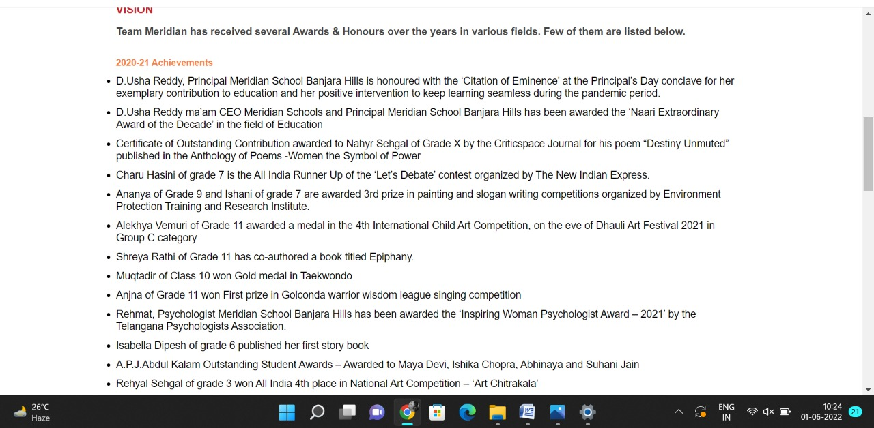

**PAGE 16:The Principal’s Message**

**HTML CODE:**

<!DOCTYPE html>

<html lang="en">

<head>

    <meta charset="UTF-8">

    <meta http-equiv="X-UA-Compatible" content="IE=edge">

    <meta name="viewport" content="width=device-width, initial-scale=1.0">

    <title>PRINICIPAL'S MESSAGE - Meridian School</title>

    <link rel="stylesheet" href="css/princimsg.css">

    <link rel="stylesheet" href="https://pro.fontawesome.com/releases/v5.10.0/css/all.css" />

    <link rel="icon" type="imag/logo2.png" href="img/logo2.png">

    <link rel="stylesheet" href="https://stackpath.bootstrapcdn.com/bootstrap/4.4.1/css/bootstrap.min.css"

        integrity="sha384-Vkoo8x4CGs03+Hhxv8T/Q5paXtkKtu6ug5TOeNV6gBiFeWPGFN9MuhOf23Q9Ifjh" crossorigin="anonymous" />

    <link rel="stylesheet" href="https://cdnjs.cloudflare.com/ajax/libs/slick-carousel/1.8.1/slick-theme.min.css"

        integrity="sha512-17EgCFERpgZKcm0j0fEq1YCJuyAWdz9KUtv1EjVuaOz8pDnh/0nZxmU6BBXwaaxqoi9PQXnRWqlcDB027hgv9A=="

        crossorigin="anonymous" referrerpolicy="no-referrer" />

    <link rel="stylesheet" href="https://cdnjs.cloudflare.com/ajax/libs/slick-carousel/1.8.1/slick.min.css"

        integrity="sha512-yHknP1/AwR+yx26cB1y0cjvQUMvEa2PFzt1c9LlS4pRQ5NOTZFWbhBig+X9G9eYW/8m0/4OXNx8pxJ6z57x0dw=="

        crossorigin="anonymous" referrerpolicy="no-referrer" />

</head>

<body>

    <section id="follow">

        <div class="followus">

            <div class="icon1">

                <i class="fa fa-phone"></i>

                <a id="phone" href="">8096918857, 9948508222</a>

            </div>

            <div class="icon1">

                <i class="fa fa-envelope"></i>

                <a id="mail" href="">info.banjara@meridianschool.in</a>

            </div>

            <div class="icon">

                <a href="https://www.facebook.com/MeridianSchoolBanjaraHills/" target="_blank"

                    class="fab fa-facebook-f"></i></a>

                <a href="https://twitter.com/meridianbanjara" target="_blank"><i class="fab fa-twitter"></i></a>

                <a href="https://www.youtube.com/channel/UCBZ_gLF9qM18O3CDWQHeN1A" target="_blank"><i

                        class="fab fa-youtube"></i></a>

                <a href="https://www.instagram.com/meridianschools/" target="_blank"><i

                        class="fab fa-instagram"></i></a>

            </div>

        </div>

    </section>

    <div class="navbar">

        <a href="home.html"><img src="img/logo.png" class="logo" alt=""></a>

        <nav>

            <a class="active" href="home.html">HOME</a>

            <div class="dropdown">

                <button class="dropbtn">ABOUT US

                </button>

                <div class="dropdown-content">

                    <a href="knowmeridian.html">KNOW MERIDIAN</a>

                    <a href="visionmission.html">THE VISION & MISSION</a>

                    <a href="http://meridianbanjara.com/the-founders/">THE FOUNDER'S MESSAGE</a>

                    <a href="ceomsg.html">CEO'S MESSAGE</a>

                    <a href="principalmsg.html">THE PRINCIPAL'S MESSAGE</a>

                    <a href="awards.html">AWARDS AND ACCOLADES</a>

                    <a href="http://meridianbanjara.com/affiliations-accreditations/">AFFILIATIONS & ACCREDITATIONS</a>

                    <a href="blog.html">BLOG</a>

                </div>

            </div>

            <div class="dropdown">

                <button class="dropbtn">LEADERSHIP TEAM

                </button>

                <div class="dropdown-content">

                    <a href="principal.html">PRINCIPAL</a>

                    <a href="vp.html">VICE PRINCIPAL</a>

                    <a href="headmistress.html">HEADMISTRESS</a>

                    <a href="midSchool.html">MIDDLE SCHOOL INCHARGE</a>

                    <a href="ipPyp.html">IB PYP COORDINATOR</a>

                    <a href="preprimary.html">PRE PRIMARY INCHARGE</a>

                    <a href="global.html">GLOBAL PARTNERSHIP COORDINATOR</a>

                </div>

            </div>

            <div class="dropdown">

                <button class="dropbtn">ACADEMICS

                </button>

                <div class="dropdown-content">

                    <a href="AcaOverview.html">OVERVIEW</a>

                    <a href="methodology.html">METHODOLOGY AND LEARNING STYLE</a>

                    <a href="curriculum.html">CURRICULUM</a>

                    <a href="faculty.html">FACULTY</a>

                    <a href="teacherTraining.html">TEACHER TRAINING</a>

                    <a href="careerGuidance.html">CAREER GUIDANCE</a>

                    <a href="scholrship.html">SCHOLARSHIP PROGRAMME</a>

                </div>

            </div>

            <div class="dropdown">

                <button class="dropbtn">BEYOND ACADEMICS

                </button>

                <div class="dropdown-content">

                    <a href="beyondAcaOverview.html">OVERVIEW</a>

                    <a href="sports.html">SPORTS</a>

                    <a href="creatveAct.html">CREATIVE ACTIVITIES</a>

                    <a href="eduTrips.html">EDUCATIONAL TRIPS AND STUDENT<br> EXCHANGE PROGRAMMES</a>

                    <a href="perfectSystem.html">PERFECT SYSTEM</a>

                    <a href="schoolSocialRes.html">SCHOOL'S SOCIAL RESPONSIBILITY</a>

                    <a href="interact.html">INTERACT</a>

                    <a href="heritageClub.html">HERITAGE CLUB</a>

                    <a href="mun.html">MUN</a>

                </div>

            </div>

            <div class="dropdown">

                <button class="dropbtn">ADMISSIONS

                </button>

                <div class="dropdown-content">

                    <a href="overview.html">OVERVIEW</a>

                    <a href="admissionpro.html">ADMISSION PROCEDURE</a>

                    <a href="feepolicy.html">FEE POLICY</a>

                    <a href="tranfercert.html">TRANSFER CERTIFICATE</a>

                    <a href="transport.html">TRANSPORT</a>

                </div>

            </div>

            <a class="active" href="gallery.html">GALLERY</a>

            <div class="dropdown">

                <button class="dropbtn">CONTACT US

                </button>

                <div class="dropdown-content">

                    <a href="contact.html">CAREERS</a>

                </div>

            </div>

        </nav>

    </div>

    <div id="mobile">

        <i id="bar" class="fas fa-outdent "></i>

    </div>

    <section id="message">

        <img src="img/aboutus/4.jpg" width="100%" />

        <div class="mess">

            <h2>PRINICIPAL'S MESSAGE</h2>

            <span id="orange"><a href="home.html">Meridian School Banjara Hills</a></span>

            <span> &gt; PRINICIPAL'S MESSAGE</span>

        </div>

    </section>

    <section id="me">

        <div class="me1">

            <div id="info">

                <h4>PRINCIPAL'S MESSAGE</h4>

                <p>William Butler Yeats rightly said, ‘Education is not the filling of a pail, but the lighting of a

                    fire.’ We at Meridian are deeply committed to kindle that spark in the child which would gradually

                    extinguish if not guarded. We are here to inspire and empower young minds to think independently,

                    integrate, excel and contribute to the betterment of the society. Anyone who walks through the gates

                    of Meridian , be it a student, a teacher or a parent feels welcomed and cared for. Such is the

                    warmth that one experiences at Meridian.</p>

                <p>As I took the charge of the post of Principal of Meridian Banjara Hills, I could sense the warmth and

                    love of the Meridian family. I too felt welcomed with open hands. Going by the very motto of the

                    school, I would try my best to connect the mind and heart in every fresh and innovative step that I

                    would take in connection with administration. Keeping in view the online instruction for the past

                    one and half years, we have introduced the concept of a bridge course as the students moved to the

                    next grade to drill them with the main concepts before the serious teaching started. Catering to the

                    demands of the NEP, we are also revising and reviewing our teaching strategies and instruction tools

                    at all levels. We are proud to claim the credit of possessing the best teaching faculty in the twin

                    cities with excellent qualification, years of experience and unflinching commitment towards their

                    noble profession. We are here not only to impart holistic education complete with 21st Century

                    skills and moral values, but also to develop in the students, the ability to apply, analyse,

                    organise and think out of the box and to connect everything they learn to real life</p>

                <p>We invite parents, as stake holders of this institution, to take an active role in the grooming of

                    the child and help us do our best and their valuable suggestions will always be received in good

                    spirit.</p>

                <p>Academics is our main objective but not cramming. Freedom is given but not at the cost of discipline.

                    Here is our promise to you: In our preoccupation with the process of assessment of scholastic and co

                    scholastic areas, we will not forget our primary goal of anchoring our dear Meridianites in a sound

                    value system.</p>

                <p>Wishing Meridian All the Best for all times.</p>

            </div>

            <div>

                <img style="float: right;" src="img/aboutus/5.jpg" />

            </div>

        </div>

    </section>

    <footer>

        <div class="col">

            <h4>ABOUT US</h4>

            <p>Meridian is a New Generation Educational Group committed to educate children for life and thus bring a

                change in the society. Learning philosophy practised at Meridian infuses traditional values into a

                progressive approach, equipping students to adapt and excel anywhere in the world. Our alumni, working

                in diverse fields, have found Meridian to be the best school for a successful career take off.</p>

        </div>

        <div class="col">

            <h4>USEFUL LINKS</h4>

            <ul class="three-col-links">

                <li><a href="home.html">HOME</a></li>

                <li><a href="AcaOverview.html">ACADEMICS</a></li>

                <li><a href="overview.html">ADMISSIONS</a></li>

                <li><a href="contact.html">CONTACT US</a></li>

                <li><a href="knowmeridian.html">ABOUT US</a></li>

                <li><a href="beyondAcaOverview.html">BEYOND ACADEMICS</a></li>

                <li><a href="contact.html">CAREERS</a></li>

            </ul>

        </div>

        <div class="col">

            <!--<div class="follow">

                <div class="icon">

                    <i class="fa fa-paper-plane-o"></i>

                </div>

        </div>-->

            <h4>MERIDIAN SCHOOL, Banjara Hills</h4>

            <p># 8-2-541, Road No 7, Banjara Hills, Hyderabad-500034, TELANGANA, INDIA.</p><br>

            <p>For contact : +91 8096918857, 9948508222, <br>For Prinicipal Appointments : 8098420002</p><br>

            <p> For Admissions / Enquires : 8096918857, 9948508222</p><br>

            <p>info.banjara@meridianschool.inA</p>

        </div>

    </footer>

    <section id="copyright">

        <div id="cr">

            <p>© Copyright MERIDIAN SCHOOL, BANJARA HILLS 2020.</p>

        </div>

    </section>

    <script src="https://ajax.googleapis.com/ajax/libs/jquery/3.6.0/jquery.min.js"></script>

    <script src="https://cdnjs.cloudflare.com/ajax/libs/slick-carousel/1.8.1/slick.min.js"

        integrity="sha512-XtmMtDEcNz2j7ekrtHvOVR4iwwaD6o/FUJe6+Zq+HgcCsk3kj4uSQQR8weQ2QVj1o0Pk6PwYLohm206ZzNfubg=="

        crossorigin="anonymous" referrerpolicy="no-referrer"></script>

**CSS CODE:**

@import url('https://fonts.googleapis.com/css2?family=Lato:wght@300;400;700&display=swap');

* {

    margin: 0;

    padding: 0;

    box-sizing: border-box;

    font-family: 'Spartan', sans-serif;

}

a:hover {

    transition: 0.2 ease;

}

/* div, section{

    border: 2px solid black;

} */

h1 {

    font-size: 40px;

    line-height: 64px;

    color: #fff;

}

h2 {

    font-weight: 500;

    font-size: 56px;

    line-height: 54px;

    color: #fff;

    text-align: center;

}

h3 {

    text-align: center;

    font-size: 22px;

    color: #c42329;

}

h6 {

    font-weight: 700;

    font-size: 12px;

}

p {

    font-size: 15px;

    line-height: 26px;

    font-weight: 400;

    font-style: normal;

    color: #444;

}

span {

    font-size: 15px;

    line-height: 26px;

    font-weight: 400;

    font-style: normal;

    color: #444444;

    text-align: center;

}

.section-p1 {

    margin: 40px 80px;

}

.section-m1 {

    margin: 40px 0;

}

button.normal {

    font-size: 14px;

    font-weight: 600;

    padding: 15px 30px;

    color: #fff;

    background-color: #c42329;

    border-radius: 4px;

    cursor: pointer;

    border: none;

    outline: none;

    transition: 0.2s;

}

body {

    width: 100%;

}

#header {

    background-color: #fff;

    border-bottom: #c42329;

    display: flex;

    align-items: center;

    justify-content: space-between;

    padding: 16px 80px;

    box-shadow: 0 5px 15px rgba(0, 0, 0, 0.06);

    /* z-index: 999; */

    position: sticky;

    top: 0;

    left: 0;

}

#header a img {

    width: 135px;

    height: 61px;

}

#header a:hover {

    border: 1px dotted orange;

}

#mobile {

    display: none;

    align-items: center;

}

#close {

    display: none;

}

/*#navbar {

    display: flex;

    align-items: center;

    justify-content: center;

}

#navbar li {

    list-style: none;

    padding: 0 8px;

    position: relative;

}

#navbar li a {

    text-decoration: none;

    font-size: 13px;

    font-weight: 600;

    color: #c42329;

    transition: 0.3 ease;

}

#navbar li a.active::after,

#navbar li a:hover::after {

    content: "";

    width: 30%;

    height: 2px;

    position: absolute;

    bottom: -4px;

    left: 20px;

}

#navbar .headButton {

    border-left: 20px;

}

#navbar .headButton:hover {

    border: #c42329;

    background-color: #fff;

    color: black;

}*/

.navbar {

    overflow: hidden;

    background-color: #fff;

}

.navbar a {

    float: left;

    font-size: 14px;

    color: #c42329;

    text-align: left;

    padding: 14px 16px;

    text-decoration: none;

}

.active {

    font-weight: 650;

}

.dropdown {

    float: left;

    overflow: hidden;

}

.dropdown .dropbtn {

    font-size: 14px;

    border: none;

    outline: none;

    color: #c42329;

    padding: 14px 16px;

    background-color: inherit;

    font-family: inherit;

    margin: 0;

    font-weight: 650;

}

.navbar a:hover,

.dropdown:hover .dropbtn {

    color: orange;

}

.dropdown-content {

    display: none;

    position: absolute;

    background-color: #c42329;

    min-width: 160px;

    box-shadow: 0px 8px 16px 0px rgba(0, 0, 0, 0.2);

    z-index: 1;

}

.dropdown-content a {

    float: none;

    color: white;

    padding: 12px 16px;

    text-decoration: none;

    display: block;

    text-align: left;

}

.dropdown-content a:hover {

    background-color: #c42329;

}

.dropdown:hover .dropdown-content {

    display: block;

}

nav {

    margin-top: 1.5%;

    margin-left: 30%;

}

.logo {

    margin-left: 60%;

    width: 135px;

    height: 61px;

}

footer {

    width: 100%;

    background-color: #c42329;

    display: flex;

    flex-direction: row;

    justify-content: space-between;

    flex-wrap: wrap;

    padding: 90px 70px 50px 70px;

}

footer .col {

    display: flex;

    flex-direction: column;

    align-items: flex-start;

    margin-bottom: 20px;

    width: 30%;

    height: 100%;

}

footer h4 {

    font-size: 20px;

    color: #fff;

    padding-bottom: 20px;

}

footer p {

    font-size: 16px;

    color: #fff;

    padding-bottom: 0 0 8px 0;

    margin-bottom: 0;

}

footer a {

    font-size: 17px;

    margin-bottom: 10px;

    color: #fff;

    text-decoration: none;

}

/* Align Links in footer */

.three-col-links {

    width: 105%;

    -webkit-column-count: 2;

    -moz-column-count: 2;

    column-count: 2;

    padding-top: 4%;

}

.three-col-links li {

    width: 100%;

    float: left;

    display: inline;

    margin-top: 8%;

    text-transform: uppercase;

}

/* END -Align Links in footer */

footer .follow {

    margin-top: 20px;

}

footer .follow i {

    color: #fff;

    padding-right: 4px;

    cursor: pointer;

}

footer .follow i:hover,

footer a:hover {

    color: orange;

}

#cr {

    background-color: black;

}

#cr p {

    text-align: center;

    color: #fff;

    padding: 20px 0;

}

#follow .icon {

    justify-content: flex-end;

}

#follow .icon i {

    color: #fff;

}

#follow .followus {

    display: flex;

    background-color: #c42329;

}

#follow .followus a {

    color: #fff;

    text-decoration: none;

    font-size: 14px;

    font-weight: 550;

}

/*#follow .followus #phone {

    padding: 10px 10px 10px 55px;

}

#follow .followus #mail {

    padding: 10px 10px 10px 35px;

}*/

#follow .followus a:hover {

    text-decoration: underline;

}

#follow .icon {

    margin-left: 890px;

    padding: 10px 10px;

}

#follow .icon i {

    padding: 0 3px;

}

#me .me1 {

    display: flex;

    margin: 150px 70px 130px 70px;

}

#me .me1 #info {

    width: 63%;

}

#me .me1 img {

    width: 372px;

    margin-left: 72px;

    height: 275px;

    border: 7px solid rgb(225, 222, 222);

}

#me .me1 #info h4 {

    margin: -55px 50px 35px 100px;

    color: #c42329;

}

#me .me1 #info p {

    margin: -10px 0px 35px 100px;

}

#message {

    position: relative;

    text-align: center;

    color: white;

}

#message .mess {

    height: 500px;

    background-repeat: no-repeat;

    padding: 230px 0 0 50px;

    /* background-position: 100%; */

    position: absolute;

    top: 50%;

    left: 50%;

    transform: translate(-160%, -50%);

}

#message .mess h2 {

    font-size: 34px;

    font-weight: 600;

    text-align: start;

    /* color: #c42329; */

}

#message .mess span {

    color: #fff;

}

#message .mess span a {

    text-decoration: none;

}

#message #orange a {

    color: #f48243;

}

#message #orange a:hover {

    color: #fff;

}

.fa {

    display: inline-block;

    font: normal normal normal 14px/1 FontAwesome;

    font-size: inherit;

    text-rendering: auto;

    color: #fff;

}

.icon1 {

    padding: 8px 15px;

}

**OUTPUT:**

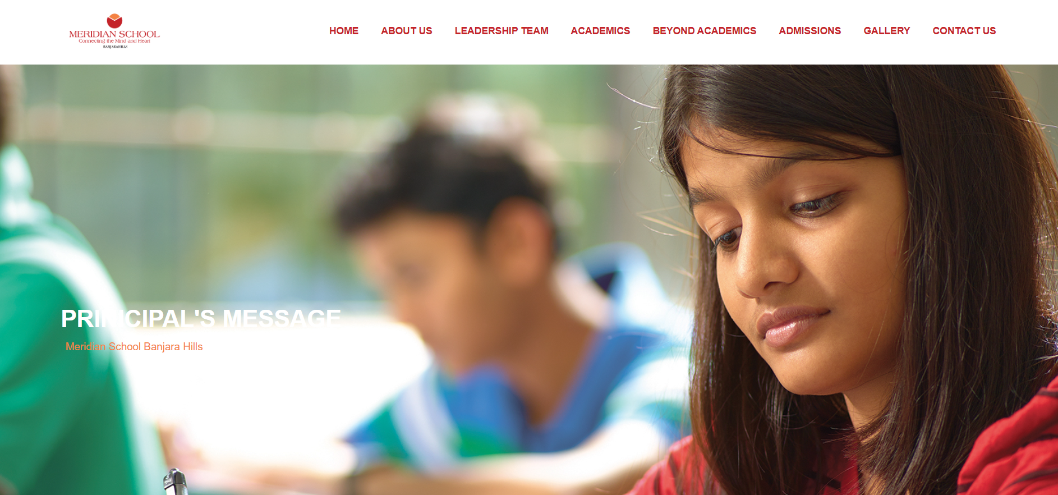

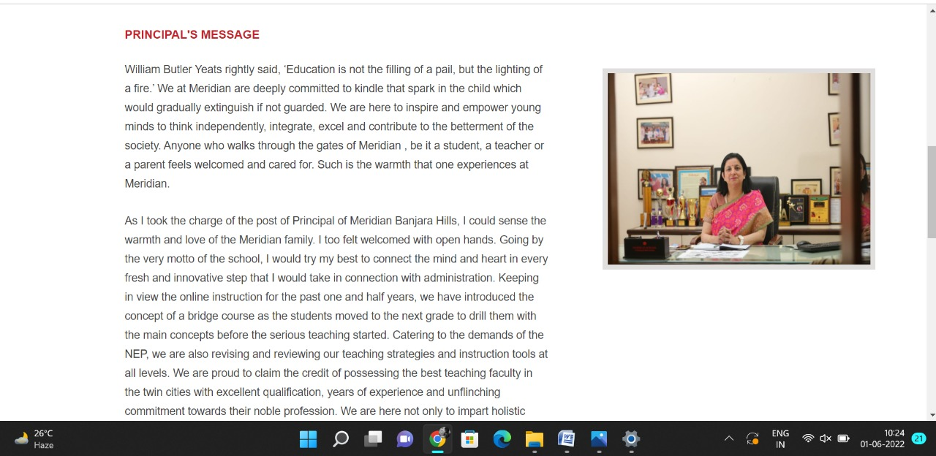

**PAGE 17:Form**

**HTML CODE:**

<html>

<head>

    <link rel="stylesheet" href="task5.css">

    <title>FORM</title>

    <script>

    </script>

</head>

<body>

    <form name="contactForm" id="form-1">

        <h2>ADMISSIONS ARE OPEN</h2>

        <div class="row">

            <div class="c1">

                <label>NAME <span style="color: red;">*</span></label>

                <input type="text" size=40 id="name">

                <div class="error" id="nameErr"></div>

            </div>

            <div class="c2">

                <label>EMAIL <span style="color: red;">*</span></label>

                <input type="text" size=40 id="mail">

                <div class="error" id="emailErr"></div>

            </div>

        </div>

        <br>

        <br />

        <div class="row">

            <div class="c1">

                <label>GRADE <span style="color: red;">*</span></label>

                <input type="text" size=40 id="address">

                <div class="error" id="addressErr"></div>

            </div>

            <div class="c2">

                <label>PHONE <span style="color: red;">*</span></label>

                <input type="text" size=40 id="mobile">

                <div class="error" id="mobileErr"></div>

            </div>

        </div>

        <br>

        <br>

        <div class="row">

            <div class="c1">

                <label>MESSAGE <span style="color: red;">*</span></label>

                <input type="text" style="height: 100px; width:260px" size=40 id="country">

                <div class="error" id="countryErr"></div>

            </div>

        </div>

        <br />

        <div class="row">

            <div class="c1">

                <input type="submit" value="Enquiry Now">

            </div>

        </div>

        <script src="./Validator.js"></script>

</body>

</html>

**CSS CODE:**

form {

    width: 408px;

    height: 420px;

    background: #fff;

    padding: 15px 40px 40px;

    border: 80px transparent black;

    margin: 50px auto 0;

    border-radius: 5px;

}

body {

    background-image: linear-gradient(rgba(0, 0, 0, 0.7), rgba(0, 0, 0, 0.7)), url(img/admission/1.jpg);

}

input,

select {

    border: 1px solid #ccc;

    padding: 10px;

    display: block;

    width: 196px;

    height: 38px;

    box-sizing: border-box;

    border-radius: 2px;

    /* border: #c42329; */

}

label {

    display: block;

    margin-bottom: 3px

}

.row {

    padding-bottom: 50px;

}

.c1 {

    float: left;

}

.c2 {

    float: right;

}

.form-inline {

    float: left;

}

.form-inline {

    border-radius: 1px;

}

.form-inline label,

.form-inline input {

    display: inline-block;

    width: auto;

    padding-right: 10px;

}

input[type="submit" i] {

    float: left;

    margin-top: 20px;

}

.error {

    color: #c42329;

    font-size: 90%;

}

**JavaScript CODE:**

var noReload = document.getElementById("form-1");

noReload.addEventListener("submit", function (e) {

    e.preventDefault();

    validation();

});

function printError(elemId, hintMsg) {

    document.getElementById(elemId).innerHTML = hintMsg;

}

function validation() {

    var name = document.contactForm.name.value;

    var email = document.contactForm.mail.value;

    var mobile = document.contactForm.mobile.value;

    var address = document.contactForm.address.value;

    var country = document.contactForm.country.value;

    var namErr = emailErr = mobileErr = addressErr = countryErr = true;

    //name

    if (name == "") {

        printError("nameErr", "This field is required");

    } else {

        var regex = /^[a-zA-Z\s]+$/;

        if (regex.test(name) === false) {

            printError("nameErr", "This field is required");

        } else {

            printError("nameErr", "");

            nameErr = false;

        }

    }

    //email

    if (email == "") {

        printError("emailErr", "This field is required");

    } else {

        // Regular expression for basic email validation

        var regex = /^\S+@\S+\.\S+$/;

        if (regex.test(email) === false) {

            printError("emailErr", "Invalid Email Id");

        } else {

            printError("emailErr", "");

            emailErr = false;

        }

    }

    //mobile

    if (mobile == "") {

        printError("mobileErr", "This field is required");

    } else {

        var regex = /^[1-9]\d{9}$/;

        if (regex.test(mobile) === false) {

            printError("mobileErr", "Invalid Number");

        } else {

            printError("mobileErr", "");

            mobileErr = false;

        }

    }

    //grade

    if (address == "") {

        printError("addressErr", "This field is required");

    } else {

        printError("addressErr", "");

        addressErr = false;

    }

    //Message

    if (country == "") {

        printError("countryErr", "This field is required");

    } else {

        printError("countryErr", "");

        countryErr = false;

    }

    if (!(nameErr || emailErr || mobileErr || addressErr || countryErr)) {

        var dataPreview = "Thank you for your response..We will contact you soon!!!\n";

        alert(dataPreview);

    }

}

**OUTPUT:**

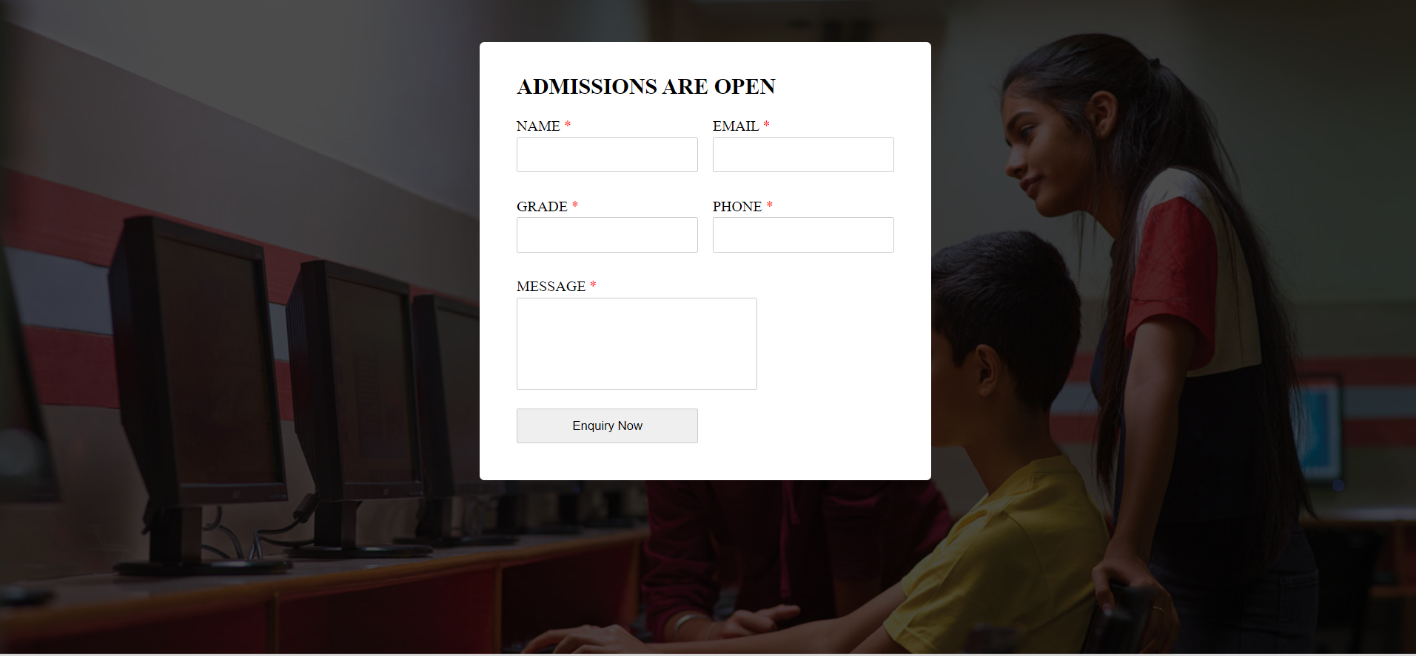

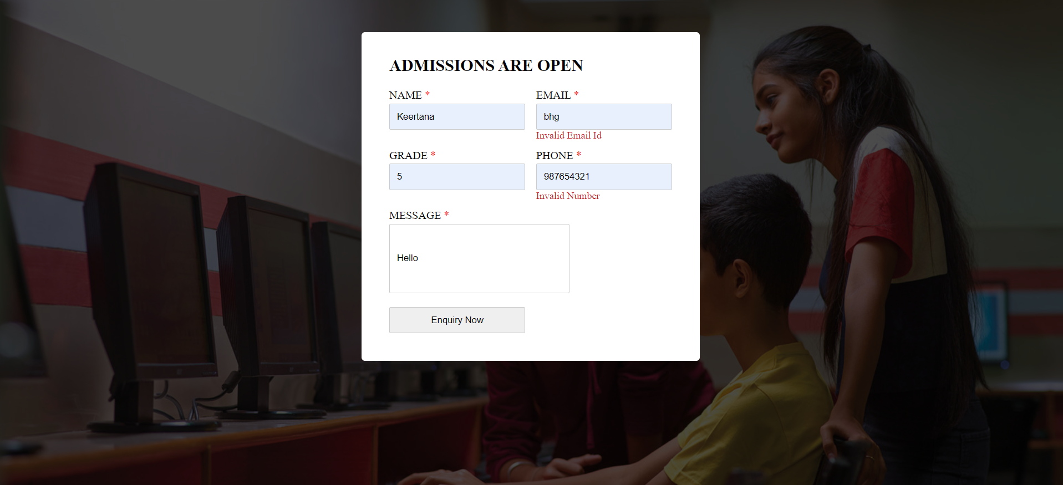

**PAGE 18:AFFILIATIONS & ACCREDITATIONS**

**HTML CODE:**

<!DOCTYPE html>

<html lang="en">

<head>

    <meta charset="UTF-8">

    <meta http-equiv="X-UA-Compatible" content="IE=edge">

    <meta name="viewport" content="width=device-width, initial-scale=1.0">

    <title>AFFILIATION & ACCREDITATIONS</title>

    <link rel="stylesheet" href="css/affiliate.css">

    <link rel="stylesheet" href="https://pro.fontawesome.com/releases/v5.10.0/css/all.css" />

    <link rel="icon" type="imag/logo2.png" href="img/logo2.png">

    <link rel="stylesheet" href="https://stackpath.bootstrapcdn.com/bootstrap/4.4.1/css/bootstrap.min.css"

        integrity="sha384-Vkoo8x4CGs03+Hhxv8T/Q5paXtkKtu6ug5TOeNV6gBiFeWPGFN9MuhOf23Q9Ifjh" crossorigin="anonymous" />

    <link rel="stylesheet" href="https://cdnjs.cloudflare.com/ajax/libs/slick-carousel/1.8.1/slick-theme.min.css"

        integrity="sha512-17EgCFERpgZKcm0j0fEq1YCJuyAWdz9KUtv1EjVuaOz8pDnh/0nZxmU6BBXwaaxqoi9PQXnRWqlcDB027hgv9A=="

        crossorigin="anonymous" referrerpolicy="no-referrer" />

    <link rel="stylesheet" href="https://cdnjs.cloudflare.com/ajax/libs/slick-carousel/1.8.1/slick.min.css"

        integrity="sha512-yHknP1/AwR+yx26cB1y0cjvQUMvEa2PFzt1c9LlS4pRQ5NOTZFWbhBig+X9G9eYW/8m0/4OXNx8pxJ6z57x0dw=="

        crossorigin="anonymous" referrerpolicy="no-referrer" />

</head>

<body>

    <section id="follow">

        <div class="followus">

            <div class="icon1">

                <i class="fa fa-phone"></i>

                <a id="phone" href="">8096918857, 9948508222</a>

            </div>

            <div class="icon1">

                <i class="fa fa-envelope"></i>

                <a id="mail" href="">info.banjara@meridianschool.in</a>

            </div>

            <div class="icon">

                <a href="https://www.facebook.com/MeridianSchoolBanjaraHills/" target="_blank"

                    class="fab fa-facebook-f"></i></a>

                <a href="https://twitter.com/meridianbanjara" target="_blank"><i class="fab fa-twitter"></i></a>

                <a href="https://www.youtube.com/channel/UCBZ_gLF9qM18O3CDWQHeN1A" target="_blank"><i

                        class="fab fa-youtube"></i></a>

                <a href="https://www.instagram.com/meridianschools/" target="_blank"><i

                        class="fab fa-instagram"></i></a>

            </div>

        </div>

    </section>

    <div class="navbar">

        <a href="IWT_Assignment/home.html"><img src="img/logo.png" class="logo" alt=""></a>

        <nav>

            <a class="active" href="IWT_Assignment/home.html">HOME</a>

            <div class="dropdown">

                <button class="dropbtn">ABOUT US

                </button>

                <div class="dropdown-content">

                    <a href="knowmeridian.html">KNOW MERIDIAN</a>

                    <a href="visionmission.html">THE VISION & MISSION</a>

                    <a href="#">THE FOUNDER'S MESSAGE</a>

                    <a href="ceomsg.html">CEO'S MESSAGE</a>

                    <a href="principalmsg.html">THE PRINCIPAL'S MESSAGE</a>

                    <a href="awards.html">AWARDS AND ACCOLADES</a>

                    <a href="affiliate.html">AFFILIATIONS & ACCREDITATIONS</a>

                    <a href="blog.html">BLOG</a>

                </div>

            </div>

            <div class="dropdown">

                <button class="dropbtn">LEADERSHIP TEAM

                </button>

                <div class="dropdown-content">

                    <a href="IWT_Assignment/principal.html">PRINCIPAL</a>

                    <a href="IWT_Assignment/vp.html">VICE PRINCIPAL</a>

                    <a href="IWT_Assignment/headmistress.html">HEADMISTRESS</a>

                    <a href="IWT_Assignment/midSchool.html">MIDDLE SCHOOL INCHARGE</a>

                    <a href="IWT_Assignment/ipPyp.html">IB PYP COORDINATOR</a>

                    <a href="IWT_Assignment/preprimary.html">PRE PRIMARY INCHARGE</a>

                    <a href="IWT_Assignment/global.html">GLOBAL PARTNERSHIP COORDINATOR</a>

                </div>

            </div>

            <div class="dropdown">

                <button class="dropbtn">ACADEMICS

                </button>

                <div class="dropdown-content">

                    <a href="IWT_Assignment/AcaOverview.html">OVERVIEW</a>

                    <a href="IWT_Assignment/methodology.html">METHODOLOGY AND LEARNING STYLE</a>

                    <a href="IWT_Assignment/curriculum.html">CURRICULUM</a>

                    <a href="IWT_Assignment/faculty.html">FACULTY</a>

                    <a href="IWT_Assignment/teacherTraining.html">TEACHER TRAINING</a>

                    <a href="IWT_Assignment/careerGuidance.html">CAREER GUIDANCE</a>

                    <a href="IWT_Assignment/scholrship.html">SCHOLARSHIP PROGRAMME</a>

                </div>

            </div>

            <div class="dropdown">

                <button class="dropbtn">BEYOND ACADEMICS

                </button>

                <div class="dropdown-content">

                    <a href="IWT_Assignment/beyondAcaOverview.html">OVERVIEW</a>

                    <a href="IWT_Assignment/sports.html">SPORTS</a>

                    <a href="IWT_Assignment/creatveAct.html">CREATIVE ACTIVITIES</a>

                    <a href="IWT_Assignment/eduTrips.html">EDUCATIONAL TRIPS AND STUDENT<br> EXCHANGE PROGRAMMES</a>

                    <a href="IWT_Assignment/perfectSystem.html">PERFECT SYSTEM</a>

                    <a href="IWT_Assignment/schoolSocialRes.html">SCHOOL'S SOCIAL RESPONSIBILITY</a>

                    <a href="IWT_Assignment/interact.html">INTERACT</a>

                    <a href="IWT_Assignment/heritageClub.html">HERITAGE CLUB</a>

                    <a href="IWT_Assignment/mun.html">MUN</a>

                </div>

            </div>

            <div class="dropdown">

                <button class="dropbtn">ADMISSIONS

                </button>

                <div class="dropdown-content">

                    <a href="overview.html">OVERVIEW</a>

                    <a href="admissionpro.html">ADMISSION PROCEDURE</a>

                    <a href="feepolicy.html">FEE POLICY</a>

                    <a href="tranfercert.html">TRANSFER CERTIFICATE</a>

                    <a href="transport.html">TRANSPORT</a>

                </div>

            </div>

            <a class="active" href="IWT_Assignment/gallery.html">GALLERY</a>

            <div class="dropdown">

                <button class="dropbtn">CONTACT US

                </button>

                <div class="dropdown-content">

                    <a href="IWT_Assignment/contact.html">CAREERS</a>

                </div>

            </div>

        </nav>

    </div>

    <div id="mobile">

        <i id="bar" class="fas fa-outdent "></i>

    </div>

    <section id="affiliate">

        <img src="img/aboutus/9.jpg" width="100%" />

        <div class="affi">

            <h2>AFFILIATION & ACCREDATIONS</h2>

            <span id="orange"><a href="home.html">Meridian School Banjara Hills</a></span>

            <span> &gt;AFFILIATION & ACCREDITATIONS</span>

        </div>

    </section>

    <section id="af">

        <div class="af1">

            <div id="info">

                <h4>AFFILIATION & ACCREDITATIONS</h4>

                <table class="arrange">

                    <tr id="row1">

                        <td><img class="pic" src="img/aboutus/10.jpg"></td>

                        <td><img class="pic" src="img/aboutus/11.jpg"></td>

                        <td><img class="pic" src="img/aboutus/12.jpg"></td>

                        <td><img class="pic" src="img/aboutus/13.jpg"></td>

                    </tr>

                    <tr id="row2">

                        <td id="item">

                            <h5>CENTRAL BOARD OF SECONDARY EDUCATION (CBSE)

                            </h5>

                        </td>

                        <td id="item">

                            <h5>INTERNATIONAL BACCALAUREATE (IB)</h5>

                        </td>

                        <td id="item">

                            <h5>BRITISH COUNCIL ACCREDITATION</h5>

                        </td>

                        <td id="item">

                            <h5>SCOUTS AND GUIDES

                            </h5>

                        </td>

                    </tr>

                    <tr id="row3">

                        <td>The School is affiliated to CBSE, New Delhi since its inception in the year 1995 and has

                            evolved into one of the best CBSE Schools in the country.</td>

                        <td>The IB offers a continuum of International Education. This programme encourages both

                            personal and academic achievements, challenging students to excel in their studies and in

                            their personal development</td>

                        <td>The school has been conferred three times consecutively with the International School Award

                            by the British Council. It is now called International Dimension in Schools. This programme

                            fosters International ethos in schools embedding it within the curriculum.</td>

                        <td>To help build a better world where people are self fulfilled as individuals and play a

                            constructive role in society, the school has started Scouts and Guides programme in

                            collaboration with Universal Scouts and Guides.</td>

                    </tr>

                </table>

            </div>

        </div>

    </section>

    <footer>

        <div class="col">

            <h4>ABOUT US</h4>

            <p>Meridian is a New Generation Educational Group committed to educate children for life and thus bring a

                change in the society. Learning philosophy practised at Meridian infuses traditional values into a

                progressive approach, equipping students to adapt and excel anywhere in the world. Our alumni, working

                in diverse fields, have found Meridian to be the best school for a successful career take off.</p>

        </div>

        <div class="col">

            <h4>USEFUL LINKS</h4>

            <ul class="three-col-links">

                <li><a href="#">HOME</a></li>

                <li><a href="#">ACADEMICS</a></li>

                <li><a href="#">ADMISSIONS</a></li>

                <li><a href="#">CONTACT US</a></li>

                <li><a href="#">ABOUT US</a></li>

                <li><a href="#">BEYOND ACADEMICS</a></li>

                <li><a href="#">CAREERS</a></li>

            </ul>

        </div>

        <div class="col">

            <!--<div class="follow">

                <div class="icon">

                    <i class="fa fa-paper-plane-o"></i>

                </div>

        </div>-->

            <h4>MERIDIAN SCHOOL, Banjara Hills</h4>

            <p># 8-2-541, Road No 7, Banjara Hills, Hyderabad-500034, TELANGANA, INDIA.</p><br>

            <p>For contact : +91 8096918857, 9948508222, <br>For Prinicipal Appointments : 8098420002</p><br>

            <p> For Admissions / Enquires : 8096918857, 9948508222</p><br>

            <p>info.banjara@meridianschool.inA</p>

        </div>

    </footer>

    <section id="copyright">

        <div id="cr">

            <p>© Copyright MERIDIAN SCHOOL, BANJARA HILLS 2020.</p>

        </div>

    </section>

    <script src="https://ajax.googleapis.com/ajax/libs/jquery/3.6.0/jquery.min.js"></script>

    <script src="https://cdnjs.cloudflare.com/ajax/libs/slick-carousel/1.8.1/slick.min.js"

        integrity="sha512-XtmMtDEcNz2j7ekrtHvOVR4iwwaD6o/FUJe6+Zq+HgcCsk3kj4uSQQR8weQ2QVj1o0Pk6PwYLohm206ZzNfubg=="

        crossorigin="anonymous" referrerpolicy="no-referrer"></script>

**CSS CODE:**

@import url('https://fonts.googleapis.com/css2?family=Lato:wght@300;400;700&display=swap');

* {

    margin: 0;

    padding: 0;

    box-sizing: border-box;

    font-family: 'Spartan', sans-serif;

}

a:hover {

    transition: 0.2 ease;

}

/* div, section{

    border: 2px solid black;

} */

h1 {

    font-size: 40px;

    line-height: 64px;

    color: #fff;

}

h2 {

    font-weight: 500;

    font-size: 56px;

    line-height: 54px;

    color: #fff;

    text-align: center;

}

h3 {

    text-align: center;

    font-size: 22px;

    color: #c42329;

}

h6 {

    font-weight: 700;

    font-size: 12px;

}

p {

    font-size: 15px;

    line-height: 26px;

    font-weight: 400;

    font-style: normal;

    color: #444;

}

span {

    font-size: 15px;

    line-height: 26px;

    font-weight: 400;

    font-style: normal;

    color: #444444;

    text-align: center;

}

.section-p1 {

    margin: 40px 80px;

}

.section-m1 {

    margin: 40px 0;

}

button.normal {

    font-size: 14px;

    font-weight: 600;

    padding: 15px 30px;

    color: #fff;

    background-color: #c42329;

    border-radius: 4px;

    cursor: pointer;

    border: none;

    outline: none;

    transition: 0.2s;

}

body {

    width: 100%;

}

#header {

    background-color: #fff;

    border-bottom: #c42329;

    display: flex;

    align-items: center;

    justify-content: space-between;

    padding: 16px 80px;

    box-shadow: 0 5px 15px rgba(0, 0, 0, 0.06);

    /* z-index: 999; */

    position: sticky;

    top: 0;

    left: 0;

}

#header a img {

    width: 135px;

    height: 61px;

}

#header a:hover {

    border: 1px dotted orange;

}

#mobile {

    display: none;

    align-items: center;

}

#close {

    display: none;

}

/*#navbar {

    display: flex;

    align-items: center;

    justify-content: center;

}

#navbar li {

    list-style: none;

    padding: 0 8px;

    position: relative;

}

#navbar li a {

    text-decoration: none;

    font-size: 13px;

    font-weight: 600;

    color: #c42329;

    transition: 0.3 ease;

}

#navbar li a.active::after,

#navbar li a:hover::after {

    content: "";

    width: 30%;

    height: 2px;

    position: absolute;

    bottom: -4px;

    left: 20px;

}

#navbar .headButton {

    border-left: 20px;

}

#navbar .headButton:hover {

    border: #c42329;

    background-color: #fff;

    color: black;

}*/

.navbar {

    overflow: hidden;

    background-color: #fff;

}

.navbar a {

    float: left;

    font-size: 14px;

    color: #c42329;

    text-align: left;

    padding: 14px 16px;

    text-decoration: none;

}

.active {

    font-weight: 650;

}

.dropdown {

    float: left;

    overflow: hidden;

}

.dropdown .dropbtn {

    font-size: 14px;

    border: none;

    outline: none;

    color: #c42329;

    padding: 14px 16px;

    background-color: inherit;

    font-family: inherit;

    margin: 0;

    font-weight: 650;

}

.navbar a:hover,

.dropdown:hover .dropbtn {

    color: orange;

}

.dropdown-content {

    display: none;

    position: absolute;

    background-color: #c42329;

    min-width: 160px;

    box-shadow: 0px 8px 16px 0px rgba(0, 0, 0, 0.2);

    z-index: 1;

}

.dropdown-content a {

    float: none;

    color: white;

    padding: 12px 16px;

    text-decoration: none;

    display: block;

    text-align: left;

}

.dropdown-content a:hover {

    background-color: #c42329;

}

.dropdown:hover .dropdown-content {

    display: block;

}

nav {

    margin-top: 1.5%;

    margin-left: 30%;

}

.logo {

    margin-left: 60%;

    width: 135px;

    height: 61px;

}

footer {

    width: 100%;

    background-color: #c42329;

    display: flex;

    flex-direction: row;

    justify-content: space-between;

    flex-wrap: wrap;

    padding: 90px 70px 50px 70px;

}

footer .col {

    display: flex;

    flex-direction: column;

    align-items: flex-start;

    margin-bottom: 20px;

    width: 30%;

    height: 100%;

}

footer h4 {

    font-size: 20px;

    color: #fff;

    padding-bottom: 20px;

}

footer p {

    font-size: 16px;

    color: #fff;

    padding-bottom: 0 0 8px 0;

    margin-bottom: 0;

}

footer a {

    font-size: 17px;

    margin-bottom: 10px;

    color: #fff;

    text-decoration: none;

}

/* Align Links in footer */

.three-col-links {

    width: 105%;

    -webkit-column-count: 2;

    -moz-column-count: 2;

    column-count: 2;

    padding-top: 4%;

}

.three-col-links li {

    width: 100%;

    float: left;

    display: inline;

    margin-top: 8%;

    text-transform: uppercase;

}

/* END -Align Links in footer */

footer .follow {

    margin-top: 20px;

}

footer .follow i {

    color: #fff;

    padding-right: 4px;

    cursor: pointer;

}

footer .follow i:hover,

footer a:hover {

    color: orange;

}

#cr {

    background-color: black;

}

#cr p {

    text-align: center;

    color: #fff;

    padding: 20px 0;

}

#follow .icon {

    justify-content: flex-end;

}

#follow .icon i {

    color: #fff;

}

#follow .followus {

    display: flex;

    background-color: #c42329;

}

#follow .followus a {

    color: #fff;

    text-decoration: none;

    font-size: 14px;

    font-weight: 550;

}

/*#follow .followus #phone {

    padding: 10px 10px 10px 55px;

}

#follow .followus #mail {

    padding: 10px 10px 10px 35px;

}*/

#follow .followus a:hover {

    text-decoration: underline;

}

#follow .icon {

    margin-left: 619px;

    padding: 10px 10px;

}

#follow .icon i {

    padding: 0 3px;

}

#af .af1 {

    display: flex;

    margin: 150px 70px 130px 70px;

}

#af .af1 #info {

    width: 50%;

}

#af .af1 img {

    width: 572px;

    margin-left: 72px;

    height: 275px;

    border: 7px solid rgb(225, 222, 222);

}

#af .af1 #info h4 {

    margin: -55px 50px 35px 100px;

    color: #c42329;

}

#af .af1 #info p {

    margin: -25px 0px 35px 100px;

}

#affiliate {

    position: relative;

    text-align: center;

    color: white;

}

#affiliate .affi {

    height: 500px;

    background-repeat: no-repeat;

    padding: 230px 0 0 50px;

    /* background-position: 100%; */

    position: absolute;

    top: 50%;

    left: 50%;

    transform: translate(-108%, -50%);

}

#affiliate .affi h2 {

    margin-top: -25px;

    font-size: 34px;

    font-weight: 600;

    text-align: start;

    /* color: #c42329; */

}

#affiliate .affi span {

    color: #fff;

}

#affiliate .affi span a {

    text-decoration: none;

}

#affiliate #orange a {

    color: #f48243;

}

#affiliate #orange a:hover {

    color: #fff;

}

#af .af1 #info .pic {

    border: none;

    width: 240px;

    height: 220px;

    padding: none;

    margin-left: 15px;

}

#af .af1 #info table #row2 {

    width: 100%;

    text-align: left;

}

#af .af1 #info #item h5 {

    color: #f48243;

    margin: 15px 20px 35px 15px;

}

.fa {

    display: inline-block;

    font: normal normal normal 14px/1 FontAwesome;

    font-size: inherit;

    text-rendering: auto;

    color: #fff;

}

.icon1 {

    padding: 8px 15px;

}

**OUTPUT:**

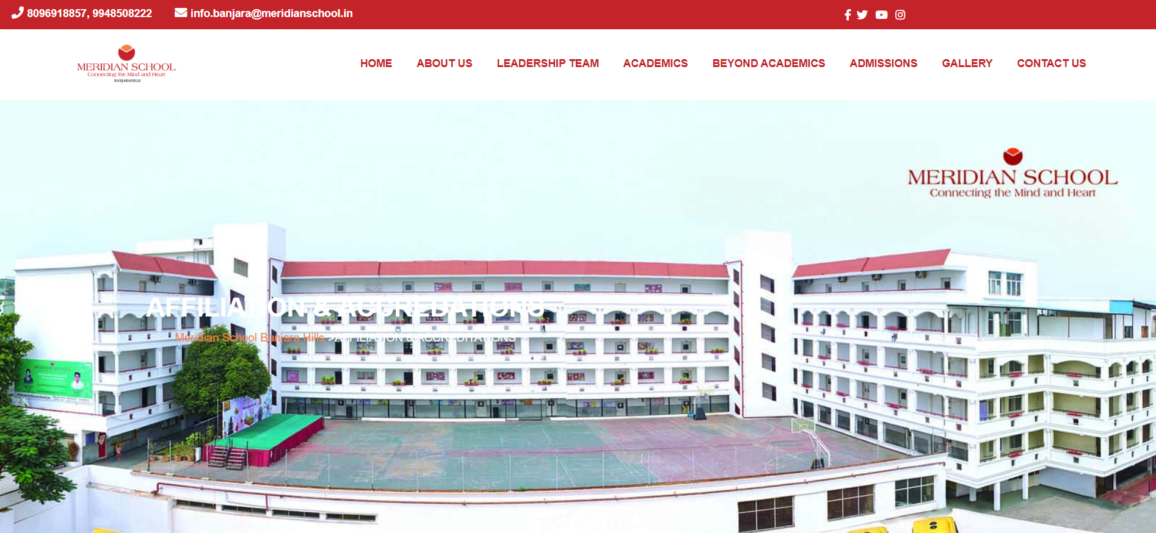

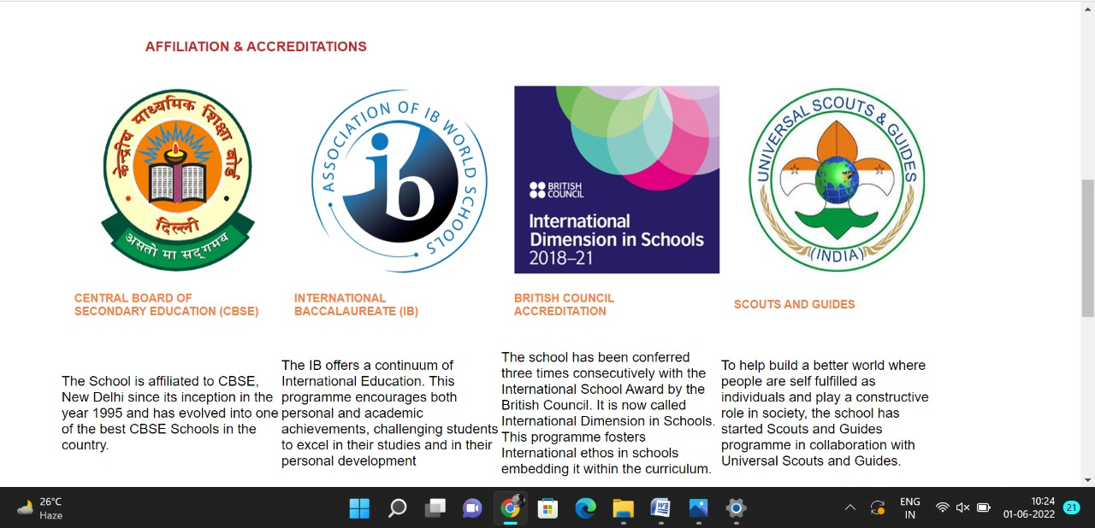

Leadership Team Pages

**PAGE 19:Principal**

**HTML CODE:**

<!DOCTYPE html>

<html lang="en">

<head>

    <meta charset="UTF-8">

    <meta http-equiv="X-UA-Compatible" content="IE=edge">

    <meta name="viewport" content="width=device-width, initial-scale=1.0">

    <title>PRINCIPAL - Meridian School</title>

    <link rel="stylesheet" href="style.css">

    <link rel="stylesheet" href="https://pro.fontawesome.com/releases/v5.10.0/css/all.css" />

    <link rel="icon" type="imag/logo2.png" href="img/logo2.png">

    <link rel="stylesheet" href="https://stackpath.bootstrapcdn.com/bootstrap/4.4.1/css/bootstrap.min.css"

        integrity="sha384-Vkoo8x4CGs03+Hhxv8T/Q5paXtkKtu6ug5TOeNV6gBiFeWPGFN9MuhOf23Q9Ifjh" crossorigin="anonymous" />

    <link rel="stylesheet" href="https://cdnjs.cloudflare.com/ajax/libs/slick-carousel/1.8.1/slick-theme.min.css"

        integrity="sha512-17EgCFERpgZKcm0j0fEq1YCJuyAWdz9KUtv1EjVuaOz8pDnh/0nZxmU6BBXwaaxqoi9PQXnRWqlcDB027hgv9A=="

        crossorigin="anonymous" referrerpolicy="no-referrer" />

    <link rel="stylesheet" href="https://cdnjs.cloudflare.com/ajax/libs/slick-carousel/1.8.1/slick.min.css"

        integrity="sha512-yHknP1/AwR+yx26cB1y0cjvQUMvEa2PFzt1c9LlS4pRQ5NOTZFWbhBig+X9G9eYW/8m0/4OXNx8pxJ6z57x0dw=="

        crossorigin="anonymous" referrerpolicy="no-referrer" />

</head>

<body>

    <section id="follow">

        <div class="followus">

            <div class="icon1">

                <i class="fa fa-phone"></i>

                <a id="phone" href="">8096918857, 9948508222</a>

            </div>

            <div class="icon1">

                <i class="fa fa-envelope"></i>

                <a id="mail" href="">info.banjara@meridianschool.in</a>

            </div>

            <div class="icon">

                <a href="https://www.facebook.com/MeridianSchoolBanjaraHills/" target="_blank"

                    class="fab fa-facebook-f"></i></a>

                <a href="https://twitter.com/meridianbanjara" target="_blank"><i class="fab fa-twitter"></i></a>

                <a href="https://www.youtube.com/channel/UCBZ_gLF9qM18O3CDWQHeN1A" target="_blank"><i

                        class="fab fa-youtube"></i></a>

                <a href="https://www.instagram.com/meridianschools/" target="_blank"><i

                        class="fab fa-instagram"></i></a>

            </div>

        </div>

    </section>

    <div class="navbar">

        <a href="home.html"><img src="img/logo.png" class="logo" alt=""></a>

        <nav>

            <a class="active" href="home.html">HOME</a>

            <div class="dropdown">

                <button class="dropbtn">ABOUT US

                </button>

                <div class="dropdown-content">

                    <a href="knowmeridian.html">KNOW MERIDIAN</a>

                    <a href="visionmission.html">THE VISION & MISSION</a>

                    <a href="http://meridianbanjara.com/the-founders/">THE FOUNDER'S MESSAGE</a>

                    <a href="ceomsg.html">CEO'S MESSAGE</a>

                    <a href="principalmsg.html">THE PRINCIPAL'S MESSAGE</a>

                    <a href="awards.html">AWARDS AND ACCOLADES</a>

                    <a href="http://meridianbanjara.com/affiliations-accreditations/">AFFILIATIONS & ACCREDITATIONS</a>

                    <a href="blog.html">BLOG</a>

                </div>

            </div>

            <div class="dropdown">

                <button class="dropbtn">LEADERSHIP TEAM

                </button>

                <div class="dropdown-content">

                    <a href="principal.html">PRINCIPAL</a>

                    <a href="vp.html">VICE PRINCIPAL</a>

                    <a href="headmistress.html">HEADMISTRESS</a>

                    <a href="midSchool.html">MIDDLE SCHOOL INCHARGE</a>

                    <a href="ipPyp.html">IB PYP COORDINATOR</a>

                    <a href="preprimary.html">PRE PRIMARY INCHARGE</a>

                    <a href="global.html">GLOBAL PARTNERSHIP COORDINATOR</a>

                </div>

            </div>

            <div class="dropdown">

                <button class="dropbtn">ACADEMICS

                </button>

                <div class="dropdown-content">

                    <a href="AcaOverview.html">OVERVIEW</a>

                    <a href="methodology.html">METHODOLOGY AND LEARNING STYLE</a>

                    <a href="curriculum.html">CURRICULUM</a>

                    <a href="faculty.html">FACULTY</a>

                    <a href="teacherTraining.html">TEACHER TRAINING</a>

                    <a href="careerGuidance.html">CAREER GUIDANCE</a>

                    <a href="scholrship.html">SCHOLARSHIP PROGRAMME</a>

                </div>

            </div>

            <div class="dropdown">

                <button class="dropbtn">BEYOND ACADEMICS

                </button>

                <div class="dropdown-content">

                    <a href="beyondAcaOverview.html">OVERVIEW</a>

                    <a href="sports.html">SPORTS</a>

                    <a href="creatveAct.html">CREATIVE ACTIVITIES</a>

                    <a href="eduTrips.html">EDUCATIONAL TRIPS AND STUDENT<br> EXCHANGE PROGRAMMES</a>

                    <a href="perfectSystem.html">PERFECT SYSTEM</a>

                    <a href="schoolSocialRes.html">SCHOOL'S SOCIAL RESPONSIBILITY</a>

                    <a href="interact.html">INTERACT</a>

                    <a href="heritageClub.html">HERITAGE CLUB</a>

                    <a href="mun.html">MUN</a>

                </div>

            </div>

            <div class="dropdown">

                <button class="dropbtn">ADMISSIONS

                </button>

                <div class="dropdown-content">

                    <a href="overview.html">OVERVIEW</a>

                    <a href="admissionpro.html">ADMISSION PROCEDURE</a>

                    <a href="feepolicy.html">FEE POLICY</a>

                    <a href="tranfercert.html">TRANSFER CERTIFICATE</a>

                    <a href="transport.html">TRANSPORT</a>

                </div>

            </div>

            <a class="active" href="gallery.html">GALLERY</a>

            <div class="dropdown">

                <button class="dropbtn">CONTACT US

                </button>

                <div class="dropdown-content">

                    <a href="contact.html">CAREERS</a>

                </div>

            </div>

        </nav>

    </div>

    <div id="mobile">

        <i id="bar" class="fas fa-outdent "></i>

    </div>

    <section id="principal">

        <div class="prin">

            <h2>PRINCIPAL</h2>

            <span id="orange"><a href="home.html">Meridian School Banjara Hills</a></span>

            <span> &gt; PRINCIPAL</span>

        </div>

    </section>

    <section id="principal1">

        <div class="princi1">

            <div id="img">

                <h4>PRINCIPAL</h4>

                <img src="img/leadership/principal1.jpg" alt="">

            </div>

            <div id="info">

                <p>William Butler Yeats rightly said, ‘Education is not the filling of a pail, but the lighting of a

                    fire.’ We at Meridian are deeply committed to kindle that spark in the child which would gradually

                    extinguish if not guarded. We are here to inspire and empower young minds to think independently,

                    integrate, excel and contribute to the betterment of the society. Anyone who walks through the gates

                    of Meridian , be it a student, a teacher or a parent feels welcomed and cared for. Such is the

                    warmth that one experiences at Meridian.</p>

                <p>As I took the charge of the post of Principal of Meridian Banjara Hills, I could sense the warmth and

                    love of the Meridian family. I too felt welcomed with open hands. Going by the very motto of the

                    school, I would try my best to connect the mind and heart in every fresh and innovative step that I

                    would take in connection with administration. Keeping in view the online instruction for the past

                    one and half years, we have introduced the concept of a bridge course as the students moved to the

                    next grade to drill them with the main concepts before the serious teaching started. Catering to the

                    demands of the NEP, we are also revising and reviewing our teaching strategies and instruction tools

                    at all levels. We are proud to claim the credit of possessing the best teaching faculty in the twin

                    cities with excellent qualification, years of experience and unflinching commitment towards their

                    noble profession. We are here not only to impart holistic education complete with 21st Century

                    skills and moral values, but also to develop in the students, the ability to apply, analyse,

                    organise and think out of the box and to connect everything they learn to real life.</p>

                <p>We invite parents, as stake holders of this institution, to take an active role in the grooming of

                    the child and help us do our best and their valuable suggestions will always be received in good

                    spirit.</p>

                <p>Academics is our main objective but not cramming. Freedom is given but not at the cost of discipline.

                    Here is our promise to you: In our preoccupation with the process of assessment of scholastic and co

                    scholastic areas, we will not forget our primary goal of anchoring our dear Meridianites in a sound

                    value system.</p>

                <p>Wishing Meridian All the Best for all times.</p>

                <p id="strong"><strong>Nishi Rana</strong></p>

                <p>Principal</p>

            </div>

        </div>

    </section>

    <footer>

        <div class="col">

            <h4>ABOUT US</h4>

            <p>Meridian is a New Generation Educational Group committed to educate children for life and thus bring a

                change in the society. Learning philosophy practised at Meridian infuses traditional values into a

                progressive approach, equipping students to adapt and excel anywhere in the world. Our alumni, working

                in diverse fields, have found Meridian to be the best school for a successful career take off.</p>

        </div>

        <div class="col">

            <h4>USEFUL LINKS</h4>

            <ul class="three-col-links">

                <li><a href="home.html">HOME</a></li>

                <li><a href="AcaOverview.html">ACADEMICS</a></li>

                <li><a href="overview.html">ADMISSIONS</a></li>

                <li><a href="contact.html">CONTACT US</a></li>

                <li><a href="knowmeridian.html">ABOUT US</a></li>

                <li><a href="beyondAcaOverview.html">BEYOND ACADEMICS</a></li>

                <li><a href="contact.html">CAREERS</a></li>

            </ul>

        </div>

        <div class="col">

            <!--<div class="follow">

                <div class="icon">

                    <i class="fa fa-paper-plane-o"></i>

                </div>

        </div>-->

            <h4>MERIDIAN SCHOOL, Banjara Hills</h4>

            <p># 8-2-541, Road No 7, Banjara Hills, Hyderabad-500034, TELANGANA, INDIA.</p>

            <p>For contact : +91 8096918857, 9948508222, For Prinicipal Appointments : 8098420002</p>

            <p> For Admissions / Enquires : 8096918857, 9948508222</p>

            <p>info.banjara@meridianschool.inA</p>

        </div>

    </footer>

    <section id="copyright">

        <div id="cr">

            <p>© Copyright MERIDIAN SCHOOL, 2021.</p>

        </div>

    </section>

</body>

</html>

**CSS CODE:**

#principal .prin {

background-image: url(img/leadership/principal.jpg);

height: 500px;

background-repeat: no-repeat;

padding: 230px 0 0 50px;

/* background-position: 100%; */

}

#principal .prin h2 {

font-size: 34px;

font-weight: 600;

text-align: start;

/* color: #c42329; */

}

#principal .prin span {

color: #fff;

}

#principal #orange {

color: #f48243;

}

#principal #orange:hover {

color: #fff;

}

#principal1 .princi1 {

display: flex;

}

#principal1 .princi1 img {

width: 250px;

height: 169px;

border: 7px solid rgb(225, 222, 222);

}

#principal1 .princi1 h4 {

text-align: start;

color: #c42329;

margin: 100px 0 35px 0px;

}

#principal1 .princi1 #img {

margin: 20px 0 0 100px;

}

#principal1 .princi1 #info {

width: 42%;

margin: 200px 53px 70px;

}

#principal1 .princi1 #info p {

margin-bottom: 20px;

}

#principal1 .princi1 #info #strong {

margin-bottom: 0px;

}

**OUTPUT:**

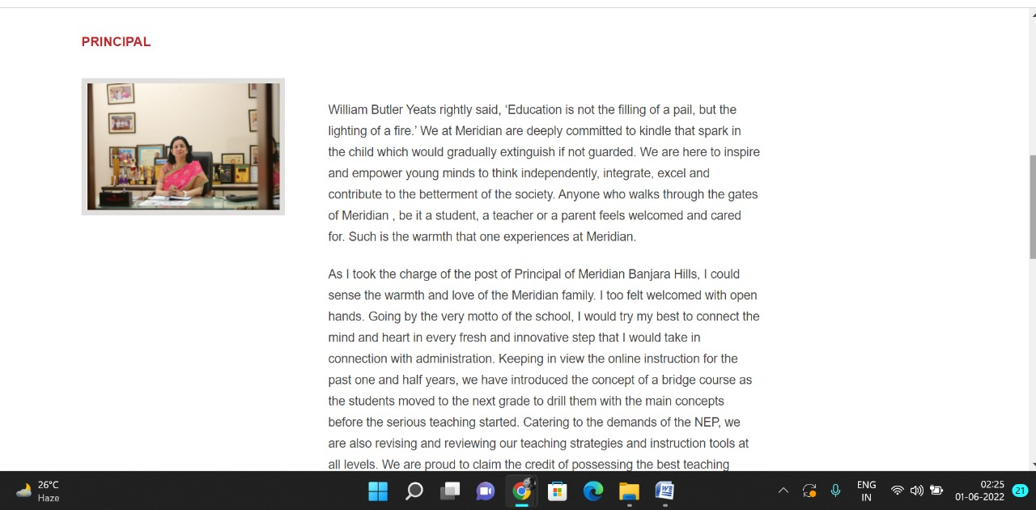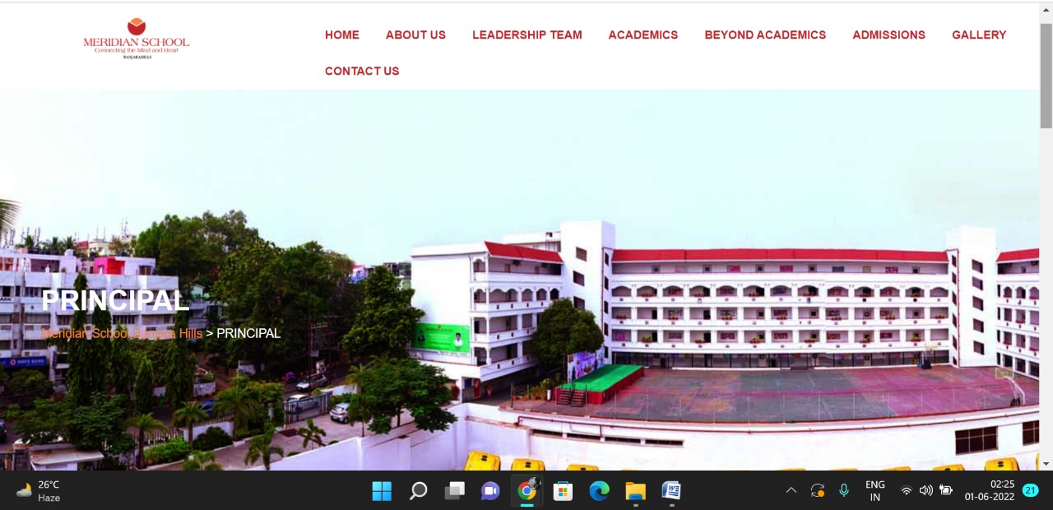

**PAGE 20:Vice Principal**

**HTML CODE:**

<!DOCTYPE html>

<html lang="en">

<head>

    <meta charset="UTF-8">

    <meta http-equiv="X-UA-Compatible" content="IE=edge">

    <meta name="viewport" content="width=device-width, initial-scale=1.0">

    <title>VICE PRINCIPAL - Meridian School</title>

    <link rel="stylesheet" href="style.css">

    <link rel="stylesheet" href="https://pro.fontawesome.com/releases/v5.10.0/css/all.css" />

    <link rel="icon" type="imag/logo2.png" href="img/logo2.png">

    <link rel="stylesheet" href="https://stackpath.bootstrapcdn.com/bootstrap/4.4.1/css/bootstrap.min.css"

        integrity="sha384-Vkoo8x4CGs03+Hhxv8T/Q5paXtkKtu6ug5TOeNV6gBiFeWPGFN9MuhOf23Q9Ifjh" crossorigin="anonymous" />

    <link rel="stylesheet" href="https://cdnjs.cloudflare.com/ajax/libs/slick-carousel/1.8.1/slick-theme.min.css"

        integrity="sha512-17EgCFERpgZKcm0j0fEq1YCJuyAWdz9KUtv1EjVuaOz8pDnh/0nZxmU6BBXwaaxqoi9PQXnRWqlcDB027hgv9A=="

        crossorigin="anonymous" referrerpolicy="no-referrer" />

    <link rel="stylesheet" href="https://cdnjs.cloudflare.com/ajax/libs/slick-carousel/1.8.1/slick.min.css"

        integrity="sha512-yHknP1/AwR+yx26cB1y0cjvQUMvEa2PFzt1c9LlS4pRQ5NOTZFWbhBig+X9G9eYW/8m0/4OXNx8pxJ6z57x0dw=="

        crossorigin="anonymous" referrerpolicy="no-referrer" />

</head>

<body>

    <section id="follow">

        <div class="followus">

            <div class="icon1">

                <i class="fa fa-phone"></i>

                <a id="phone" href="">8096918857, 9948508222</a>

            </div>

            <div class="icon1">

                <i class="fa fa-envelope"></i>

                <a id="mail" href="">info.banjara@meridianschool.in</a>

            </div>

            <div class="icon">

                <a href="https://www.facebook.com/MeridianSchoolBanjaraHills/" target="_blank"

                    class="fab fa-facebook-f"></i></a>

                <a href="https://twitter.com/meridianbanjara" target="_blank"><i class="fab fa-twitter"></i></a>

                <a href="https://www.youtube.com/channel/UCBZ_gLF9qM18O3CDWQHeN1A" target="_blank"><i

                        class="fab fa-youtube"></i></a>

                <a href="https://www.instagram.com/meridianschools/" target="_blank"><i

                        class="fab fa-instagram"></i></a>

            </div>

        </div>

    </section>

    <div class="navbar">

        <a href="home.html"><img src="img/logo.png" class="logo" alt=""></a>

        <nav>

            <a class="active" href="home.html">HOME</a>

            <div class="dropdown">

                <button class="dropbtn">ABOUT US

                </button>

                <div class="dropdown-content">

                    <a href="knowmeridian.html">KNOW MERIDIAN</a>

                    <a href="visionmission.html">THE VISION & MISSION</a>

                    <a href="http://meridianbanjara.com/the-founders/">THE FOUNDER'S MESSAGE</a>

                    <a href="ceomsg.html">CEO'S MESSAGE</a>

                    <a href="principalmsg.html">THE PRINCIPAL'S MESSAGE</a>

                    <a href="awards.html">AWARDS AND ACCOLADES</a>

                    <a href="http://meridianbanjara.com/affiliations-accreditations/">AFFILIATIONS & ACCREDITATIONS</a>

                    <a href="blog.html">BLOG</a>

                </div>

            </div>

            <div class="dropdown">

                <button class="dropbtn">LEADERSHIP TEAM

                </button>

                <div class="dropdown-content">

                    <a href="principal.html">PRINCIPAL</a>

                    <a href="vp.html">VICE PRINCIPAL</a>

                    <a href="headmistress.html">HEADMISTRESS</a>

                    <a href="midSchool.html">MIDDLE SCHOOL INCHARGE</a>

                    <a href="ipPyp.html">IB PYP COORDINATOR</a>

                    <a href="preprimary.html">PRE PRIMARY INCHARGE</a>

                    <a href="global.html">GLOBAL PARTNERSHIP COORDINATOR</a>

                </div>

            </div>

            <div class="dropdown">

                <button class="dropbtn">ACADEMICS

                </button>

                <div class="dropdown-content">

                    <a href="AcaOverview.html">OVERVIEW</a>

                    <a href="methodology.html">METHODOLOGY AND LEARNING STYLE</a>

                    <a href="curriculum.html">CURRICULUM</a>

                    <a href="faculty.html">FACULTY</a>

                    <a href="teacherTraining.html">TEACHER TRAINING</a>

                    <a href="careerGuidance.html">CAREER GUIDANCE</a>

                    <a href="scholrship.html">SCHOLARSHIP PROGRAMME</a>

                </div>

            </div>

            <div class="dropdown">

                <button class="dropbtn">BEYOND ACADEMICS

                </button>

                <div class="dropdown-content">

                    <a href="beyondAcaOverview.html">OVERVIEW</a>

                    <a href="sports.html">SPORTS</a>

                    <a href="creatveAct.html">CREATIVE ACTIVITIES</a>

                    <a href="eduTrips.html">EDUCATIONAL TRIPS AND STUDENT<br> EXCHANGE PROGRAMMES</a>

                    <a href="perfectSystem.html">PERFECT SYSTEM</a>

                    <a href="schoolSocialRes.html">SCHOOL'S SOCIAL RESPONSIBILITY</a>

                    <a href="interact.html">INTERACT</a>

                    <a href="heritageClub.html">HERITAGE CLUB</a>

                    <a href="mun.html">MUN</a>

                </div>

            </div>

            <div class="dropdown">

                <button class="dropbtn">ADMISSIONS

                </button>

                <div class="dropdown-content">

                    <a href="overview.html">OVERVIEW</a>

                    <a href="admissionpro.html">ADMISSION PROCEDURE</a>

                    <a href="feepolicy.html">FEE POLICY</a>

                    <a href="tranfercert.html">TRANSFER CERTIFICATE</a>

                    <a href="transport.html">TRANSPORT</a>

                </div>

            </div>

            <a class="active" href="gallery.html">GALLERY</a>

            <div class="dropdown">

                <button class="dropbtn">CONTACT US

                </button>

                <div class="dropdown-content">

                    <a href="contact.html">CAREERS</a>

                </div>

            </div>

        </nav>

    </div>

    <div id="mobile">

        <i id="bar" class="fas fa-outdent "></i>

    </div>

    <section id="principal">

        <div class="prin">

            <h2>VICE PRINCIPAL</h2>

            <span id="orange"><a href="home.html">Meridian School Banjara Hills</a></span>

            <span> &gt; VICE PRINCIPAL</span>

        </div>

    </section>

    <section id="vp">

        <div class="vp1">

            <div id="info">

                <h4>VICE PRINCIPAL</h4>

                <h5>Ms. Rahat Rashed</h5>

                <p>Mrs.Rahat Rashed, a proud recipient of two prestigious awards – APJ Kalam Career Excellence and

                    Dr.Radha Krishnan Aadarsh Shikshak Samman is the Vice Principal, Meridian School, Banjara Hills. She

                    is an experienced educator and psychologist. A double Post Graduate in Organic Chemistry and

                    Psychology, Mrs.Rahat Rashed adopts a holistic approach in handling children and adolescents and has

                    over 20 years of teaching and administrative experience. It is determination, goal oriented focus

                    and hard work that drive her to achieve.</p>

                <p>She has extraordinary interpersonal skills and her interaction with parents, teachers and students is

                    exemplary. Her rapport with all the stakeholders of the institution exhibits her empathy, problem

                    solving skills and a holistic approach towards the issue at hand. Mrs.Rahat is proficient in almost

                    all subjects and has taught Math, Science, English, Social Science and Chemistry at various levels.

                    Mrs. Rahat is Incharge of Senior Secondary and currently teaches Science and Psychology at Senior

                    Secondary level. Her contribution towards the growth of the school working in various capacities is

                    highly noteworthy. Her upward journey from a faculty member to Headmistress of Primary School and to

                    the current position of Vice Principal is a testimony to her diligence and commitment.</p>

                <p>The Heads of the institute know her as an ardent Incharge that they can rely upon. Under her

                    innovative guidance the school has showcased many memorable and successful Annual Days and

                    scintillating Sports Days. Her colleagues know her as a perfectionist and a wonderful superior to

                    work with. Her style of working provides a proportionate combination of flexibility and rigidity.

                    For the students, she is the most friendly and accessible mentor who understands them better than

                    their parents themselves. She has counseled and mentored many adolescents, both girls and boys,

                    assisting them in passing through the tough phase of life comfortably. Being a scholar in psychology

                    Mrs.Rahat is keen about the policy of inclusive education and is passionate about implementing

                    differential and special education methods while handling differently abled students.</p>

                <p>Her never give up attitude has inspired many youngsters. Her friendly nature, willingness to serve

                    the needy and sense of wit and humour have touched many hearts. Mrs.Rahat has been an integral part

                    of the journey of Meridian school and is an indispensable asset of the same.</p>

            </div>

            <div id="img">

                <img src="img/leadership/vp.jpeg" alt="">

            </div>

        </div>

    </section>

    <footer>

        <div class="col">

            <h4>ABOUT US</h4>

            <p>Meridian is a New Generation Educational Group committed to educate children for life and thus bring a

                change in the society. Learning philosophy practised at Meridian infuses traditional values into a

                progressive approach, equipping students to adapt and excel anywhere in the world. Our alumni, working

                in diverse fields, have found Meridian to be the best school for a successful career take off.</p>

        </div>

        <div class="col">

            <h4>USEFUL LINKS</h4>

            <ul class="three-col-links">

                <li><a href="home.html">HOME</a></li>

                <li><a href="AcaOverview.html">ACADEMICS</a></li>

                <li><a href="overview.html">ADMISSIONS</a></li>

                <li><a href="contact.html">CONTACT US</a></li>

                <li><a href="knowmeridian.html">ABOUT US</a></li>

                <li><a href="beyondAcaOverview.html">BEYOND ACADEMICS</a></li>

                <li><a href="contact.html">CAREERS</a></li>

            </ul>

        </div>

        <div class="col">

            <!--<div class="follow">

                <div class="icon">

                    <i class="fa fa-paper-plane-o"></i>

                </div>

        </div>-->

            <h4>MERIDIAN SCHOOL, Banjara Hills</h4>

            <p># 8-2-541, Road No 7, Banjara Hills, Hyderabad-500034, TELANGANA, INDIA.</p>

            <p>For contact : +91 8096918857, 9948508222, For Prinicipal Appointments : 8098420002</p>

            <p> For Admissions / Enquires : 8096918857, 9948508222</p>

            <p>info.banjara@meridianschool.inA</p>

        </div>

    </footer>

    <section id="copyright">

        <div id="cr">

            <p>© Copyright MERIDIAN SCHOOL, 2021.</p>

        </div>

    </section>

</body>

</html>

**CSS CODE:**

[7:02 pm, 01/06/2022] Roshini C3: #vp .vp1 {

display: flex;

margin: 150px 70px 130px 70px;

}

#vp .vp1 #info {

width: 70%;

}

#vp .vp1 #info h4 {

margin: -55px 0px 35px 0px;

color: #c42329;

}

#vp .vp1 #info h5 {

color: #f48243;

margin: 20px 0 14px 0;

}

#vp .vp1 #info p {

margin-bottom: 20px;

}

#vp .vp1 img {

width: 361px;

height: 413px;

border: 7px solid rgb(225, 222, 222);

}

#vp .vp1 #img {

margin-left: 60px;

}

#vp .vp1 img {

width: 272px;

margin-left: 72px;

height: 315px;

border: 7px solid rgb(225, 222, 222);

}

#vp .vp1 #info2 {

width: 70%;

}

[7:03 pm, 01/06/2022] Roshini C3: /* leadership -> midschool incharge(midschool.html) */

#vp .vp1 #img3 img {

width: 366px;

height: 600px;

margin-left: 20px;

}

[7:03 pm, 01/06/2022] Roshini C3: /* leadership -> PRE PRIMARY INCHARGE (preprimary.html) */

#vp .vp1 #img4 img {

width: 366px;

height: 385px;

margin-left: 20px;

}

[7:03 pm, 01/06/2022] Roshini C3: /* leadership -> IB PYP COORDINATOR (ipPyp.html) */

#ip .ip1 {

display: flex;

margin: 80px 60px;

}

#ip .ip1 #img4 img {

width: 233px;

height: 280px;

border: 7px solid rgb(225, 222, 222);

}

#ip .ip1 #info2 {

width: 80%;

margin: 73px 40px;

}

#ip .ip1 #info2 h5 {

margin: 0px 0 25px;

color: #f48243;

}

#ip .ip1 #info2 p {

margin-bottom: 20px;

}

**OUTPUT:**

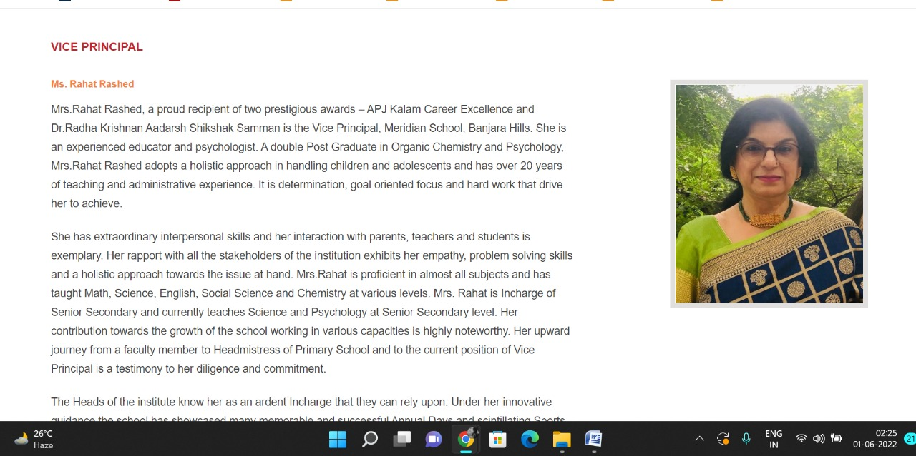

**PAGE 21:Headmistress**

**HTML CODE:**

<!DOCTYPE html>

<html lang="en">

<head>

    <meta charset="UTF-8">

    <meta http-equiv="X-UA-Compatible" content="IE=edge">

    <meta name="viewport" content="width=device-width, initial-scale=1.0">

    <title>HEADMISTRESS - Meridian School</title>

    <link rel="stylesheet" href="style.css">

    <link rel="stylesheet" href="https://pro.fontawesome.com/releases/v5.10.0/css/all.css" />

    <link rel="icon" type="imag/logo2.png" href="img/logo2.png">

    <link rel="stylesheet" href="https://stackpath.bootstrapcdn.com/bootstrap/4.4.1/css/bootstrap.min.css"

        integrity="sha384-Vkoo8x4CGs03+Hhxv8T/Q5paXtkKtu6ug5TOeNV6gBiFeWPGFN9MuhOf23Q9Ifjh" crossorigin="anonymous" />

    <link rel="stylesheet" href="https://cdnjs.cloudflare.com/ajax/libs/slick-carousel/1.8.1/slick-theme.min.css"

        integrity="sha512-17EgCFERpgZKcm0j0fEq1YCJuyAWdz9KUtv1EjVuaOz8pDnh/0nZxmU6BBXwaaxqoi9PQXnRWqlcDB027hgv9A=="

        crossorigin="anonymous" referrerpolicy="no-referrer" />

    <link rel="stylesheet" href="https://cdnjs.cloudflare.com/ajax/libs/slick-carousel/1.8.1/slick.min.css"

        integrity="sha512-yHknP1/AwR+yx26cB1y0cjvQUMvEa2PFzt1c9LlS4pRQ5NOTZFWbhBig+X9G9eYW/8m0/4OXNx8pxJ6z57x0dw=="

        crossorigin="anonymous" referrerpolicy="no-referrer" />

</head>

<body>

    <section id="follow">

        <div class="followus">

            <div class="icon1">

                <i class="fa fa-phone"></i>

                <a id="phone" href="">8096918857, 9948508222</a>

            </div>

            <div class="icon1">

                <i class="fa fa-envelope"></i>

                <a id="mail" href="">info.banjara@meridianschool.in</a>

            </div>

            <div class="icon">

                <a href="https://www.facebook.com/MeridianSchoolBanjaraHills/" target="_blank"

                    class="fab fa-facebook-f"></i></a>

                <a href="https://twitter.com/meridianbanjara" target="_blank"><i class="fab fa-twitter"></i></a>

                <a href="https://www.youtube.com/channel/UCBZ_gLF9qM18O3CDWQHeN1A" target="_blank"><i

                        class="fab fa-youtube"></i></a>

                <a href="https://www.instagram.com/meridianschools/" target="_blank"><i

                        class="fab fa-instagram"></i></a>

            </div>

        </div>

    </section>

    <div class="navbar">

        <a href="home.html"><img src="img/logo.png" class="logo" alt=""></a>

        <nav>

            <a class="active" href="home.html">HOME</a>

            <div class="dropdown">

                <button class="dropbtn">ABOUT US

                </button>

                <div class="dropdown-content">

                    <a href="knowmeridian.html">KNOW MERIDIAN</a>

                    <a href="visionmission.html">THE VISION & MISSION</a>

                    <a href="http://meridianbanjara.com/the-founders/">THE FOUNDER'S MESSAGE</a>

                    <a href="ceomsg.html">CEO'S MESSAGE</a>

                    <a href="principalmsg.html">THE PRINCIPAL'S MESSAGE</a>

                    <a href="awards.html">AWARDS AND ACCOLADES</a>

                    <a href="http://meridianbanjara.com/affiliations-accreditations/">AFFILIATIONS & ACCREDITATIONS</a>

                    <a href="blog.html">BLOG</a>

                </div>

            </div>

            <div class="dropdown">

                <button class="dropbtn">LEADERSHIP TEAM

                </button>

                <div class="dropdown-content">

                    <a href="principal.html">PRINCIPAL</a>

                    <a href="vp.html">VICE PRINCIPAL</a>

                    <a href="headmistress.html">HEADMISTRESS</a>

                    <a href="midSchool.html">MIDDLE SCHOOL INCHARGE</a>

                    <a href="ipPyp.html">IB PYP COORDINATOR</a>

                    <a href="preprimary.html">PRE PRIMARY INCHARGE</a>

                    <a href="global.html">GLOBAL PARTNERSHIP COORDINATOR</a>

                </div>

            </div>

            <div class="dropdown">

                <button class="dropbtn">ACADEMICS

                </button>

                <div class="dropdown-content">

                    <a href="AcaOverview.html">OVERVIEW</a>

                    <a href="methodology.html">METHODOLOGY AND LEARNING STYLE</a>

                    <a href="curriculum.html">CURRICULUM</a>

                    <a href="faculty.html">FACULTY</a>

                    <a href="teacherTraining.html">TEACHER TRAINING</a>

                    <a href="careerGuidance.html">CAREER GUIDANCE</a>

                    <a href="scholrship.html">SCHOLARSHIP PROGRAMME</a>

                </div>

            </div>

            <div class="dropdown">

                <button class="dropbtn">BEYOND ACADEMICS

                </button>

                <div class="dropdown-content">

                    <a href="beyondAcaOverview.html">OVERVIEW</a>

                    <a href="sports.html">SPORTS</a>

                    <a href="creatveAct.html">CREATIVE ACTIVITIES</a>

                    <a href="eduTrips.html">EDUCATIONAL TRIPS AND STUDENT<br> EXCHANGE PROGRAMMES</a>

                    <a href="perfectSystem.html">PERFECT SYSTEM</a>

                    <a href="schoolSocialRes.html">SCHOOL'S SOCIAL RESPONSIBILITY</a>

                    <a href="interact.html">INTERACT</a>

                    <a href="heritageClub.html">HERITAGE CLUB</a>

                    <a href="mun.html">MUN</a>

                </div>

            </div>

            <div class="dropdown">

                <button class="dropbtn">ADMISSIONS

                </button>

                <div class="dropdown-content">

                    <a href="overview.html">OVERVIEW</a>

                    <a href="admissionpro.html">ADMISSION PROCEDURE</a>

                    <a href="feepolicy.html">FEE POLICY</a>

                    <a href="tranfercert.html">TRANSFER CERTIFICATE</a>

                    <a href="transport.html">TRANSPORT</a>

                </div>

            </div>

            <a class="active" href="gallery.html">GALLERY</a>

            <div class="dropdown">

                <button class="dropbtn">CONTACT US

                </button>

                <div class="dropdown-content">

                    <a href="contact.html">CAREERS</a>

                </div>

            </div>

        </nav>

    </div>

    <div id="mobile">

        <i id="bar" class="fas fa-outdent "></i>

    </div>

    <section id="principal">

        <div class="prin">

            <h2>HEADMISTRESS</h2>

            <span id="orange"><a href="home.html">Meridian School Banjara Hills</a></span>

            <span> &gt; HEADMISTRESS</span>

        </div>

    </section>

    <section id="vp">

        <div class="vp1">

            <div id="info">

                <h4>HEADMISTRESS</h4>

                <h5>Ms. Rajkamal Matthews</h5>

                <p>Ms.Rajkamal Matthews has served Meridian School, Banjara Hills for over one and a half decade in the

                    capacity of Headmistress for the High School. She has more than 25 years of experience in the field

                    of education and administration. A Post Graduate in English Literature, PGCTE from EFLU and with

                    B.Ed in English and Special English , her authority lies in communications skills and creative

                    expression.</p>

                <p>Ms. Matthews is a passionate teacher of English and a compassionate administrator working with the

                    team. Her continuous efforts in adapting to the latest teaching strategies and skills have helped

                    teachers and learners to achieve the best results. She is known for her methodical approach,

                    meticulous planning in providing the needed guidance and mentorship to her team.</p>

                <p>Ms. Matthews is a strict disciplinarian who believes in self – discipline and value based approach to

                    academics. She maintains a friendly rapport with students as well as parents and is very

                    approachable.</p>

                <p>Her enthusiasm in taking the academic challenges in the ever changing scenario of the department of

                    education resulted in excellent performance at the Boards year after year. Under her able guidance

                    and keen involvement, Meridian has presented numerous Annual days and Sports days down the years

                    with huge success. Her contribution to the growth of the school is highly commendable and she is a

                    valuable asset to the Meridian family.</p>

            </div>

            <div id="img2">

                <img src="img/leadership/headmastress.jpeg" alt="">

            </div>

        </div>

    </section>

    <footer>

        <div class="col">

            <h4>ABOUT US</h4>

            <p>Meridian is a New Generation Educational Group committed to educate children for life and thus bring a

                change in the society. Learning philosophy practised at Meridian infuses traditional values into a

                progressive approach, equipping students to adapt and excel anywhere in the world. Our alumni, working

                in diverse fields, have found Meridian to be the best school for a successful career take off.</p>

        </div>

        <div class="col">

            <h4>USEFUL LINKS</h4>

            <ul class="three-col-links">

                <li><a href="home.html">HOME</a></li>

                <li><a href="AcaOverview.html">ACADEMICS</a></li>

                <li><a href="overview.html">ADMISSIONS</a></li>

                <li><a href="contact.html">CONTACT US</a></li>

                <li><a href="knowmeridian.html">ABOUT US</a></li>

                <li><a href="beyondAcaOverview.html">BEYOND ACADEMICS</a></li>

                <li><a href="contact.html">CAREERS</a></li>

            </ul>

        </div>

        <div class="col">

            <!--<div class="follow">

                <div class="icon">

                    <i class="fa fa-paper-plane-o"></i>

                </div>

        </div>-->

            <h4>MERIDIAN SCHOOL, Banjara Hills</h4>

            <p># 8-2-541, Road No 7, Banjara Hills, Hyderabad-500034, TELANGANA, INDIA.</p>

            <p>For contact : +91 8096918857, 9948508222, For Prinicipal Appointments : 8098420002</p>

            <p> For Admissions / Enquires : 8096918857, 9948508222</p>

            <p>info.banjara@meridianschool.inA</p>

        </div>

    </footer>

    <section id="copyright">

        <div id="cr">

            <p>© Copyright MERIDIAN SCHOOL, 2021.</p>

        </div>

    </section>

</body>

</html>

**CSS CODE:**

#principal .prin {

background-image: url(img/leadership/headmistress.jpg);

height: 500px;

background-repeat: no-repeat;

padding: 230px 0 0 50px;

/* background-position: 100%; */

}

#principal .prin h2 {

font-size: 34px;

font-weight: 600;

text-align: start;

/* color: #c42329; */

}

#principal .prin span {

color: #fff;

}

#principal #orange {

color: #f48243;

}

#principal #orange:hover {

color: #fff;

}

#principal1 .princi1 {

display: flex;

}

#principal1 .princi1 img {

width: 250px;

height: 169px;

border: 7px solid rgb(225, 222, 222);

}

#principal1 .princi1 h4 {

text-align: start;

color: #c42329;

margin: 100px 0 35px 0px;

}

#principal1 .princi1 #img {

margin: 20px 0 0 100px;

}

#principal1 .princi1 #info {

width: 42%;

margin: 200px 53px 70px;

}

#principal1 .princi1 #info p {

margin-bottom: 20px;

}

#principal1 .princi1 #info #strong {

margin-bottom: 0px;

}

**OUTPUT:**

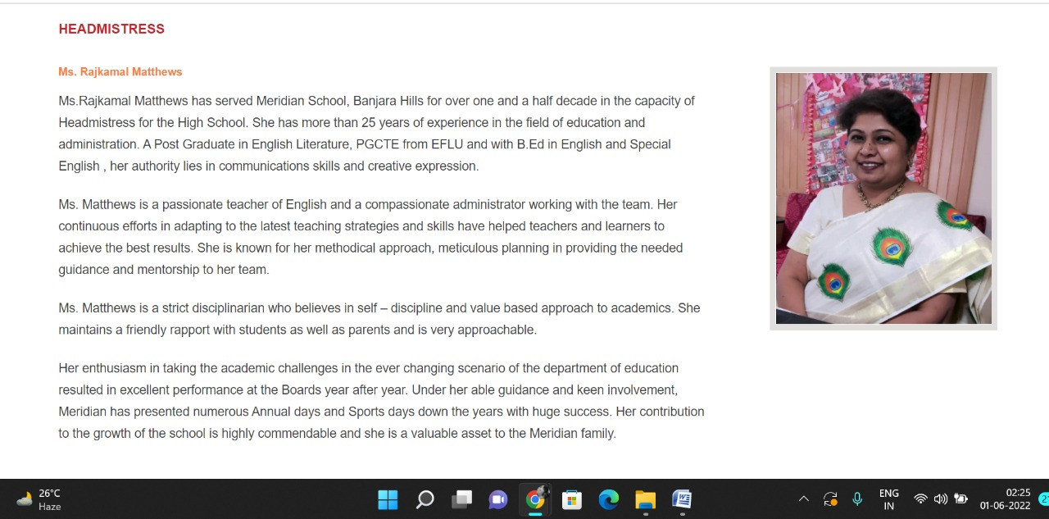

**PAGE 22:Middle School Incharge**

**HTML CODE:**

<!DOCTYPE html>

<html lang="en">

<head>

    <meta charset="UTF-8">

    <meta http-equiv="X-UA-Compatible" content="IE=edge">

    <meta name="viewport" content="width=device-width, initial-scale=1.0">

    <title>MIDDLE SCHOOL INCHARGE - Meridian School</title>

    <link rel="stylesheet" href="style.css">

    <link rel="stylesheet" href="https://pro.fontawesome.com/releases/v5.10.0/css/all.css" />

    <link rel="icon" type="imag/logo2.png" href="img/logo2.png">

    <link rel="stylesheet" href="https://stackpath.bootstrapcdn.com/bootstrap/4.4.1/css/bootstrap.min.css"

        integrity="sha384-Vkoo8x4CGs03+Hhxv8T/Q5paXtkKtu6ug5TOeNV6gBiFeWPGFN9MuhOf23Q9Ifjh" crossorigin="anonymous" />

    <link rel="stylesheet" href="https://cdnjs.cloudflare.com/ajax/libs/slick-carousel/1.8.1/slick-theme.min.css"

        integrity="sha512-17EgCFERpgZKcm0j0fEq1YCJuyAWdz9KUtv1EjVuaOz8pDnh/0nZxmU6BBXwaaxqoi9PQXnRWqlcDB027hgv9A=="

        crossorigin="anonymous" referrerpolicy="no-referrer" />

    <link rel="stylesheet" href="https://cdnjs.cloudflare.com/ajax/libs/slick-carousel/1.8.1/slick.min.css"

        integrity="sha512-yHknP1/AwR+yx26cB1y0cjvQUMvEa2PFzt1c9LlS4pRQ5NOTZFWbhBig+X9G9eYW/8m0/4OXNx8pxJ6z57x0dw=="

        crossorigin="anonymous" referrerpolicy="no-referrer" />

</head>

<body>

    <section id="follow">

        <div class="followus">

            <div class="icon1">

                <i class="fa fa-phone"></i>

                <a id="phone" href="">8096918857, 9948508222</a>

            </div>

            <div class="icon1">

                <i class="fa fa-envelope"></i>

                <a id="mail" href="">info.banjara@meridianschool.in</a>

            </div>

            <div class="icon">

                <a href="https://www.facebook.com/MeridianSchoolBanjaraHills/" target="_blank"

                    class="fab fa-facebook-f"></i></a>

                <a href="https://twitter.com/meridianbanjara" target="_blank"><i class="fab fa-twitter"></i></a>

                <a href="https://www.youtube.com/channel/UCBZ_gLF9qM18O3CDWQHeN1A" target="_blank"><i

                        class="fab fa-youtube"></i></a>

                <a href="https://www.instagram.com/meridianschools/" target="_blank"><i

                        class="fab fa-instagram"></i></a>

            </div>

        </div>

    </section>

    <div class="navbar">

        <a href="home.html"><img src="img/logo.png" class="logo" alt=""></a>

        <nav>

            <a class="active" href="home.html">HOME</a>

            <div class="dropdown">

                <button class="dropbtn">ABOUT US

                </button>

                <div class="dropdown-content">

                    <a href="knowmeridian.html">KNOW MERIDIAN</a>

                    <a href="visionmission.html">THE VISION & MISSION</a>

                    <a href="http://meridianbanjara.com/the-founders/">THE FOUNDER'S MESSAGE</a>

                    <a href="ceomsg.html">CEO'S MESSAGE</a>

                    <a href="principalmsg.html">THE PRINCIPAL'S MESSAGE</a>

                    <a href="awards.html">AWARDS AND ACCOLADES</a>

                    <a href="http://meridianbanjara.com/affiliations-accreditations/">AFFILIATIONS & ACCREDITATIONS</a>

                    <a href="blog.html">BLOG</a>

                </div>

            </div>

            <div class="dropdown">

                <button class="dropbtn">LEADERSHIP TEAM

                </button>

                <div class="dropdown-content">

                    <a href="principal.html">PRINCIPAL</a>

                    <a href="vp.html">VICE PRINCIPAL</a>

                    <a href="headmistress.html">HEADMISTRESS</a>

                    <a href="midSchool.html">MIDDLE SCHOOL INCHARGE</a>

                    <a href="ipPyp.html">IB PYP COORDINATOR</a>

                    <a href="preprimary.html">PRE PRIMARY INCHARGE</a>

                    <a href="global.html">GLOBAL PARTNERSHIP COORDINATOR</a>

                </div>

            </div>

            <div class="dropdown">

                <button class="dropbtn">ACADEMICS

                </button>

                <div class="dropdown-content">

                    <a href="AcaOverview.html">OVERVIEW</a>

                    <a href="methodology.html">METHODOLOGY AND LEARNING STYLE</a>

                    <a href="curriculum.html">CURRICULUM</a>

                    <a href="faculty.html">FACULTY</a>

                    <a href="teacherTraining.html">TEACHER TRAINING</a>

                    <a href="careerGuidance.html">CAREER GUIDANCE</a>

                    <a href="scholrship.html">SCHOLARSHIP PROGRAMME</a>

                </div>

            </div>

            <div class="dropdown">

                <button class="dropbtn">BEYOND ACADEMICS

                </button>

                <div class="dropdown-content">

                    <a href="beyondAcaOverview.html">OVERVIEW</a>

                    <a href="sports.html">SPORTS</a>

                    <a href="creatveAct.html">CREATIVE ACTIVITIES</a>

                    <a href="eduTrips.html">EDUCATIONAL TRIPS AND STUDENT<br> EXCHANGE PROGRAMMES</a>

                    <a href="perfectSystem.html">PERFECT SYSTEM</a>

                    <a href="schoolSocialRes.html">SCHOOL'S SOCIAL RESPONSIBILITY</a>

                    <a href="interact.html">INTERACT</a>

                    <a href="heritageClub.html">HERITAGE CLUB</a>

                    <a href="mun.html">MUN</a>

                </div>

            </div>

            <div class="dropdown">

                <button class="dropbtn">ADMISSIONS

                </button>

                <div class="dropdown-content">

                    <a href="overview.html">OVERVIEW</a>

                    <a href="admissionpro.html">ADMISSION PROCEDURE</a>

                    <a href="feepolicy.html">FEE POLICY</a>

                    <a href="tranfercert.html">TRANSFER CERTIFICATE</a>

                    <a href="transport.html">TRANSPORT</a>

                </div>

            </div>

            <a class="active" href="gallery.html">GALLERY</a>

            <div class="dropdown">

                <button class="dropbtn">CONTACT US

                </button>

                <div class="dropdown-content">

                    <a href="contact.html">CAREERS</a>

                </div>

            </div>

        </nav>

    </div>

    <div id="mobile">

        <i id="bar" class="fas fa-outdent "></i>

    </div>

    <section id="principal">

        <div class="prin">

            <h2>MIDDLE SCHOOL INCHARGE</h2>

            <span id="orange"><a href="home.html">Meridian School Banjara Hills</a></span>

            <span> &gt; MIDDLE SCHOOL INCHARGE</span>

        </div>

    </section>

    <section id="vp">

        <div class="vp1">

            <div id="info">

                <h4>MIDDLE SCHOOL INCHARGE</h4>

                <h5>Ms. Padmashree Madabhushi</h5>

                <p>Mrs.Padmashree Madabhushi , In-Charge Middle School, has had a long and enriching association with

                    Meridian Banjara both as a parent and as a teacher of Legal Studies at the Senior Secondary level.

                    Recipient of the Telangana State Best Teacher Award from Telangana Government , she combines her

                    administrative abilities with academic initiatives to bring Quality Learning. Her contribution to

                    the success of the school as In-Charge Primary and now as In-Charge Middle School remains

                    unparalleled. Actively involved in Social Outreach Programs like flood relief measures she

                    inculcates a sense of social commitment in students. She combines passion with perseverance in the

                    pursuit of excellence and leads through example and inspiration.</p>

                <p>As a Legal Studies instructor, Ms.Padmashree is instrumental in initiating the Inter school Moot

                    Court competition the first ever of its kind in the twin cities. She also handles the responsibility

                    of organizing various Inter school competitions and orientation programmes like Scouts and Guides

                    which enabled the students to join an interactive session with the President of India, His

                    Excellency Ramnath Kovind. Her role in the working of the school is valuable and indispensable.</p>

            </div>

            <div id="img3">

                <img src="img/leadership/midSchoolIncharge.jpeg" alt="">

            </div>

        </div>

    </section>

    <footer>

        <div class="col">

            <h4>ABOUT US</h4>

            <p>Meridian is a New Generation Educational Group committed to educate children for life and thus bring a

                change in the society. Learning philosophy practised at Meridian infuses traditional values into a

                progressive approach, equipping students to adapt and excel anywhere in the world. Our alumni, working

                in diverse fields, have found Meridian to be the best school for a successful career take off.</p>

        </div>

        <div class="col">

            <h4>USEFUL LINKS</h4>

            <ul class="three-col-links">

                <li><a href="home.html">HOME</a></li>

                <li><a href="AcaOverview.html">ACADEMICS</a></li>

                <li><a href="overview.html">ADMISSIONS</a></li>

                <li><a href="contact.html">CONTACT US</a></li>

                <li><a href="knowmeridian.html">ABOUT US</a></li>

                <li><a href="beyondAcaOverview.html">BEYOND ACADEMICS</a></li>

                <li><a href="contact.html">CAREERS</a></li>

            </ul>

        </div>

        <div class="col">

            <!--<div class="follow">

                <div class="icon">

                    <i class="fa fa-paper-plane-o"></i>

                </div>

        </div>-->

            <h4>MERIDIAN SCHOOL, Banjara Hills</h4>

            <p># 8-2-541, Road No 7, Banjara Hills, Hyderabad-500034, TELANGANA, INDIA.</p>

            <p>For contact : +91 8096918857, 9948508222, For Prinicipal Appointments : 8098420002</p>

            <p> For Admissions / Enquires : 8096918857, 9948508222</p>

            <p>info.banjara@meridianschool.inA</p>

        </div>

    </footer>

    <section id="copyright">

        <div id="cr">

            <p>© Copyright MERIDIAN SCHOOL, 2021.</p>

        </div>

    </section>

</body>

</html>

**CSS CODE:**

#principal .prin h2 {

font-size: 34px;

font-weight: 600;

text-align: start;

/* color: #c42329; */

}

#principal .prin span {

color: #fff;

}

#principal #orange {

color: #f48243;

}

#principal #orange:hover {

color: #fff;

}

#principal1 .princi1 {

display: flex;

}

#principal1 .princi1 img {

width: 250px;

height: 169px;

border: 7px solid rgb(225, 222, 222);

}

#principal1 .princi1 h4 {

text-align: start;

color: #c42329;

margin: 100px 0 35px 0px;

}

#principal1 .princi1 #info {

width: 42%;

margin: 200px 53px 70px;

}

#principal1 .princi1 #info p {

margin-bottom: 20px;

}

#principal1 .princi1 #info #strong {

margin-bottom: 0px;

}

#principal .princi1 #info h5 {

    color: #f48243;

    margin: -20px 0px 35px 70px;

}

**OUTPUT:**

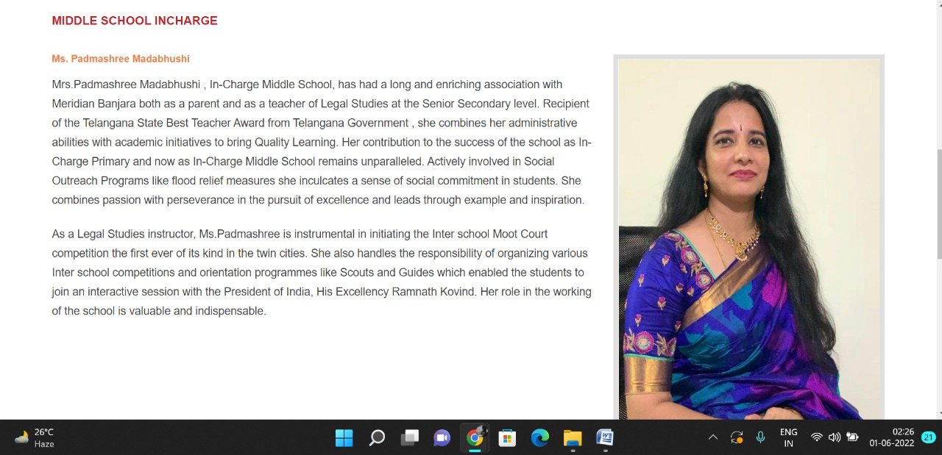

**PAGE 23:IB PYP Coordinator**

**HTML CODE:**

<!DOCTYPE html>

<html lang="en">

<head>

    <meta charset="UTF-8">

    <meta http-equiv="X-UA-Compatible" content="IE=edge">

    <meta name="viewport" content="width=device-width, initial-scale=1.0">

    <title>IB PYP COORDINATOR - Meridian School</title>

    <link rel="stylesheet" href="style.css">

    <link rel="stylesheet" href="https://pro.fontawesome.com/releases/v5.10.0/css/all.css" />

    <link rel="icon" type="imag/logo2.png" href="img/logo2.png">

    <link rel="stylesheet" href="https://stackpath.bootstrapcdn.com/bootstrap/4.4.1/css/bootstrap.min.css"

        integrity="sha384-Vkoo8x4CGs03+Hhxv8T/Q5paXtkKtu6ug5TOeNV6gBiFeWPGFN9MuhOf23Q9Ifjh" crossorigin="anonymous" />

    <link rel="stylesheet" href="https://cdnjs.cloudflare.com/ajax/libs/slick-carousel/1.8.1/slick-theme.min.css"

        integrity="sha512-17EgCFERpgZKcm0j0fEq1YCJuyAWdz9KUtv1EjVuaOz8pDnh/0nZxmU6BBXwaaxqoi9PQXnRWqlcDB027hgv9A=="

        crossorigin="anonymous" referrerpolicy="no-referrer" />

    <link rel="stylesheet" href="https://cdnjs.cloudflare.com/ajax/libs/slick-carousel/1.8.1/slick.min.css"

        integrity="sha512-yHknP1/AwR+yx26cB1y0cjvQUMvEa2PFzt1c9LlS4pRQ5NOTZFWbhBig+X9G9eYW/8m0/4OXNx8pxJ6z57x0dw=="

        crossorigin="anonymous" referrerpolicy="no-referrer" />

</head>

<body>

    <section id="follow">

        <div class="followus">

            <div class="icon1">

                <i class="fa fa-phone"></i>

                <a id="phone" href="">8096918857, 9948508222</a>

            </div>

            <div class="icon1">

                <i class="fa fa-envelope"></i>

                <a id="mail" href="">info.banjara@meridianschool.in</a>

            </div>

            <div class="icon">

                <a href="https://www.facebook.com/MeridianSchoolBanjaraHills/" target="_blank"

                    class="fab fa-facebook-f"></i></a>

                <a href="https://twitter.com/meridianbanjara" target="_blank"><i class="fab fa-twitter"></i></a>

                <a href="https://www.youtube.com/channel/UCBZ_gLF9qM18O3CDWQHeN1A" target="_blank"><i

                        class="fab fa-youtube"></i></a>

                <a href="https://www.instagram.com/meridianschools/" target="_blank"><i

                        class="fab fa-instagram"></i></a>

            </div>

        </div>

    </section>

    <div class="navbar">

        <a href="home.html"><img src="img/logo.png" class="logo" alt=""></a>

        <nav>

            <a class="active" href="home.html">HOME</a>

            <div class="dropdown">

                <button class="dropbtn">ABOUT US

                </button>

                <div class="dropdown-content">

                    <a href="knowmeridian.html">KNOW MERIDIAN</a>

                    <a href="visionmission.html">THE VISION & MISSION</a>

                    <a href="http://meridianbanjara.com/the-founders/">THE FOUNDER'S MESSAGE</a>

                    <a href="ceomsg.html">CEO'S MESSAGE</a>

                    <a href="principalmsg.html">THE PRINCIPAL'S MESSAGE</a>

                    <a href="awards.html">AWARDS AND ACCOLADES</a>

                    <a href="http://meridianbanjara.com/affiliations-accreditations/">AFFILIATIONS & ACCREDITATIONS</a>

                    <a href="blog.html">BLOG</a>

                </div>

            </div>

            <div class="dropdown">

                <button class="dropbtn">LEADERSHIP TEAM

                </button>

                <div class="dropdown-content">

                    <a href="principal.html">PRINCIPAL</a>

                    <a href="vp.html">VICE PRINCIPAL</a>

                    <a href="headmistress.html">HEADMISTRESS</a>

                    <a href="midSchool.html">MIDDLE SCHOOL INCHARGE</a>

                    <a href="ipPyp.html">IB PYP COORDINATOR</a>

                    <a href="preprimary.html">PRE PRIMARY INCHARGE</a>

                    <a href="global.html">GLOBAL PARTNERSHIP COORDINATOR</a>

                </div>

            </div>

            <div class="dropdown">

                <button class="dropbtn">ACADEMICS

                </button>

                <div class="dropdown-content">

                    <a href="AcaOverview.html">OVERVIEW</a>

                    <a href="methodology.html">METHODOLOGY AND LEARNING STYLE</a>

                    <a href="curriculum.html">CURRICULUM</a>

                    <a href="faculty.html">FACULTY</a>

                    <a href="teacherTraining.html">TEACHER TRAINING</a>

                    <a href="careerGuidance.html">CAREER GUIDANCE</a>

                    <a href="scholrship.html">SCHOLARSHIP PROGRAMME</a>

                </div>

            </div>

            <div class="dropdown">

                <button class="dropbtn">BEYOND ACADEMICS

                </button>

                <div class="dropdown-content">

                    <a href="beyondAcaOverview.html">OVERVIEW</a>

                    <a href="sports.html">SPORTS</a>

                    <a href="creatveAct.html">CREATIVE ACTIVITIES</a>

                    <a href="eduTrips.html">EDUCATIONAL TRIPS AND STUDENT<br> EXCHANGE PROGRAMMES</a>

                    <a href="perfectSystem.html">PERFECT SYSTEM</a>

                    <a href="schoolSocialRes.html">SCHOOL'S SOCIAL RESPONSIBILITY</a>

                    <a href="interact.html">INTERACT</a>

                    <a href="heritageClub.html">HERITAGE CLUB</a>

                    <a href="mun.html">MUN</a>

                </div>

            </div>

            <div class="dropdown">

                <button class="dropbtn">ADMISSIONS

                </button>

                <div class="dropdown-content">

                    <a href="overview.html">OVERVIEW</a>

                    <a href="admissionpro.html">ADMISSION PROCEDURE</a>

                    <a href="feepolicy.html">FEE POLICY</a>

                    <a href="tranfercert.html">TRANSFER CERTIFICATE</a>

                    <a href="transport.html">TRANSPORT</a>

                </div>

            </div>

            <a class="active" href="gallery.html">GALLERY</a>

            <div class="dropdown">

                <button class="dropbtn">CONTACT US

                </button>

                <div class="dropdown-content">

                    <a href="contact.html">CAREERS</a>

                </div>

            </div>

        </nav>

    </div>

    <div id="mobile">

        <i id="bar" class="fas fa-outdent "></i>

    </div>

    <section id="principal">

        <div class="prin">

            <h2>IB PYP COORDINATOR</h2>

            <span id="orange"><a href="home.html">Meridian School Banjara Hills</a></span>

            <span> &gt; IB PYP COORDINATOR</span>

        </div>

    </section>

    <section id="ip">

        <div class="ip1">

            <div id="img4">

                <h4>IB PYP COORDINATOR</h4>

                <img src="img/leadership/ipPyp.jpeg" alt="">

            </div>

            <div id="info2">

                <h5>Ms. Sailaja Koduri</h5>

                <p>Recipient of the Dr. S. Radhakrishnan Aadarsh Shikshak Samman Award , Sailaja Koduri is the IB PYPC

                    with 20 + years of teaching experience. Her passion for teaching made her leave a lucrative job in

                    the Corporate world. Armed with MA, PGDBM, PGCTE AND PGDTE she is a qualified Primary Years

                    Programme Coordinator and Workshop Leader prior to which she has been teaching English Literature .

                </p>

                <p>A silver medallist in HR she has been a workshop leader for the SAIBSA South Asia IB Schools

                    Association Job Alike Sessions in South India as well. An avid reader, artist and a perfectionist

                    Sailaja has brought IB PYP to Meridian School, Banjara Hills within 2 years of the candidacy phase.

                    She has been the Programme of Inquiry Developer and Curriculum Coordinator since the inception of IB

                    PYP. She has undergone intense training and attended many workshops and was the Single Point of

                    Contact for the TCS Study Program and won the Fastest Learner Award.</p>

                <p>Approachable and amicable Sailaja goes by the motto ‘ All Achievers are Believers and All Believers

                    are Achievers’ and strongly believes that meticulous dedicated work coupled with passion for the job

                    are the stepping stones to success. She sees to it that the learnings and teachings percolate down

                    to both the teacher and student / parent level believing that all three are pillars for the

                    Education Industry. She is a strong advocator of participative and collaborative teaching and

                    learning at all levels.</p>

            </div>

        </div>

    </section>

    <footer>

        <div class="col">

            <h4>ABOUT US</h4>

            <p>Meridian is a New Generation Educational Group committed to educate children for life and thus bring a

                change in the society. Learning philosophy practised at Meridian infuses traditional values into a

                progressive approach, equipping students to adapt and excel anywhere in the world. Our alumni, working

                in diverse fields, have found Meridian to be the best school for a successful career take off.</p>

        </div>

        <div class="col">

            <h4>USEFUL LINKS</h4>

            <ul class="three-col-links">

                <li><a href="home.html">HOME</a></li>

                <li><a href="AcaOverview.html">ACADEMICS</a></li>

                <li><a href="overview.html">ADMISSIONS</a></li>

                <li><a href="contact.html">CONTACT US</a></li>

                <li><a href="knowmeridian.html">ABOUT US</a></li>

                <li><a href="beyondAcaOverview.html">BEYOND ACADEMICS</a></li>

                <li><a href="contact.html">CAREERS</a></li>

            </ul>

        </div>

        <div class="col">

            <!--<div class="follow">

                <div class="icon">

                    <i class="fa fa-paper-plane-o"></i>

                </div>

        </div>-->

            <h4>MERIDIAN SCHOOL, Banjara Hills</h4>

            <p># 8-2-541, Road No 7, Banjara Hills, Hyderabad-500034, TELANGANA, INDIA.</p>

            <p>For contact : +91 8096918857, 9948508222, For Prinicipal Appointments : 8098420002</p>

            <p> For Admissions / Enquires : 8096918857, 9948508222</p>

            <p>info.banjara@meridianschool.inA</p>

        </div>

    </footer>

    <section id="copyright">

        <div id="cr">

            <p>© Copyright MERIDIAN SCHOOL, 2021.</p>

        </div>

    </section>

</body>

</html>

**CSS CODE:**

#vp .vp1 #img3 img {

width: 366px;

height: 600px;

margin-left: 20px;

}

#principal .prin h2 {

font-size: 34px;

font-weight: 600;

text-align: start;

/* color: #c42329; */

}

#principal .prin span {

color: #fff;

}

#principal #orange {

color: #f48243;

}

#principal #orange:hover {

color: #fff;

}

#principal1 .princi1 {

display: flex;

}

#principal1 .princi1 img {

width: 250px;

height: 169px;

border: 7px solid rgb(225, 222, 222);

}

#principal1 .princi1 h4 {

text-align: start;

color: #c42329;

margin: 100px 0 35px 0px;

}

#principal1 .princi1 #info {

width: 42%;

margin: 200px 53px 70px;

}

#principal1 .princi1 #info p {

margin-bottom: 20px;

}

#principal1 .princi1 #info #strong {

margin-bottom: 0px;

}

**OUTPUT:**

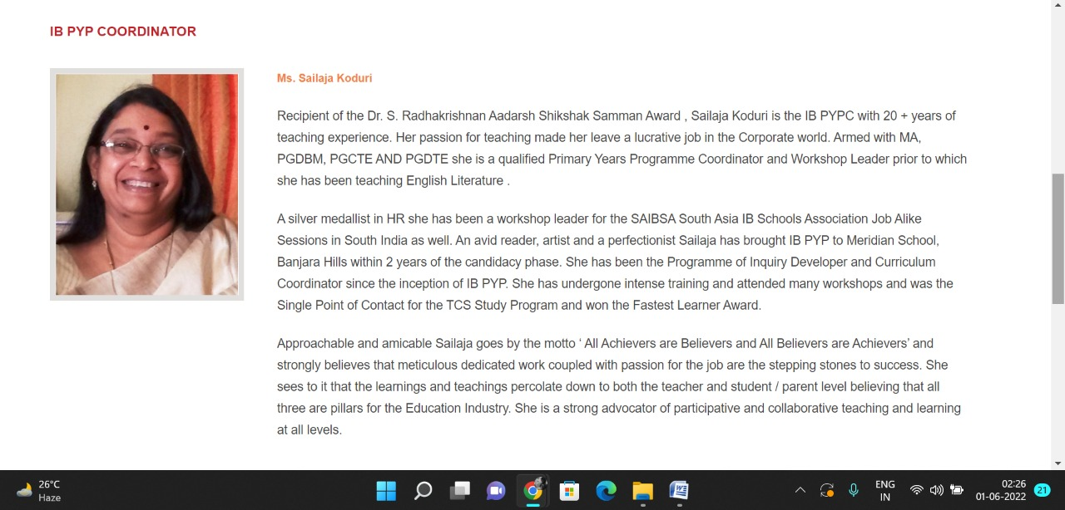

**PAGE 24:Pre Primary Incharge**

**HTML CODE:**

<!DOCTYPE html>

<html lang="en">

<head>

    <meta charset="UTF-8">

    <meta http-equiv="X-UA-Compatible" content="IE=edge">

    <meta name="viewport" content="width=device-width, initial-scale=1.0">

    <title>PRE PRIMARY INCHARGE - Meridian School</title>

    <link rel="stylesheet" href="style.css">

    <link rel="stylesheet" href="https://pro.fontawesome.com/releases/v5.10.0/css/all.css" />

    <link rel="icon" type="imag/logo2.png" href="img/logo2.png">

    <link rel="stylesheet" href="https://stackpath.bootstrapcdn.com/bootstrap/4.4.1/css/bootstrap.min.css"

        integrity="sha384-Vkoo8x4CGs03+Hhxv8T/Q5paXtkKtu6ug5TOeNV6gBiFeWPGFN9MuhOf23Q9Ifjh" crossorigin="anonymous" />

    <link rel="stylesheet" href="https://cdnjs.cloudflare.com/ajax/libs/slick-carousel/1.8.1/slick-theme.min.css"

        integrity="sha512-17EgCFERpgZKcm0j0fEq1YCJuyAWdz9KUtv1EjVuaOz8pDnh/0nZxmU6BBXwaaxqoi9PQXnRWqlcDB027hgv9A=="

        crossorigin="anonymous" referrerpolicy="no-referrer" />

    <link rel="stylesheet" href="https://cdnjs.cloudflare.com/ajax/libs/slick-carousel/1.8.1/slick.min.css"

        integrity="sha512-yHknP1/AwR+yx26cB1y0cjvQUMvEa2PFzt1c9LlS4pRQ5NOTZFWbhBig+X9G9eYW/8m0/4OXNx8pxJ6z57x0dw=="

        crossorigin="anonymous" referrerpolicy="no-referrer" />

</head>

<body>

    <section id="follow">

        <div class="followus">

            <div class="icon1">

                <i class="fa fa-phone"></i>

                <a id="phone" href="">8096918857, 9948508222</a>

            </div>

            <div class="icon1">

                <i class="fa fa-envelope"></i>

                <a id="mail" href="">info.banjara@meridianschool.in</a>

            </div>

            <div class="icon">

                <a href="https://www.facebook.com/MeridianSchoolBanjaraHills/" target="_blank"

                    class="fab fa-facebook-f"></i></a>

                <a href="https://twitter.com/meridianbanjara" target="_blank"><i class="fab fa-twitter"></i></a>

                <a href="https://www.youtube.com/channel/UCBZ_gLF9qM18O3CDWQHeN1A" target="_blank"><i

                        class="fab fa-youtube"></i></a>

                <a href="https://www.instagram.com/meridianschools/" target="_blank"><i

                        class="fab fa-instagram"></i></a>

            </div>

        </div>

    </section>

    <div class="navbar">

        <a href="home.html"><img src="img/logo.png" class="logo" alt=""></a>

        <nav>

            <a class="active" href="home.html">HOME</a>

            <div class="dropdown">

                <button class="dropbtn">ABOUT US

                </button>

                <div class="dropdown-content">

                    <a href="knowmeridian.html">KNOW MERIDIAN</a>

                    <a href="visionmission.html">THE VISION & MISSION</a>

                    <a href="http://meridianbanjara.com/the-founders/">THE FOUNDER'S MESSAGE</a>

                    <a href="ceomsg.html">CEO'S MESSAGE</a>

                    <a href="principalmsg.html">THE PRINCIPAL'S MESSAGE</a>

                    <a href="awards.html">AWARDS AND ACCOLADES</a>

                    <a href="http://meridianbanjara.com/affiliations-accreditations/">AFFILIATIONS & ACCREDITATIONS</a>

                    <a href="blog.html">BLOG</a>

                </div>

            </div>

            <div class="dropdown">

                <button class="dropbtn">LEADERSHIP TEAM

                </button>

                <div class="dropdown-content">

                    <a href="principal.html">PRINCIPAL</a>

                    <a href="vp.html">VICE PRINCIPAL</a>

                    <a href="headmistress.html">HEADMISTRESS</a>

                    <a href="midSchool.html">MIDDLE SCHOOL INCHARGE</a>

                    <a href="ipPyp.html">IB PYP COORDINATOR</a>

                    <a href="preprimary.html">PRE PRIMARY INCHARGE</a>

                    <a href="global.html">GLOBAL PARTNERSHIP COORDINATOR</a>

                </div>

            </div>

            <div class="dropdown">

                <button class="dropbtn">ACADEMICS

                </button>

                <div class="dropdown-content">

                    <a href="AcaOverview.html">OVERVIEW</a>

                    <a href="methodology.html">METHODOLOGY AND LEARNING STYLE</a>

                    <a href="curriculum.html">CURRICULUM</a>

                    <a href="faculty.html">FACULTY</a>

                    <a href="teacherTraining.html">TEACHER TRAINING</a>

                    <a href="careerGuidance.html">CAREER GUIDANCE</a>

                    <a href="scholrship.html">SCHOLARSHIP PROGRAMME</a>

                </div>

            </div>

            <div class="dropdown">

                <button class="dropbtn">BEYOND ACADEMICS

                </button>

                <div class="dropdown-content">

                    <a href="beyondAcaOverview.html">OVERVIEW</a>

                    <a href="sports.html">SPORTS</a>

                    <a href="creatveAct.html">CREATIVE ACTIVITIES</a>

                    <a href="eduTrips.html">EDUCATIONAL TRIPS AND STUDENT<br> EXCHANGE PROGRAMMES</a>

                    <a href="perfectSystem.html">PERFECT SYSTEM</a>

                    <a href="schoolSocialRes.html">SCHOOL'S SOCIAL RESPONSIBILITY</a>

                    <a href="interact.html">INTERACT</a>

                    <a href="heritageClub.html">HERITAGE CLUB</a>

                    <a href="mun.html">MUN</a>

                </div>

            </div>

            <div class="dropdown">

                <button class="dropbtn">ADMISSIONS

                </button>

                <div class="dropdown-content">

                    <a href="overview.html">OVERVIEW</a>

                    <a href="admissionpro.html">ADMISSION PROCEDURE</a>

                    <a href="feepolicy.html">FEE POLICY</a>

                    <a href="tranfercert.html">TRANSFER CERTIFICATE</a>

                    <a href="transport.html">TRANSPORT</a>

                </div>

            </div>

            <a class="active" href="gallery.html">GALLERY</a>

            <div class="dropdown">

                <button class="dropbtn">CONTACT US

                </button>

                <div class="dropdown-content">

                    <a href="contact.html">CAREERS</a>

                </div>

            </div>

        </nav>

    </div>

    <div id="mobile">

        <i id="bar" class="fas fa-outdent "></i>

    </div>

    <section id="principal">

        <div class="prin">

            <h2>PRE PRIMARY INCHARGE</h2>

            <span id="orange"><a href="home.html">Meridian School Banjara Hills</a></span>

            <span> &gt; PRE PRIMARY INCHARGE</span>

        </div>

    </section>

    <section id="vp">

        <div class="vp1">

            <div id="info">

                <h4>PRE PRIMARY INCHARGE</h4>

                <h5>Ms. Usha Gonela</h5>

                <p>Usha Gonela joined Meridian way back in 1997. The oldest member of this esteemed Educational

                    Institute Usha comes across as a loving, caring and most amicable person. She believes in being

                    there for each and every parent, be it morning, noon or evening.</p>

                <p>Having joined Meridian as an Art and Craft hand, Usha has been serving as the Pre Primary Incharge

                    for the past 16 years. Armed with a BA she is a trained IB Facilitator too. She is now Incharge for

                    Grades 1 and 2 as well.</p>

                <p>Her motto is to place prority of the child before anybody or anything else. Ever smiling and

                    sprightly Usha believes that hardwork is the only way to success. Soft spoken and shy Usha is a

                    tigress in Pre Primary Education.</p>

            </div>

            <div id="img4">

                <img src="img/leadership/preprimary.jpeg" alt="">

            </div>

        </div>

    </section>

    <footer>

        <div class="col">

            <h4>ABOUT US</h4>

            <p>Meridian is a New Generation Educational Group committed to educate children for life and thus bring a

                change in the society. Learning philosophy practised at Meridian infuses traditional values into a

                progressive approach, equipping students to adapt and excel anywhere in the world. Our alumni, working

                in diverse fields, have found Meridian to be the best school for a successful career take off.</p>

        </div>

        <div class="col">

            <h4>USEFUL LINKS</h4>

            <ul class="three-col-links">

                <li><a href="home.html">HOME</a></li>

                <li><a href="AcaOverview.html">ACADEMICS</a></li>

                <li><a href="overview.html">ADMISSIONS</a></li>

                <li><a href="contact.html">CONTACT US</a></li>

                <li><a href="knowmeridian.html">ABOUT US</a></li>

                <li><a href="beyondAcaOverview.html">BEYOND ACADEMICS</a></li>

                <li><a href="contact.html">CAREERS</a></li>

            </ul>

        </div>

        <div class="col">

            <!--<div class="follow">

                <div class="icon">

                    <i class="fa fa-paper-plane-o"></i>

                </div>

        </div>-->

            <h4>MERIDIAN SCHOOL, Banjara Hills</h4>

            <p># 8-2-541, Road No 7, Banjara Hills, Hyderabad-500034, TELANGANA, INDIA.</p>

            <p>For contact : +91 8096918857, 9948508222, For Prinicipal Appointments : 8098420002</p>

            <p> For Admissions / Enquires : 8096918857, 9948508222</p>

            <p>info.banjara@meridianschool.inA</p>

        </div>

    </footer>

    <section id="copyright">

        <div id="cr">

            <p>© Copyright MERIDIAN SCHOOL, 2021.</p>

        </div>

    </section>

</body>

</html>

**CSS CODE:**

#vp .vp1 #img4 img {

width: 366px;

height: 385px;

margin-left: 20px;

}

#principal .prin h2 {

font-size: 34px;

font-weight: 600;

text-align: start;

/* color: #c42329; */

}

#principal .prin span {

color: #fff;

}

#principal #orange {

color: #f48243;

}

#principal #orange:hover {

color: #fff;

}

#principal1 .princi1 {

display: flex;

}

#principal1 .princi1 img {

width: 250px;

height: 169px;

border: 7px solid rgb(225, 222, 222);

}

#principal1 .princi1 h4 {

text-align: start;

color: #c42329;

margin: 100px 0 35px 0px;

}

#principal1 .princi1 #info {

width: 42%;

margin: 200px 53px 70px;

}

#principal1 .princi1 #info p {

margin-bottom: 20px;

}

#principal1 .princi1 #info #strong {

margin-bottom: 0px;

}

**OUTPUT:**

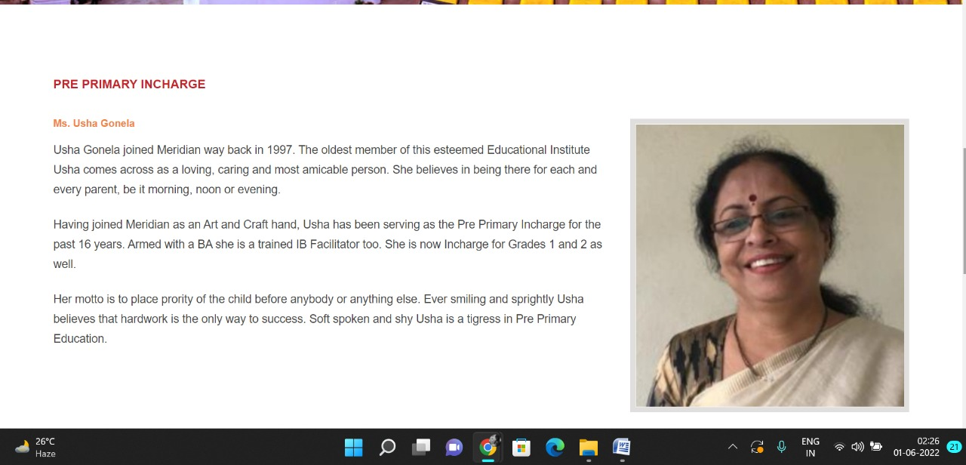

**PAGE 25:Global Partnership Coordinator**

**HTML CODE:**

<!DOCTYPE html>

<html lang="en">

<head>

    <meta charset="UTF-8">

    <meta http-equiv="X-UA-Compatible" content="IE=edge">

    <meta name="viewport" content="width=device-width, initial-scale=1.0">

    <title>GLOBAL PARTNERSHIP COORDINATOR - Meridian School</title>

    <link rel="stylesheet" href="style.css">

    <link rel="stylesheet" href="https://pro.fontawesome.com/releases/v5.10.0/css/all.css" />

    <link rel="icon" type="imag/logo2.png" href="img/logo2.png">

    <link rel="stylesheet" href="https://stackpath.bootstrapcdn.com/bootstrap/4.4.1/css/bootstrap.min.css"

        integrity="sha384-Vkoo8x4CGs03+Hhxv8T/Q5paXtkKtu6ug5TOeNV6gBiFeWPGFN9MuhOf23Q9Ifjh" crossorigin="anonymous" />

    <link rel="stylesheet" href="https://cdnjs.cloudflare.com/ajax/libs/slick-carousel/1.8.1/slick-theme.min.css"

        integrity="sha512-17EgCFERpgZKcm0j0fEq1YCJuyAWdz9KUtv1EjVuaOz8pDnh/0nZxmU6BBXwaaxqoi9PQXnRWqlcDB027hgv9A=="

        crossorigin="anonymous" referrerpolicy="no-referrer" />

    <link rel="stylesheet" href="https://cdnjs.cloudflare.com/ajax/libs/slick-carousel/1.8.1/slick.min.css"

        integrity="sha512-yHknP1/AwR+yx26cB1y0cjvQUMvEa2PFzt1c9LlS4pRQ5NOTZFWbhBig+X9G9eYW/8m0/4OXNx8pxJ6z57x0dw=="

        crossorigin="anonymous" referrerpolicy="no-referrer" />

</head>

<body>

    <section id="follow">

        <div class="followus">

            <div class="icon1">

                <i class="fa fa-phone"></i>

                <a id="phone" href="">8096918857, 9948508222</a>

            </div>

            <div class="icon1">

                <i class="fa fa-envelope"></i>

                <a id="mail" href="">info.banjara@meridianschool.in</a>

            </div>

            <div class="icon">

                <a href="https://www.facebook.com/MeridianSchoolBanjaraHills/" target="_blank"

                    class="fab fa-facebook-f"></i></a>

                <a href="https://twitter.com/meridianbanjara" target="_blank"><i class="fab fa-twitter"></i></a>

                <a href="https://www.youtube.com/channel/UCBZ_gLF9qM18O3CDWQHeN1A" target="_blank"><i

                        class="fab fa-youtube"></i></a>

                <a href="https://www.instagram.com/meridianschools/" target="_blank"><i

                        class="fab fa-instagram"></i></a>

            </div>

        </div>

    </section>

    <div class="navbar">

        <a href="home.html"><img src="img/logo.png" class="logo" alt=""></a>

        <nav>

            <a class="active" href="home.html">HOME</a>

            <div class="dropdown">

                <button class="dropbtn">ABOUT US

                </button>

                <div class="dropdown-content">

                    <a href="knowmeridian.html">KNOW MERIDIAN</a>

                    <a href="visionmission.html">THE VISION & MISSION</a>

                    <a href="http://meridianbanjara.com/the-founders/">THE FOUNDER'S MESSAGE</a>

                    <a href="ceomsg.html">CEO'S MESSAGE</a>

                    <a href="principalmsg.html">THE PRINCIPAL'S MESSAGE</a>

                    <a href="awards.html">AWARDS AND ACCOLADES</a>

                    <a href="http://meridianbanjara.com/affiliations-accreditations/">AFFILIATIONS & ACCREDITATIONS</a>

                    <a href="blog.html">BLOG</a>

                </div>

            </div>

            <div class="dropdown">

                <button class="dropbtn">LEADERSHIP TEAM

                </button>

                <div class="dropdown-content">

                    <a href="principal.html">PRINCIPAL</a>

                    <a href="vp.html">VICE PRINCIPAL</a>

                    <a href="headmistress.html">HEADMISTRESS</a>

                    <a href="midSchool.html">MIDDLE SCHOOL INCHARGE</a>

                    <a href="ipPyp.html">IB PYP COORDINATOR</a>

                    <a href="preprimary.html">PRE PRIMARY INCHARGE</a>

                    <a href="global.html">GLOBAL PARTNERSHIP COORDINATOR</a>

                </div>

            </div>

            <div class="dropdown">

                <button class="dropbtn">ACADEMICS

                </button>

                <div class="dropdown-content">

                    <a href="AcaOverview.html">OVERVIEW</a>

                    <a href="methodology.html">METHODOLOGY AND LEARNING STYLE</a>

                    <a href="curriculum.html">CURRICULUM</a>

                    <a href="faculty.html">FACULTY</a>

                    <a href="teacherTraining.html">TEACHER TRAINING</a>

                    <a href="careerGuidance.html">CAREER GUIDANCE</a>

                    <a href="scholrship.html">SCHOLARSHIP PROGRAMME</a>

                </div>

            </div>

            <div class="dropdown">

                <button class="dropbtn">BEYOND ACADEMICS

                </button>

                <div class="dropdown-content">

                    <a href="beyondAcaOverview.html">OVERVIEW</a>

                    <a href="sports.html">SPORTS</a>

                    <a href="creatveAct.html">CREATIVE ACTIVITIES</a>

                    <a href="eduTrips.html">EDUCATIONAL TRIPS AND STUDENT<br> EXCHANGE PROGRAMMES</a>

                    <a href="perfectSystem.html">PERFECT SYSTEM</a>

                    <a href="schoolSocialRes.html">SCHOOL'S SOCIAL RESPONSIBILITY</a>

                    <a href="interact.html">INTERACT</a>

                    <a href="heritageClub.html">HERITAGE CLUB</a>

                    <a href="mun.html">MUN</a>

                </div>

            </div>

            <div class="dropdown">

                <button class="dropbtn">ADMISSIONS

                </button>

                <div class="dropdown-content">

                    <a href="overview.html">OVERVIEW</a>

                    <a href="admissionpro.html">ADMISSION PROCEDURE</a>

                    <a href="feepolicy.html">FEE POLICY</a>

                    <a href="tranfercert.html">TRANSFER CERTIFICATE</a>

                    <a href="transport.html">TRANSPORT</a>

                </div>

            </div>

            <a class="active" href="gallery.html">GALLERY</a>

            <div class="dropdown">

                <button class="dropbtn">CONTACT US

                </button>

                <div class="dropdown-content">

                    <a href="contact.html">CAREERS</a>

                </div>

            </div>

        </nav>

    </div>

    <div id="mobile">

        <i id="bar" class="fas fa-outdent "></i>

    </div>

    <section id="principal">

        <div class="prin">

            <h2>GLOBAL PARTNERSHIP COORDINATOR</h2>

            <span id="orange"><a href="home.html">Meridian School Banjara Hills</a></span>

            <span> &gt; GLOBAL PARTNERSHIP COORDINATOR</span>

        </div>

    </section>

    <section id="ip">

        <div class="ip1">

            <div id="img4">

                <h4>GLOBAL PARTNERSHIP COORDINATOR</h4>

                <img src="img/leadership/global.jpeg" alt="">

            </div>

            <div id="info3">

                <h5>Ms. Rajatha Gora</h5>

                <p>Ms.Rajatha ,a Certified Career Counsellor is a multi talented Senior Secondary teacher of Mass Media

                    and has been with Meridian School for over one and a half decade in various capacities. Apart from

                    holding a Masters degree in English Literature, Ms. Rajatha received Cambridge Teacher’s Training

                    and had participated in Intel Teach Programme. She was one among the final nominees for the 2019

                    International Career and College Counselling , IC3 Awards for her accomplishment as a successful

                    career counsellor.</p>

                <p>She is a passionate dancer and being a very active youth, won many awards in her college days like

                    Best Youth Award, Nikhil Koithara Award for Young activists, First Female and Youngest District

                    Rotaract Representative and many more. Rajatha has lead and been part of International Youth

                    Exchange programmes. Compassionate at heart, Ms.Rajatha involves herself in the activities of many

                    Social Service Organisations. She possesses excellent collaborative and interpersonal skills</p>

                <p>As the Career Guidance Counsellor at Meridian, Ms.Rajatha is in-charge of organizing activities,

                    workshops, field trips, exposure visits, guest lectures and internships for students from grade I –

                    XII. She is also a Faculty advisor for Meridian Model United Nations sessions. She also plans and

                    executes International exposure programmes for students and Internships at CERN, WFUNA, FUTURESAKE

                    and International MUNs. With her empathetic approach to the teenagers , She has guided many

                    aspirants to their dream courses and careers through her counselling.</p>

            </div>

        </div>

    </section>

    <footer>

        <div class="col">

            <h4>ABOUT US</h4>

            <p>Meridian is a New Generation Educational Group committed to educate children for life and thus bring a

                change in the society. Learning philosophy practised at Meridian infuses traditional values into a

                progressive approach, equipping students to adapt and excel anywhere in the world. Our alumni, working

                in diverse fields, have found Meridian to be the best school for a successful career take off.</p>

        </div>

        <div class="col">

            <h4>USEFUL LINKS</h4>

            <ul class="three-col-links">

                <li><a href="home.html">HOME</a></li>

                <li><a href="AcaOverview.html">ACADEMICS</a></li>

                <li><a href="overview.html">ADMISSIONS</a></li>

                <li><a href="contact.html">CONTACT US</a></li>

                <li><a href="knowmeridian.html">ABOUT US</a></li>

                <li><a href="beyondAcaOverview.html">BEYOND ACADEMICS</a></li>

                <li><a href="contact.html">CAREERS</a></li>

            </ul>

        </div>

        <div class="col">

            <!--<div class="follow">

                <div class="icon">

                    <i class="fa fa-paper-plane-o"></i>

                </div>

        </div>-->

            <h4>MERIDIAN SCHOOL, Banjara Hills</h4>

            <p># 8-2-541, Road No 7, Banjara Hills, Hyderabad-500034, TELANGANA, INDIA.</p>

            <p>For contact : +91 8096918857, 9948508222, For Prinicipal Appointments : 8098420002</p>

            <p> For Admissions / Enquires : 8096918857, 9948508222</p>

            <p>info.banjara@meridianschool.inA</p>

        </div>

    </footer>

    <section id="copyright">

        <div id="cr">

            <p>© Copyright MERIDIAN SCHOOL, 2021.</p>

        </div>

    </section>

</body>

</html>

**CSS CODE:**

ip .ip1 #img4 h4 {

margin: 15px 0px 35px;

color: #c42329;

}

#ip .ip1 #info3 h5 {

color: #f48243;

margin-bottom: 16px;

}

#ip .ip1 #info3 {

width: 75%;

margin: 68px -48px;

}

#ip .ip1 #info3 p {

margin-bottom: 20px;

}

#principal1 .princi1 #info {

width: 42%;

margin: 200px 53px 70px;

}

#principal1 .princi1 #info p {

margin-bottom: 20px;

}

#principal1 .princi1 #info #strong {

margin-bottom: 0px;

}

#principal .prin h2 {

font-size: 34px;

font-weight: 600;

text-align: start;

/* color: #c42329; */

}

#principal .prin span {

color: #fff;

}

#principal #orange {

color: #f48243;

}

#principal #orange:hover {

color: #fff;

}

#principal1 .princi1 {

display: flex;

}

#principal1 .princi1 img {

width: 250px;

height: 169px;

border: 7px solid rgb(225, 222, 222);

}

#principal1 .princi1 h4 {

text-align: start;

color: #c42329;

margin: 100px 0 35px 0px;

}

**OUTPUT:**

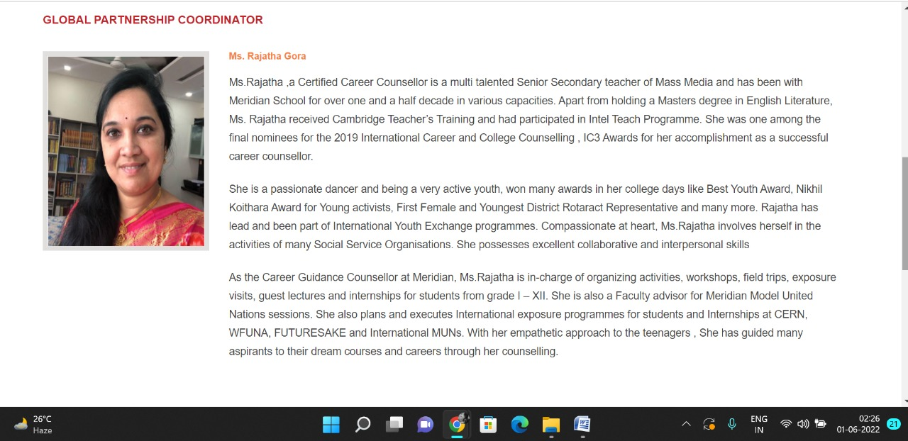

Academics Pages

**PAGE 26:Overview**

**HTML CODE:**

<!DOCTYPE html>

<html lang="en">

<head>

    <meta charset="UTF-8">

    <meta http-equiv="X-UA-Compatible" content="IE=edge">

    <meta name="viewport" content="width=device-width, initial-scale=1.0">

    <title>OVERVIEW - Meridian School</title>

    <link rel="stylesheet" href="style.css">

    <link rel="stylesheet" href="https://pro.fontawesome.com/releases/v5.10.0/css/all.css" />

    <link rel="icon" type="imag/logo2.png" href="img/logo2.png">

    <link rel="stylesheet" href="https://stackpath.bootstrapcdn.com/bootstrap/4.4.1/css/bootstrap.min.css"

        integrity="sha384-Vkoo8x4CGs03+Hhxv8T/Q5paXtkKtu6ug5TOeNV6gBiFeWPGFN9MuhOf23Q9Ifjh" crossorigin="anonymous" />

    <link rel="stylesheet" href="https://cdnjs.cloudflare.com/ajax/libs/slick-carousel/1.8.1/slick-theme.min.css"

        integrity="sha512-17EgCFERpgZKcm0j0fEq1YCJuyAWdz9KUtv1EjVuaOz8pDnh/0nZxmU6BBXwaaxqoi9PQXnRWqlcDB027hgv9A=="

        crossorigin="anonymous" referrerpolicy="no-referrer" />

    <link rel="stylesheet" href="https://cdnjs.cloudflare.com/ajax/libs/slick-carousel/1.8.1/slick.min.css"

        integrity="sha512-yHknP1/AwR+yx26cB1y0cjvQUMvEa2PFzt1c9LlS4pRQ5NOTZFWbhBig+X9G9eYW/8m0/4OXNx8pxJ6z57x0dw=="

        crossorigin="anonymous" referrerpolicy="no-referrer" />

</head>

<body>

    <section id="follow">

        <div class="followus">

            <div class="icon1">

                <i class="fa fa-phone"></i>

                <a id="phone" href="">8096918857, 9948508222</a>

            </div>

            <div class="icon1">

                <i class="fa fa-envelope"></i>

                <a id="mail" href="">info.banjara@meridianschool.in</a>

            </div>

            <div class="icon">

                <a href="https://www.facebook.com/MeridianSchoolBanjaraHills/" target="_blank"

                    class="fab fa-facebook-f"></i></a>

                <a href="https://twitter.com/meridianbanjara" target="_blank"><i class="fab fa-twitter"></i></a>

                <a href="https://www.youtube.com/channel/UCBZ_gLF9qM18O3CDWQHeN1A" target="_blank"><i

                        class="fab fa-youtube"></i></a>

                <a href="https://www.instagram.com/meridianschools/" target="_blank"><i

                        class="fab fa-instagram"></i></a>

            </div>

        </div>

    </section>

    <div class="navbar">

        <a href="home.html"><img src="img/logo.png" class="logo" alt=""></a>

        <nav>

            <a class="active" href="home.html">HOME</a>

            <div class="dropdown">

                <button class="dropbtn">ABOUT US

                </button>

                <div class="dropdown-content">

                    <a href="knowmeridian.html">KNOW MERIDIAN</a>

                    <a href="visionmission.html">THE VISION & MISSION</a>

                    <a href="http://meridianbanjara.com/the-founders/">THE FOUNDER'S MESSAGE</a>

                    <a href="ceomsg.html">CEO'S MESSAGE</a>

                    <a href="principalmsg.html">THE PRINCIPAL'S MESSAGE</a>

                    <a href="awards.html">AWARDS AND ACCOLADES</a>

                    <a href="http://meridianbanjara.com/affiliations-accreditations/">AFFILIATIONS & ACCREDITATIONS</a>

                    <a href="blog.html">BLOG</a>

                </div>

            </div>

            <div class="dropdown">

                <button class="dropbtn">LEADERSHIP TEAM

                </button>

                <div class="dropdown-content">

                    <a href="principal.html">PRINCIPAL</a>

                    <a href="vp.html">VICE PRINCIPAL</a>

                    <a href="headmistress.html">HEADMISTRESS</a>

                    <a href="midSchool.html">MIDDLE SCHOOL INCHARGE</a>

                    <a href="ipPyp.html">IB PYP COORDINATOR</a>

                    <a href="preprimary.html">PRE PRIMARY INCHARGE</a>

                    <a href="global.html">GLOBAL PARTNERSHIP COORDINATOR</a>

                </div>

            </div>

            <div class="dropdown">

                <button class="dropbtn">ACADEMICS

                </button>

                <div class="dropdown-content">

                    <a href="AcaOverview.html">OVERVIEW</a>

                    <a href="methodology.html">METHODOLOGY AND LEARNING STYLE</a>

                    <a href="curriculum.html">CURRICULUM</a>

                    <a href="faculty.html">FACULTY</a>

                    <a href="teacherTraining.html">TEACHER TRAINING</a>

                    <a href="careerGuidance.html">CAREER GUIDANCE</a>

                    <a href="scholrship.html">SCHOLARSHIP PROGRAMME</a>

                </div>

            </div>

            <div class="dropdown">

                <button class="dropbtn">BEYOND ACADEMICS

                </button>

                <div class="dropdown-content">

                    <a href="beyondAcaOverview.html">OVERVIEW</a>

                    <a href="sports.html">SPORTS</a>

                    <a href="creatveAct.html">CREATIVE ACTIVITIES</a>

                    <a href="eduTrips.html">EDUCATIONAL TRIPS AND STUDENT<br> EXCHANGE PROGRAMMES</a>

                    <a href="perfectSystem.html">PERFECT SYSTEM</a>

                    <a href="schoolSocialRes.html">SCHOOL'S SOCIAL RESPONSIBILITY</a>

                    <a href="interact.html">INTERACT</a>

                    <a href="heritageClub.html">HERITAGE CLUB</a>

                    <a href="mun.html">MUN</a>

                </div>

            </div>

            <div class="dropdown">

                <button class="dropbtn">ADMISSIONS

                </button>

                <div class="dropdown-content">

                    <a href="overview.html">OVERVIEW</a>

                    <a href="admissionpro.html">ADMISSION PROCEDURE</a>

                    <a href="feepolicy.html">FEE POLICY</a>

                    <a href="tranfercert.html">TRANSFER CERTIFICATE</a>

                    <a href="transport.html">TRANSPORT</a>

                </div>

            </div>

            <a class="active" href="gallery.html">GALLERY</a>

            <div class="dropdown">

                <button class="dropbtn">CONTACT US

                </button>

                <div class="dropdown-content">

                    <a href="contact.html">CAREERS</a>

                </div>

            </div>

        </nav>

    </div>

    <div id="mobile">

        <i id="bar" class="fas fa-outdent "></i>

    </div>

    <section id="principal">

        <div class="prin" id="overview1">

            <h2>OVERVIEW</h2>

            <span id="orange"><a href="home.html">Meridian School Banjara Hills</a></span>

            <span> &gt; OVERVIEW</span>

        </div>

    </section>

    <section id="principal1">

        <div class="academics" id="overview">

            <h4>OVERVIEW</h4>

            <p>Meridian School is one of the finest schools in the twin cities, with a strong intellectual pulse with a

                meaningful motto, ‘Connecting the mind and heart.’</p>

            <p>Keeping pace with today’s vibrant and competitive environment, the <strong> Best School in Banjara Hills,

                    Meridian School, </strong> understands the importance of cooperative teaching and its positive

                influence on children. This enables us to engage students in experiential learning and nurture

                innovators, educators, leaders and learners of 21st century. Academics has always been the top priority

                of the school. It has the credit of a record of cent percent pass results till date. It also produced

                National and State level rank holders.</p>

            <p><strong>Abhinaya Otikunta </strong>secured 1st rank in Telangana State in AISSE 2019-20</p>

            <p><strong>Harshini Maddala </strong>secured 3rd rank at All India Level in AISSE 2018-19</p>

            <p>Apart from the consistent success rate at the Boards, the school enrolls its students in national and

                international competitive examinations like SOF, NELTAS, IAIS, NOF, Talent Search exams etc. wherein

                many students have bagged excellent results and certificates of extraordinary performance and top

                rankers.</p>

            <img src="img/academics/overview2.png" alt="">

        </div>

        </div>

    </section>

    <footer>

        <div class="col">

            <h4>ABOUT US</h4>

            <p>Meridian is a New Generation Educational Group committed to educate children for life and thus bring a

                change in the society. Learning philosophy practised at Meridian infuses traditional values into a

                progressive approach, equipping students to adapt and excel anywhere in the world. Our alumni, working

                in diverse fields, have found Meridian to be the best school for a successful career take off.</p>

            <ul id="pic">

                <li><a href="https://www.facebook.com/MeridianSchoolBanjarahills/" target="_blank"><i

                            class="fa fa-facebook"></i></a></li>

                <li><a href="https://twitter.com/meridianbanjara" target="_blank"><i class="fa fa-twitter"></i></a></li>

                <li><a href="https://www.instagram.com/meridianschools/" target="_blank"><i

                            class="fa fa-instagram"></i></a></li>

            </ul>

        </div>

        <div class="col">

            <h4>USEFUL LINKS</h4>

            <ul class="three-col-links">

                <li>> <a href="#">HOME</a></li>

                <li>> <a href="#">ACADEMICS</a></li>

                <li>> <a href="#">ADMISSIONS</a></li>

                <li>> <a href="#">CONTACT US</a></li>

                <li>> <a href="#">ABOUT US</a></li>

                <li>> <a href="#">BEYOND ACADEMICS</a></li>

                <li>> <a href="#">CAREERS</a></li>

            </ul>

        </div>

        <div class="col">

            <!--<div class="follow">

                <div class="icon">

                    <i class="fa fa-paper-plane-o"></i>

                </div>

        </div>-->

            <h4>MERIDIAN SCHOOL, Banjara Hills</h4>

            <p># 8-2-541, Road No 7, Banjara Hills, Hyderabad-500034, TELANGANA, INDIA.</p>

            <p>For contact : +91 8096918857, 9948508222, For Prinicipal Appointments : 8098420002</p>

            <p> For Admissions / Enquires : 8096918857, 9948508222</p>

            <p>info.banjara@meridianschool.inA</p>

        </div>

    </footer>

    <section id="copyright">

        <div id="cr">

            <p>© Copyright MERIDIAN SCHOOL, BANJARA HILLS, 2020.</p>

        </div>

    </section>

</body>

</html>

**CSS CODE:**

#principal .prin h2 {

font-size: 34px;

font-weight: 600;

text-align: start;

/* color: #c42329; */

}

#principal .prin span {

color: #fff;

}

#principal #orange {

color: #f48243;

}

#principal #orange:hover {

color: #fff;

}

#principal1 .princi1 {

display: flex;

}

#principal1 .princi1 img {

width: 250px;

height: 169px;

border: 7px solid rgb(225, 222, 222);

}

#principal1 .princi1 h4 {

text-align: start;

color: #c42329;

margin: 100px 0 35px 0px;

}

#principal1 .princi1 #info {

width: 42%;

margin: 200px 53px 70px;

}

#principal1 .princi1 #info p {

margin-bottom: 20px;

}

#principal1 .princi1 #info #strong {

margin-bottom: 0px;

}

**OUTPUT:**

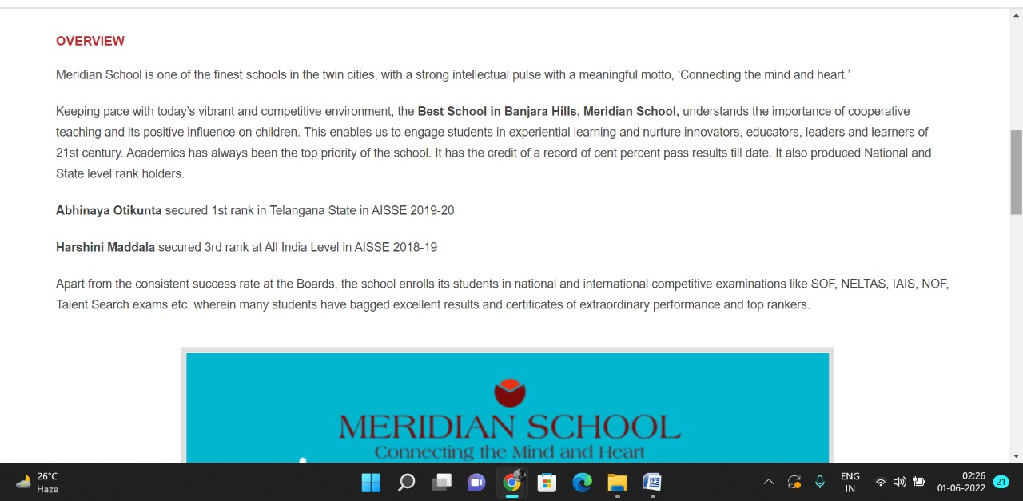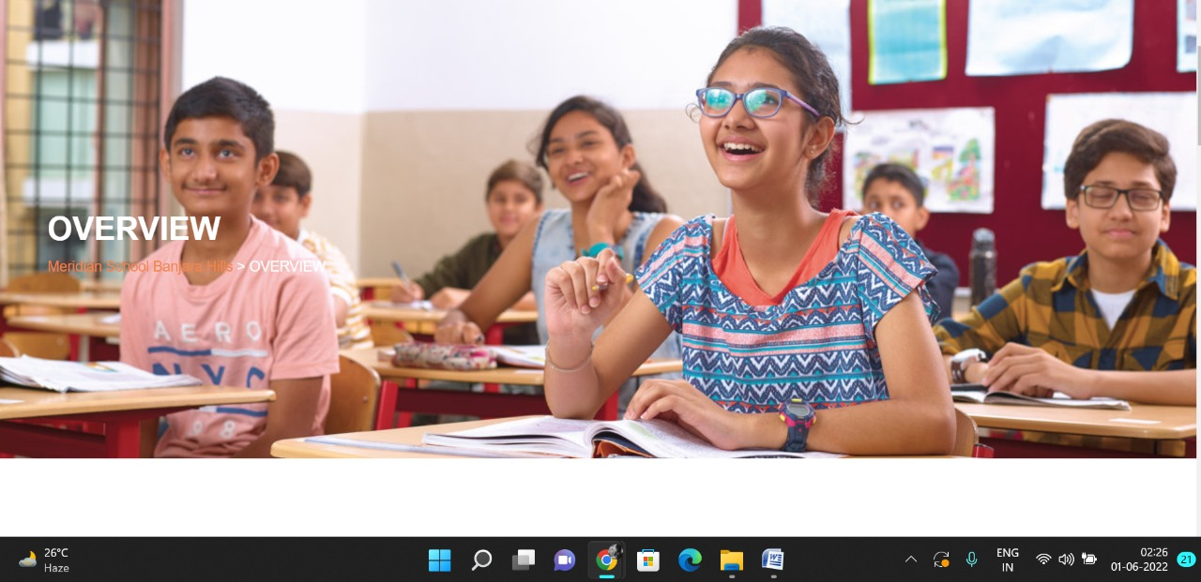

**PAGE 27:Methodology and Learning Style**

**HTML CODE:**

<!DOCTYPE html>

<html lang="en">

<head>

    <meta charset="UTF-8">

    <meta http-equiv="X-UA-Compatible" content="IE=edge">

    <meta name="viewport" content="width=device-width, initial-scale=1.0">

    <title>METHODOLOGY AND LEARNING STYLE - Meridian School</title>

    <link rel="stylesheet" href="style.css">

    <link rel="stylesheet" href="https://pro.fontawesome.com/releases/v5.10.0/css/all.css" />

    <link rel="icon" type="imag/logo2.png" href="img/logo2.png">

    <link rel="stylesheet" href="https://stackpath.bootstrapcdn.com/bootstrap/4.4.1/css/bootstrap.min.css"

        integrity="sha384-Vkoo8x4CGs03+Hhxv8T/Q5paXtkKtu6ug5TOeNV6gBiFeWPGFN9MuhOf23Q9Ifjh" crossorigin="anonymous" />

    <link rel="stylesheet" href="https://cdnjs.cloudflare.com/ajax/libs/slick-carousel/1.8.1/slick-theme.min.css"

        integrity="sha512-17EgCFERpgZKcm0j0fEq1YCJuyAWdz9KUtv1EjVuaOz8pDnh/0nZxmU6BBXwaaxqoi9PQXnRWqlcDB027hgv9A=="

        crossorigin="anonymous" referrerpolicy="no-referrer" />

    <link rel="stylesheet" href="https://cdnjs.cloudflare.com/ajax/libs/slick-carousel/1.8.1/slick.min.css"

        integrity="sha512-yHknP1/AwR+yx26cB1y0cjvQUMvEa2PFzt1c9LlS4pRQ5NOTZFWbhBig+X9G9eYW/8m0/4OXNx8pxJ6z57x0dw=="

        crossorigin="anonymous" referrerpolicy="no-referrer" />

</head>

<body>

    <section id="follow">

        <div class="followus">

            <div class="icon1">

                <i class="fa fa-phone"></i>

                <a id="phone" href="">8096918857, 9948508222</a>

            </div>

            <div class="icon1">

                <i class="fa fa-envelope"></i>

                <a id="mail" href="">info.banjara@meridianschool.in</a>

            </div>

            <div class="icon">

                <a href="https://www.facebook.com/MeridianSchoolBanjaraHills/" target="_blank"

                    class="fab fa-facebook-f"></i></a>

                <a href="https://twitter.com/meridianbanjara" target="_blank"><i class="fab fa-twitter"></i></a>

                <a href="https://www.youtube.com/channel/UCBZ_gLF9qM18O3CDWQHeN1A" target="_blank"><i

                        class="fab fa-youtube"></i></a>

                <a href="https://www.instagram.com/meridianschools/" target="_blank"><i

                        class="fab fa-instagram"></i></a>

            </div>

        </div>

    </section>

    <div class="navbar">

        <a href="home.html"><img src="img/logo.png" class="logo" alt=""></a>

        <nav>

            <a class="active" href="home.html">HOME</a>

            <div class="dropdown">

                <button class="dropbtn">ABOUT US

                </button>

                <div class="dropdown-content">

                    <a href="knowmeridian.html">KNOW MERIDIAN</a>

                    <a href="visionmission.html">THE VISION & MISSION</a>

                    <a href="http://meridianbanjara.com/the-founders/">THE FOUNDER'S MESSAGE</a>

                    <a href="ceomsg.html">CEO'S MESSAGE</a>

                    <a href="principalmsg.html">THE PRINCIPAL'S MESSAGE</a>

                    <a href="awards.html">AWARDS AND ACCOLADES</a>

                    <a href="http://meridianbanjara.com/affiliations-accreditations/">AFFILIATIONS & ACCREDITATIONS</a>

                    <a href="blog.html">BLOG</a>

                </div>

            </div>

            <div class="dropdown">

                <button class="dropbtn">LEADERSHIP TEAM

                </button>

                <div class="dropdown-content">

                    <a href="principal.html">PRINCIPAL</a>

                    <a href="vp.html">VICE PRINCIPAL</a>

                    <a href="headmistress.html">HEADMISTRESS</a>

                    <a href="midSchool.html">MIDDLE SCHOOL INCHARGE</a>

                    <a href="ipPyp.html">IB PYP COORDINATOR</a>

                    <a href="preprimary.html">PRE PRIMARY INCHARGE</a>

                    <a href="global.html">GLOBAL PARTNERSHIP COORDINATOR</a>

                </div>

            </div>

            <div class="dropdown">

                <button class="dropbtn">ACADEMICS

                </button>

                <div class="dropdown-content">

                    <a href="AcaOverview.html">OVERVIEW</a>

                    <a href="methodology.html">METHODOLOGY AND LEARNING STYLE</a>

                    <a href="curriculum.html">CURRICULUM</a>

                    <a href="faculty.html">FACULTY</a>

                    <a href="teacherTraining.html">TEACHER TRAINING</a>

                    <a href="careerGuidance.html">CAREER GUIDANCE</a>

                    <a href="scholrship.html">SCHOLARSHIP PROGRAMME</a>

                </div>

            </div>

            <div class="dropdown">

                <button class="dropbtn">BEYOND ACADEMICS

                </button>

                <div class="dropdown-content">

                    <a href="beyondAcaOverview.html">OVERVIEW</a>

                    <a href="sports.html">SPORTS</a>

                    <a href="creatveAct.html">CREATIVE ACTIVITIES</a>

                    <a href="eduTrips.html">EDUCATIONAL TRIPS AND STUDENT<br> EXCHANGE PROGRAMMES</a>

                    <a href="perfectSystem.html">PERFECT SYSTEM</a>

                    <a href="schoolSocialRes.html">SCHOOL'S SOCIAL RESPONSIBILITY</a>

                    <a href="interact.html">INTERACT</a>

                    <a href="heritageClub.html">HERITAGE CLUB</a>

                    <a href="mun.html">MUN</a>

                </div>

            </div>

            <div class="dropdown">

                <button class="dropbtn">ADMISSIONS

                </button>

                <div class="dropdown-content">

                    <a href="overview.html">OVERVIEW</a>

                    <a href="admissionpro.html">ADMISSION PROCEDURE</a>

                    <a href="feepolicy.html">FEE POLICY</a>

                    <a href="tranfercert.html">TRANSFER CERTIFICATE</a>

                    <a href="transport.html">TRANSPORT</a>

                </div>

            </div>

            <a class="active" href="gallery.html">GALLERY</a>

            <div class="dropdown">

                <button class="dropbtn">CONTACT US

                </button>

                <div class="dropdown-content">

                    <a href="contact.html">CAREERS</a>

                </div>

            </div>

        </nav>

    </div>

    <div id="mobile">

        <i id="bar" class="fas fa-outdent "></i>

    </div>

    <section id="principal">

        <div class="prin" id="overview1">

            <h2>METHODOLOGY AND LEARNING STYLE</h2>

            <span id="orange"><a href="home.html">Meridian School Banjara Hills</a></span>

            <span> &gt; METHODOLOGY AND LEARNING STYLE</span>

        </div>

    </section>

    <section id="principal1">

        <div class="academics" id="overview">

            <h4>METHODOLOGY AND LEARNING STYLE</h4>

            <p class="headOrange">Multiple learning styles</p>

            <p>Teachers at Meridian school Banjara Hills take all the different styles of learning into account while

                delivering the lessons in a class of varied abilities. Each class is fitted with a Smart board with

                uninterrupted connectivity to enable teachers to present their lessons visually and students too share

                their presentations through the same. The school is tied up Extramarks to impart visual and aural

                instruction. The social learning takes place through social service activities including visits to Old

                age homes and orphanages, raising funds for relief etc.</p>

            <p><strong>Internship Programmes: </strong>Learning in Senior Secondary classes is strengthened by hands on

                experience through a week long internship programmes in both science and commerce streams. Students

                visit different organisations and Laboratories and hospitals as a part of learning the practical side of

                the theory lessons learnt in the classrooms. Some of the organisations that offered internship are

                Metamorphosis, Best Mom, Corteva, Corpus Juris Law Firm, Cancer Hospital.</p>

            <p>The school focuses more on Problem based teaching methods than the traditional methods. At the same time

                values are not lost. More of student and teacher orientation programs is facilitated to create a

                friendly learning environment for all.</p>

            <p><strong>Workshops and Orientation sessions: </strong>Every subject organises number of workshops and

                orientation programmes for students offered by eminent resource persons. This added information helps

                them understand the range and scope of the subject.</p>

            <p class="headOrange">Learning is Fun</p>

            <p><strong>Book Reading Club, Under the Mango Tree: </strong>The Department of English has initiated a book

                reading club where in the members are encouraged to indulge in the hobby of reading novels, both classic

                and modern. The club conducts quizzes and puzzles based on the books read in the fortnight.</p>

        </div>

        </div>

    </section>

    <footer>

        <div class="col">

            <h4>ABOUT US</h4>

            <p>Meridian is a New Generation Educational Group committed to educate children for life and thus bring a

                change in the society. Learning philosophy practised at Meridian infuses traditional values into a

                progressive approach, equipping students to adapt and excel anywhere in the world. Our alumni, working

                in diverse fields, have found Meridian to be the best school for a successful career take off.</p>

        </div>

        <div class="col">

            <h4>USEFUL LINKS</h4>

            <ul class="three-col-links">

                <li><a href="home.html">HOME</a></li>

                <li><a href="AcaOverview.html">ACADEMICS</a></li>

                <li><a href="overview.html">ADMISSIONS</a></li>

                <li><a href="contact.html">CONTACT US</a></li>

                <li><a href="knowmeridian.html">ABOUT US</a></li>

                <li><a href="beyondAcaOverview.html">BEYOND ACADEMICS</a></li>

                <li><a href="contact.html">CAREERS</a></li>

            </ul>

        </div>

        <div class="col">

            <!--<div class="follow">

                <div class="icon">

                    <i class="fa fa-paper-plane-o"></i>

                </div>

        </div>-->

            <h4>MERIDIAN SCHOOL, Banjara Hills</h4>

            <p># 8-2-541, Road No 7, Banjara Hills, Hyderabad-500034, TELANGANA, INDIA.</p>

            <p>For contact : +91 8096918857, 9948508222, For Prinicipal Appointments : 8098420002</p>

            <p> For Admissions / Enquires : 8096918857, 9948508222</p>

            <p>info.banjara@meridianschool.inA</p>

        </div>

    </footer>

    <section id="copyright">

        <div id="cr">

            <p>© Copyright MERIDIAN SCHOOL, 2021.</p>

        </div>

    </section>

</body>

</html>

**CSS CODE:**

#principal .prin h2 {

font-size: 34px;

font-weight: 600;

text-align: start;

/* color: #c42329; */

}

#principal .prin span {

color: #fff;

}

#principal #orange {

color: #f48243;

}

#principal #orange:hover {

color: #fff;

}

#principal1 .princi1 {

display: flex;

}

#principal1 .princi1 img {

width: 250px;

height: 169px;

border: 7px solid rgb(225, 222, 222);

}

#principal1 .princi1 h4 {

text-align: start;

color: #c42329;

margin: 100px 0 35px 0px;

}

#principal1 .princi1 #info {

width: 42%;

margin: 200px 53px 70px;

}

#principal1 .princi1 #info p {

margin-bottom: 20px;

}

#principal1 .princi1 #info #strong {

margin-bottom: 0px;

}

#principal .princi1 #info h5 {

    color: #f48243;

    margin: -20px 0px 35px 70px;

}

**OUTPUT:**

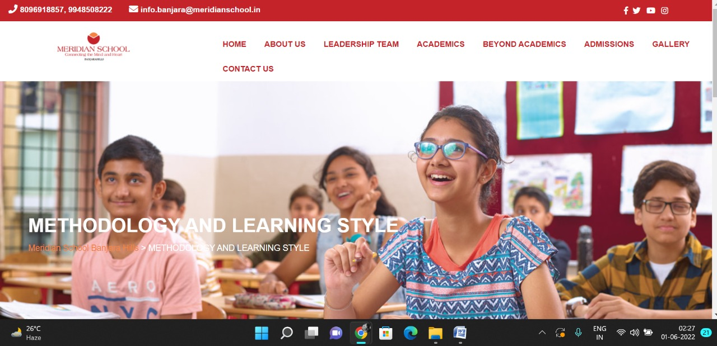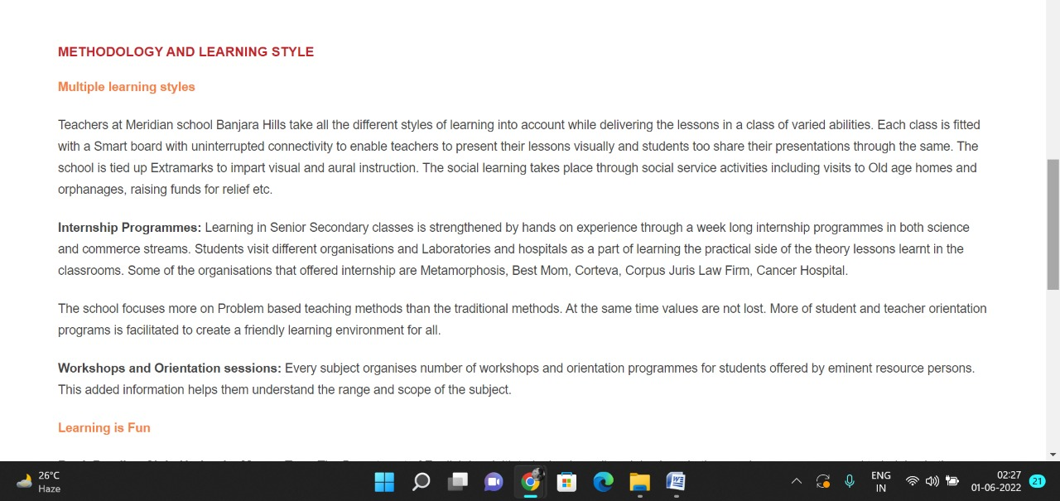

**PAGE 28:Curriculum**

**HTML CODE:**

<!DOCTYPE html>

<html lang="en">

<head>

    <meta charset="UTF-8">

    <meta http-equiv="X-UA-Compatible" content="IE=edge">

    <meta name="viewport" content="width=device-width, initial-scale=1.0">

    <title>CURRICULUM - Meridian School</title>

    <link rel="stylesheet" href="style.css">

    <link rel="stylesheet" href="https://pro.fontawesome.com/releases/v5.10.0/css/all.css" />

    <link rel="icon" type="imag/logo2.png" href="img/logo2.png">

    <link rel="stylesheet" href="https://stackpath.bootstrapcdn.com/bootstrap/4.4.1/css/bootstrap.min.css"

        integrity="sha384-Vkoo8x4CGs03+Hhxv8T/Q5paXtkKtu6ug5TOeNV6gBiFeWPGFN9MuhOf23Q9Ifjh" crossorigin="anonymous" />

    <link rel="stylesheet" href="https://cdnjs.cloudflare.com/ajax/libs/slick-carousel/1.8.1/slick-theme.min.css"

        integrity="sha512-17EgCFERpgZKcm0j0fEq1YCJuyAWdz9KUtv1EjVuaOz8pDnh/0nZxmU6BBXwaaxqoi9PQXnRWqlcDB027hgv9A=="

        crossorigin="anonymous" referrerpolicy="no-referrer" />

    <link rel="stylesheet" href="https://cdnjs.cloudflare.com/ajax/libs/slick-carousel/1.8.1/slick.min.css"

        integrity="sha512-yHknP1/AwR+yx26cB1y0cjvQUMvEa2PFzt1c9LlS4pRQ5NOTZFWbhBig+X9G9eYW/8m0/4OXNx8pxJ6z57x0dw=="

        crossorigin="anonymous" referrerpolicy="no-referrer" />

</head>

<body>

    <section id="follow">

        <div class="followus">

            <div class="icon1">

                <i class="fa fa-phone"></i>

                <a id="phone" href="">8096918857, 9948508222</a>

            </div>

            <div class="icon1">

                <i class="fa fa-envelope"></i>

                <a id="mail" href="">info.banjara@meridianschool.in</a>

            </div>

            <div class="icon">

                <a href="https://www.facebook.com/MeridianSchoolBanjaraHills/" target="_blank"

                    class="fab fa-facebook-f"></i></a>

                <a href="https://twitter.com/meridianbanjara" target="_blank"><i class="fab fa-twitter"></i></a>

                <a href="https://www.youtube.com/channel/UCBZ_gLF9qM18O3CDWQHeN1A" target="_blank"><i

                        class="fab fa-youtube"></i></a>

                <a href="https://www.instagram.com/meridianschools/" target="_blank"><i

                        class="fab fa-instagram"></i></a>

            </div>

        </div>

    </section>

    <div class="navbar">

        <a href="home.html"><img src="img/logo.png" class="logo" alt=""></a>

        <nav>

            <a class="active" href="home.html">HOME</a>

            <div class="dropdown">

                <button class="dropbtn">ABOUT US

                </button>

                <div class="dropdown-content">

                    <a href="knowmeridian.html">KNOW MERIDIAN</a>

                    <a href="visionmission.html">THE VISION & MISSION</a>

                    <a href="http://meridianbanjara.com/the-founders/">THE FOUNDER'S MESSAGE</a>

                    <a href="ceomsg.html">CEO'S MESSAGE</a>

                    <a href="principalmsg.html">THE PRINCIPAL'S MESSAGE</a>

                    <a href="awards.html">AWARDS AND ACCOLADES</a>

                    <a href="http://meridianbanjara.com/affiliations-accreditations/">AFFILIATIONS & ACCREDITATIONS</a>

                    <a href="blog.html">BLOG</a>

                </div>

            </div>

            <div class="dropdown">

                <button class="dropbtn">LEADERSHIP TEAM

                </button>

                <div class="dropdown-content">

                    <a href="principal.html">PRINCIPAL</a>

                    <a href="vp.html">VICE PRINCIPAL</a>

                    <a href="headmistress.html">HEADMISTRESS</a>

                    <a href="midSchool.html">MIDDLE SCHOOL INCHARGE</a>

                    <a href="ipPyp.html">IB PYP COORDINATOR</a>

                    <a href="preprimary.html">PRE PRIMARY INCHARGE</a>

                    <a href="global.html">GLOBAL PARTNERSHIP COORDINATOR</a>

                </div>

            </div>

            <div class="dropdown">

                <button class="dropbtn">ACADEMICS

                </button>

                <div class="dropdown-content">

                    <a href="AcaOverview.html">OVERVIEW</a>

                    <a href="methodology.html">METHODOLOGY AND LEARNING STYLE</a>

                    <a href="curriculum.html">CURRICULUM</a>

                    <a href="faculty.html">FACULTY</a>

                    <a href="teacherTraining.html">TEACHER TRAINING</a>

                    <a href="careerGuidance.html">CAREER GUIDANCE</a>

                    <a href="scholrship.html">SCHOLARSHIP PROGRAMME</a>

                </div>

            </div>

            <div class="dropdown">

                <button class="dropbtn">BEYOND ACADEMICS

                </button>

                <div class="dropdown-content">

                    <a href="beyondAcaOverview.html">OVERVIEW</a>

                    <a href="sports.html">SPORTS</a>

                    <a href="creatveAct.html">CREATIVE ACTIVITIES</a>

                    <a href="eduTrips.html">EDUCATIONAL TRIPS AND STUDENT<br> EXCHANGE PROGRAMMES</a>

                    <a href="perfectSystem.html">PERFECT SYSTEM</a>

                    <a href="schoolSocialRes.html">SCHOOL'S SOCIAL RESPONSIBILITY</a>

                    <a href="interact.html">INTERACT</a>

                    <a href="heritageClub.html">HERITAGE CLUB</a>

                    <a href="mun.html">MUN</a>

                </div>

            </div>

            <div class="dropdown">

                <button class="dropbtn">ADMISSIONS

                </button>

                <div class="dropdown-content">

                    <a href="overview.html">OVERVIEW</a>

                    <a href="admissionpro.html">ADMISSION PROCEDURE</a>

                    <a href="feepolicy.html">FEE POLICY</a>

                    <a href="tranfercert.html">TRANSFER CERTIFICATE</a>

                    <a href="transport.html">TRANSPORT</a>

                </div>

            </div>

            <a class="active" href="gallery.html">GALLERY</a>

            <div class="dropdown">

                <button class="dropbtn">CONTACT US

                </button>

                <div class="dropdown-content">

                    <a href="contact.html">CAREERS</a>

                </div>

            </div>

        </nav>

    </div>

    <div id="mobile">

        <i id="bar" class="fas fa-outdent "></i>

    </div>

    <section id="principal">

        <div class="prin" id="overview1">

            <h2>CURRICULUM</h2>

            <span id="orange"><a href="home.html">Meridian School Banjara Hills</a></span>

            <span> &gt; CURRICULUM</span>

        </div>

    </section>

    <section id="principal1">

        <div class="academics" id="overview">

            <h4>CURRICULUM</h4>

            <p>Keeping the vision of our school in mind i.e. balanced achievers with futuristic approach and not leaving

                the old world values, our curriculum lays stress on key concepts of right learning. Our diverse

                curriculum opens the door to a more structured phase of their school life.</p>

            <p class="headOrange">Pre-primary and Primary School</p>

            <p>The Pre Primary and Primary Section follows PYP (Primary Years Programme) of International Baccalaureate

                Organization (IBO), which focuses on the development of the whole child as an inquirer, both in the

                classroom and in the world outside. Our primary years focus on Inquiry based teaching-learning and

                concept driven curriculum rather than mere content driven curriculum. The transdisciplinary approach

                reiterates our belief that knowledge transcends beyond individual subject areas, thus aiding development

                of skills, concepts and attitudes, which form the core of any learning.</p>

            <p class="headOrange">Secondary School</p>

            <p>CBSE curriculum is followed at the Secondary School which encompasses a wide range of potential

                educational and instructional practices that help the students to enhance knowledge and skills that are

                required in the field. It provides students with a broad and balanced knowledge of key subjects, as well

                as effective critical thinking and communication skills. Curriculum mapping is done from time to time to

                maintain standardization in the ever-changing scenario that has led to the school being declared as one

                of the<strong> Top 10 CBSE School in India </strong>and the <strong> Best School in Telangana</strong>

            </p>

        </div>

        </div>

    </section>

    <footer>

        <div class="col">

            <h4>ABOUT US</h4>

            <p>Meridian is a New Generation Educational Group committed to educate children for life and thus bring a

                change in the society. Learning philosophy practised at Meridian infuses traditional values into a

                progressive approach, equipping students to adapt and excel anywhere in the world. Our alumni, working

                in diverse fields, have found Meridian to be the best school for a successful career take off.</p>

        </div>

        <div class="col">

            <h4>USEFUL LINKS</h4>

            <ul class="three-col-links">

                <li><a href="home.html">HOME</a></li>

                <li><a href="AcaOverview.html">ACADEMICS</a></li>

                <li><a href="overview.html">ADMISSIONS</a></li>

                <li><a href="contact.html">CONTACT US</a></li>

                <li><a href="knowmeridian.html">ABOUT US</a></li>

                <li><a href="beyondAcaOverview.html">BEYOND ACADEMICS</a></li>

                <li><a href="contact.html">CAREERS</a></li>

            </ul>

        </div>

        <div class="col">

            <!--<div class="follow">

                <div class="icon">

                    <i class="fa fa-paper-plane-o"></i>

                </div>

        </div>-->

            <h4>MERIDIAN SCHOOL, Banjara Hills</h4>

            <p># 8-2-541, Road No 7, Banjara Hills, Hyderabad-500034, TELANGANA, INDIA.</p>

            <p>For contact : +91 8096918857, 9948508222, For Prinicipal Appointments : 8098420002</p>

            <p> For Admissions / Enquires : 8096918857, 9948508222</p>

            <p>info.banjara@meridianschool.inA</p>

        </div>

    </footer>

    <section id="copyright">

        <div id="cr">

            <p>© Copyright MERIDIAN SCHOOL, 2021.</p>

        </div>

    </section>

</body>

</html>

**CSS CODE:**

#principal .prin h2 {

font-size: 34px;

font-weight: 600;

text-align: start;

/* color: #c42329; */

}

#principal .prin span {

color: #fff;

}

#principal #orange {

color: #f48243;

}

#principal #orange:hover {

color: #fff;

}

#principal1 .princi1 {

display: flex;

}

#principal1 .princi1 img {

width: 250px;

height: 169px;

border: 7px solid rgb(225, 222, 222);

}

#principal1 .princi1 h4 {

text-align: start;

color: #c42329;

margin: 100px 0 35px 0px;

}

#principal1 .princi1 #info {

width: 42%;

margin: 200px 53px 70px;

}

#principal1 .princi1 #info p {

margin-bottom: 20px;

}

#principal1 .princi1 #info #strong {

margin-bottom: 0px;

}

#principal .princi1 #info h5 {

    color: #f48243;

    margin: -20px 0px 35px 70px;

}

**OUTPUT:** 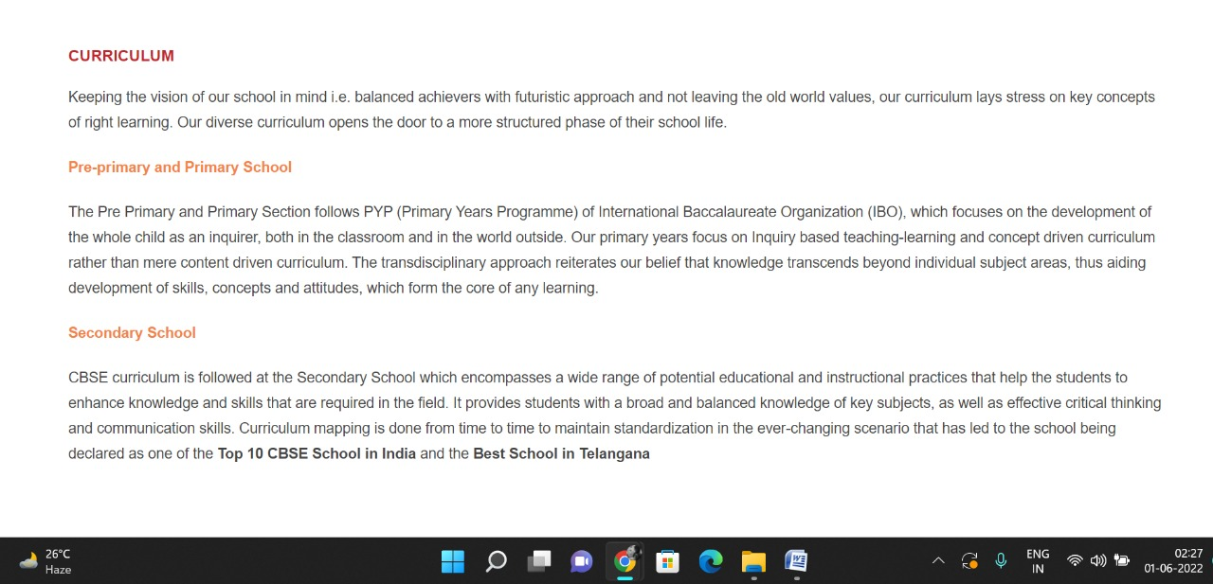

**PAGE 29:Faculty**

**HTML CODE:**

<!DOCTYPE html>

<html lang="en">

<head>

    <meta charset="UTF-8">

    <meta http-equiv="X-UA-Compatible" content="IE=edge">

    <meta name="viewport" content="width=device-width, initial-scale=1.0">

    <title>FACULTY - Meridian School</title>

    <link rel="stylesheet" href="style.css">

    <link rel="stylesheet" href="https://pro.fontawesome.com/releases/v5.10.0/css/all.css" />

    <link rel="icon" type="imag/logo2.png" href="img/logo2.png">

    <link rel="stylesheet" href="https://stackpath.bootstrapcdn.com/bootstrap/4.4.1/css/bootstrap.min.css"

        integrity="sha384-Vkoo8x4CGs03+Hhxv8T/Q5paXtkKtu6ug5TOeNV6gBiFeWPGFN9MuhOf23Q9Ifjh" crossorigin="anonymous" />

    <link rel="stylesheet" href="https://cdnjs.cloudflare.com/ajax/libs/slick-carousel/1.8.1/slick-theme.min.css"

        integrity="sha512-17EgCFERpgZKcm0j0fEq1YCJuyAWdz9KUtv1EjVuaOz8pDnh/0nZxmU6BBXwaaxqoi9PQXnRWqlcDB027hgv9A=="

        crossorigin="anonymous" referrerpolicy="no-referrer" />

    <link rel="stylesheet" href="https://cdnjs.cloudflare.com/ajax/libs/slick-carousel/1.8.1/slick.min.css"

        integrity="sha512-yHknP1/AwR+yx26cB1y0cjvQUMvEa2PFzt1c9LlS4pRQ5NOTZFWbhBig+X9G9eYW/8m0/4OXNx8pxJ6z57x0dw=="

        crossorigin="anonymous" referrerpolicy="no-referrer" />

</head>

<body>

    <section id="follow">

        <div class="followus">

            <div class="icon1">

                <i class="fa fa-phone"></i>

                <a id="phone" href="">8096918857, 9948508222</a>

            </div>

            <div class="icon1">

                <i class="fa fa-envelope"></i>

                <a id="mail" href="">info.banjara@meridianschool.in</a>

            </div>

            <div class="icon">

                <a href="https://www.facebook.com/MeridianSchoolBanjaraHills/" target="_blank"

                    class="fab fa-facebook-f"></i></a>

                <a href="https://twitter.com/meridianbanjara" target="_blank"><i class="fab fa-twitter"></i></a>

                <a href="https://www.youtube.com/channel/UCBZ_gLF9qM18O3CDWQHeN1A" target="_blank"><i

                        class="fab fa-youtube"></i></a>

                <a href="https://www.instagram.com/meridianschools/" target="_blank"><i

                        class="fab fa-instagram"></i></a>

            </div>

        </div>

    </section>

    <div class="navbar">

        <a href="home.html"><img src="img/logo.png" class="logo" alt=""></a>

        <nav>

            <a class="active" href="home.html">HOME</a>

            <div class="dropdown">

                <button class="dropbtn">ABOUT US

                </button>

                <div class="dropdown-content">

                    <a href="knowmeridian.html">KNOW MERIDIAN</a>

                    <a href="visionmission.html">THE VISION & MISSION</a>

                    <a href="http://meridianbanjara.com/the-founders/">THE FOUNDER'S MESSAGE</a>

                    <a href="ceomsg.html">CEO'S MESSAGE</a>

                    <a href="principalmsg.html">THE PRINCIPAL'S MESSAGE</a>

                    <a href="awards.html">AWARDS AND ACCOLADES</a>

                    <a href="http://meridianbanjara.com/affiliations-accreditations/">AFFILIATIONS & ACCREDITATIONS</a>

                    <a href="blog.html">BLOG</a>

                </div>

            </div>

            <div class="dropdown">

                <button class="dropbtn">LEADERSHIP TEAM

                </button>

                <div class="dropdown-content">

                    <a href="principal.html">PRINCIPAL</a>

                    <a href="vp.html">VICE PRINCIPAL</a>

                    <a href="headmistress.html">HEADMISTRESS</a>

                    <a href="midSchool.html">MIDDLE SCHOOL INCHARGE</a>

                    <a href="ipPyp.html">IB PYP COORDINATOR</a>

                    <a href="preprimary.html">PRE PRIMARY INCHARGE</a>

                    <a href="global.html">GLOBAL PARTNERSHIP COORDINATOR</a>

                </div>

            </div>

            <div class="dropdown">

                <button class="dropbtn">ACADEMICS

                </button>

                <div class="dropdown-content">

                    <a href="AcaOverview.html">OVERVIEW</a>

                    <a href="methodology.html">METHODOLOGY AND LEARNING STYLE</a>

                    <a href="curriculum.html">CURRICULUM</a>

                    <a href="faculty.html">FACULTY</a>

                    <a href="teacherTraining.html">TEACHER TRAINING</a>

                    <a href="careerGuidance.html">CAREER GUIDANCE</a>

                    <a href="scholrship.html">SCHOLARSHIP PROGRAMME</a>

                </div>

            </div>

            <div class="dropdown">

                <button class="dropbtn">BEYOND ACADEMICS

                </button>

                <div class="dropdown-content">

                    <a href="beyondAcaOverview.html">OVERVIEW</a>

                    <a href="sports.html">SPORTS</a>

                    <a href="creatveAct.html">CREATIVE ACTIVITIES</a>

                    <a href="eduTrips.html">EDUCATIONAL TRIPS AND STUDENT<br> EXCHANGE PROGRAMMES</a>

                    <a href="perfectSystem.html">PERFECT SYSTEM</a>

                    <a href="schoolSocialRes.html">SCHOOL'S SOCIAL RESPONSIBILITY</a>

                    <a href="interact.html">INTERACT</a>

                    <a href="heritageClub.html">HERITAGE CLUB</a>

                    <a href="mun.html">MUN</a>

                </div>

            </div>

            <div class="dropdown">

                <button class="dropbtn">ADMISSIONS

                </button>

                <div class="dropdown-content">

                    <a href="overview.html">OVERVIEW</a>

                    <a href="admissionpro.html">ADMISSION PROCEDURE</a>

                    <a href="feepolicy.html">FEE POLICY</a>

                    <a href="tranfercert.html">TRANSFER CERTIFICATE</a>

                    <a href="transport.html">TRANSPORT</a>

                </div>

            </div>

            <a class="active" href="gallery.html">GALLERY</a>

            <div class="dropdown">

                <button class="dropbtn">CONTACT US

                </button>

                <div class="dropdown-content">

                    <a href="contact.html">CAREERS</a>

                </div>

            </div>

        </nav>

    </div>

    <div id="mobile">

        <i id="bar" class="fas fa-outdent "></i>

    </div>

    <section id="principal">

        <div class="prin" id="faculty">

            <h2>FACULTY</h2>

            <span id="orange"><a href="home.html">Meridian School Banjara Hills</a></span>

            <span> &gt; FACULTY</span>

        </div>

    </section>

    <section id="principal1">

        <div class="academics" id="overview">

            <h4>FACULTY</h4>

            <p>‘Education is an endless journey through knowledge and enlightenment.’ Our learned faculty at Meridian

                are forever enthusiastic to learn and grow with latest trends in the field of teaching. True to the

                tagline of the school connecting the mind and heart, the teachers combined their knowledge with emotions

                of heart to create balanced individuals. While facilitating experiential learning, our faculty provide

                healthy environment for the students to explore, discover and excel. The faculty is the strength of the

                school. They are known for their dedication, devotion, commitment and discipline. This has resulted in

                100% pass at the boards for the past 25 years and also helped achieve state and national level ranks.

                The faculty is given various opportunities to refresh their skills and knowledge through webinars,

                workshops, online trainings and department meetings etc. They are also motivated to participate and

                train students in various collaborative activities and programmes that enrich the students and also help

                the society.</p>

        </div>

        </div>

    </section>

    <footer>

        <div class="col">

            <h4>ABOUT US</h4>

            <p>Meridian is a New Generation Educational Group committed to educate children for life and thus bring a

                change in the society. Learning philosophy practised at Meridian infuses traditional values into a

                progressive approach, equipping students to adapt and excel anywhere in the world. Our alumni, working

                in diverse fields, have found Meridian to be the best school for a successful career take off.</p>

        </div>

        <div class="col">

            <h4>USEFUL LINKS</h4>

            <ul class="three-col-links">

                <li><a href="home.html">HOME</a></li>

                <li><a href="AcaOverview.html">ACADEMICS</a></li>

                <li><a href="overview.html">ADMISSIONS</a></li>

                <li><a href="contact.html">CONTACT US</a></li>

                <li><a href="knowmeridian.html">ABOUT US</a></li>

                <li><a href="beyondAcaOverview.html">BEYOND ACADEMICS</a></li>

                <li><a href="contact.html">CAREERS</a></li>

            </ul>

        </div>

        <div class="col">

            <!--<div class="follow">

                <div class="icon">

                    <i class="fa fa-paper-plane-o"></i>

                </div>

        </div>-->

            <h4>MERIDIAN SCHOOL, Banjara Hills</h4>

            <p># 8-2-541, Road No 7, Banjara Hills, Hyderabad-500034, TELANGANA, INDIA.</p>

            <p>For contact : +91 8096918857, 9948508222, For Prinicipal Appointments : 8098420002</p>

            <p> For Admissions / Enquires : 8096918857, 9948508222</p>

            <p>info.banjara@meridianschool.inA</p>

        </div>

    </footer>

    <section id="copyright">

        <div id="cr">

            <p>© Copyright MERIDIAN SCHOOL, 2021.</p>

        </div>

    </section>

</body>

</html>

**CSS CODE:**

#principal .prin h2 {

font-size: 34px;

font-weight: 600;

text-align: start;

/* color: #c42329; */

}

#principal .prin span {

color: #fff;

}

#principal #orange {

color: #f48243;

}

#principal #orange:hover {

color: #fff;

}

#principal1 .princi1 {

display: flex;

}

#principal1 .princi1 img {

width: 250px;

height: 169px;

border: 7px solid rgb(225, 222, 222);

}

#principal1 .princi1 h4 {

text-align: start;

color: #c42329;

margin: 100px 0 35px 0px;

}

#principal1 .princi1 #info {

width: 42%;

margin: 200px 53px 70px;

}

#principal1 .princi1 #info p {

margin-bottom: 20px;

}

#principal1 .princi1 #info #strong {

margin-bottom: 0px;

}

#principal .princi1 #info h5 {

    color: #f48243;

    margin: -20px 0px 35px 70px;

}

**OUTPUT:**

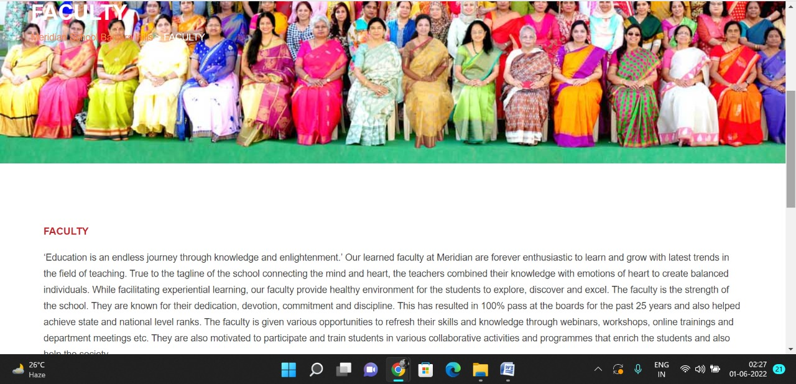

**PAGE 30:Teacher Training**

**HTML CODE:**

<!DOCTYPE html>

<html lang="en">

<head>

    <meta charset="UTF-8">

    <meta http-equiv="X-UA-Compatible" content="IE=edge">

    <meta name="viewport" content="width=device-width, initial-scale=1.0">

    <title>TEACHER TRAINING - Meridian School</title>

    <link rel="stylesheet" href="style.css">

    <link rel="stylesheet" href="https://pro.fontawesome.com/releases/v5.10.0/css/all.css" />

    <link rel="icon" type="imag/logo2.png" href="img/logo2.png">

    <link rel="stylesheet" href="https://stackpath.bootstrapcdn.com/bootstrap/4.4.1/css/bootstrap.min.css"

        integrity="sha384-Vkoo8x4CGs03+Hhxv8T/Q5paXtkKtu6ug5TOeNV6gBiFeWPGFN9MuhOf23Q9Ifjh" crossorigin="anonymous" />

    <link rel="stylesheet" href="https://cdnjs.cloudflare.com/ajax/libs/slick-carousel/1.8.1/slick-theme.min.css"

        integrity="sha512-17EgCFERpgZKcm0j0fEq1YCJuyAWdz9KUtv1EjVuaOz8pDnh/0nZxmU6BBXwaaxqoi9PQXnRWqlcDB027hgv9A=="

        crossorigin="anonymous" referrerpolicy="no-referrer" />

    <link rel="stylesheet" href="https://cdnjs.cloudflare.com/ajax/libs/slick-carousel/1.8.1/slick.min.css"

        integrity="sha512-yHknP1/AwR+yx26cB1y0cjvQUMvEa2PFzt1c9LlS4pRQ5NOTZFWbhBig+X9G9eYW/8m0/4OXNx8pxJ6z57x0dw=="

        crossorigin="anonymous" referrerpolicy="no-referrer" />

</head>

<body>

    <section id="follow">

        <div class="followus">

            <div class="icon1">

                <i class="fa fa-phone"></i>

                <a id="phone" href="">8096918857, 9948508222</a>

            </div>

            <div class="icon1">

                <i class="fa fa-envelope"></i>

                <a id="mail" href="">info.banjara@meridianschool.in</a>

            </div>

            <div class="icon">

                <a href="https://www.facebook.com/MeridianSchoolBanjaraHills/" target="_blank"

                    class="fab fa-facebook-f"></i></a>

                <a href="https://twitter.com/meridianbanjara" target="_blank"><i class="fab fa-twitter"></i></a>

                <a href="https://www.youtube.com/channel/UCBZ_gLF9qM18O3CDWQHeN1A" target="_blank"><i

                        class="fab fa-youtube"></i></a>

                <a href="https://www.instagram.com/meridianschools/" target="_blank"><i

                        class="fab fa-instagram"></i></a>

            </div>

        </div>

    </section>

    <div class="navbar">

        <a href="home.html"><img src="img/logo.png" class="logo" alt=""></a>

        <nav>

            <a class="active" href="home.html">HOME</a>

            <div class="dropdown">

                <button class="dropbtn">ABOUT US

                </button>

                <div class="dropdown-content">

                    <a href="knowmeridian.html">KNOW MERIDIAN</a>

                    <a href="visionmission.html">THE VISION & MISSION</a>

                    <a href="http://meridianbanjara.com/the-founders/">THE FOUNDER'S MESSAGE</a>

                    <a href="ceomsg.html">CEO'S MESSAGE</a>

                    <a href="principalmsg.html">THE PRINCIPAL'S MESSAGE</a>

                    <a href="awards.html">AWARDS AND ACCOLADES</a>

                    <a href="http://meridianbanjara.com/affiliations-accreditations/">AFFILIATIONS & ACCREDITATIONS</a>

                    <a href="blog.html">BLOG</a>

                </div>

            </div>

            <div class="dropdown">

                <button class="dropbtn">LEADERSHIP TEAM

                </button>

                <div class="dropdown-content">

                    <a href="principal.html">PRINCIPAL</a>

                    <a href="vp.html">VICE PRINCIPAL</a>

                    <a href="headmistress.html">HEADMISTRESS</a>

                    <a href="midSchool.html">MIDDLE SCHOOL INCHARGE</a>

                    <a href="ipPyp.html">IB PYP COORDINATOR</a>

                    <a href="preprimary.html">PRE PRIMARY INCHARGE</a>

                    <a href="global.html">GLOBAL PARTNERSHIP COORDINATOR</a>

                </div>

            </div>

            <div class="dropdown">

                <button class="dropbtn">ACADEMICS

                </button>

                <div class="dropdown-content">

                    <a href="AcaOverview.html">OVERVIEW</a>

                    <a href="methodology.html">METHODOLOGY AND LEARNING STYLE</a>

                    <a href="curriculum.html">CURRICULUM</a>

                    <a href="faculty.html">FACULTY</a>

                    <a href="teacherTraining.html">TEACHER TRAINING</a>

                    <a href="careerGuidance.html">CAREER GUIDANCE</a>

                    <a href="scholrship.html">SCHOLARSHIP PROGRAMME</a>

                </div>

            </div>

            <div class="dropdown">

                <button class="dropbtn">BEYOND ACADEMICS

                </button>

                <div class="dropdown-content">

                    <a href="beyondAcaOverview.html">OVERVIEW</a>

                    <a href="sports.html">SPORTS</a>

                    <a href="creatveAct.html">CREATIVE ACTIVITIES</a>

                    <a href="eduTrips.html">EDUCATIONAL TRIPS AND STUDENT<br> EXCHANGE PROGRAMMES</a>

                    <a href="perfectSystem.html">PERFECT SYSTEM</a>

                    <a href="schoolSocialRes.html">SCHOOL'S SOCIAL RESPONSIBILITY</a>

                    <a href="interact.html">INTERACT</a>

                    <a href="heritageClub.html">HERITAGE CLUB</a>

                    <a href="mun.html">MUN</a>

                </div>

            </div>

            <div class="dropdown">

                <button class="dropbtn">ADMISSIONS

                </button>

                <div class="dropdown-content">

                    <a href="overview.html">OVERVIEW</a>

                    <a href="admissionpro.html">ADMISSION PROCEDURE</a>

                    <a href="feepolicy.html">FEE POLICY</a>

                    <a href="tranfercert.html">TRANSFER CERTIFICATE</a>

                    <a href="transport.html">TRANSPORT</a>

                </div>

            </div>

            <a class="active" href="gallery.html">GALLERY</a>

            <div class="dropdown">

                <button class="dropbtn">CONTACT US

                </button>

                <div class="dropdown-content">

                    <a href="contact.html">CAREERS</a>

                </div>

            </div>

        </nav>

    </div>

    <div id="mobile">

        <i id="bar" class="fas fa-outdent "></i>

    </div>

    <section id="principal">

        <div class="prin" id="overview1">

            <h2>TEACHER TRAINING</h2>

            <span id="orange"><a href="home.html">Meridian School Banjara Hills</a></span>

            <span> &gt; TEACHER TRAINING</span>

        </div>

    </section>

    <section id="principal1">

        <div class="academics" id="overview">

            <h4>TEACHERS’ PROFESSIONAL DEVELOPMENT @ Meridian</h4>

            <p>A teacher must grow not only with but above the student in order to win the confidence of the latter.

                Meridian believes in updating and upgrading teachers professional skills by honing not only their

                academic skills but also their social and emotional skills in various methods. This is done to improve

                their competency levels and to empower them to teach to a child of next generation.</p>

            <p>Professional development of teachers takes place through</p>

            <ul>

                <li>Various workshops conducted by eminent resource persons in varied methodologies with remarkable

                    expertise. Some are subject oriented and some are generic.</li>

                <li>In service teacher orientation programs conducted by CBSE.</li>

                <li>Enrolling in online courses through reputed universities like Cambridge, Allison, Stanford, Harvard,

                    Coursera etc.</li>

                <li>Appearing for CENTA – TPO exam</li>

                <li>Attending Subject wise Department Meetings on a weekly basis.</li>

                <li>Attending Evaluation Orientation Sessions conducted by CBSE</li>

                <li>Exchange programs with other schools</li>

                <li>Sharing any new development in the field of education.</li>

            </ul>

            <p><strong>Social and Emotional skills</strong></p>

            <ul>

                <li>Workshops dealing with stress management, self-introspection and personality development</li>

                <li>Meditation sessions to enhance physical and emotional well-being in the evenings during pandemic

                </li>

                <li>Practice of yoga in the leisure time and during breaks</li>

                <li>Outings and recreational staff picnics</li>

            </ul>

        </div>

    </section>

    <footer>

        <div class="col">

            <h4>ABOUT US</h4>

            <p>Meridian is a New Generation Educational Group committed to educate children for life and thus bring a

                change in the society. Learning philosophy practised at Meridian infuses traditional values into a

                progressive approach, equipping students to adapt and excel anywhere in the world. Our alumni, working

                in diverse fields, have found Meridian to be the best school for a successful career take off.</p>

        </div>

        <div class="col">

            <h4>USEFUL LINKS</h4>

            <ul class="three-col-links">

                <li><a href="home.html">HOME</a></li>

                <li><a href="AcaOverview.html">ACADEMICS</a></li>

                <li><a href="overview.html">ADMISSIONS</a></li>

                <li><a href="contact.html">CONTACT US</a></li>

                <li><a href="knowmeridian.html">ABOUT US</a></li>

                <li><a href="beyondAcaOverview.html">BEYOND ACADEMICS</a></li>

                <li><a href="contact.html">CAREERS</a></li>

            </ul>

        </div>

        <div class="col">

            <!--<div class="follow">

                <div class="icon">

                    <i class="fa fa-paper-plane-o"></i>

                </div>

        </div>-->

            <h4>MERIDIAN SCHOOL, Banjara Hills</h4>

            <p># 8-2-541, Road No 7, Banjara Hills, Hyderabad-500034, TELANGANA, INDIA.</p>

            <p>For contact : +91 8096918857, 9948508222, For Prinicipal Appointments : 8098420002</p>

            <p> For Admissions / Enquires : 8096918857, 9948508222</p>

            <p>info.banjara@meridianschool.inA</p>

        </div>

    </footer>

    <section id="copyright">

        <div id="cr">

            <p>© Copyright MERIDIAN SCHOOL, 2021.</p>

        </div>

    </section>

</body>

</html>

**CSS CODE:**

#principal .prin h2 {

font-size: 34px;

font-weight: 600;

text-align: start;

/* color: #c42329; */

}

#principal .prin span {

color: #fff;

}

#principal #orange {

color: #f48243;

}

#principal #orange:hover {

color: #fff;

}

#principal1 .princi1 {

display: flex;

}

#principal1 .princi1 img {

width: 250px;

height: 169px;

border: 7px solid rgb(225, 222, 222);

}

#principal1 .princi1 h4 {

text-align: start;

color: #c42329;

margin: 100px 0 35px 0px;

}

#principal1 .princi1 #info {

width: 42%;

margin: 200px 53px 70px;

}

#principal1 .princi1 #info p {

margin-bottom: 20px;

}

#principal1 .princi1 #info #strong {

margin-bottom: 0px;

}

#principal .princi1 #info h5 {

    color: #f48243;

    margin: -20px 0px 35px 70px;

}

**OUTPUT:**

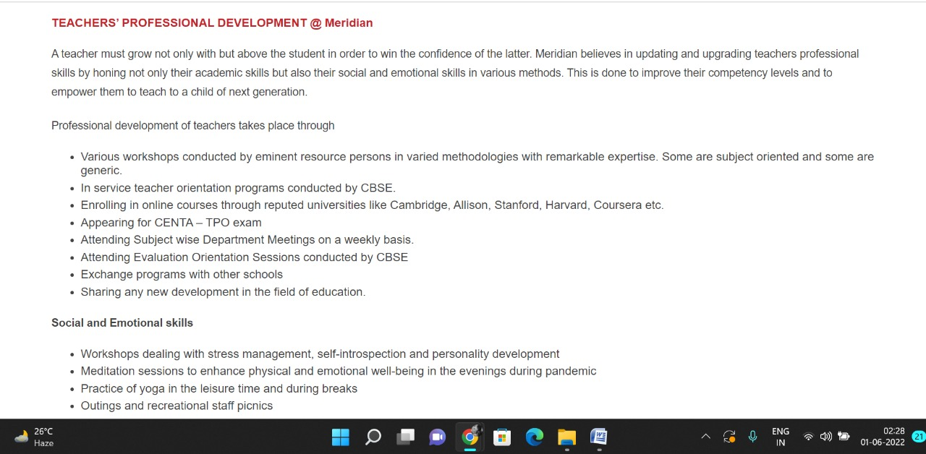

**PAGE 31:Career Guidance**

**HTML CODE:**

<!DOCTYPE html>

<html lang="en">

<head>

    <meta charset="UTF-8">

    <meta http-equiv="X-UA-Compatible" content="IE=edge">

    <meta name="viewport" content="width=device-width, initial-scale=1.0">

    <title>CAREER GUIDANCE - Meridian School</title>

    <link rel="stylesheet" href="style.css">

    <link rel="stylesheet" href="https://pro.fontawesome.com/releases/v5.10.0/css/all.css" />

    <link rel="icon" type="imag/logo2.png" href="img/logo2.png">

    <link rel="stylesheet" href="https://stackpath.bootstrapcdn.com/bootstrap/4.4.1/css/bootstrap.min.css"

        integrity="sha384-Vkoo8x4CGs03+Hhxv8T/Q5paXtkKtu6ug5TOeNV6gBiFeWPGFN9MuhOf23Q9Ifjh" crossorigin="anonymous" />

    <link rel="stylesheet" href="https://cdnjs.cloudflare.com/ajax/libs/slick-carousel/1.8.1/slick-theme.min.css"

        integrity="sha512-17EgCFERpgZKcm0j0fEq1YCJuyAWdz9KUtv1EjVuaOz8pDnh/0nZxmU6BBXwaaxqoi9PQXnRWqlcDB027hgv9A=="

        crossorigin="anonymous" referrerpolicy="no-referrer" />

    <link rel="stylesheet" href="https://cdnjs.cloudflare.com/ajax/libs/slick-carousel/1.8.1/slick.min.css"

        integrity="sha512-yHknP1/AwR+yx26cB1y0cjvQUMvEa2PFzt1c9LlS4pRQ5NOTZFWbhBig+X9G9eYW/8m0/4OXNx8pxJ6z57x0dw=="

        crossorigin="anonymous" referrerpolicy="no-referrer" />

</head>

<body>

    <section id="follow">

        <div class="followus">

            <div class="icon1">

                <i class="fa fa-phone"></i>

                <a id="phone" href="">8096918857, 9948508222</a>

            </div>

            <div class="icon1">

                <i class="fa fa-envelope"></i>

                <a id="mail" href="">info.banjara@meridianschool.in</a>

            </div>

            <div class="icon">

                <a href="https://www.facebook.com/MeridianSchoolBanjaraHills/" target="_blank"

                    class="fab fa-facebook-f"></i></a>

                <a href="https://twitter.com/meridianbanjara" target="_blank"><i class="fab fa-twitter"></i></a>

                <a href="https://www.youtube.com/channel/UCBZ_gLF9qM18O3CDWQHeN1A" target="_blank"><i

                        class="fab fa-youtube"></i></a>

                <a href="https://www.instagram.com/meridianschools/" target="_blank"><i

                        class="fab fa-instagram"></i></a>

            </div>

        </div>

    </section>

    <div class="navbar">

        <a href="home.html"><img src="img/logo.png" class="logo" alt=""></a>

        <nav>

            <a class="active" href="home.html">HOME</a>

            <div class="dropdown">

                <button class="dropbtn">ABOUT US

                </button>

                <div class="dropdown-content">

                    <a href="knowmeridian.html">KNOW MERIDIAN</a>

                    <a href="visionmission.html">THE VISION & MISSION</a>

                    <a href="http://meridianbanjara.com/the-founders/">THE FOUNDER'S MESSAGE</a>

                    <a href="ceomsg.html">CEO'S MESSAGE</a>

                    <a href="principalmsg.html">THE PRINCIPAL'S MESSAGE</a>

                    <a href="awards.html">AWARDS AND ACCOLADES</a>

                    <a href="http://meridianbanjara.com/affiliations-accreditations/">AFFILIATIONS & ACCREDITATIONS</a>

                    <a href="blog.html">BLOG</a>

                </div>

            </div>

            <div class="dropdown">

                <button class="dropbtn">LEADERSHIP TEAM

                </button>

                <div class="dropdown-content">

                    <a href="principal.html">PRINCIPAL</a>

                    <a href="vp.html">VICE PRINCIPAL</a>

                    <a href="headmistress.html">HEADMISTRESS</a>

                    <a href="midSchool.html">MIDDLE SCHOOL INCHARGE</a>

                    <a href="ipPyp.html">IB PYP COORDINATOR</a>

                    <a href="preprimary.html">PRE PRIMARY INCHARGE</a>

                    <a href="global.html">GLOBAL PARTNERSHIP COORDINATOR</a>

                </div>

            </div>

            <div class="dropdown">

                <button class="dropbtn">ACADEMICS

                </button>

                <div class="dropdown-content">

                    <a href="AcaOverview.html">OVERVIEW</a>

                    <a href="methodology.html">METHODOLOGY AND LEARNING STYLE</a>

                    <a href="curriculum.html">CURRICULUM</a>

                    <a href="faculty.html">FACULTY</a>

                    <a href="teacherTraining.html">TEACHER TRAINING</a>

                    <a href="careerGuidance.html">CAREER GUIDANCE</a>

                    <a href="scholrship.html">SCHOLARSHIP PROGRAMME</a>

                </div>

            </div>

            <div class="dropdown">

                <button class="dropbtn">BEYOND ACADEMICS

                </button>

                <div class="dropdown-content">

                    <a href="beyondAcaOverview.html">OVERVIEW</a>

                    <a href="sports.html">SPORTS</a>

                    <a href="creatveAct.html">CREATIVE ACTIVITIES</a>

                    <a href="eduTrips.html">EDUCATIONAL TRIPS AND STUDENT<br> EXCHANGE PROGRAMMES</a>

                    <a href="perfectSystem.html">PERFECT SYSTEM</a>

                    <a href="schoolSocialRes.html">SCHOOL'S SOCIAL RESPONSIBILITY</a>

                    <a href="interact.html">INTERACT</a>

                    <a href="heritageClub.html">HERITAGE CLUB</a>

                    <a href="mun.html">MUN</a>

                </div>

            </div>

            <div class="dropdown">

                <button class="dropbtn">ADMISSIONS

                </button>

                <div class="dropdown-content">

                    <a href="overview.html">OVERVIEW</a>

                    <a href="admissionpro.html">ADMISSION PROCEDURE</a>

                    <a href="feepolicy.html">FEE POLICY</a>

                    <a href="tranfercert.html">TRANSFER CERTIFICATE</a>

                    <a href="transport.html">TRANSPORT</a>

                </div>

            </div>

            <a class="active" href="gallery.html">GALLERY</a>

            <div class="dropdown">

                <button class="dropbtn">CONTACT US

                </button>

                <div class="dropdown-content">

                    <a href="contact.html">CAREERS</a>

                </div>

            </div>

        </nav>

    </div>

    <div id="mobile">

        <i id="bar" class="fas fa-outdent "></i>

    </div>

    <section id="principal">

        <div class="prin" id="overview1">

            <h2>CAREER GUIDANCE</h2>

            <span id="orange"><a href="home.html">Meridian School Banjara Hills</a></span>

            <span> &gt; CAREER GUIDANCE</span>

        </div>

    </section>

    <section id="principal1">

        <div class="academics" id="overview">

            <h4>CAREER COUNSELLING & GUIDANCE</h4>

            <p>Career guidance at MERIDIAN begins in Class 9.</p>

            <p>The school hosts University Fairs, wherein groups of Universities from USA, Canada, UK, Australia and

                India visit the campus each year to provide information about the courses on offer.</p>

            <p>The school hosts University Fairs, wherein groups of Universities from USA, Canada, UK, Australia and

                India visit the campus each year to provide information about the courses on offer.</p>

            <p class="headOrange">Guest Lectures and Professional Career Advice</p>

            <p>Choosing a career or program of study is a daunting task. Meridian provides our students with

                opportunities to meet experts from different fields who can offer a wealth of experience to allow

                students to make educated decisions for their futures.</p>

            <p class="headOrange">Essay Writing Workshops</p>

            <p>While grades and test scores are important, an exceptional college application essay is a crucial factor

                in University Application process.</p>

            <p>To help students learn much of what is needed to write that standout application essay. This year also we

                organized Essay Writing Workshops that help students get started and work their way through the essay

                writing process.</p>

            <p class="headOrange">Preparatory courses and testing for SAT, PSAT, AP and ACT</p>

            <p>We guide students related to Preparatory courses and tests like SAT, PSAT, AP and ACT</p>

            <p class="headOrange">Personalised Attention</p>

            <p>One-on-one counselling is offered to students to know their aptitudes, skills and preferences, to help

                them identify Universities, majors and courses best suited for their individual priorities and needs.

            </p>

            <p class="headOrange">Summer Internship</p>

            <p>Meridian’s career guidance department provides students with support to participate in virtual

                internships and summer internships at reputed organizations across different industries. Our students

                have participated and won accolades at the Harvard, Oxford and other University summer programmes.</p>

            <p class="headOrange">Alumni Interactions</p>

            <p>Alumni sessions are organized to increase interaction and knowledge sharing.</p>

            <p>Meridian alumni are attending the best Universities in India and around the world.</p>

            <div id="career">

                <img class="car1" src="img/academics/career1.jpg" alt="">

                <img class="car1" src="img/academics/career2.jpg" alt="">

                <img class="car1" src="img/academics/career3.jpg" alt="">

                <img class="car1" src="img/academics/career4.jpg" alt="">

                <img class="car1" src="img/academics/career5.jpg" alt="">

                <img class="car1" src="img/academics/career6.jpg" alt="">

                <img class="car1" src="img/academics/career7.jpg" alt="">

                <img class="car1" src="img/academics/career8.jpg" alt="">

            </div>

        </div>

    </section>

    <footer>

        <div class="col">

            <h4>ABOUT US</h4>

            <p>Meridian is a New Generation Educational Group committed to educate children for life and thus bring a

                change in the society. Learning philosophy practised at Meridian infuses traditional values into a

                progressive approach, equipping students to adapt and excel anywhere in the world. Our alumni, working

                in diverse fields, have found Meridian to be the best school for a successful career take off.</p>

        </div>

        <div class="col">

            <h4>USEFUL LINKS</h4>

            <ul class="three-col-links">

                <li><a href="home.html">HOME</a></li>

                <li><a href="AcaOverview.html">ACADEMICS</a></li>

                <li><a href="overview.html">ADMISSIONS</a></li>

                <li><a href="contact.html">CONTACT US</a></li>

                <li><a href="knowmeridian.html">ABOUT US</a></li>

                <li><a href="beyondAcaOverview.html">BEYOND ACADEMICS</a></li>

                <li><a href="contact.html">CAREERS</a></li>

            </ul>

        </div>

        <div class="col">

            <!--<div class="follow">

                <div class="icon">

                    <i class="fa fa-paper-plane-o"></i>

                </div>

        </div>-->

            <h4>MERIDIAN SCHOOL, Banjara Hills</h4>

            <p># 8-2-541, Road No 7, Banjara Hills, Hyderabad-500034, TELANGANA, INDIA.</p>

            <p>For contact : +91 8096918857, 9948508222, For Prinicipal Appointments : 8098420002</p>

            <p> For Admissions / Enquires : 8096918857, 9948508222</p>

            <p>info.banjara@meridianschool.inA</p>

        </div>

    </footer>

    <section id="copyright">

        <div id="cr">

            <p>© Copyright MERIDIAN SCHOOL, 2021.</p>

        </div>

    </section>

</body>

</html>

**CSS CODE:**

#principal .prin h2 {

font-size: 34px;

font-weight: 600;

text-align: start;

/* color: #c42329; */

}

#principal .prin span {

color: #fff;

}

#principal #orange {

color: #f48243;

}

#principal #orange:hover {

color: #fff;

}

#principal1 .princi1 {

display: flex;

}

#principal1 .princi1 img {

width: 250px;

height: 169px;

border: 7px solid rgb(225, 222, 222);

}

#principal1 .princi1 h4 {

text-align: start;

color: #c42329;

margin: 100px 0 35px 0px;

}

#principal1 .princi1 #info {

width: 42%;

margin: 200px 53px 70px;

}

#principal1 .princi1 #info p {

margin-bottom: 20px;

}

#principal1 .princi1 #info #strong {

margin-bottom: 0px;

}

#principal .princi1 #info h5 {

color: #f48243;

margin: -20px 0px 35px 70px;

}

**OUTPUT:**

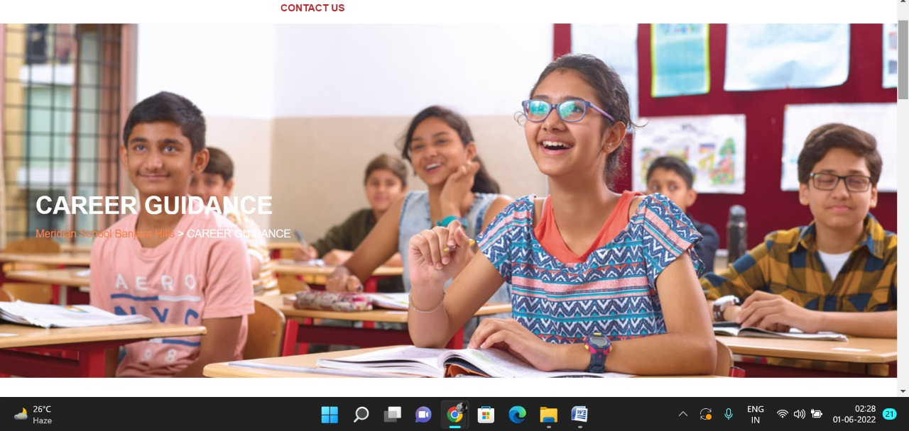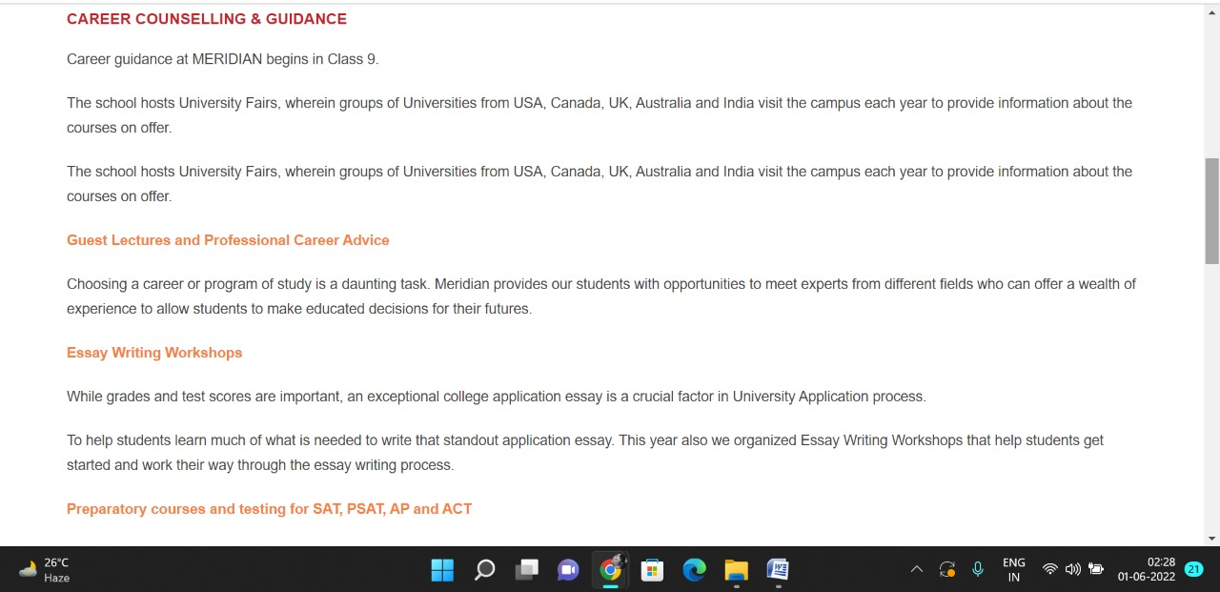

**PAGE 32:Scholarship Programme**

**HTML CODE:**

<!DOCTYPE html>

<html lang="en">

<head>

    <meta charset="UTF-8">

    <meta http-equiv="X-UA-Compatible" content="IE=edge">

    <meta name="viewport" content="width=device-width, initial-scale=1.0">

    <title>SCHOLARSHIP PROGRAMME - Meridian School</title>

    <link rel="stylesheet" href="style.css">

    <link rel="stylesheet" href="https://pro.fontawesome.com/releases/v5.10.0/css/all.css" />

    <link rel="icon" type="imag/logo2.png" href="img/logo2.png">

    <link rel="stylesheet" href="https://stackpath.bootstrapcdn.com/bootstrap/4.4.1/css/bootstrap.min.css"

        integrity="sha384-Vkoo8x4CGs03+Hhxv8T/Q5paXtkKtu6ug5TOeNV6gBiFeWPGFN9MuhOf23Q9Ifjh" crossorigin="anonymous" />

    <link rel="stylesheet" href="https://cdnjs.cloudflare.com/ajax/libs/slick-carousel/1.8.1/slick-theme.min.css"

        integrity="sha512-17EgCFERpgZKcm0j0fEq1YCJuyAWdz9KUtv1EjVuaOz8pDnh/0nZxmU6BBXwaaxqoi9PQXnRWqlcDB027hgv9A=="

        crossorigin="anonymous" referrerpolicy="no-referrer" />

    <link rel="stylesheet" href="https://cdnjs.cloudflare.com/ajax/libs/slick-carousel/1.8.1/slick.min.css"

        integrity="sha512-yHknP1/AwR+yx26cB1y0cjvQUMvEa2PFzt1c9LlS4pRQ5NOTZFWbhBig+X9G9eYW/8m0/4OXNx8pxJ6z57x0dw=="

        crossorigin="anonymous" referrerpolicy="no-referrer" />

</head>

<body>

    <section id="follow">

        <div class="followus">

            <div class="icon1">

                <i class="fa fa-phone"></i>

                <a id="phone" href="">8096918857, 9948508222</a>

            </div>

            <div class="icon1">

                <i class="fa fa-envelope"></i>

                <a id="mail" href="">info.banjara@meridianschool.in</a>

            </div>

            <div class="icon">

                <a href="https://www.facebook.com/MeridianSchoolBanjaraHills/" target="_blank"

                    class="fab fa-facebook-f"></i></a>

                <a href="https://twitter.com/meridianbanjara" target="_blank"><i class="fab fa-twitter"></i></a>

                <a href="https://www.youtube.com/channel/UCBZ_gLF9qM18O3CDWQHeN1A" target="_blank"><i

                        class="fab fa-youtube"></i></a>

                <a href="https://www.instagram.com/meridianschools/" target="_blank"><i

                        class="fab fa-instagram"></i></a>

            </div>

        </div>

    </section>

    <div class="navbar">

        <a href="home.html"><img src="img/logo.png" class="logo" alt=""></a>

        <nav>

            <a class="active" href="home.html">HOME</a>

            <div class="dropdown">

                <button class="dropbtn">ABOUT US

                </button>

                <div class="dropdown-content">

                    <a href="knowmeridian.html">KNOW MERIDIAN</a>

                    <a href="visionmission.html">THE VISION & MISSION</a>

                    <a href="http://meridianbanjara.com/the-founders/">THE FOUNDER'S MESSAGE</a>

                    <a href="ceomsg.html">CEO'S MESSAGE</a>

                    <a href="principalmsg.html">THE PRINCIPAL'S MESSAGE</a>

                    <a href="awards.html">AWARDS AND ACCOLADES</a>

                    <a href="http://meridianbanjara.com/affiliations-accreditations/">AFFILIATIONS & ACCREDITATIONS</a>

                    <a href="blog.html">BLOG</a>

                </div>

            </div>

            <div class="dropdown">

                <button class="dropbtn">LEADERSHIP TEAM

                </button>

                <div class="dropdown-content">

                    <a href="principal.html">PRINCIPAL</a>

                    <a href="vp.html">VICE PRINCIPAL</a>

                    <a href="headmistress.html">HEADMISTRESS</a>

                    <a href="midSchool.html">MIDDLE SCHOOL INCHARGE</a>

                    <a href="ipPyp.html">IB PYP COORDINATOR</a>

                    <a href="preprimary.html">PRE PRIMARY INCHARGE</a>

                    <a href="global.html">GLOBAL PARTNERSHIP COORDINATOR</a>

                </div>

            </div>

            <div class="dropdown">

                <button class="dropbtn">ACADEMICS

                </button>

                <div class="dropdown-content">

                    <a href="AcaOverview.html">OVERVIEW</a>

                    <a href="methodology.html">METHODOLOGY AND LEARNING STYLE</a>

                    <a href="curriculum.html">CURRICULUM</a>

                    <a href="faculty.html">FACULTY</a>

                    <a href="teacherTraining.html">TEACHER TRAINING</a>

                    <a href="careerGuidance.html">CAREER GUIDANCE</a>

                    <a href="scholrship.html">SCHOLARSHIP PROGRAMME</a>

                </div>

            </div>

            <div class="dropdown">

                <button class="dropbtn">BEYOND ACADEMICS

                </button>

                <div class="dropdown-content">

                    <a href="beyondAcaOverview.html">OVERVIEW</a>

                    <a href="sports.html">SPORTS</a>

                    <a href="creatveAct.html">CREATIVE ACTIVITIES</a>

                    <a href="eduTrips.html">EDUCATIONAL TRIPS AND STUDENT<br> EXCHANGE PROGRAMMES</a>

                    <a href="perfectSystem.html">PERFECT SYSTEM</a>

                    <a href="schoolSocialRes.html">SCHOOL'S SOCIAL RESPONSIBILITY</a>

                    <a href="interact.html">INTERACT</a>

                    <a href="heritageClub.html">HERITAGE CLUB</a>

                    <a href="mun.html">MUN</a>

                </div>

            </div>

            <div class="dropdown">

                <button class="dropbtn">ADMISSIONS

                </button>

                <div class="dropdown-content">

                    <a href="overview.html">OVERVIEW</a>

                    <a href="admissionpro.html">ADMISSION PROCEDURE</a>

                    <a href="feepolicy.html">FEE POLICY</a>

                    <a href="tranfercert.html">TRANSFER CERTIFICATE</a>

                    <a href="transport.html">TRANSPORT</a>

                </div>

            </div>

            <a class="active" href="gallery.html">GALLERY</a>

            <div class="dropdown">

                <button class="dropbtn">CONTACT US

                </button>

                <div class="dropdown-content">

                    <a href="contact.html">CAREERS</a>

                </div>

            </div>

        </nav>

    </div>

    <div id="mobile">

        <i id="bar" class="fas fa-outdent "></i>

    </div>

    <section id="principal">

        <div class="prin" id="overview1">

            <h2>SCHOLARSHIP PROGRAMME</h2>

            <span id="orange"><a href="home.html">Meridian School Banjara Hills</a></span>

            <span> &gt; SCHOLARSHIP PROGRAMME</span>

        </div>

    </section>

    <section id="principal1">

        <div class="academics" id="overview">

            <h4>SCHOLARSHIP PROGRAMME</h4>

            <p>Meridian Scholarship Programme aims to award scholarships to exceptional, highly motivated and deserving

                students in the area of <strong> Academics / Sports.</strong></p>

            <ul>

                <li>Scholarships shall be strictly based on their <strong> Merit cum Need.</strong></li>

                <li>Scholarships are available to new students taking admission to either <strong> Grade 9 or Grade 11

                    </strong> and shall be awarded for a maximum of <strong> two-year </strong> academic period.</li>

                <li>All Scholarships granted are reviewed annually and are based on the continued performance of the

                    awardee.</li>

            </ul>

            <p class="headOrange">Academics</p>

            <p>To be eligible to apply, students must meet the following ‘Minimum Eligibility Criterion’ in the

                preceding grade:</p>

            <table border="1" cellpadding="40px" cellspacing="0">

                <tr>

                    <th>Curriculum</th>

                    <th> Minimum Eligibility Criterion</th>

                </tr>

                <tr>

                    <td>CBSE</td>

                    <td>92% and above</td>

                </tr>

                <tr>

                    <td>ICSE</td>

                    <td>92% and above</td>

                </tr>

                <tr>

                    <td>IGCSE</td>

                    <td>Minimum 5 A*and not more than one C</td>

                </tr>

                <tr>

                    <td>Any other Curriculum</td>

                    <td>Equivalent to the grading system above for which Meridian shall create a matrix</td>

                </tr>

            </table>

            <p class="headOrange">Sports</p>

            <p>For students who have consistently shown outstanding merit and achievement at <strong> National and

                    International level Sporting Events & Tournaments.</strong></p>

            <p>The criterion mentioned above merely defines the ‘eligibility’ for applying for a Scholarship.

                Scholarships are limited in number and the decision of awarding a scholarship will be based on a series

                of processes in addition to some other assessment criterion. Scholarships can never be assumed as a

                right.</p>

        </div>

    </section>

    <footer>

        <div class="col">

            <h4>ABOUT US</h4>

            <p>Meridian is a New Generation Educational Group committed to educate children for life and thus bring a

                change in the society. Learning philosophy practised at Meridian infuses traditional values into a

                progressive approach, equipping students to adapt and excel anywhere in the world. Our alumni, working

                in diverse fields, have found Meridian to be the best school for a successful career take off.</p>

        </div>

        <div class="col">

            <h4>USEFUL LINKS</h4>

            <ul class="three-col-links">

                <li><a href="home.html">HOME</a></li>

                <li><a href="AcaOverview.html">ACADEMICS</a></li>

                <li><a href="overview.html">ADMISSIONS</a></li>

                <li><a href="contact.html">CONTACT US</a></li>

                <li><a href="knowmeridian.html">ABOUT US</a></li>

                <li><a href="beyondAcaOverview.html">BEYOND ACADEMICS</a></li>

                <li><a href="contact.html">CAREERS</a></li>

            </ul>

        </div>

        <div class="col">

            <!--<div class="follow">

                <div class="icon">

                    <i class="fa fa-paper-plane-o"></i>

                </div>

        </div>-->

            <h4>MERIDIAN SCHOOL, Banjara Hills</h4>

            <p># 8-2-541, Road No 7, Banjara Hills, Hyderabad-500034, TELANGANA, INDIA.</p>

            <p>For contact : +91 8096918857, 9948508222, For Prinicipal Appointments : 8098420002</p>

            <p> For Admissions / Enquires : 8096918857, 9948508222</p>

            <p>info.banjara@meridianschool.inA</p>

        </div>

    </footer>

    <section id="copyright">

        <div id="cr">

            <p>© Copyright MERIDIAN SCHOOL, 2021.</p>

        </div>

    </section>

</body>

</html>

**CSS CODE:**

#principal .prin h2 {

font-size: 34px;

font-weight: 600;

text-align: start;

/* color: #c42329; */

}

#principal .prin span {

color: #fff;

}

#principal #orange {

color: #f48243;

}

#principal #orange:hover {

color: #fff;

}

#principal1 .princi1 {

display: flex;

}

#principal1 .princi1 img {

width: 250px;

height: 169px;

border: 7px solid rgb(225, 222, 222);

}

#principal1 .princi1 h4 {

text-align: start;

color: #c42329;

margin: 100px 0 35px 0px;

}

#principal1 .princi1 #info {

width: 42%;

margin: 200px 53px 70px;

}

#principal1 .princi1 #info p {

margin-bottom: 20px;

}

#principal1 .princi1 #info #strong {

margin-bottom: 0px;

}

#principal .princi1 #info h5 {

color: #f48243;

margin: -20px 0px 35px 70px;

}

**OUTPUT:**

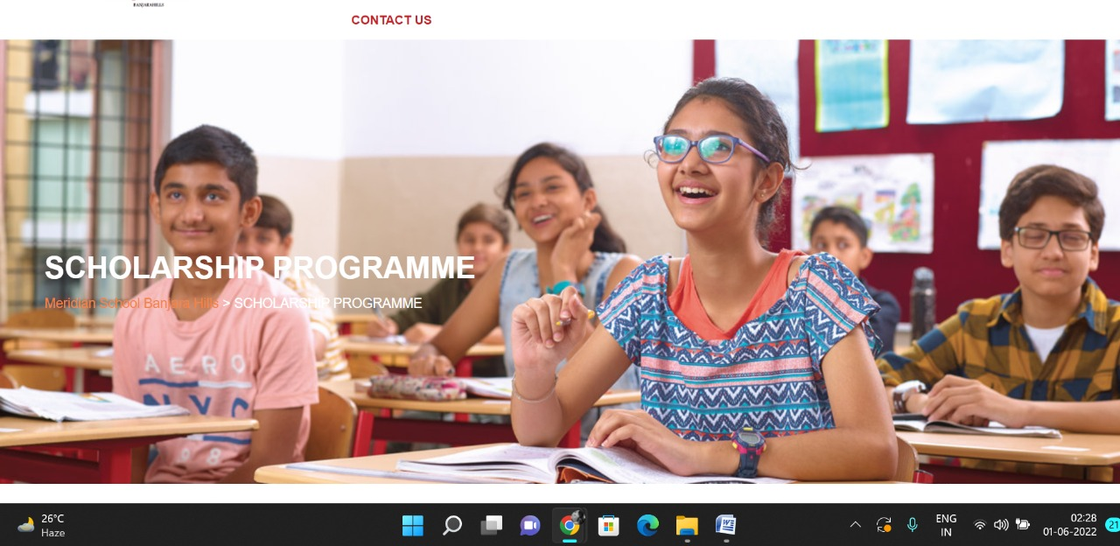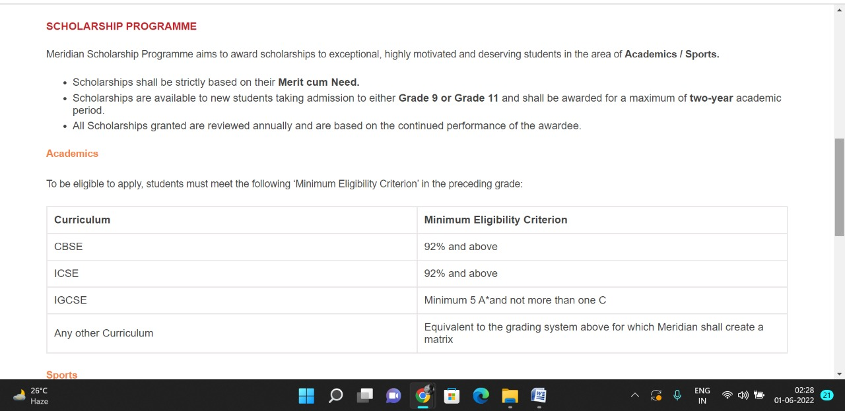

Contact Us Pages

**PAGE 33:Career**

**HTML CODE:**

<!DOCTYPE html>

<html lang="en">

<head>

    <meta charset="UTF-8">

    <meta http-equiv="X-UA-Compatible" content="IE=edge">

    <meta name="viewport" content="width=device-width, initial-scale=1.0">

    <title>CAREERS - Meridian School</title>

    <link rel="stylesheet" href="style.css">

    <link rel="stylesheet" href="https://pro.fontawesome.com/releases/v5.10.0/css/all.css" />

    <link rel="icon" type="imag/logo2.png" href="img/logo2.png">

    <link rel="stylesheet" href="https://stackpath.bootstrapcdn.com/bootstrap/4.4.1/css/bootstrap.min.css"

        integrity="sha384-Vkoo8x4CGs03+Hhxv8T/Q5paXtkKtu6ug5TOeNV6gBiFeWPGFN9MuhOf23Q9Ifjh" crossorigin="anonymous" />

    <link rel="stylesheet" href="https://cdnjs.cloudflare.com/ajax/libs/slick-carousel/1.8.1/slick-theme.min.css"

        integrity="sha512-17EgCFERpgZKcm0j0fEq1YCJuyAWdz9KUtv1EjVuaOz8pDnh/0nZxmU6BBXwaaxqoi9PQXnRWqlcDB027hgv9A=="

        crossorigin="anonymous" referrerpolicy="no-referrer" />

    <link rel="stylesheet" href="https://cdnjs.cloudflare.com/ajax/libs/slick-carousel/1.8.1/slick.min.css"

        integrity="sha512-yHknP1/AwR+yx26cB1y0cjvQUMvEa2PFzt1c9LlS4pRQ5NOTZFWbhBig+X9G9eYW/8m0/4OXNx8pxJ6z57x0dw=="

        crossorigin="anonymous" referrerpolicy="no-referrer" />

</head>

<body>

    <section id="follow">

        <div class="followus">

            <div class="icon1">

                <i class="fa fa-phone"></i>

                <a id="phone" href="">8096918857, 9948508222</a>

            </div>

            <div class="icon1">

                <i class="fa fa-envelope"></i>

                <a id="mail" href="">info.banjara@meridianschool.in</a>

            </div>

            <div class="icon">

                <a href="https://www.facebook.com/MeridianSchoolBanjaraHills/" target="_blank"

                    class="fab fa-facebook-f"></i></a>

                <a href="https://twitter.com/meridianbanjara" target="_blank"><i class="fab fa-twitter"></i></a>

                <a href="https://www.youtube.com/channel/UCBZ_gLF9qM18O3CDWQHeN1A" target="_blank"><i

                        class="fab fa-youtube"></i></a>

                <a href="https://www.instagram.com/meridianschools/" target="_blank"><i

                        class="fab fa-instagram"></i></a>

            </div>

        </div>

    </section>

    <div class="navbar">

        <a href="home.html"><img src="img/logo.png" class="logo" alt=""></a>

        <nav>

            <a class="active" href="home.html">HOME</a>

            <div class="dropdown">

                <button class="dropbtn">ABOUT US

                </button>

                <div class="dropdown-content">

                    <a href="knowmeridian.html">KNOW MERIDIAN</a>

                    <a href="visionmission.html">THE VISION & MISSION</a>

                    <a href="http://meridianbanjara.com/the-founders/">THE FOUNDER'S MESSAGE</a>

                    <a href="ceomsg.html">CEO'S MESSAGE</a>

                    <a href="principalmsg.html">THE PRINCIPAL'S MESSAGE</a>

                    <a href="awards.html">AWARDS AND ACCOLADES</a>

                    <a href="http://meridianbanjara.com/affiliations-accreditations/">AFFILIATIONS & ACCREDITATIONS</a>

                    <a href="blog.html">BLOG</a>

                </div>

            </div>

            <div class="dropdown">

                <button class="dropbtn">LEADERSHIP TEAM

                </button>

                <div class="dropdown-content">

                    <a href="principal.html">PRINCIPAL</a>

                    <a href="vp.html">VICE PRINCIPAL</a>

                    <a href="headmistress.html">HEADMISTRESS</a>

                    <a href="midSchool.html">MIDDLE SCHOOL INCHARGE</a>

                    <a href="ipPyp.html">IB PYP COORDINATOR</a>

                    <a href="preprimary.html">PRE PRIMARY INCHARGE</a>

                    <a href="global.html">GLOBAL PARTNERSHIP COORDINATOR</a>

                </div>

            </div>

            <div class="dropdown">

                <button class="dropbtn">ACADEMICS

                </button>

                <div class="dropdown-content">

                    <a href="AcaOverview.html">OVERVIEW</a>

                    <a href="methodology.html">METHODOLOGY AND LEARNING STYLE</a>

                    <a href="curriculum.html">CURRICULUM</a>

                    <a href="faculty.html">FACULTY</a>

                    <a href="teacherTraining.html">TEACHER TRAINING</a>

                    <a href="careerGuidance.html">CAREER GUIDANCE</a>

                    <a href="scholrship.html">SCHOLARSHIP PROGRAMME</a>

                </div>

            </div>

            <div class="dropdown">

                <button class="dropbtn">BEYOND ACADEMICS

                </button>

                <div class="dropdown-content">

                    <a href="beyondAcaOverview.html">OVERVIEW</a>

                    <a href="sports.html">SPORTS</a>

                    <a href="creatveAct.html">CREATIVE ACTIVITIES</a>

                    <a href="eduTrips.html">EDUCATIONAL TRIPS AND STUDENT<br> EXCHANGE PROGRAMMES</a>

                    <a href="perfectSystem.html">PERFECT SYSTEM</a>

                    <a href="schoolSocialRes.html">SCHOOL'S SOCIAL RESPONSIBILITY</a>

                    <a href="interact.html">INTERACT</a>

                    <a href="heritageClub.html">HERITAGE CLUB</a>

                    <a href="mun.html">MUN</a>

                </div>

            </div>

            <div class="dropdown">

                <button class="dropbtn">ADMISSIONS

                </button>

                <div class="dropdown-content">

                    <a href="overview.html">OVERVIEW</a>

                    <a href="admissionpro.html">ADMISSION PROCEDURE</a>

                    <a href="feepolicy.html">FEE POLICY</a>

                    <a href="tranfercert.html">TRANSFER CERTIFICATE</a>

                    <a href="transport.html">TRANSPORT</a>

                </div>

            </div>

            <a class="active" href="gallery.html">GALLERY</a>

            <div class="dropdown">

                <button class="dropbtn">CONTACT US

                </button>

                <div class="dropdown-content">

                    <a href="contact.html">CAREERS</a>

                </div>

            </div>

        </nav>

    </div>

    <div id="mobile">

        <i id="bar" class="fas fa-outdent "></i>

    </div>

    <section id="principal">

        <div class="prin" id="overview1">

            <h2>CAREERS</h2>

            <span id="orange"><a href="home.html">Meridian School Banjara Hills</a></span>

            <span> &gt; CAREERS</span>

        </div>

    </section>

    <section id="contactMail">

        <p style="text-align: center;"><strong>You may post your resumes at the following emails given

                below</strong><br> <strong>Pay Scales will match the best in the industry with additional

                benefits</strong><br> <strong>E-mail :</strong> <a

                href="mailto:agm.hr@buttabroup.com">agm.hr@buttagroup.com</a>&nbsp;&nbsp;&nbsp;&nbsp;&nbsp;&nbsp;&nbsp;&nbsp;&nbsp;&nbsp;&nbsp;&nbsp;&nbsp;&nbsp;&nbsp;&nbsp;&nbsp;&nbsp;&nbsp;&nbsp;&nbsp;&nbsp;&nbsp;&nbsp;&nbsp;&nbsp;&nbsp;&nbsp;

            Mobile : 7659861111<br> <strong>E-mail : </strong><a

                href="mailto:hr.banjara@meridianschool.in">hr.banjara@meridianschool.in</a>

            &nbsp;&nbsp;&nbsp;&nbsp;&nbsp;&nbsp;&nbsp;&nbsp;&nbsp;&nbsp;&nbsp;&nbsp;&nbsp;&nbsp;&nbsp;&nbsp;&nbsp;&nbsp;&nbsp;&nbsp;

            Mobile : 7036130123</p>

    </section>

    <section id="contactFlexbox">

        <div id="contacttflexbox">

            <div class="contactflex">

                <p class="headingCont" style="text-align: center;"><strong>Banjara Hills Campus&nbsp;</strong></p>

                <p style="text-align: center;"># 8-2-541, Road No 7, Banjara Hills<br> Hyderabad-500034<br>

                    Mobile:7036130123<br> <a href="mailto:hr.banjara@meridianschool.in">hr.banjara@meridianschool.in</a>

                </p>

            </div>

            <div class="contactflex">

                <h4 class="headingCont" style="text-align: center;"><strong>Madhapur Campus</strong></h4>

                <p style="text-align: center;">#11/4 &amp; 11/5 , 100 feet Road,<br> Madhapur Hyderabad-500081<br>

                    Mobile: 8499948123<br> <a

                        href="mailto:hrd.madhapur@meridianschool.in">hrd.madhapur@meridianschool.in</a></p>

            </div>

            <div class="contactflex">

                <p class="headingCont" style="text-align: center;"><strong>Kukatpally Campus</strong></p>

                <p style="text-align: center;">Near Sujana Form Mall KPHB VI Phase<br> Kukatpally Hyderabad<br>

                    Hyderabad – 500085<br> <a

                        href="mailto:hrd.kukatpally@meridianschool.in">hrd.kukatpally@meridianschool.in</a></p>

            </div>

        </div>

    </section>

    <footer>

        <div class="col">

            <h4>ABOUT US</h4>

            <p>Meridian is a New Generation Educational Group committed to educate children for life and thus bring a

                change in the society. Learning philosophy practised at Meridian infuses traditional values into a

                progressive approach, equipping students to adapt and excel anywhere in the world. Our alumni, working

                in diverse fields, have found Meridian to be the best school for a successful career take off.</p>

        </div>

        <div class="col">

            <h4>USEFUL LINKS</h4>

            <ul class="three-col-links">

                <li><a href="home.html">HOME</a></li>

                <li><a href="AcaOverview.html">ACADEMICS</a></li>

                <li><a href="overview.html">ADMISSIONS</a></li>

                <li><a href="contact.html">CONTACT US</a></li>

                <li><a href="knowmeridian.html">ABOUT US</a></li>

                <li><a href="beyondAcaOverview.html">BEYOND ACADEMICS</a></li>

                <li><a href="contact.html">CAREERS</a></li>

            </ul>

        </div>

        <div class="col">

            <!--<div class="follow">

                <div class="icon">

                    <i class="fa fa-paper-plane-o"></i>

                </div>

        </div>-->

            <h4>MERIDIAN SCHOOL, Banjara Hills</h4>

            <p># 8-2-541, Road No 7, Banjara Hills, Hyderabad-500034, TELANGANA, INDIA.</p>

            <p>For contact : +91 8096918857, 9948508222, For Prinicipal Appointments : 8098420002</p>

            <p> For Admissions / Enquires : 8096918857, 9948508222</p>

            <p>info.banjara@meridianschool.inA</p>

        </div>

    </footer>

    <section id="copyright">

        <div id="cr">

            <p>© Copyright MERIDIAN SCHOOL, 2021.</p>

        </div>

    </section>

</body>

</html>

**CSS CODE:**

#contactMail {

margin: 99px 0 42px;

}

#contactMail a {

color: #c42329;

text-decoration: none;

}

#contactMail a:hover {

color: #f48243;

transition: 0.3s ease;

}

#contacttflexbox {

display: flex;

margin: 10px 0 120px;

}

#contacttflexbox .contactflex {

width: 33%;

}

#contacttflexbox .contactflex h4 {

color: #f48243;

}

#contacttflexbox .contactflex a {

color: #c42329;

text-decoration: none;

}

#contacttflexbox .contactflex a:hover {

color: #f48243;

transition: 0.3s ease;

}

#contacttflexbox .contactflex .headingCont {

margin: 30px 0 24px;

}

**OUTPUT:**

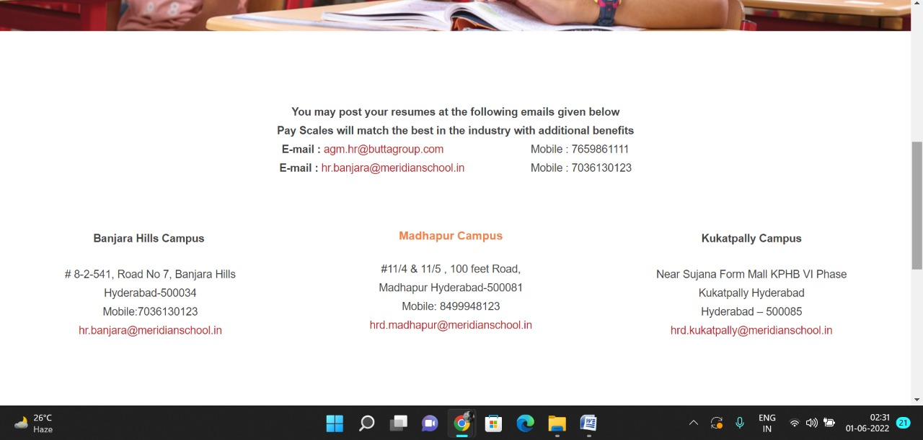

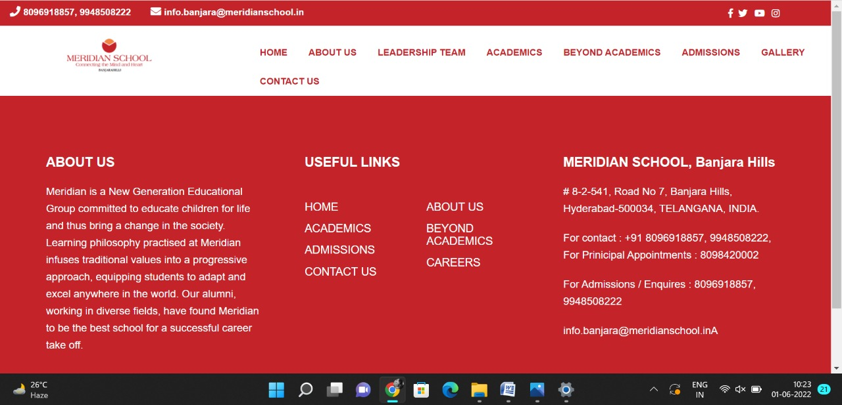

Admissions Pages

**PAGE 34:Overview**

**HTML CODE:**

<!DOCTYPE html>

<html lang="en">

<head>

    <meta charset="UTF-8">

    <meta http-equiv="X-UA-Compatible" content="IE=edge">

    <meta name="viewport" content="width=device-width, initial-scale=1.0">

    <title>OVERVIEW - Meridian School</title>

    <link rel="stylesheet" href="css/overview.css">

    <link rel="stylesheet" href="https://pro.fontawesome.com/releases/v5.10.0/css/all.css" />

    <link rel="icon" type="imag/logo2.png" href="img/logo2.png">

    <link rel="stylesheet" href="https://stackpath.bootstrapcdn.com/bootstrap/4.4.1/css/bootstrap.min.css"

        integrity="sha384-Vkoo8x4CGs03+Hhxv8T/Q5paXtkKtu6ug5TOeNV6gBiFeWPGFN9MuhOf23Q9Ifjh" crossorigin="anonymous" />

    <link rel="stylesheet" href="https://cdnjs.cloudflare.com/ajax/libs/slick-carousel/1.8.1/slick-theme.min.css"

        integrity="sha512-17EgCFERpgZKcm0j0fEq1YCJuyAWdz9KUtv1EjVuaOz8pDnh/0nZxmU6BBXwaaxqoi9PQXnRWqlcDB027hgv9A=="

        crossorigin="anonymous" referrerpolicy="no-referrer" />

    <link rel="stylesheet" href="https://cdnjs.cloudflare.com/ajax/libs/slick-carousel/1.8.1/slick.min.css"

        integrity="sha512-yHknP1/AwR+yx26cB1y0cjvQUMvEa2PFzt1c9LlS4pRQ5NOTZFWbhBig+X9G9eYW/8m0/4OXNx8pxJ6z57x0dw=="

        crossorigin="anonymous" referrerpolicy="no-referrer" />

</head>

<body>

    <section id="follow">

        <div class="followus">

            <div class="icon1">

                <i class="fa fa-phone"></i>

                <a id="phone" href="">8096918857, 9948508222</a>

            </div>

            <div class="icon1">

                <i class="fa fa-envelope"></i>

                <a id="mail" href="">info.banjara@meridianschool.in</a>

            </div>

            <div class="icon">

                <a href="https://www.facebook.com/MeridianSchoolBanjaraHills/" target="_blank"

                    class="fab fa-facebook-f"></i></a>

                <a href="https://twitter.com/meridianbanjara" target="_blank"><i class="fab fa-twitter"></i></a>

                <a href="https://www.youtube.com/channel/UCBZ_gLF9qM18O3CDWQHeN1A" target="_blank"><i

                        class="fab fa-youtube"></i></a>

                <a href="https://www.instagram.com/meridianschools/" target="_blank"><i

                        class="fab fa-instagram"></i></a>

            </div>

        </div>

    </section>

    <div class="navbar">

        <a href="home.html"><img src="img/logo.png" class="logo" alt=""></a>

        <nav>

            <a class="active" href="home.html">HOME</a>

            <div class="dropdown">

                <button class="dropbtn">ABOUT US

                </button>

                <div class="dropdown-content">

                    <a href="knowmeridian.html">KNOW MERIDIAN</a>

                    <a href="visionmission.html">THE VISION & MISSION</a>

                    <a href="http://meridianbanjara.com/the-founders/">THE FOUNDER'S MESSAGE</a>

                    <a href="ceomsg.html">CEO'S MESSAGE</a>

                    <a href="principalmsg.html">THE PRINCIPAL'S MESSAGE</a>

                    <a href="awards.html">AWARDS AND ACCOLADES</a>

                    <a href="http://meridianbanjara.com/affiliations-accreditations/">AFFILIATIONS & ACCREDITATIONS</a>

                    <a href="blog.html">BLOG</a>

                </div>

            </div>

            <div class="dropdown">

                <button class="dropbtn">LEADERSHIP TEAM

                </button>

                <div class="dropdown-content">

                    <a href="principal.html">PRINCIPAL</a>

                    <a href="vp.html">VICE PRINCIPAL</a>

                    <a href="headmistress.html">HEADMISTRESS</a>

                    <a href="midSchool.html">MIDDLE SCHOOL INCHARGE</a>

                    <a href="ipPyp.html">IB PYP COORDINATOR</a>

                    <a href="preprimary.html">PRE PRIMARY INCHARGE</a>

                    <a href="global.html">GLOBAL PARTNERSHIP COORDINATOR</a>

                </div>

            </div>

            <div class="dropdown">

                <button class="dropbtn">ACADEMICS

                </button>

                <div class="dropdown-content">

                    <a href="AcaOverview.html">OVERVIEW</a>

                    <a href="methodology.html">METHODOLOGY AND LEARNING STYLE</a>

                    <a href="curriculum.html">CURRICULUM</a>

                    <a href="faculty.html">FACULTY</a>

                    <a href="teacherTraining.html">TEACHER TRAINING</a>

                    <a href="careerGuidance.html">CAREER GUIDANCE</a>

                    <a href="scholrship.html">SCHOLARSHIP PROGRAMME</a>

                </div>

            </div>

            <div class="dropdown">

                <button class="dropbtn">BEYOND ACADEMICS

                </button>

                <div class="dropdown-content">

                    <a href="beyondAcaOverview.html">OVERVIEW</a>

                    <a href="sports.html">SPORTS</a>

                    <a href="creatveAct.html">CREATIVE ACTIVITIES</a>

                    <a href="eduTrips.html">EDUCATIONAL TRIPS AND STUDENT<br> EXCHANGE PROGRAMMES</a>

                    <a href="perfectSystem.html">PERFECT SYSTEM</a>

                    <a href="schoolSocialRes.html">SCHOOL'S SOCIAL RESPONSIBILITY</a>

                    <a href="interact.html">INTERACT</a>

                    <a href="heritageClub.html">HERITAGE CLUB</a>

                    <a href="mun.html">MUN</a>

                </div>

            </div>

            <div class="dropdown">

                <button class="dropbtn">ADMISSIONS

                </button>

                <div class="dropdown-content">

                    <a href="overview.html">OVERVIEW</a>

                    <a href="admissionpro.html">ADMISSION PROCEDURE</a>

                    <a href="feepolicy.html">FEE POLICY</a>

                    <a href="tranfercert.html">TRANSFER CERTIFICATE</a>

                    <a href="transport.html">TRANSPORT</a>

                </div>

            </div>

            <a class="active" href="gallery.html">GALLERY</a>

            <div class="dropdown">

                <button class="dropbtn">CONTACT US

                </button>

                <div class="dropdown-content">

                    <a href="contact.html">CAREERS</a>

                </div>

            </div>

        </nav>

    </div>

    <div id="mobile">

        <i id="bar" class="fas fa-outdent "></i>

    </div>

    <section id="overview">

        <img src="img/admission/1.jpg" width="100%" />

        <div class="over">

            <h2>OVERVIEW</h2>

            <span id="orange"><a href="home.html">Meridian School Banjara Hills</a></span>

            <span> &gt; OVERVIEW</span>

        </div>

    </section>

    <section id="ov">

        <div class="ov1">

            <div>

                <img style="float: right;" src="img/admission/2.png" width="100%" />

            </div>

            <div id="info">

                <h4>OVERVIEW</h4>

                <p>

                    Join a White House Institution for an exceptional educational system. Discover the schooling

                    experience as it unfurls everyday which would be a lifetime experience of learning. Meridian School

                    for Boys and Girls has a transparent and hassle-free admission procedure which has allowed us the

                    delight of working with students coming from different backgrounds thus making the school a

                    microcosm of India.

                </p>

            </div>

        </div>

    </section>

    <footer>

        <div class="col">

            <h4>ABOUT US</h4>

            <p>Meridian is a New Generation Educational Group committed to educate children for life and thus bring a

                change in the society. Learning philosophy practised at Meridian infuses traditional values into a

                progressive approach, equipping students to adapt and excel anywhere in the world. Our alumni, working

                in diverse fields, have found Meridian to be the best school for a successful career take off.</p>

        </div>

        <div class="col">

            <h4>USEFUL LINKS</h4>

            <ul class="three-col-links">

                <li><a href="home.html">HOME</a></li>

                <li><a href="AcaOverview.html">ACADEMICS</a></li>

                <li><a href="overview.html">ADMISSIONS</a></li>

                <li><a href="contact.html">CONTACT US</a></li>

                <li><a href="knowmeridian.html">ABOUT US</a></li>

                <li><a href="beyondAcaOverview.html">BEYOND ACADEMICS</a></li>

                <li><a href="contact.html">CAREERS</a></li>

            </ul>

        </div>

        <div class="col">

            <!--<div class="follow">

                <div class="icon">

                    <i class="fa fa-paper-plane-o"></i>

                </div>

        </div>-->

            <h4>MERIDIAN SCHOOL, Banjara Hills</h4>

            <p># 8-2-541, Road No 7, Banjara Hills, Hyderabad-500034, TELANGANA, INDIA.</p><br>

            <p>For contact : +91 8096918857, 9948508222, <br>For Prinicipal Appointments : 8098420002</p><br>

            <p> For Admissions / Enquires : 8096918857, 9948508222</p><br>

            <p>info.banjara@meridianschool.inA</p>

        </div>

    </footer>

    <section id="copyright">

        <div id="cr">

            <p>© Copyright MERIDIAN SCHOOL, BANJARA HILLS 2020.</p>

        </div>

    </section>

    <script src="https://ajax.googleapis.com/ajax/libs/jquery/3.6.0/jquery.min.js"></script>

    <script src="https://cdnjs.cloudflare.com/ajax/libs/slick-carousel/1.8.1/slick.min.js"

        integrity="sha512-XtmMtDEcNz2j7ekrtHvOVR4iwwaD6o/FUJe6+Zq+HgcCsk3kj4uSQQR8weQ2QVj1o0Pk6PwYLohm206ZzNfubg=="

        crossorigin="anonymous" referrerpolicy="no-referrer"></script>

**CSS CODE:**

@import url('https://fonts.googleapis.com/css2?family=Lato:wght@300;400;700&display=swap');

* {

    margin: 0;

    padding: 0;

    box-sizing: border-box;

    font-family: 'Spartan', sans-serif;

}

a:hover {

    transition: 0.2 ease;

}

/* div, section{

    border: 2px solid black;

} */

h1 {

    font-size: 40px;

    line-height: 64px;

    color: #fff;

}

h2 {

    font-weight: 500;

    font-size: 56px;

    line-height: 54px;

    color: #fff;

    text-align: center;

}

h3 {

    text-align: center;

    font-size: 22px;

    color: #c42329;

}

h6 {

    font-weight: 700;

    font-size: 12px;

}

p {

    font-size: 15px;

    line-height: 26px;

    font-weight: 400;

    font-style: normal;

    color: #444;

}

span {

    font-size: 15px;

    line-height: 26px;

    font-weight: 400;

    font-style: normal;

    color: #444444;

    text-align: center;

}

.section-p1 {

    margin: 40px 80px;

}

.section-m1 {

    margin: 40px 0;

}

button.normal {

    font-size: 14px;

    font-weight: 600;

    padding: 15px 30px;

    color: #fff;

    background-color: #c42329;

    border-radius: 4px;

    cursor: pointer;

    border: none;

    outline: none;

    transition: 0.2s;

}

body {

    width: 100%;

}

#header {

    background-color: #fff;

    border-bottom: #c42329;

    display: flex;

    align-items: center;

    justify-content: space-between;

    padding: 16px 80px;

    box-shadow: 0 5px 15px rgba(0, 0, 0, 0.06);

    /* z-index: 999; */

    position: sticky;

    top: 0;

    left: 0;

}

#header a img {

    width: 135px;

    height: 61px;

}

#header a:hover {

    border: 1px dotted orange;

}

#mobile {

    display: none;

    align-items: center;

}

#close {

    display: none;

}

/*#navbar {

    display: flex;

    align-items: center;

    justify-content: center;

}

#navbar li {

    list-style: none;

    padding: 0 8px;

    position: relative;

}

#navbar li a {

    text-decoration: none;

    font-size: 13px;

    font-weight: 600;

    color: #c42329;

    transition: 0.3 ease;

}

#navbar li a.active::after,

#navbar li a:hover::after {

    content: "";

    width: 30%;

    height: 2px;

    position: absolute;

    bottom: -4px;

    left: 20px;

}

#navbar .headButton {

    border-left: 20px;

}

#navbar .headButton:hover {

    border: #c42329;

    background-color: #fff;

    color: black;

}*/

.navbar {

    overflow: hidden;

    background-color: #fff;

}

.navbar a {

    float: left;

    font-size: 14px;

    color: #c42329;

    text-align: left;

    padding: 14px 16px;

    text-decoration: none;

}

.active {

    font-weight: 650;

}

.dropdown {

    float: left;

    overflow: hidden;

}

.dropdown .dropbtn {

    font-size: 14px;

    border: none;

    outline: none;

    color: #c42329;

    padding: 14px 16px;

    background-color: inherit;

    font-family: inherit;

    margin: 0;

    font-weight: 650;

}

.navbar a:hover,

.dropdown:hover .dropbtn {

    color: orange;

}

.dropdown-content {

    display: none;

    position: absolute;

    background-color: #c42329;

    min-width: 160px;

    box-shadow: 0px 8px 16px 0px rgba(0, 0, 0, 0.2);

    z-index: 1;

}

.dropdown-content a {

    float: none;

    color: white;

    padding: 12px 16px;

    text-decoration: none;

    display: block;

    text-align: left;

}

.dropdown-content a:hover {

    background-color: #c42329;

}

.dropdown:hover .dropdown-content {

    display: block;

}

nav {

    margin-top: 1.5%;

    margin-left: 30%;

}

.logo {

    margin-left: 60%;

    width: 135px;

    height: 61px;

}

footer {

    width: 100%;

    background-color: #c42329;

    display: flex;

    flex-direction: row;

    justify-content: space-between;

    flex-wrap: wrap;

    padding: 90px 70px 50px 70px;

}

footer .col {

    display: flex;

    flex-direction: column;

    align-items: flex-start;

    margin-bottom: 20px;

    width: 30%;

    height: 100%;

}

footer h4 {

    font-size: 20px;

    color: #fff;

    padding-bottom: 20px;

}

footer p {

    font-size: 16px;

    color: #fff;

    padding-bottom: 0 0 8px 0;

    margin-bottom: 0;

}

footer a {

    font-size: 17px;

    margin-bottom: 10px;

    color: #fff;

    text-decoration: none;

}

/* Align Links in footer */

.three-col-links {

    width: 105%;

    -webkit-column-count: 2;

    -moz-column-count: 2;

    column-count: 2;

    padding-top: 4%;

}

.three-col-links li {

    width: 100%;

    float: left;

    display: inline;

    margin-top: 8%;

    text-transform: uppercase;

}

/* END -Align Links in footer */

footer .follow {

    margin-top: 20px;

}

footer .follow i {

    color: #fff;

    padding-right: 4px;

    cursor: pointer;

}

footer .follow i:hover,

footer a:hover {

    color: orange;

}

#cr {

    background-color: black;

}

#cr p {

    text-align: center;

    color: #fff;

    padding: 20px 0;

}

#follow .icon {

    justify-content: flex-end;

}

#follow .icon i {

    color: #fff;

}

#follow .followus {

    display: flex;

    background-color: #c42329;

}

#follow .followus a {

    color: #fff;

    text-decoration: none;

    font-size: 14px;

    font-weight: 550;

}

/*#follow .followus #phone {

    padding: 10px 10px 10px 55px;

}

#follow .followus #mail {

    padding: 10px 10px 10px 35px;

}*/

#follow .followus a:hover {

    text-decoration: underline;

}

#follow .icon {

    margin-left: 890px;

    padding: 10px 10px;

}

#follow .icon i {

    padding: 0 3px;

}

#ov .ov1 {

    display: flex;

    margin: 150px 70px 130px 70px;

}

#ov .ov1 #info {

    width: 50%;

}

#ov .ov1 img {

    position: relative;

    width: 270px;

    height: 330px;

    margin-left: 70px;

    border: none;

    top: -20px;

}

#ov .ov1 #info h4 {

    margin: -20px 0px 35px 40px;

    color: #c42329;

}

#ov .ov1 #info p {

    margin: -20px 0px 35px 40px;

    font-size: 15px;

}

#overview {

    position: relative;

    text-align: center;

    color: white;

}

#overview .over {

    height: 500px;

    background-repeat: no-repeat;

    padding: 230px 0 0 50px;

    /* background-position: 100%; */

    position: absolute;

    top: 50%;

    left: 50%;

    transform: translate(-160%, -50%);

}

#overview .over h2 {

    font-size: 34px;

    font-weight: 600;

    text-align: start;

    /* color: #c42329; */

}

#overview .over span {

    color: #fff;

}

#overview .over span a {

    text-decoration: none;

}

#overview #orange a {

    color: #f48243;

}

#overview #orange a:hover {

    color: #fff;

}

.fa {

    display: inline-block;

    font: normal normal normal 14px/1 FontAwesome;

    font-size: inherit;

    text-rendering: auto;

    color: #fff;

}

.icon1 {

    padding: 8px 15px;

}

**OUTPUT:**

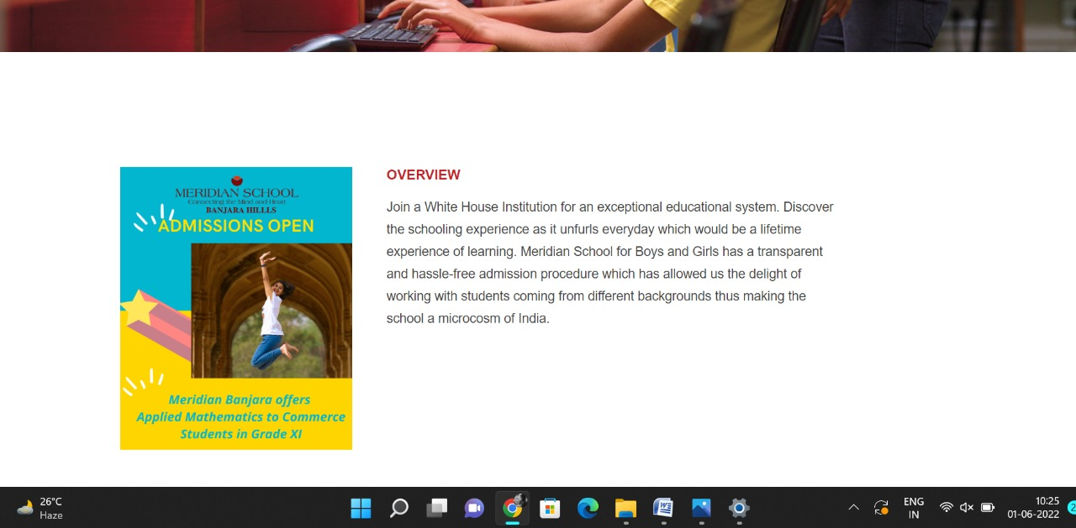

**PAGE 35:Admission Procedure**

**HTML CODE:**

<!DOCTYPE html>

<html lang="en">

<head>

    <meta charset="UTF-8">

    <meta http-equiv="X-UA-Compatible" content="IE=edge">

    <meta name="viewport" content="width=device-width, initial-scale=1.0">

    <title>ADMISSION PROCEDURE - Meridian School</title>

    <link rel="stylesheet" href="css/admissionpro.css">

    <link rel="stylesheet" href="https://pro.fontawesome.com/releases/v5.10.0/css/all.css" />

    <link rel="icon" type="imag/logo2.png" href="img/logo2.png">

    <link rel="stylesheet" href="https://stackpath.bootstrapcdn.com/bootstrap/4.4.1/css/bootstrap.min.css"

        integrity="sha384-Vkoo8x4CGs03+Hhxv8T/Q5paXtkKtu6ug5TOeNV6gBiFeWPGFN9MuhOf23Q9Ifjh" crossorigin="anonymous" />

    <link rel="stylesheet" href="https://cdnjs.cloudflare.com/ajax/libs/slick-carousel/1.8.1/slick-theme.min.css"

        integrity="sha512-17EgCFERpgZKcm0j0fEq1YCJuyAWdz9KUtv1EjVuaOz8pDnh/0nZxmU6BBXwaaxqoi9PQXnRWqlcDB027hgv9A=="

        crossorigin="anonymous" referrerpolicy="no-referrer" />

    <link rel="stylesheet" href="https://cdnjs.cloudflare.com/ajax/libs/slick-carousel/1.8.1/slick.min.css"

        integrity="sha512-yHknP1/AwR+yx26cB1y0cjvQUMvEa2PFzt1c9LlS4pRQ5NOTZFWbhBig+X9G9eYW/8m0/4OXNx8pxJ6z57x0dw=="

        crossorigin="anonymous" referrerpolicy="no-referrer" />

</head>

<body>

    <section id="follow">

        <div class="followus">

            <div class="icon1">

                <i class="fa fa-phone"></i>

                <a id="phone" href="">8096918857, 9948508222</a>

            </div>

            <div class="icon1">

                <i class="fa fa-envelope"></i>

                <a id="mail" href="">info.banjara@meridianschool.in</a>

            </div>

            <div class="icon">

                <a href="https://www.facebook.com/MeridianSchoolBanjaraHills/" target="_blank"

                    class="fab fa-facebook-f"></i></a>

                <a href="https://twitter.com/meridianbanjara" target="_blank"><i class="fab fa-twitter"></i></a>

                <a href="https://www.youtube.com/channel/UCBZ_gLF9qM18O3CDWQHeN1A" target="_blank"><i

                        class="fab fa-youtube"></i></a>

                <a href="https://www.instagram.com/meridianschools/" target="_blank"><i

                        class="fab fa-instagram"></i></a>

            </div>

        </div>

    </section>

    <div class="navbar">

        <a href="home.html"><img src="img/logo.png" class="logo" alt=""></a>

        <nav>

            <a class="active" href="home.html">HOME</a>

            <div class="dropdown">

                <button class="dropbtn">ABOUT US

                </button>

                <div class="dropdown-content">

                    <a href="knowmeridian.html">KNOW MERIDIAN</a>

                    <a href="visionmission.html">THE VISION & MISSION</a>

                    <a href="http://meridianbanjara.com/the-founders/">THE FOUNDER'S MESSAGE</a>

                    <a href="ceomsg.html">CEO'S MESSAGE</a>

                    <a href="principalmsg.html">THE PRINCIPAL'S MESSAGE</a>

                    <a href="awards.html">AWARDS AND ACCOLADES</a>

                    <a href="http://meridianbanjara.com/affiliations-accreditations/">AFFILIATIONS & ACCREDITATIONS</a>

                    <a href="blog.html">BLOG</a>

                </div>

            </div>

            <div class="dropdown">

                <button class="dropbtn">LEADERSHIP TEAM

                </button>

                <div class="dropdown-content">

                    <a href="principal.html">PRINCIPAL</a>

                    <a href="vp.html">VICE PRINCIPAL</a>

                    <a href="headmistress.html">HEADMISTRESS</a>

                    <a href="midSchool.html">MIDDLE SCHOOL INCHARGE</a>

                    <a href="ipPyp.html">IB PYP COORDINATOR</a>

                    <a href="preprimary.html">PRE PRIMARY INCHARGE</a>

                    <a href="global.html">GLOBAL PARTNERSHIP COORDINATOR</a>

                </div>

            </div>

            <div class="dropdown">

                <button class="dropbtn">ACADEMICS

                </button>

                <div class="dropdown-content">

                    <a href="AcaOverview.html">OVERVIEW</a>

                    <a href="methodology.html">METHODOLOGY AND LEARNING STYLE</a>

                    <a href="curriculum.html">CURRICULUM</a>

                    <a href="faculty.html">FACULTY</a>

                    <a href="teacherTraining.html">TEACHER TRAINING</a>

                    <a href="careerGuidance.html">CAREER GUIDANCE</a>

                    <a href="scholrship.html">SCHOLARSHIP PROGRAMME</a>

                </div>

            </div>

            <div class="dropdown">

                <button class="dropbtn">BEYOND ACADEMICS

                </button>

                <div class="dropdown-content">

                    <a href="beyondAcaOverview.html">OVERVIEW</a>

                    <a href="sports.html">SPORTS</a>

                    <a href="creatveAct.html">CREATIVE ACTIVITIES</a>

                    <a href="eduTrips.html">EDUCATIONAL TRIPS AND STUDENT<br> EXCHANGE PROGRAMMES</a>

                    <a href="perfectSystem.html">PERFECT SYSTEM</a>

                    <a href="schoolSocialRes.html">SCHOOL'S SOCIAL RESPONSIBILITY</a>

                    <a href="interact.html">INTERACT</a>

                    <a href="heritageClub.html">HERITAGE CLUB</a>

                    <a href="mun.html">MUN</a>

                </div>

            </div>

            <div class="dropdown">

                <button class="dropbtn">ADMISSIONS

                </button>

                <div class="dropdown-content">

                    <a href="overview.html">OVERVIEW</a>

                    <a href="admissionpro.html">ADMISSION PROCEDURE</a>

                    <a href="feepolicy.html">FEE POLICY</a>

                    <a href="tranfercert.html">TRANSFER CERTIFICATE</a>

                    <a href="transport.html">TRANSPORT</a>

                </div>

            </div>

            <a class="active" href="gallery.html">GALLERY</a>

            <div class="dropdown">

                <button class="dropbtn">CONTACT US

                </button>

                <div class="dropdown-content">

                    <a href="contact.html">CAREERS</a>

                </div>

            </div>

        </nav>

    </div>

    <div id="mobile">

        <i id="bar" class="fas fa-outdent "></i>

    </div>

    <section id="admission">

        <img src="img/admission/4.jpg" width="100%" />

        <div class="admi">

            <h2>ADMISSION PROCEDURE</h2>

            <span id="orange"><a href="home.html">Meridian School Banjara Hills</a></span>

            <span> &gt; ADMISSION PROCEDURE</span>

        </div>

    </section>

    <section id="ad">

        <div class="ad1">

            <div id="info">

                <h4>ADMISSION PROCEDURE</h4>

                <h6>School Visit & Interaction</h6>

                <p>You are most welcome to visit <b>Meridian School, Banjara Hills</b> and have an informal discussion

                    with or without your child.

                    <br>

                    This can be done by fixing a prior appointment with the Head of Admissions & Communication through

                    mail or telephone.

                    <br>

                    If you are not able to schedule, we would still be able to take you around, please walk-in.

                </p>

                <h6>Application</h6>

                <p> Forms are available on-line and at our office with all details given in the prospectus.<br>

                    In case you are not able to visit school in person for admission we would be happy to help you with

                    online admission.<br>

                    Child should have attained minimum age required for the grade applied.<br>

                    Students applying to Middle School, Secondary and Senior Secondary must submit academic records of

                    the previous class. If required entrance exam will be conducted.<br>

                    Online Application <a style="text-decoration: none; color:#c42329"

                        href="https://meridian.myclassboard.com/ApplicationForm/6577A76A-A415-4DEC-932C-AC38BBB08601/1"

                        onMouseOver="style.color='#f48243'" onMouseOut="style.color='#c42329'">Click

                        here</a></p><br>

                <h6>Admission</h6>

                <p>On being offered admission, parents are requested to pay the one-time Admission Fee, Refundable

                    Security Deposit and Term I fee within two weeks to secure the admission of the student.

                    Subsequently, the student is issued a Student Admission number.</p>

                <h6>Documents to be submitted while applying for admission:</h6>

                <ol type="1">

                    <li>Attested True Copy of the Birth Certificate</li>

                    <li>Copy of the last transcript from previous school (Bring the original)</li>

                    <li>Original Transfer Certificate in case child has attended another school</li>

                    <li>For enrollment in Grade X and XII CBSE registration card of Grade IX and XI are required.</li>

                    <li>Aadhar card copy</li>

                    <li>Original Caste Certificate (if applicable)</li>

                    <li>For students, other than Indian nationals a copy of the passport with visa details to be

                        submitted.</li>

                    <li>2 copies of passport size photographs</li>

                </ol>

                <h6>Parent Login</h6>

                <p>All parents are issued usernames and passwords to access their child’s progress through the web.<br>

                    Half-yearly and Annual Progress Reports can also be accessed through this.<br>

                    For <span id="diary"><a href="pdf/DIARY.pdf">DIARY</a></span>

                </p>

                <h4>For Admission Queries:</h4>

                <p>

                    Mail: info.banjara@meridianschool.in, admissions.banjara@meridianschool.in<br>

                    Telephone: 8096918857, 9948508222, 040-23420561, 040-23420562

                </p>

                <div>

                    <img src="img/admission/2.png" width="100%">

                </div>

            </div>

        </div>

    </section>

    <footer>

        <div class="col">

            <h4>ABOUT US</h4>

            <p>Meridian is a New Generation Educational Group committed to educate children for life and thus bring a

                change in the society. Learning philosophy practised at Meridian infuses traditional values into a

                progressive approach, equipping students to adapt and excel anywhere in the world. Our alumni, working

                in diverse fields, have found Meridian to be the best school for a successful career take off.</p>

        </div>

        <div class="col">

            <h4>USEFUL LINKS</h4>

            <ul class="three-col-links">

                <li><a href="home.html">HOME</a></li>

                <li><a href="AcaOverview.html">ACADEMICS</a></li>

                <li><a href="overview.html">ADMISSIONS</a></li>

                <li><a href="contact.html">CONTACT US</a></li>

                <li><a href="knowmeridian.html">ABOUT US</a></li>

                <li><a href="beyondAcaOverview.html">BEYOND ACADEMICS</a></li>

                <li><a href="contact.html">CAREERS</a></li>

            </ul>

        </div>

        <div class="col">

            <!--<div class="follow">

                <div class="icon">

                    <i class="fa fa-paper-plane-o"></i>

                </div>

        </div>-->

            <h4>MERIDIAN SCHOOL, Banjara Hills</h4>

            <p># 8-2-541, Road No 7, Banjara Hills, Hyderabad-500034, TELANGANA, INDIA.</p><br>

            <p>For contact : +91 8096918857, 9948508222, <br>For Prinicipal Appointments : 8098420002</p><br>

            <p> For Admissions / Enquires : 8096918857, 9948508222</p><br>

            <p>info.banjara@meridianschool.inA</p>

        </div>

    </footer>

    <section id="copyright">

        <div id="cr">

            <p>© Copyright MERIDIAN SCHOOL, BANJARA HILLS 2020.</p>

        </div>

    </section>

    <script src="https://ajax.googleapis.com/ajax/libs/jquery/3.6.0/jquery.min.js"></script>

    <script src="https://cdnjs.cloudflare.com/ajax/libs/slick-carousel/1.8.1/slick.min.js"

        integrity="sha512-XtmMtDEcNz2j7ekrtHvOVR4iwwaD6o/FUJe6+Zq+HgcCsk3kj4uSQQR8weQ2QVj1o0Pk6PwYLohm206ZzNfubg=="

        crossorigin="anonymous" referrerpolicy="no-referrer"></script>

**CSS CODE:**

@import url('https://fonts.googleapis.com/css2?family=Lato:wght@300;400;700&display=swap');

* {

    margin: 0;

    padding: 0;

    box-sizing: border-box;

    font-family: 'Spartan', sans-serif;

}

a:hover {

    transition: 0.2 ease;

}

/* div, section{

border: 2px solid black;

} */

h1 {

    font-size: 40px;

    line-height: 64px;

    color: #fff;

}

h2 {

    font-weight: 500;

    font-size: 56px;

    line-height: 54px;

    color: #fff;

    text-align: center;

}

h3 {

    text-align: center;

    font-size: 22px;

    color: #c42329;

}

h6 {

    font-weight: 700;

    font-size: 12px;

}

p {

    font-size: 15px;

    line-height: 26px;

    font-weight: 400;

    font-style: normal;

    color: #444;

}

span {

    font-size: 15px;

    line-height: 26px;

    font-weight: 400;

    font-style: normal;

    color: #444444;

    text-align: center;

}

.section-p1 {

    margin: 40px 80px;

}

.section-m1 {

    margin: 40px 0;

}

button.normal {

    font-size: 14px;

    font-weight: 600;

    padding: 15px 30px;

    color: #fff;

    background-color: #c42329;

    border-radius: 4px;

    cursor: pointer;

    border: none;

    outline: none;

    transition: 0.2s;

}

body {

    width: 100%;

}

#header {

    background-color: #fff;

    border-bottom: #c42329;

    display: flex;

    align-items: center;

    justify-content: space-between;

    padding: 16px 80px;

    box-shadow: 0 5px 15px rgba(0, 0, 0, 0.06);

    /* z-index: 999; */

    position: sticky;

    top: 0;

    left: 0;

}

#header a img {

    width: 135px;

    height: 61px;

}

#header a:hover {

    border: 1px dotted orange;

}

#mobile {

    display: none;

    align-items: center;

}

#close {

    display: none;

}

/*#navbar {

    display: flex;

    align-items: center;

    justify-content: center;

}

#navbar li {

    list-style: none;

    padding: 0 8px;

    position: relative;

}

#navbar li a {

    text-decoration: none;

    font-size: 13px;

    font-weight: 600;

    color: #c42329;

    transition: 0.3 ease;

}

#navbar li a.active::after,

#navbar li a:hover::after {

    content: "";

    width: 30%;

    height: 2px;

    position: absolute;

    bottom: -4px;

    left: 20px;

}

#navbar .headButton {

    border-left: 20px;

}

#navbar .headButton:hover {

    border: #c42329;

    background-color: #fff;

    color: black;

}*/

.navbar {

    overflow: hidden;

    background-color: #fff;

}

.navbar a {

    float: left;

    font-size: 14px;

    color: #c42329;

    text-align: left;

    padding: 14px 16px;

    text-decoration: none;

}

.active {

    font-weight: 650;

}

.dropdown {

    float: left;

    overflow: hidden;

}

.dropdown .dropbtn {

    font-size: 14px;

    border: none;

    outline: none;

    color: #c42329;

    padding: 14px 16px;

    background-color: inherit;

    font-family: inherit;

    margin: 0;

    font-weight: 650;

}

.navbar a:hover,

.dropdown:hover .dropbtn {

    color: orange;

}

.dropdown-content {

    display: none;

    position: absolute;

    background-color: #c42329;

    min-width: 160px;

    box-shadow: 0px 8px 16px 0px rgba(0, 0, 0, 0.2);

    z-index: 1;

}

.dropdown-content a {

    float: none;

    color: white;

    padding: 12px 16px;

    text-decoration: none;

    display: block;

    text-align: left;

}

.dropdown-content a:hover {

    background-color: #c42329;

}

.dropdown:hover .dropdown-content {

    display: block;

}

nav {

    margin-top: 1.5%;

    margin-left: 30%;

}

.logo {

    margin-left: 60%;

    width: 135px;

    height: 61px;

}

footer {

    width: 100%;

    background-color: #c42329;

    display: flex;

    flex-direction: row;

    justify-content: space-between;

    flex-wrap: wrap;

    padding: 90px 70px 50px 70px;

}

footer .col {

    display: flex;

    flex-direction: column;

    align-items: flex-start;

    margin-bottom: 20px;

    width: 30%;

    height: 100%;

}

footer h4 {

    font-size: 20px;

    color: #fff;

    padding-bottom: 20px;

}

footer p {

    font-size: 16px;

    color: #fff;

    padding-bottom: 0 0 8px 0;

    margin-bottom: 0;

}

footer a {

    font-size: 17px;

    margin-bottom: 10px;

    color: #fff;

    text-decoration: none;

}

/* Align Links in footer */

.three-col-links {

    width: 105%;

    -webkit-column-count: 2;

    -moz-column-count: 2;

    column-count: 2;

    padding-top: 4%;

}

.three-col-links li {

    width: 100%;

    float: left;

    display: inline;

    margin-top: 8%;

    text-transform: uppercase;

}

/* END -Align Links in footer */

footer .follow {

    margin-top: 20px;

}

footer .follow i {

    color: #fff;

    padding-right: 4px;

    cursor: pointer;

}

footer .follow i:hover,

footer a:hover {

    color: orange;

}

#cr {

    background-color: black;

}

#cr p {

    text-align: center;

    color: #fff;

    padding: 20px 0;

}

#follow .icon {

    justify-content: flex-end;

}

#follow .icon i {

    color: #fff;

}

#follow .followus {

    display: flex;

    background-color: #c42329;

}

#follow .followus a {

    color: #fff;

    text-decoration: none;

    font-size: 14px;

    font-weight: 550;

}

/*#follow .followus #phone {

    padding: 10px 10px 10px 55px;

}

#follow .followus #mail {

    padding: 10px 10px 10px 35px;

}*/

#follow .followus a:hover {

    text-decoration: underline;

}

#follow .icon {

    margin-left: 890px;

    padding: 10px 10px;

}

#follow .icon i {

    padding: 0 3px;

}

#ad .ad1 {

    display: flex;

    margin: 150px 70px 130px 70px;

}

#ad .ad1 #info {

    width: 90%;

}

#ad .ad1 img {

    position: relative;

    width: 820px;

    height: 1024px;

    margin-left: 260px;

    margin-right: 260px;

    border: none;

    top: -20px;

}

#ad .ad1 #info h4 {

    margin: -20px 0px 35px 70px;

    color: #c42329;

}

#ad .ad1 #info h6 {

    color: #f48243;

    margin: -20px 0px 35px 70px;

}

#ad .ad1 #info p {

    margin: -20px 70px 35px 100px;

    font-size: 15px;

    line-height: 50px;

}

#ad .ad1 #info ol {

    margin: -20px 70px 35px 110px;

    font-size: 15px;

    line-height: 30px;

}

#admission {

    position: relative;

    text-align: center;

    color: white;

}

#admission .admi {

    height: 500px;

    background-repeat: no-repeat;

    padding: 230px 0 0 50px;

    /* background-position: 100%; */

    position: absolute;

    top: 50%;

    left: 50%;

    transform: translate(-130%, -50%);

}

#admission .admi h2 {

    font-size: 34px;

    font-weight: 600;

    text-align: start;

    /* color: #c42329; */

}

#admission .admi span {

    color: #fff;

}

#admission .admi span a {

    text-decoration: none;

}

#admission #orange a {

    color: #f48243;

}

#admission #orange a:hover {

    color: #fff;

}

#ad #diary a {

    text-decoration: none;

    font-weight: bold;

    color: #c42329;

}

#ad #diary a:hover {

    color: #f48243

}

.fa {

    display: inline-block;

    font: normal normal normal 14px/1 FontAwesome;

    font-size: inherit;

    text-rendering: auto;

    color: #fff;

}

.icon1 {

    padding: 8px 15px;

}

**OUTPUT:**

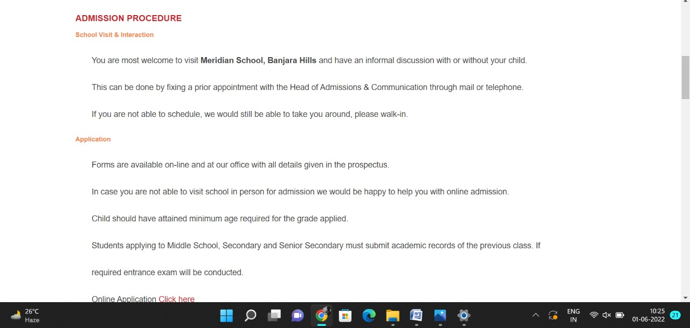

**PAGE 36:Fee Policy**

**HTML CODE:**

<!DOCTYPE html>

<html lang="en">

<head>

    <meta charset="UTF-8">

    <meta http-equiv="X-UA-Compatible" content="IE=edge">

    <meta name="viewport" content="width=device-width, initial-scale=1.0">

    <title>FEE POLICY - Meridian School</title>

    <link rel="stylesheet" href="css/feepolicy.css">

    <link rel="stylesheet" href="https://pro.fontawesome.com/releases/v5.10.0/css/all.css" />

    <link rel="icon" type="imag/logo2.png" href="img/logo2.png">

    <link rel="stylesheet" href="https://stackpath.bootstrapcdn.com/bootstrap/4.4.1/css/bootstrap.min.css"

        integrity="sha384-Vkoo8x4CGs03+Hhxv8T/Q5paXtkKtu6ug5TOeNV6gBiFeWPGFN9MuhOf23Q9Ifjh" crossorigin="anonymous" />

    <link rel="stylesheet" href="https://cdnjs.cloudflare.com/ajax/libs/slick-carousel/1.8.1/slick-theme.min.css"

        integrity="sha512-17EgCFERpgZKcm0j0fEq1YCJuyAWdz9KUtv1EjVuaOz8pDnh/0nZxmU6BBXwaaxqoi9PQXnRWqlcDB027hgv9A=="

        crossorigin="anonymous" referrerpolicy="no-referrer" />

    <link rel="stylesheet" href="https://cdnjs.cloudflare.com/ajax/libs/slick-carousel/1.8.1/slick.min.css"

        integrity="sha512-yHknP1/AwR+yx26cB1y0cjvQUMvEa2PFzt1c9LlS4pRQ5NOTZFWbhBig+X9G9eYW/8m0/4OXNx8pxJ6z57x0dw=="

        crossorigin="anonymous" referrerpolicy="no-referrer" />

</head>

<body>

    <section id="follow">

        <div class="followus">

            <div class="icon1">

                <i class="fa fa-phone"></i>

                <a id="phone" href="">8096918857, 9948508222</a>

            </div>

            <div class="icon1">

                <i class="fa fa-envelope"></i>

                <a id="mail" href="">info.banjara@meridianschool.in</a>

            </div>

            <div class="icon">

                <a href="https://www.facebook.com/MeridianSchoolBanjaraHills/" target="_blank"

                    class="fab fa-facebook-f"></i></a>

                <a href="https://twitter.com/meridianbanjara" target="_blank"><i class="fab fa-twitter"></i></a>

                <a href="https://www.youtube.com/channel/UCBZ_gLF9qM18O3CDWQHeN1A" target="_blank"><i

                        class="fab fa-youtube"></i></a>

                <a href="https://www.instagram.com/meridianschools/" target="_blank"><i

                        class="fab fa-instagram"></i></a>

            </div>

        </div>

    </section>

    <div class="navbar">

        <a href="home.html"><img src="img/logo.png" class="logo" alt=""></a>

        <nav>

            <a class="active" href="home.html">HOME</a>

            <div class="dropdown">

                <button class="dropbtn">ABOUT US

                </button>

                <div class="dropdown-content">

                    <a href="knowmeridian.html">KNOW MERIDIAN</a>

                    <a href="visionmission.html">THE VISION & MISSION</a>

                    <a href="http://meridianbanjara.com/the-founders/">THE FOUNDER'S MESSAGE</a>

                    <a href="ceomsg.html">CEO'S MESSAGE</a>

                    <a href="principalmsg.html">THE PRINCIPAL'S MESSAGE</a>

                    <a href="awards.html">AWARDS AND ACCOLADES</a>

                    <a href="http://meridianbanjara.com/affiliations-accreditations/">AFFILIATIONS & ACCREDITATIONS</a>

                    <a href="blog.html">BLOG</a>

                </div>

            </div>

            <div class="dropdown">

                <button class="dropbtn">LEADERSHIP TEAM

                </button>

                <div class="dropdown-content">

                    <a href="principal.html">PRINCIPAL</a>

                    <a href="vp.html">VICE PRINCIPAL</a>

                    <a href="headmistress.html">HEADMISTRESS</a>

                    <a href="midSchool.html">MIDDLE SCHOOL INCHARGE</a>

                    <a href="ipPyp.html">IB PYP COORDINATOR</a>

                    <a href="preprimary.html">PRE PRIMARY INCHARGE</a>

                    <a href="global.html">GLOBAL PARTNERSHIP COORDINATOR</a>

                </div>

            </div>

            <div class="dropdown">

                <button class="dropbtn">ACADEMICS

                </button>

                <div class="dropdown-content">

                    <a href="AcaOverview.html">OVERVIEW</a>

                    <a href="methodology.html">METHODOLOGY AND LEARNING STYLE</a>

                    <a href="curriculum.html">CURRICULUM</a>

                    <a href="faculty.html">FACULTY</a>

                    <a href="teacherTraining.html">TEACHER TRAINING</a>

                    <a href="careerGuidance.html">CAREER GUIDANCE</a>

                    <a href="scholrship.html">SCHOLARSHIP PROGRAMME</a>

                </div>

            </div>

            <div class="dropdown">

                <button class="dropbtn">BEYOND ACADEMICS

                </button>

                <div class="dropdown-content">

                    <a href="beyondAcaOverview.html">OVERVIEW</a>

                    <a href="sports.html">SPORTS</a>

                    <a href="creatveAct.html">CREATIVE ACTIVITIES</a>

                    <a href="eduTrips.html">EDUCATIONAL TRIPS AND STUDENT<br> EXCHANGE PROGRAMMES</a>

                    <a href="perfectSystem.html">PERFECT SYSTEM</a>

                    <a href="schoolSocialRes.html">SCHOOL'S SOCIAL RESPONSIBILITY</a>

                    <a href="interact.html">INTERACT</a>

                    <a href="heritageClub.html">HERITAGE CLUB</a>

                    <a href="mun.html">MUN</a>

                </div>

            </div>

            <div class="dropdown">

                <button class="dropbtn">ADMISSIONS

                </button>

                <div class="dropdown-content">

                    <a href="overview.html">OVERVIEW</a>

                    <a href="admissionpro.html">ADMISSION PROCEDURE</a>

                    <a href="feepolicy.html">FEE POLICY</a>

                    <a href="tranfercert.html">TRANSFER CERTIFICATE</a>

                    <a href="transport.html">TRANSPORT</a>

                </div>

            </div>

            <a class="active" href="gallery.html">GALLERY</a>

            <div class="dropdown">

                <button class="dropbtn">CONTACT US

                </button>

                <div class="dropdown-content">

                    <a href="contact.html">CAREERS</a>

                </div>

            </div>

        </nav>

    </div>

    <div id="mobile">

        <i id="bar" class="fas fa-outdent "></i>

    </div>

    <section id="feepolic">

        <img src="img/admission/4.jpg" width="100%" />

        <div class="fee">

            <h2>FEE POLICY</h2>

            <span id="orange"><a href="home.html">Meridian School Banjara Hills</a></span>

            <span> &gt; FEE POLICY</span>

        </div>

    </section>

    <section id="fe">

        <div class="fe1">

            <div id="info">

                <h4>FEE POLICY</h4>

                <p>

                    School fee as per the Fee Proforma Invoice can be deposited at the time of accepting the admission

                    but not later than the dates indicated in the Fee Structure of the school. There are three terms.

                    Each term fee must be paid within one week of the start of new term.Students shall not be allowed to

                    attend the school if all or any part of the Fee/ Amount is due.</p>

                <br>

                <p> All cheques/ drafts/ remittances should be made in favour of Meridian Educational Society payable at

                    Hyderabad. All Cheques/drafts/remittances must clearly state</p>

                <br>

                <p> (a) Invoice Number<br>

                    (b) Student’s Name<br>

                    (c) Grade Applied For<br>

                    (d) Student Admission No. if allotted

                </p>

            </div>

        </div>

    </section>

    <footer>

        <div class="col">

            <h4>ABOUT US</h4>

            <p>Meridian is a New Generation Educational Group committed to educate children for life and thus bring a

                change in the society. Learning philosophy practised at Meridian infuses traditional values into a

                progressive approach, equipping students to adapt and excel anywhere in the world. Our alumni, working

                in diverse fields, have found Meridian to be the best school for a successful career take off.</p>

        </div>

        <div class="col">

            <h4>USEFUL LINKS</h4>

            <ul class="three-col-links">

                <li><a href="home.html">HOME</a></li>

                <li><a href="AcaOverview.html">ACADEMICS</a></li>

                <li><a href="overview.html">ADMISSIONS</a></li>

                <li><a href="contact.html">CONTACT US</a></li>

                <li><a href="knowmeridian.html">ABOUT US</a></li>

                <li><a href="beyondAcaOverview.html">BEYOND ACADEMICS</a></li>

                <li><a href="contact.html">CAREERS</a></li>

            </ul>

        </div>

        <div class="col">

            <!--<div class="follow">

                <div class="icon">

                    <i class="fa fa-paper-plane-o"></i>

                </div>

        </div>-->

            <h4>MERIDIAN SCHOOL, Banjara Hills</h4>

            <p># 8-2-541, Road No 7, Banjara Hills, Hyderabad-500034, TELANGANA, INDIA.</p><br>

            <p>For contact : +91 8096918857, 9948508222, <br>For Prinicipal Appointments : 8098420002</p><br>

            <p> For Admissions / Enquires : 8096918857, 9948508222</p><br>

            <p>info.banjara@meridianschool.inA</p>

        </div>

    </footer>

    <section id="copyright">

        <div id="cr">

            <p>© Copyright MERIDIAN SCHOOL, BANJARA HILLS 2020.</p>

        </div>

    </section>

    <script src="https://ajax.googleapis.com/ajax/libs/jquery/3.6.0/jquery.min.js"></script>

    <script src="https://cdnjs.cloudflare.com/ajax/libs/slick-carousel/1.8.1/slick.min.js"

        integrity="sha512-XtmMtDEcNz2j7ekrtHvOVR4iwwaD6o/FUJe6+Zq+HgcCsk3kj4uSQQR8weQ2QVj1o0Pk6PwYLohm206ZzNfubg=="

        crossorigin="anonymous" referrerpolicy="no-referrer"></script>

**CSS CODE:**

@import url('https://fonts.googleapis.com/css2?family=Lato:wght@300;400;700&display=swap');

* {

    margin: 0;

    padding: 0;

    box-sizing: border-box;

    font-family: 'Spartan', sans-serif;

}

a:hover {

    transition: 0.2 ease;

}

/* div, section{

    border: 2px solid black;

} */

h1 {

    font-size: 40px;

    line-height: 64px;

    color: #fff;

}

h2 {

    font-weight: 500;

    font-size: 56px;

    line-height: 54px;

    color: #fff;

    text-align: center;

}

h3 {

    text-align: center;

    font-size: 22px;

    color: #c42329;

}

h6 {

    font-weight: 700;

    font-size: 12px;

}

p {

    font-size: 15px;

    line-height: 26px;

    font-weight: 400;

    font-style: normal;

    color: #444;

}

span {

    font-size: 15px;

    line-height: 26px;

    font-weight: 400;

    font-style: normal;

    color: #444444;

    text-align: center;

}

.section-p1 {

    margin: 40px 80px;

}

.section-m1 {

    margin: 40px 0;

}

button.normal {

    font-size: 14px;

    font-weight: 600;

    padding: 15px 30px;

    color: #fff;

    background-color: #c42329;

    border-radius: 4px;

    cursor: pointer;

    border: none;

    outline: none;

    transition: 0.2s;

}

body {

    width: 100%;

}

#header {

    background-color: #fff;

    border-bottom: #c42329;

    display: flex;

    align-items: center;

    justify-content: space-between;

    padding: 16px 80px;

    box-shadow: 0 5px 15px rgba(0, 0, 0, 0.06);

    /* z-index: 999; */

    position: sticky;

    top: 0;

    left: 0;

}

#header a img {

    width: 135px;

    height: 61px;

}

#header a:hover {

    border: 1px dotted orange;

}

#mobile {

    display: none;

    align-items: center;

}

#close {

    display: none;

}

/*#navbar {

    display: flex;

    align-items: center;

    justify-content: center;

}

#navbar li {

    list-style: none;

    padding: 0 8px;

    position: relative;

}

#navbar li a {

    text-decoration: none;

    font-size: 13px;

    font-weight: 600;

    color: #c42329;

    transition: 0.3 ease;

}

#navbar li a.active::after,

#navbar li a:hover::after {

    content: "";

    width: 30%;

    height: 2px;

    position: absolute;

    bottom: -4px;

    left: 20px;

}

#navbar .headButton {

    border-left: 20px;

}

#navbar .headButton:hover {

    border: #c42329;

    background-color: #fff;

    color: black;

}*/

.navbar {

    overflow: hidden;

    background-color: #fff;

}

.navbar a {

    float: left;

    font-size: 14px;

    color: #c42329;

    text-align: left;

    padding: 14px 16px;

    text-decoration: none;

}

.active {

    font-weight: 650;

}

.dropdown {

    float: left;

    overflow: hidden;

}

.dropdown .dropbtn {

    font-size: 14px;

    border: none;

    outline: none;

    color: #c42329;

    padding: 14px 16px;

    background-color: inherit;

    font-family: inherit;

    margin: 0;

    font-weight: 650;

}

.navbar a:hover,

.dropdown:hover .dropbtn {

    color: orange;

}

.dropdown-content {

    display: none;

    position: absolute;

    background-color: #c42329;

    min-width: 160px;

    box-shadow: 0px 8px 16px 0px rgba(0, 0, 0, 0.2);

    z-index: 1;

}

.dropdown-content a {

    float: none;

    color: white;

    padding: 12px 16px;

    text-decoration: none;

    display: block;

    text-align: left;

}

.dropdown-content a:hover {

    background-color: #c42329;

}

.dropdown:hover .dropdown-content {

    display: block;

}

nav {

    margin-top: 1.5%;

    margin-left: 30%;

}

.logo {

    margin-left: 60%;

    width: 135px;

    height: 61px;

}

footer {

    width: 100%;

    background-color: #c42329;

    display: flex;

    flex-direction: row;

    justify-content: space-between;

    flex-wrap: wrap;

    padding: 90px 70px 50px 70px;

}

footer .col {

    display: flex;

    flex-direction: column;

    align-items: flex-start;

    margin-bottom: 20px;

    width: 30%;

    height: 100%;

}

footer h4 {

    font-size: 20px;

    color: #fff;

    padding-bottom: 20px;

}

footer p {

    font-size: 16px;

    color: #fff;

    padding-bottom: 0 0 8px 0;

    margin-bottom: 0;

}

footer a {

    font-size: 17px;

    margin-bottom: 10px;

    color: #fff;

    text-decoration: none;

}

/* Align Links in footer */

.three-col-links {

    width: 105%;

    -webkit-column-count: 2;

    -moz-column-count: 2;

    column-count: 2;

    padding-top: 4%;

}

.three-col-links li {

    width: 100%;

    float: left;

    display: inline;

    margin-top: 8%;

    text-transform: uppercase;

}

/* END -Align Links in footer */

footer .follow {

    margin-top: 20px;

}

footer .follow i {

    color: #fff;

    padding-right: 4px;

    cursor: pointer;

}

footer .follow i:hover,

footer a:hover {

    color: orange;

}

#cr {

    background-color: black;

}

#cr p {

    text-align: center;

    color: #fff;

    padding: 20px 0;

}

#follow .icon {

    justify-content: flex-end;

}

#follow .icon i {

    color: #fff;

}

#follow .followus {

    display: flex;

    background-color: #c42329;

}

#follow .followus a {

    color: #fff;

    text-decoration: none;

    font-size: 14px;

    font-weight: 550;

}

/*#follow .followus #phone {

    padding: 10px 10px 10px 55px;

}

#follow .followus #mail {

    padding: 10px 10px 10px 35px;

}*/

#follow .followus a:hover {

    text-decoration: underline;

}

#follow .icon {

    margin-left: 890px;

    padding: 10px 10px;

}

#follow .icon i {

    padding: 0 3px;

}

#fe .fe1 {

    display: flex;

    margin: 100px 70px 100px 70px;

}

#fe .fe1 #info {

    width: 90%;

}

#fe .fe1 img {

    position: relative;

    width: 270px;

    height: 330px;

    margin-left: 70px;

    border: none;

    top: -20px;

}

#fe .fe1 #info h4 {

    margin: -20px 0px 35px 70px;

    color: #c42329;

}

#fe .fe1 #info p {

    margin: -20px 0px 35px 70px;

    font-size: 15px;

}

#feepolic {

    position: relative;

    text-align: center;

    color: white;

}

#feepolic .fee {

    height: 500px;

    background-repeat: no-repeat;

    padding: 230px 0 0 50px;

    /* background-position: 100%; */

    position: absolute;

    top: 50%;

    left: 50%;

    transform: translate(-160%, -50%);

}

#feepolic .fee h2 {

    font-size: 34px;

    font-weight: 600;

    text-align: start;

    /* color: #c42329; */

}

#feepolic .fee span {

    color: #fff;

}

#feepolic .fee span a {

    text-decoration: none;

}

#feepolic #orange a {

    color: #f48243;

}

#feepolic #orange a:hover {

    color: #fff;

}

.fa {

    display: inline-block;

    font: normal normal normal 14px/1 FontAwesome;

    font-size: inherit;

    text-rendering: auto;

    color: #fff;

}

.icon1 {

    padding: 8px 15px;

}

**OUTPUT:**

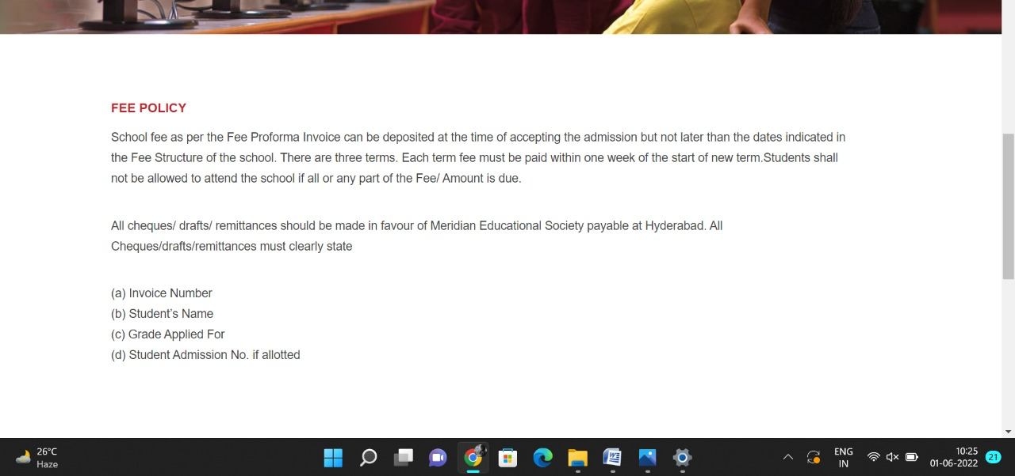+

**PAGE 37:Transfer Certificate**

**HTML CODE:**

<!DOCTYPE html>

<html lang="en">

<head>

    <meta charset="UTF-8">

    <meta http-equiv="X-UA-Compatible" content="IE=edge">

    <meta name="viewport" content="width=device-width, initial-scale=1.0">

    <title>TRANSFER CERTIFICATE - Meridian School</title>

    <link rel="stylesheet" href="css/tranfercert.css">

    <link rel="stylesheet" href="https://pro.fontawesome.com/releases/v5.10.0/css/all.css" />

    <link rel="icon" type="imag/logo2.png" href="img/logo2.png">

    <link rel="stylesheet" href="https://stackpath.bootstrapcdn.com/bootstrap/4.4.1/css/bootstrap.min.css"

        integrity="sha384-Vkoo8x4CGs03+Hhxv8T/Q5paXtkKtu6ug5TOeNV6gBiFeWPGFN9MuhOf23Q9Ifjh" crossorigin="anonymous" />

    <link rel="stylesheet" href="https://cdnjs.cloudflare.com/ajax/libs/slick-carousel/1.8.1/slick-theme.min.css"

        integrity="sha512-17EgCFERpgZKcm0j0fEq1YCJuyAWdz9KUtv1EjVuaOz8pDnh/0nZxmU6BBXwaaxqoi9PQXnRWqlcDB027hgv9A=="

        crossorigin="anonymous" referrerpolicy="no-referrer" />

    <link rel="stylesheet" href="https://cdnjs.cloudflare.com/ajax/libs/slick-carousel/1.8.1/slick.min.css"

        integrity="sha512-yHknP1/AwR+yx26cB1y0cjvQUMvEa2PFzt1c9LlS4pRQ5NOTZFWbhBig+X9G9eYW/8m0/4OXNx8pxJ6z57x0dw=="

        crossorigin="anonymous" referrerpolicy="no-referrer" />

</head>

<body>

    <section id="follow">

        <div class="followus">

            <div class="icon1">

                <i class="fa fa-phone"></i>

                <a id="phone" href="">8096918857, 9948508222</a>

            </div>

            <div class="icon1">

                <i class="fa fa-envelope"></i>

                <a id="mail" href="">info.banjara@meridianschool.in</a>

            </div>

            <div class="icon">

                <a href="https://www.facebook.com/MeridianSchoolBanjaraHills/" target="_blank"

                    class="fab fa-facebook-f"></i></a>

                <a href="https://twitter.com/meridianbanjara" target="_blank"><i class="fab fa-twitter"></i></a>

                <a href="https://www.youtube.com/channel/UCBZ_gLF9qM18O3CDWQHeN1A" target="_blank"><i

                        class="fab fa-youtube"></i></a>

                <a href="https://www.instagram.com/meridianschools/" target="_blank"><i

                        class="fab fa-instagram"></i></a>

            </div>

        </div>

    </section>

    <div class="navbar">

        <a href="home.html"><img src="img/logo.png" class="logo" alt=""></a>

        <nav>

            <a class="active" href="home.html">HOME</a>

            <div class="dropdown">

                <button class="dropbtn">ABOUT US

                </button>

                <div class="dropdown-content">

                    <a href="knowmeridian.html">KNOW MERIDIAN</a>

                    <a href="visionmission.html">THE VISION & MISSION</a>

                    <a href="http://meridianbanjara.com/the-founders/">THE FOUNDER'S MESSAGE</a>

                    <a href="ceomsg.html">CEO'S MESSAGE</a>

                    <a href="principalmsg.html">THE PRINCIPAL'S MESSAGE</a>

                    <a href="awards.html">AWARDS AND ACCOLADES</a>

                    <a href="http://meridianbanjara.com/affiliations-accreditations/">AFFILIATIONS & ACCREDITATIONS</a>

                    <a href="blog.html">BLOG</a>

                </div>

            </div>

            <div class="dropdown">

                <button class="dropbtn">LEADERSHIP TEAM

                </button>

                <div class="dropdown-content">

                    <a href="principal.html">PRINCIPAL</a>

                    <a href="vp.html">VICE PRINCIPAL</a>

                    <a href="headmistress.html">HEADMISTRESS</a>

                    <a href="midSchool.html">MIDDLE SCHOOL INCHARGE</a>

                    <a href="ipPyp.html">IB PYP COORDINATOR</a>

                    <a href="preprimary.html">PRE PRIMARY INCHARGE</a>

                    <a href="global.html">GLOBAL PARTNERSHIP COORDINATOR</a>

                </div>

            </div>

            <div class="dropdown">

                <button class="dropbtn">ACADEMICS

                </button>

                <div class="dropdown-content">

                    <a href="AcaOverview.html">OVERVIEW</a>

                    <a href="methodology.html">METHODOLOGY AND LEARNING STYLE</a>

                    <a href="curriculum.html">CURRICULUM</a>

                    <a href="faculty.html">FACULTY</a>

                    <a href="teacherTraining.html">TEACHER TRAINING</a>

                    <a href="careerGuidance.html">CAREER GUIDANCE</a>

                    <a href="scholrship.html">SCHOLARSHIP PROGRAMME</a>

                </div>

            </div>

            <div class="dropdown">

                <button class="dropbtn">BEYOND ACADEMICS

                </button>

                <div class="dropdown-content">

                    <a href="beyondAcaOverview.html">OVERVIEW</a>

                    <a href="sports.html">SPORTS</a>

                    <a href="creatveAct.html">CREATIVE ACTIVITIES</a>

                    <a href="eduTrips.html">EDUCATIONAL TRIPS AND STUDENT<br> EXCHANGE PROGRAMMES</a>

                    <a href="perfectSystem.html">PERFECT SYSTEM</a>

                    <a href="schoolSocialRes.html">SCHOOL'S SOCIAL RESPONSIBILITY</a>

                    <a href="interact.html">INTERACT</a>

                    <a href="heritageClub.html">HERITAGE CLUB</a>

                    <a href="mun.html">MUN</a>

                </div>

            </div>

            <div class="dropdown">

                <button class="dropbtn">ADMISSIONS

                </button>

                <div class="dropdown-content">

                    <a href="overview.html">OVERVIEW</a>

                    <a href="admissionpro.html">ADMISSION PROCEDURE</a>

                    <a href="feepolicy.html">FEE POLICY</a>

                    <a href="tranfercert.html">TRANSFER CERTIFICATE</a>

                    <a href="transport.html">TRANSPORT</a>

                </div>

            </div>

            <a class="active" href="gallery.html">GALLERY</a>

            <div class="dropdown">

                <button class="dropbtn">CONTACT US

                </button>

                <div class="dropdown-content">

                    <a href="contact.html">CAREERS</a>

                </div>

            </div>

        </nav>

    </div>

    <div id="mobile">

        <i id="bar" class="fas fa-outdent "></i>

    </div>

    <section id="transfer">

        <img src="img/admission/4.jpg" width="100%" />

        <div class="tran">

            <h2>TRANSFER CERTIFICATE</h2>

            <span id="orange"><a href="home.html">Meridian School Banjara Hills</a></span>

            <span> &gt; TRANSFER CERTIFICATE</span>

        </div>

    </section>

    <section id="tr">

        <div class="tr1">

            <div id="info">

                <h4>TRANSFER CERTIFICATE</h4>

                <h5>WITHDRAWLS:</h5>

                <ol type="1">

                    <li>Requisition for Transfer Certificate must be made personally by the parents on or before 31st

                        Term

                        fee will be charged if the child attends school in the new session even for a day.</li><br>

                    <li>Refund of Caution Deposit should be collected in the same academic session when the TC is

                        applied

                        for, on production of the Caution Deposit receipt (original), Bank details for online transfer

                        and No Dues Certificate</li><br>

                    <li>Rules regarding refund of Caution Deposit</li><br>

                </ol>

                <ul>

                    <li>Before 31st March – 100% refund</li><br>

                    <li>After 31st March – 50% refund</li>

                </ul>

            </div>

        </div>

    </section>

    <footer>

        <div class="col">

            <h4>ABOUT US</h4>

            <p>Meridian is a New Generation Educational Group committed to educate children for life and thus bring a

                change in the society. Learning philosophy practised at Meridian infuses traditional values into a

                progressive approach, equipping students to adapt and excel anywhere in the world. Our alumni, working

                in diverse fields, have found Meridian to be the best school for a successful career take off.</p>

        </div>

        <div class="col">

            <h4>USEFUL LINKS</h4>

            <ul class="three-col-links">

                <li><a href="home.html">HOME</a></li>

                <li><a href="AcaOverview.html">ACADEMICS</a></li>

                <li><a href="overview.html">ADMISSIONS</a></li>

                <li><a href="contact.html">CONTACT US</a></li>

                <li><a href="knowmeridian.html">ABOUT US</a></li>

                <li><a href="beyondAcaOverview.html">BEYOND ACADEMICS</a></li>

                <li><a href="contact.html">CAREERS</a></li>

            </ul>

        </div>

        <div class="col">

            <!--<div class="follow">

                <div class="icon">

                    <i class="fa fa-paper-plane-o"></i>

                </div>

        </div>-->

            <h4>MERIDIAN SCHOOL, Banjara Hills</h4>

            <p># 8-2-541, Road No 7, Banjara Hills, Hyderabad-500034, TELANGANA, INDIA.</p><br>

            <p>For contact : +91 8096918857, 9948508222, <br>For Prinicipal Appointments : 8098420002</p><br>

            <p> For Admissions / Enquires : 8096918857, 9948508222</p><br>

            <p>info.banjara@meridianschool.inA</p>

        </div>

    </footer>

    <section id="copyright">

        <div id="cr">

            <p>© Copyright MERIDIAN SCHOOL, BANJARA HILLS 2020.</p>

        </div>

    </section>

    <script src="https://ajax.googleapis.com/ajax/libs/jquery/3.6.0/jquery.min.js"></script>

    <script src="https://cdnjs.cloudflare.com/ajax/libs/slick-carousel/1.8.1/slick.min.js"

        integrity="sha512-XtmMtDEcNz2j7ekrtHvOVR4iwwaD6o/FUJe6+Zq+HgcCsk3kj4uSQQR8weQ2QVj1o0Pk6PwYLohm206ZzNfubg=="

        crossorigin="anonymous" referrerpolicy="no-referrer"></script>

**CSS CODE:**

@import url('https://fonts.googleapis.com/css2?family=Lato:wght@300;400;700&display=swap');

* {

    margin: 0;

    padding: 0;

    box-sizing: border-box;

    font-family: 'Spartan', sans-serif;

}

a:hover {

    transition: 0.2 ease;

}

/* div, section{

    border: 2px solid black;

} */

h1 {

    font-size: 40px;

    line-height: 64px;

    color: #fff;

}

h2 {

    font-weight: 500;

    font-size: 56px;

    line-height: 54px;

    color: #fff;

    text-align: center;

}

h3 {

    text-align: center;

    font-size: 22px;

    color: #c42329;

}

h6 {

    font-weight: 700;

    font-size: 12px;

}

p {

    font-size: 15px;

    line-height: 26px;

    font-weight: 400;

    font-style: normal;

    color: #444;

}

span {

    font-size: 15px;

    line-height: 26px;

    font-weight: 400;

    font-style: normal;

    color: #444444;

    text-align: center;

}

.section-p1 {

    margin: 40px 80px;

}

.section-m1 {

    margin: 40px 0;

}

button.normal {

    font-size: 14px;

    font-weight: 600;

    padding: 15px 30px;

    color: #fff;

    background-color: #c42329;

    border-radius: 4px;

    cursor: pointer;

    border: none;

    outline: none;

    transition: 0.2s;

}

body {

    width: 100%;

}

#header {

    background-color: #fff;

    border-bottom: #c42329;

    display: flex;

    align-items: center;

    justify-content: space-between;

    padding: 16px 80px;

    box-shadow: 0 5px 15px rgba(0, 0, 0, 0.06);

    /* z-index: 999; */

    position: sticky;

    top: 0;

    left: 0;

}

#header a img {

    width: 135px;

    height: 61px;

}

#header a:hover {

    border: 1px dotted orange;

}

#mobile {

    display: none;

    align-items: center;

}

#close {

    display: none;

}

/*#navbar {

    display: flex;

    align-items: center;

    justify-content: center;

}

#navbar li {

    list-style: none;

    padding: 0 8px;

    position: relative;

}

#navbar li a {

    text-decoration: none;

    font-size: 13px;

    font-weight: 600;

    color: #c42329;

    transition: 0.3 ease;

}

#navbar li a.active::after,

#navbar li a:hover::after {

    content: "";

    width: 30%;

    height: 2px;

    position: absolute;

    bottom: -4px;

    left: 20px;

}

#navbar .headButton {

    border-left: 20px;

}

#navbar .headButton:hover {

    border: #c42329;

    background-color: #fff;

    color: black;

}*/

.navbar {

    overflow: hidden;

    background-color: #fff;

}

.navbar a {

    float: left;

    font-size: 14px;

    color: #c42329;

    text-align: left;

    padding: 14px 16px;

    text-decoration: none;

}

.active {

    font-weight: 650;

}

.dropdown {

    float: left;

    overflow: hidden;

}

.dropdown .dropbtn {

    font-size: 14px;

    border: none;

    outline: none;

    color: #c42329;

    padding: 14px 16px;

    background-color: inherit;

    font-family: inherit;

    margin: 0;

    font-weight: 650;

}

.navbar a:hover,

.dropdown:hover .dropbtn {

    color: orange;

}

.dropdown-content {

    display: none;

    position: absolute;

    background-color: #c42329;

    min-width: 160px;

    box-shadow: 0px 8px 16px 0px rgba(0, 0, 0, 0.2);

    z-index: 1;

}

.dropdown-content a {

    float: none;

    color: white;

    padding: 12px 16px;

    text-decoration: none;

    display: block;

    text-align: left;

}

.dropdown-content a:hover {

    background-color: #c42329;

}

.dropdown:hover .dropdown-content {

    display: block;

}

nav {

    margin-top: 1.5%;

    margin-left: 30%;

}

.logo {

    margin-left: 60%;

    width: 135px;

    height: 61px;

}

footer {

    width: 100%;

    background-color: #c42329;

    display: flex;

    flex-direction: row;

    justify-content: space-between;

    flex-wrap: wrap;

    padding: 90px 70px 50px 70px;

}

footer .col {

    display: flex;

    flex-direction: column;

    align-items: flex-start;

    margin-bottom: 20px;

    width: 30%;

    height: 100%;

}

footer h4 {

    font-size: 20px;

    color: #fff;

    padding-bottom: 20px;

}

footer p {

    font-size: 16px;

    color: #fff;

    padding-bottom: 0 0 8px 0;

    margin-bottom: 0;

}

footer a {

    font-size: 17px;

    margin-bottom: 10px;

    color: #fff;

    text-decoration: none;

}

/* Align Links in footer */

.three-col-links {

    width: 105%;

    -webkit-column-count: 2;

    -moz-column-count: 2;

    column-count: 2;

    padding-top: 4%;

}

.three-col-links li {

    width: 100%;

    float: left;

    display: inline;

    margin-top: 8%;

    text-transform: uppercase;

}

/* END -Align Links in footer */

footer .follow {

    margin-top: 20px;

}

footer .follow i {

    color: #fff;

    padding-right: 4px;

    cursor: pointer;

}

footer .follow i:hover,

footer a:hover {

    color: orange;

}

#cr {

    background-color: black;

}

#cr p {

    text-align: center;

    color: #fff;

    padding: 20px 0;

}

#follow .icon {

    justify-content: flex-end;

}

#follow .icon i {

    color: #fff;

}

#follow .followus {

    display: flex;

    background-color: #c42329;

}

#follow .followus a {

    color: #fff;

    text-decoration: none;

    font-size: 14px;

    font-weight: 550;

}

/*#follow .followus #phone {

    padding: 10px 10px 10px 55px;

}

#follow .followus #mail {

    padding: 10px 10px 10px 35px;

}*/

#follow .followus a:hover {

    text-decoration: underline;

}

#follow .icon {

    margin-left: 890px;

    padding: 10px 10px;

}

#follow .icon i {

    padding: 0 3px;

}

#tr .tr1 {

    display: flex;

    margin: 150px 70px 130px 70px;

}

#tr .tr1 #info {

    width: 90%;

}

#tr .tr1 img {

    position: relative;

    width: 270px;

    height: 330px;

    margin-left: 70px;

    border: none;

    top: -20px;

}

#tr .tr1 #info h4 {

    margin: -20px 0px 35px 70px;

    color: #c42329;

}

#tr .tr1 #info h5 {

    color: #f48243;

    margin: -20px 0px 35px 70px;

}

#tr .tr1 #info ol {

    margin: -20px 70px 35px 110px;

    font-size: 15px;

    line-height: 15px;

}

#tr .tr1 #info ul {

    margin: -20px 70px 35px 110px;

    font-size: 15px;

    line-height: 15px;

}

#transfer {

    position: relative;

    text-align: center;

    color: white;

}

#transfer .tran {

    height: 500px;

    background-repeat: no-repeat;

    padding: 230px 0 0 50px;

    /* background-position: 100%; */

    position: absolute;

    top: 50%;

    left: 50%;

    transform: translate(-160%, -50%);

}

#transfer .tran h2 {

    font-size: 34px;

    font-weight: 600;

    text-align: start;

    /* color: #c42329; */

}

#transfer .tran span {

    color: #fff;

}

#transfer .tran span a {

    text-decoration: none;

}

#transfer #orange a {

    color: #f48243;

}

#transfer #orange a:hover {

    color: #fff;

}

.fa {

    display: inline-block;

    font: normal normal normal 14px/1 FontAwesome;

    font-size: inherit;

    text-rendering: auto;

    color: #fff;

}

.icon1 {

    padding: 8px 15px;

}

**OUTPUT:**

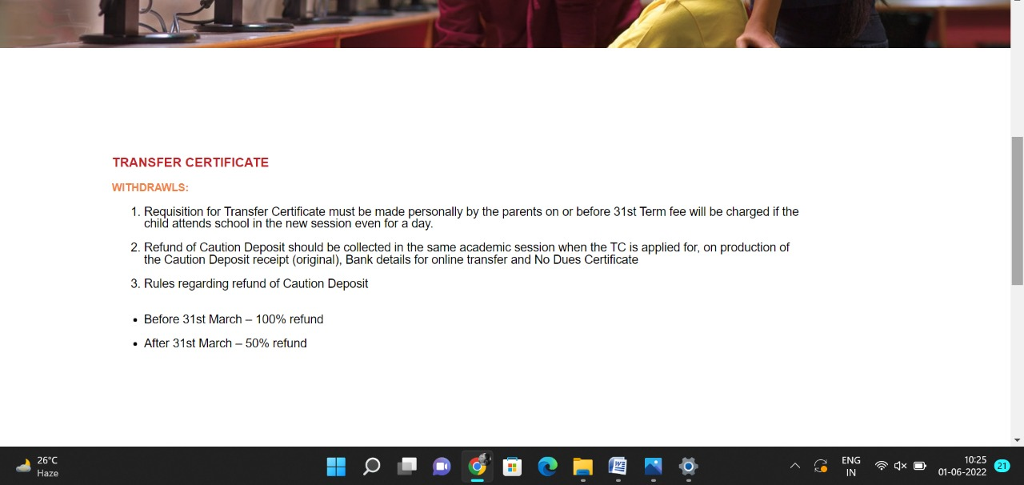

**PAGE 38:Transport**

**HTML CODE:**

<!DOCTYPE html>

<html lang="en">

<head>

    <meta charset="UTF-8">

    <meta http-equiv="X-UA-Compatible" content="IE=edge">

    <meta name="viewport" content="width=device-width, initial-scale=1.0">

    <title>TRANSPORT - Meridian School</title>

    <link rel="stylesheet" href="css/transport.css">

    <link rel="stylesheet" href="https://pro.fontawesome.com/releases/v5.10.0/css/all.css" />

    <link rel="icon" type="imag/logo2.png" href="img/logo2.png">

    <link rel="stylesheet" href="https://stackpath.bootstrapcdn.com/bootstrap/4.4.1/css/bootstrap.min.css"

        integrity="sha384-Vkoo8x4CGs03+Hhxv8T/Q5paXtkKtu6ug5TOeNV6gBiFeWPGFN9MuhOf23Q9Ifjh" crossorigin="anonymous" />

    <link rel="stylesheet" href="https://cdnjs.cloudflare.com/ajax/libs/slick-carousel/1.8.1/slick-theme.min.css"

        integrity="sha512-17EgCFERpgZKcm0j0fEq1YCJuyAWdz9KUtv1EjVuaOz8pDnh/0nZxmU6BBXwaaxqoi9PQXnRWqlcDB027hgv9A=="

        crossorigin="anonymous" referrerpolicy="no-referrer" />

    <link rel="stylesheet" href="https://cdnjs.cloudflare.com/ajax/libs/slick-carousel/1.8.1/slick.min.css"

        integrity="sha512-yHknP1/AwR+yx26cB1y0cjvQUMvEa2PFzt1c9LlS4pRQ5NOTZFWbhBig+X9G9eYW/8m0/4OXNx8pxJ6z57x0dw=="

        crossorigin="anonymous" referrerpolicy="no-referrer" />

</head>

<body>

    <section id="follow">

        <div class="followus">

            <div class="icon1">

                <i class="fa fa-phone"></i>

                <a id="phone" href="">8096918857, 9948508222</a>

            </div>

            <div class="icon1">

                <i class="fa fa-envelope"></i>

                <a id="mail" href="">info.banjara@meridianschool.in</a>

            </div>

            <div class="icon">

                <a href="https://www.facebook.com/MeridianSchoolBanjaraHills/" target="_blank"

                    class="fab fa-facebook-f"></i></a>

                <a href="https://twitter.com/meridianbanjara" target="_blank"><i class="fab fa-twitter"></i></a>

                <a href="https://www.youtube.com/channel/UCBZ_gLF9qM18O3CDWQHeN1A" target="_blank"><i

                        class="fab fa-youtube"></i></a>

                <a href="https://www.instagram.com/meridianschools/" target="_blank"><i

                        class="fab fa-instagram"></i></a>

            </div>

        </div>

    </section>

    <div class="navbar">

        <a href="home.html"><img src="img/logo.png" class="logo" alt=""></a>

        <nav>

            <a class="active" href="home.html">HOME</a>

            <div class="dropdown">

                <button class="dropbtn">ABOUT US

                </button>

                <div class="dropdown-content">

                    <a href="knowmeridian.html">KNOW MERIDIAN</a>

                    <a href="visionmission.html">THE VISION & MISSION</a>

                    <a href="http://meridianbanjara.com/the-founders/">THE FOUNDER'S MESSAGE</a>

                    <a href="ceomsg.html">CEO'S MESSAGE</a>

                    <a href="principalmsg.html">THE PRINCIPAL'S MESSAGE</a>

                    <a href="awards.html">AWARDS AND ACCOLADES</a>

                    <a href="http://meridianbanjara.com/affiliations-accreditations/">AFFILIATIONS & ACCREDITATIONS</a>

                    <a href="blog.html">BLOG</a>

                </div>

            </div>

            <div class="dropdown">

                <button class="dropbtn">LEADERSHIP TEAM

                </button>

                <div class="dropdown-content">

                    <a href="principal.html">PRINCIPAL</a>

                    <a href="vp.html">VICE PRINCIPAL</a>

                    <a href="headmistress.html">HEADMISTRESS</a>

                    <a href="midSchool.html">MIDDLE SCHOOL INCHARGE</a>

                    <a href="ipPyp.html">IB PYP COORDINATOR</a>

                    <a href="preprimary.html">PRE PRIMARY INCHARGE</a>

                    <a href="global.html">GLOBAL PARTNERSHIP COORDINATOR</a>

                </div>

            </div>

            <div class="dropdown">

                <button class="dropbtn">ACADEMICS

                </button>

                <div class="dropdown-content">

                    <a href="AcaOverview.html">OVERVIEW</a>

                    <a href="methodology.html">METHODOLOGY AND LEARNING STYLE</a>

                    <a href="curriculum.html">CURRICULUM</a>

                    <a href="faculty.html">FACULTY</a>

                    <a href="teacherTraining.html">TEACHER TRAINING</a>

                    <a href="careerGuidance.html">CAREER GUIDANCE</a>

                    <a href="scholrship.html">SCHOLARSHIP PROGRAMME</a>

                </div>

            </div>

            <div class="dropdown">

                <button class="dropbtn">BEYOND ACADEMICS

                </button>

                <div class="dropdown-content">

                    <a href="beyondAcaOverview.html">OVERVIEW</a>

                    <a href="sports.html">SPORTS</a>

                    <a href="creatveAct.html">CREATIVE ACTIVITIES</a>

                    <a href="eduTrips.html">EDUCATIONAL TRIPS AND STUDENT<br> EXCHANGE PROGRAMMES</a>

                    <a href="perfectSystem.html">PERFECT SYSTEM</a>

                    <a href="schoolSocialRes.html">SCHOOL'S SOCIAL RESPONSIBILITY</a>

                    <a href="interact.html">INTERACT</a>

                    <a href="heritageClub.html">HERITAGE CLUB</a>

                    <a href="mun.html">MUN</a>

                </div>

            </div>

            <div class="dropdown">

                <button class="dropbtn">ADMISSIONS

                </button>

                <div class="dropdown-content">

                    <a href="overview.html">OVERVIEW</a>

                    <a href="admissionpro.html">ADMISSION PROCEDURE</a>

                    <a href="feepolicy.html">FEE POLICY</a>

                    <a href="tranfercert.html">TRANSFER CERTIFICATE</a>

                    <a href="transport.html">TRANSPORT</a>

                </div>

            </div>

            <a class="active" href="gallery.html">GALLERY</a>

            <div class="dropdown">

                <button class="dropbtn">CONTACT US

                </button>

                <div class="dropdown-content">

                    <a href="contact.html">CAREERS</a>

                </div>

            </div>

        </nav>

    </div>

    <div id="mobile">

        <i id="bar" class="fas fa-outdent "></i>

    </div>

    <section id="transport">

        <img src="img/admission/4.jpg" width="100%" />

        <div class="port">

            <h2>TRANSPORT</h2>

            <span id="orange"><a href="home.html">Meridian School Banjara Hills</a></span>

            <span> &gt; TRANSPORT</span>

        </div>

    </section>

    <section id="tp">

        <div class="tp1">

            <div id="info">

                <h4>TRANSPORT</h4>

                <p>

                    School has more than 40 air-conditioned buses which ply to all parts of the city. We provide both

                    point-drop as well as door to door drop according to the need of the child.GPS tracker enables

                    parents to monitor the location of bus and also receive an SMS before the bus reaches the assigned

                    pickup point. Trained drivers and Security guards in each bus ensure that the school transport

                    system is extremely safe. They are regularly trained and supervised by the Head of Admin department.

                </p>

            </div>

        </div>

    </section>

    <footer>

        <div class="col">

            <h4>ABOUT US</h4>

            <p>Meridian is a New Generation Educational Group committed to educate children for life and thus bring a

                change in the society. Learning philosophy practised at Meridian infuses traditional values into a

                progressive approach, equipping students to adapt and excel anywhere in the world. Our alumni, working

                in diverse fields, have found Meridian to be the best school for a successful career take off.</p>

        </div>

        <div class="col">

            <h4>USEFUL LINKS</h4>

            <ul class="three-col-links">

                <li><a href="home.html">HOME</a></li>

                <li><a href="AcaOverview.html">ACADEMICS</a></li>

                <li><a href="overview.html">ADMISSIONS</a></li>

                <li><a href="contact.html">CONTACT US</a></li>

                <li><a href="knowmeridian.html">ABOUT US</a></li>

                <li><a href="beyondAcaOverview.html">BEYOND ACADEMICS</a></li>

                <li><a href="contact.html">CAREERS</a></li>

            </ul>

        </div>

        <div class="col">

            <!--<div class="follow">

                <div class="icon">

                    <i class="fa fa-paper-plane-o"></i>

                </div>

        </div>-->

            <h4>MERIDIAN SCHOOL, Banjara Hills</h4>

            <p># 8-2-541, Road No 7, Banjara Hills, Hyderabad-500034, TELANGANA, INDIA.</p><br>

            <p>For contact : +91 8096918857, 9948508222, <br>For Prinicipal Appointments : 8098420002</p><br>

            <p> For Admissions / Enquires : 8096918857, 9948508222</p><br>

            <p>info.banjara@meridianschool.inA</p>

        </div>

    </footer>

    <section id="copyright">

        <div id="cr">

            <p>© Copyright MERIDIAN SCHOOL, BANJARA HILLS 2020.</p>

        </div>

    </section>

    <script src="https://ajax.googleapis.com/ajax/libs/jquery/3.6.0/jquery.min.js"></script>

    <script src="https://cdnjs.cloudflare.com/ajax/libs/slick-carousel/1.8.1/slick.min.js"

        integrity="sha512-XtmMtDEcNz2j7ekrtHvOVR4iwwaD6o/FUJe6+Zq+HgcCsk3kj4uSQQR8weQ2QVj1o0Pk6PwYLohm206ZzNfubg=="

        crossorigin="anonymous" referrerpolicy="no-referrer"></script>

**CSS CODE:**

@import url('https://fonts.googleapis.com/css2?family=Lato:wght@300;400;700&display=swap');

* {

    margin: 0;

    padding: 0;

    box-sizing: border-box;

    font-family: 'Spartan', sans-serif;

}

a:hover {

    transition: 0.2 ease;

}

/* div, section{

    border: 2px solid black;

} */

h1 {

    font-size: 40px;

    line-height: 64px;

    color: #fff;

}

h2 {

    font-weight: 500;

    font-size: 56px;

    line-height: 54px;

    color: #fff;

    text-align: center;

}

h3 {

    text-align: center;

    font-size: 22px;

    color: #c42329;

}

h6 {

    font-weight: 700;

    font-size: 12px;

}

p {

    font-size: 15px;

    line-height: 26px;

    font-weight: 400;

    font-style: normal;

    color: #444;

}

span {

    font-size: 15px;

    line-height: 26px;

    font-weight: 400;

    font-style: normal;

    color: #444444;

    text-align: center;

}

.section-p1 {

    margin: 40px 80px;

}

.section-m1 {

    margin: 40px 0;

}

button.normal {

    font-size: 14px;

    font-weight: 600;

    padding: 15px 30px;

    color: #fff;

    background-color: #c42329;

    border-radius: 4px;

    cursor: pointer;

    border: none;

    outline: none;

    transition: 0.2s;

}

body {

    width: 100%;

}

#header {

    background-color: #fff;

    border-bottom: #c42329;

    display: flex;

    align-items: center;

    justify-content: space-between;

    padding: 16px 80px;

    box-shadow: 0 5px 15px rgba(0, 0, 0, 0.06);

    /* z-index: 999; */

    position: sticky;

    top: 0;

    left: 0;

}

#header a img {

    width: 135px;

    height: 61px;

}

#header a:hover {

    border: 1px dotted orange;

}

#mobile {

    display: none;

    align-items: center;

}

#close {

    display: none;

}

/*#navbar {

    display: flex;

    align-items: center;

    justify-content: center;

}

#navbar li {

    list-style: none;

    padding: 0 8px;

    position: relative;

}

#navbar li a {

    text-decoration: none;

    font-size: 13px;

    font-weight: 600;

    color: #c42329;

    transition: 0.3 ease;

}

#navbar li a.active::after,

#navbar li a:hover::after {

    content: "";

    width: 30%;

    height: 2px;

    position: absolute;

    bottom: -4px;

    left: 20px;

}

#navbar .headButton {

    border-left: 20px;

}

#navbar .headButton:hover {

    border: #c42329;

    background-color: #fff;

    color: black;

}*/

.navbar {

    overflow: hidden;

    background-color: #fff;

}

.navbar a {

    float: left;

    font-size: 14px;

    color: #c42329;

    text-align: left;

    padding: 14px 16px;

    text-decoration: none;

}

.active {

    font-weight: 650;

}

.dropdown {

    float: left;

    overflow: hidden;

}

.dropdown .dropbtn {

    font-size: 14px;

    border: none;

    outline: none;

    color: #c42329;

    padding: 14px 16px;

    background-color: inherit;

    font-family: inherit;

    margin: 0;

    font-weight: 650;

}

.navbar a:hover,

.dropdown:hover .dropbtn {

    color: orange;

}

.dropdown-content {

    display: none;

    position: absolute;

    background-color: #c42329;

    min-width: 160px;

    box-shadow: 0px 8px 16px 0px rgba(0, 0, 0, 0.2);

    z-index: 1;

}

.dropdown-content a {

    float: none;

    color: white;

    padding: 12px 16px;

    text-decoration: none;

    display: block;

    text-align: left;

}

.dropdown-content a:hover {

    background-color: #c42329;

}

.dropdown:hover .dropdown-content {

    display: block;

}

nav {

    margin-top: 1.5%;

    margin-left: 30%;

}

.logo {

    margin-left: 60%;

    width: 135px;

    height: 61px;

}

footer {

    width: 100%;

    background-color: #c42329;

    display: flex;

    flex-direction: row;

    justify-content: space-between;

    flex-wrap: wrap;

    padding: 90px 70px 50px 70px;

}

footer .col {

    display: flex;

    flex-direction: column;

    align-items: flex-start;

    margin-bottom: 20px;

    width: 30%;

    height: 100%;

}

footer h4 {

    font-size: 20px;

    color: #fff;

    padding-bottom: 20px;

}

footer p {

    font-size: 16px;

    color: #fff;

    padding-bottom: 0 0 8px 0;

    margin-bottom: 0;

}

footer a {

    font-size: 17px;

    margin-bottom: 10px;

    color: #fff;

    text-decoration: none;

}

/* Align Links in footer */

.three-col-links {

    width: 105%;

    -webkit-column-count: 2;

    -moz-column-count: 2;

    column-count: 2;

    padding-top: 4%;

}

.three-col-links li {

    width: 100%;

    float: left;

    display: inline;

    margin-top: 8%;

    text-transform: uppercase;

}

/* END -Align Links in footer */

footer .follow {

    margin-top: 20px;

}

footer .follow i {

    color: #fff;

    padding-right: 4px;

    cursor: pointer;

}

footer .follow i:hover,

footer a:hover {

    color: orange;

}

#cr {

    background-color: black;

}

#cr p {

    text-align: center;

    color: #fff;

    padding: 20px 0;

}

#follow .icon {

    justify-content: flex-end;

}

#follow .icon i {

    color: #fff;

}

#follow .followus {

    display: flex;

    background-color: #c42329;

}

#follow .followus a {

    color: #fff;

    text-decoration: none;

    font-size: 14px;

    font-weight: 550;

}

/*#follow .followus #phone {

    padding: 10px 10px 10px 55px;

}

#follow .followus #mail {

    padding: 10px 10px 10px 35px;

}*/

#follow .followus a:hover {

    text-decoration: underline;

}

#follow .icon {

    margin-left: 890px;

    padding: 10px 10px;

}

#follow .icon i {

    padding: 0 3px;

}

#tp .tp1 {

    display: flex;

    margin: 100px 60px 100px 100px;

}

#tp .tp1 #info {

    width: 90%;

}

#tp .tp1 img {

    position: relative;

    width: 270px;

    height: 330px;

    margin-left: 70px;

    border: none;

    top: -20px;

}

#tp .tp1 #info h4 {

    margin: -20px 0px 35px 70px;

    color: #c42329;

}

#tp .tp1 #info p {

    margin: -20px 0px 35px 70px;

    font-size: 15px;

}

#transport {

    position: relative;

    text-align: center;

    color: white;

}

#transport .port {

    height: 500px;

    background-repeat: no-repeat;

    padding: 230px 0 0 50px;

    /* background-position: 100%; */

    position: absolute;

    top: 50%;

    left: 50%;

    transform: translate(-160%, -50%);

}

#transport .port h2 {

    font-size: 34px;

    font-weight: 600;

    text-align: start;

    /* color: #c42329; */

}

#transport .port span {

    color: #fff;

}

#transport .port span a {

    text-decoration: none;

}

#transport #orange a {

    color: #f48243;

}

#transport #orange a:hover {

    color: #fff;

}

.fa {

    display: inline-block;

    font: normal normal normal 14px/1 FontAwesome;

    font-size: inherit;

    text-rendering: auto;

    color: #fff;

}

.icon1 {

    padding: 8px 15px;

}

**OUTPUT:**

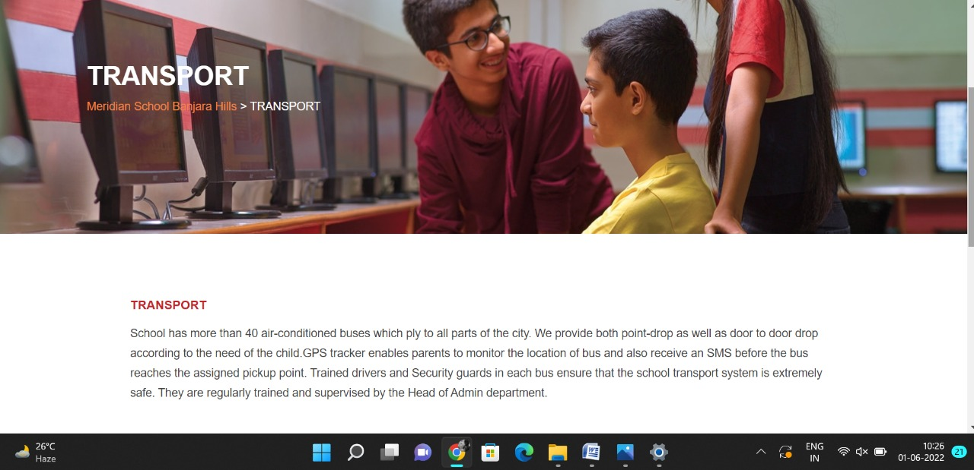

Gallery Pages

**PAGE 39:Gallery**

**HTML CODE:**

<!DOCTYPE html>

<html lang="en">

<head>

    <meta charset="UTF-8">

    <meta http-equiv="X-UA-Compatible" content="IE=edge">

    <meta name="viewport" content="width=device-width, initial-scale=1.0">

    <title>Gallery - Meridian School</title>

    <link rel="stylesheet" href="style.css">

    <link rel="stylesheet" href="https://pro.fontawesome.com/releases/v5.10.0/css/all.css" />

    <link rel="icon" type="imag/logo2.png" href="img/logo2.png">

    <link rel="stylesheet" href="https://stackpath.bootstrapcdn.com/bootstrap/4.4.1/css/bootstrap.min.css"

        integrity="sha384-Vkoo8x4CGs03+Hhxv8T/Q5paXtkKtu6ug5TOeNV6gBiFeWPGFN9MuhOf23Q9Ifjh" crossorigin="anonymous" />

    <link rel="stylesheet" href="https://cdnjs.cloudflare.com/ajax/libs/slick-carousel/1.8.1/slick-theme.min.css"

        integrity="sha512-17EgCFERpgZKcm0j0fEq1YCJuyAWdz9KUtv1EjVuaOz8pDnh/0nZxmU6BBXwaaxqoi9PQXnRWqlcDB027hgv9A=="

        crossorigin="anonymous" referrerpolicy="no-referrer" />

    <link rel="stylesheet" href="https://cdnjs.cloudflare.com/ajax/libs/slick-carousel/1.8.1/slick.min.css"

        integrity="sha512-yHknP1/AwR+yx26cB1y0cjvQUMvEa2PFzt1c9LlS4pRQ5NOTZFWbhBig+X9G9eYW/8m0/4OXNx8pxJ6z57x0dw=="

        crossorigin="anonymous" referrerpolicy="no-referrer" />

</head>

<body>

    <section id="follow">

        <div class="followus">

            <div class="icon1">

                <i class="fa fa-phone"></i>

                <a id="phone" href="">8096918857, 9948508222</a>

            </div>

            <div class="icon1">

                <i class="fa fa-envelope"></i>

                <a id="mail" href="">info.banjara@meridianschool.in</a>

            </div>

            <div class="icon">

                <a href="https://www.facebook.com/MeridianSchoolBanjaraHills/" target="_blank"

                    class="fab fa-facebook-f"></i></a>

                <a href="https://twitter.com/meridianbanjara" target="_blank"><i class="fab fa-twitter"></i></a>

                <a href="https://www.youtube.com/channel/UCBZ_gLF9qM18O3CDWQHeN1A" target="_blank"><i

                        class="fab fa-youtube"></i></a>

                <a href="https://www.instagram.com/meridianschools/" target="_blank"><i

                        class="fab fa-instagram"></i></a>

            </div>

        </div>

    </section>

    <div class="navbar">

        <a href="home.html"><img src="img/logo.png" class="logo" alt=""></a>

        <nav>

            <a class="active" href="home.html">HOME</a>

            <div class="dropdown">

                <button class="dropbtn">ABOUT US

                </button>

                <div class="dropdown-content">

                    <a href="knowmeridian.html">KNOW MERIDIAN</a>

                    <a href="visionmission.html">THE VISION & MISSION</a>

                    <a href="http://meridianbanjara.com/the-founders/">THE FOUNDER'S MESSAGE</a>

                    <a href="ceomsg.html">CEO'S MESSAGE</a>

                    <a href="principalmsg.html">THE PRINCIPAL'S MESSAGE</a>

                    <a href="awards.html">AWARDS AND ACCOLADES</a>

                    <a href="http://meridianbanjara.com/affiliations-accreditations/">AFFILIATIONS & ACCREDITATIONS</a>

                    <a href="blog.html">BLOG</a>

                </div>

            </div>

            <div class="dropdown">

                <button class="dropbtn">LEADERSHIP TEAM

                </button>

                <div class="dropdown-content">

                    <a href="principal.html">PRINCIPAL</a>

                    <a href="vp.html">VICE PRINCIPAL</a>

                    <a href="headmistress.html">HEADMISTRESS</a>

                    <a href="midSchool.html">MIDDLE SCHOOL INCHARGE</a>

                    <a href="ipPyp.html">IB PYP COORDINATOR</a>

                    <a href="preprimary.html">PRE PRIMARY INCHARGE</a>

                    <a href="global.html">GLOBAL PARTNERSHIP COORDINATOR</a>

                </div>

            </div>

            <div class="dropdown">

                <button class="dropbtn">ACADEMICS

                </button>

                <div class="dropdown-content">

                    <a href="AcaOverview.html">OVERVIEW</a>

                    <a href="methodology.html">METHODOLOGY AND LEARNING STYLE</a>

                    <a href="curriculum.html">CURRICULUM</a>

                    <a href="faculty.html">FACULTY</a>

                    <a href="teacherTraining.html">TEACHER TRAINING</a>

                    <a href="careerGuidance.html">CAREER GUIDANCE</a>

                    <a href="scholrship.html">SCHOLARSHIP PROGRAMME</a>

                </div>

            </div>

            <div class="dropdown">

                <button class="dropbtn">BEYOND ACADEMICS

                </button>

                <div class="dropdown-content">

                    <a href="beyondAcaOverview.html">OVERVIEW</a>

                    <a href="sports.html">SPORTS</a>

                    <a href="creatveAct.html">CREATIVE ACTIVITIES</a>

                    <a href="eduTrips.html">EDUCATIONAL TRIPS AND STUDENT<br> EXCHANGE PROGRAMMES</a>

                    <a href="perfectSystem.html">PERFECT SYSTEM</a>

                    <a href="schoolSocialRes.html">SCHOOL'S SOCIAL RESPONSIBILITY</a>

                    <a href="interact.html">INTERACT</a>

                    <a href="heritageClub.html">HERITAGE CLUB</a>

                    <a href="mun.html">MUN</a>

                </div>

            </div>

            <div class="dropdown">

                <button class="dropbtn">ADMISSIONS

                </button>

                <div class="dropdown-content">

                    <a href="overview.html">OVERVIEW</a>

                    <a href="admissionpro.html">ADMISSION PROCEDURE</a>

                    <a href="feepolicy.html">FEE POLICY</a>

                    <a href="tranfercert.html">TRANSFER CERTIFICATE</a>

                    <a href="transport.html">TRANSPORT</a>

                </div>

            </div>

            <a class="active" href="gallery.html">GALLERY</a>

            <div class="dropdown">

                <button class="dropbtn">CONTACT US

                </button>

                <div class="dropdown-content">

                    <a href="contact.html">CAREERS</a>

                </div>

            </div>

        </nav>

    </div>

    <div id="mobile">

        <i id="bar" class="fas fa-outdent "></i>

    </div>

    <section id="principal">

        <div class="prin" id="overview1">

            <h2>Gallery</h2>

            <span id="orange"><a href="home.html">Meridian School Banjara Hills</a></span>

            <span> &gt; Gallery</span>

        </div>

    </section>

    <section id="principal1">

        <div class="academics" id="overview">

            <h4>Event Gallery</h4>

            <div id="career">

                <img class="car1" src="img/gallery/1.jpg" alt="">

                <img class="car1" src="img/gallery/2.jpg" alt="">

                <img class="car1" src="img/gallery/3.png" alt="">

                <img class="car1" src="img/gallery/4.jpg" alt="">

                <img class="car1" src="img/gallery/5.png" alt="">

                <img class="car1" src="img/gallery/6.png" alt="">

                <img class="car1" src="img/gallery/7.jpg" alt="">

                <img class="car1" src="img/gallery/8.jpg" alt="">

                <img class="car1" src="img/gallery/9.png" alt="">

                <img class="car1" src="img/gallery/10.png" alt="">

                <img class="car1" src="img/gallery/11.png" alt="">

                <img class="car1" src="img/gallery/12.jpg" alt="">

                <img class="car1" src="img/gallery/13.png" alt="">

                <img class="car1" src="img/gallery/14.png" alt="">

                <img class="car1" src="img/gallery/15.png" alt="">

                <img class="car1" src="img/gallery/16.png" alt="">

                <img class="car1" src="img/gallery/17.png" alt="">

                <img class="car1" src="img/gallery/18.png" alt="">

                <img class="car1" src="img/gallery/19.png" alt="">

                <img class="car1" src="img/gallery/20.png" alt="">

                <img class="car1" src="img/gallery/21.png" alt="">

                <img class="car1" src="img/gallery/22.png" alt="">

                <img class="car1" src="img/gallery/23.jpg" alt="">

                <img class="car1" src="img/gallery/24.jpg" alt="">

                <img class="car1" src="img/gallery/25.jpg" alt="">

                <img class="car1" src="img/gallery/26.jpg" alt="">

                <img class="car1" src="img/gallery/27.jpg" alt="">

                <img class="car1" src="img/gallery/28.jpg" alt="">

                <img class="car1" src="img/gallery/29.jpg" alt="">

                <img class="car1" src="img/gallery/30.jpg" alt="">

                <img class="car1" src="img/gallery/31.jpg" alt="">

                <img class="car1" src="img/gallery/32.jpg" alt="">

                <img class="car1" src="img/gallery/33.jpg" alt="">

                <img class="car1" src="img/gallery/34.jpg" alt="">

                <img class="car1" src="img/gallery/35.jpg" alt="">

                <img class="car1" src="img/gallery/36.jpg" alt="">

                <img class="car1" src="img/gallery/37.jpg" alt="">

                <img class="car1" src="img/gallery/38].jpg" alt="">

                <img class="car1" src="img/gallery/39.jpg" alt="">

                <img class="car1" src="img/gallery/40.jpg" alt="">

                <img class="car1" src="img/gallery/41.jpg" alt="">

                <img class="car1" src="img/gallery/42.jpg" alt="">

                <img class="car1" src="img/gallery/43.jpg" alt="">

                <img class="car1" src="img/gallery/44.jpg" alt="">

                <img class="car1" src="img/gallery/45.jpg" alt="">

                <img class="car1" src="img/gallery/46.jpg" alt="">

                <img class="car1" src="img/gallery/47.jpg" alt="">

                <img class="car1" src="img/gallery/48.jpg" alt="">

                <img class="car1" src="img/gallery/49.jpg" alt="">

                <img class="car1" src="img/gallery/50.jpg" alt="">

                <img class="car1" src="img/gallery/51.jpg" alt="">

                <img class="car1" src="img/gallery/52.jpg" alt="">

                <img class="car1" src="img/gallery/53.jpg" alt="">

                <img class="car1" src="img/gallery/54.jpg" alt="">

                <img class="car1" src="img/gallery/55.jpg" alt="">

                <img class="car1" src="img/gallery/56.jpg" alt="">

                <img class="car1" src="img/gallery/57.jpg" alt="">

                <img class="car1" src="img/gallery/58.jpg" alt="">

                <img class="car1" src="img/gallery/59.jpg" alt="">

                <img class="car1" src="img/gallery/60.jpg" alt="">

                <img class="car1" src="img/gallery/61.jpg" alt="">

                <img class="car1" src="img/gallery/62.jpg" alt="">

                <img class="car1" src="img/gallery/63.jpg" alt="">

                <img class="car1" src="img/gallery/64.jpg" alt="">

                <img class="car1" src="img/gallery/65.jpg" alt="">

                <img class="car1" src="img/gallery/66.jpg" alt="">

                <img class="car1" src="img/gallery/67.png" alt="">

                <img class="car1" src="img/gallery/68.png" alt="">

                <img class="car1" src="img/gallery/69.jpeg" alt="">

                <img class="car1" src="img/gallery/70.jpg" alt="">

                <img class="car1" src="img/gallery/71.jpg" alt="">

                <img class="car1" src="img/gallery/72.jpg" alt="">

                <img class="car1" src="img/gallery/73.jpg" alt="">

                <img class="car1" src="img/gallery/74.jpg" alt="">

                <img class="car1" src="img/gallery/75.jpg" alt="">

                <img class="car1" src="img/gallery/76.jpg" alt="">

                <img class="car1" src="img/gallery/77.jpg" alt="">

                <img class="car1" src="img/gallery/78.jpg" alt="">

                <img class="car1" src="img/gallery/79.jpg" alt="">

                <img class="car1" src="img/gallery/80.jpg" alt="">

                <img class="car1" src="img/gallery/81.jpg" alt="">

                <img class="car1" src="img/gallery/82.jpg" alt="">

                <img class="car1" src="img/gallery/83.jpg" alt="">

                <img class="car1" src="img/gallery/84.jpg" alt="">

            </div>

        </div>

    </section>

    <footer>

        <div class="col">

            <h4>ABOUT US</h4>

            <p>Meridian is a New Generation Educational Group committed to educate children for life and thus bring a

                change in the society. Learning philosophy practised at Meridian infuses traditional values into a

                progressive approach, equipping students to adapt and excel anywhere in the world. Our alumni, working

                in diverse fields, have found Meridian to be the best school for a successful career take off.</p>

        </div>

        <div class="col">

            <h4>USEFUL LINKS</h4>

            <ul class="three-col-links">

                <li><a href="home.html">HOME</a></li>

                <li><a href="AcaOverview.html">ACADEMICS</a></li>

                <li><a href="overview.html">ADMISSIONS</a></li>

                <li><a href="contact.html">CONTACT US</a></li>

                <li><a href="knowmeridian.html">ABOUT US</a></li>

                <li><a href="beyondAcaOverview.html">BEYOND ACADEMICS</a></li>

                <li><a href="contact.html">CAREERS</a></li>

            </ul>

        </div>

        <div class="col">

            <!--<div class="follow">

                <div class="icon">

                    <i class="fa fa-paper-plane-o"></i>

                </div>

        </div>-->

            <h4>MERIDIAN SCHOOL, Banjara Hills</h4>

            <p># 8-2-541, Road No 7, Banjara Hills, Hyderabad-500034, TELANGANA, INDIA.</p>

            <p>For contact : +91 8096918857, 9948508222, For Prinicipal Appointments : 8098420002</p>

            <p> For Admissions / Enquires : 8096918857, 9948508222</p>

            <p>info.banjara@meridianschool.inA</p>

        </div>

    </footer>

    <section id="copyright">

        <div id="cr">

            <p>© Copyright MERIDIAN SCHOOL, 2021.</p>

        </div>

    </section>

</body>

</html>

**CSS CODE:**

table td,

table th {

width: 50%;

text-align: start;

padding: 10px;

color: #444

}

table {

width: 100%;

margin-bottom: 20px;

}

table,

th,

td {

border: 1px solid #e7e2e2;

}

**OUTPUT:**

